FORM THREE GEOGRAPHY PAPER 2 (312/2)
MID TERM 3 2022 EXAM
TIME 2HOURS 45 MINUTES
INSTRUCTIONS
- This paper two sections: A and B
- Answer all the question A.
- In section B answer question6 and any other two questions.
- All answers must be written in the foolscaps provided.
- Candidates must answer the questions in English.
SECTION A
1. (a) Give three ways in which minerals occur (3marks)

(b) State two factors which influence the exploitation of minerals. (2marks)

2. (a) What is a photograph? (2marks)

(b) State three characteristics of oblique aerial photographs. (3marks)

3. (a) Name three climatic elements that influence agriculture . (3marks)

(b) State three characteristics of extensive mechanized grain cultivation. (3marks)

4. State four reasons why British Columbia region in Canada is a major producer of softwoods. (4marks)
5. (a) Give two forms of commercial livestock farming. (2marks)
(b) Name two indigenous breeds of cattle kept by nomadic pastoralists in Kenya. (3marks)

SECTION B
(Answer question6 and any other two questions from this section.)

6. The table below shows the value in Ksh Millionof exports from Kenya and imports from the main geographical regions of the world in 2016. Use it to answer question (a) and (b).
GEOGRAPHICAL REGION | EXPORTS | IMPORTS
AFRICA | 235,000 | 140,000
EUROPE | 142,000 | 264,000
MIDDLE EAST | 50,000 | 195,000
FAR EAST | 90,000 | 762,000
AMERICAS | 53,000 | 65,000
Source: Economic survey 2017
(a) (i) What is the difference in value between exports and imports from Africa? (2marks)
(ii) Calculate the total value of imports in the year 2016. (2marks)
(iii) What is the percentage of the region with the least export value in 2016? (2marks)
(b) (i) Apart from comparative bar graphs, give two other statistical methods that can be usedto present the data in the table. (2marks)
(ii) Using a vertical scale of 1cm to represent Ksh 50 Billion, draw a comparative bar graph to present the data. (10marks)
(iii) State three conclusions that can be made from the graph that you have drawn. (3marks)
(c) State four characteristics of bar graphs. (4marks)

7. Study the map of East Africa below and use it to answer question (a).
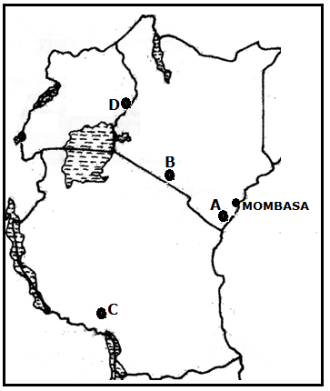
(a) Identify the minerals in the parts marked A, B, C and D. (4marks)
(b) (i) Apart from solution method, give three other methods of underground mining.. (3marks)
(ii) Describe how minerals are extracted using solution method. (6marks)
(c) State four negative effects of mining on the environment. (4marks)
(d) Explain four contributions of petroleum production to the economies of Middle East countries. (6marks)
(e) State two ways in which land derelics can be reclaimed (2marks)

8. (a) (i) What is forestry?. (2marks)
(ii) State two reasons why afforestation is being encouraged in Kenya (2 marks)
(b) Explain four factors that favour the growth of Mau forest. (8marks)
(c) Explain three problems that face forestry in Canada. (6marks)
(d) You intend to carry out a field study on a forest in your sub county.
(i) State three reasons why it is important to conduct a pre visit of the area. (3marks)
(ii) State three observations that that you would make to indicate the forest is well managed. (3marks)
9. Study the sketch map of Ghana below and use it to answer the following questions
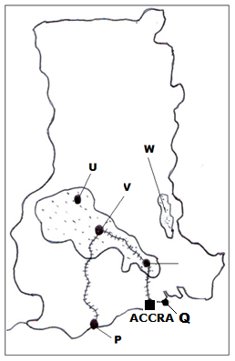
a) Name: (i) The cocoa growing areas marked U, V and W (3marks)
ii) The port cities marked P and Q (2marks)
b) State five physical conditions favoring cocoa growing in Ghana (5marks)
c) Describe the stages involved in cocoa processing in Ghana. (7marks)
d) Explain four economic problems facing cocoa farmers in Ghana (8marks)
10. (a) State three physical condition that favour coffee growing in the central highlands of Kenya. (3marks)
(b) Describe the stages involved in coffee production from picking to marketing. (8marks)
(c) Give four differences between coffee production in Kenya and in Brazil. (8marks)
(d) Your Geography class carried out a field study on a coffee farm
(i) State four methods the class would use to collect data. (4marks)
(ii) During the study, the class collected data on quantities of coffee produced from the farm in the last five years. State two methods that the class may have used to present the data (2marks)

