MIDTERM 3 2022
FORM I MATHEMATICS EXAM
MARKING SCHEME

No | WORKING | AWARD | EXPLANATION
1. | (a)-10-(-3)=-7  -11 -10 -9 -8 -7 -6 -5 -4 -3 -2 -1 0 1  (b)+1-(-8)=+9  -1 0 1 2 3 4 5 6 7 8 9 10 11 | A1  M1  A1  M1 | Correct answer  Correct line  Correct answer  Correct line
2. | $\left\{\left(1\frac{1}{4}-\frac{3}{8}\right)÷2\frac{1}{2}+1\frac{3}{4}÷1\frac{1}{4}\right\}$  BODMAS  $\left(1\frac{1}{4}-\frac{3}{8}\right)=\left(\frac{5}{4}-\frac{3}{8}\right)=\frac{10-8}{8}=\frac{7}{8}$  =$\frac{7}{8}÷2\frac{1}{2}=\frac{7}{8}÷\frac{5}{2}=\frac{7}{8}×\frac{2}{5}=\frac{7}{20}$  $1\frac{3}{4}÷1\frac{1}{4}=\frac{7}{4}÷\frac{5}{4}=\frac{7}{4}×\frac{4}{5}=\frac{7}{5}$  $=\frac{7}{20}+\frac{7}{5}=\frac{7+28}{20}=\frac{35}{20}$  $=1\frac{3}{4}$ | M1  M1  A1 | Removing brackets  Addition
3. | $\frac{29}{36}→Sh.330$  $\frac{36}{36}→?$  =$\frac{36}{36}×Sh.330÷\frac{29}{36}$  = $\frac{36}{36}×Sh.330×\frac{36}{29}$  =$Sh.409.66$  =$Sh.410$ | M1  B1  A1
4. | $Distance=Speed×Time$  =$56×2\frac{1}{2}$  $=140Km$ | M1  M1  A1
5. | $\frac{\text{x+1}}{\text{2}}\text{+}\frac{\text{2x+1}}{\text{3}}\text{=9}$  $\text{6(}\frac{\text{x+1}}{\text{2}}\text{)+6(}\frac{\text{2x+1}}{\text{3}}\text{)=9×6}$  $\text{3x+3+4x+2=54}$  $\text{7x+5=54}$  $\text{7x=54-5}$  $\text{7x=49}$  $\text{x=}\frac{\text{49}}{\text{7}}$, $x=7$ | M1  M1  A1
6. | $90\%→Sh.3150$  $100\%→?$  $=\frac{100\%×Sh.3150}{90\%}$  $=Sh.3500$ | M1  M1  A1
7. | A B  Or  A B | M1  M1  B1  OR  B1  M1  M1 | METHOD 1  Construction of an acute angle.  Subdivision of the line obtained  Construction of parallel lines(Use of a set square.  METHOD 2  Construction of equal acute angles at A and B.  Dividing the two line obtained equally.  Joining the subdivisions
8. | a) $=\frac{3}{4}×100$  $=75\%$  b) $r=2.304304$  $10r=23.04304$  $100r=230.4304$  $1000r=2304.304$  $1000r-r=2304.304304-2.304304$  $999r=2302$  $r=\frac{2302}{999}$  $=2\frac{304}{999}$ | M1  A1  M1  A1
9. | 5,005,005,005 | M1  M1  A1
10 | $=\frac{6}{20}=\frac{3}{10}$ | M1  B1 | Total count  Simplification
11 | (i)70.864  Value= 70 | M1  B1 | Correct calculation  Correct value
12 | (a) 0  (b) 2500 | M1  M1
13 | 3 3 7 11 13  7 11 13 1 1 1 1 7 1 1 1 11 11 1 1 13 13 13 1  Lcm 3 x 7 x 11 x 13  = 3003 + 1  = 3004 | M1  M1  A1
14 | Let the exterior angle be x  7x + x =180  8x=180  X=22.5  n =  n = 16 sides | M1  M1  A1
15 | =2(-6) – 3(-2) +4  =-2 | M1  A1 | substitution
16 | 1 Chinese Yen=KSh. 12.34  195250Chinese Yen=?  $=\frac{195250×12.34}{1}=KSh.2,409,385$  Balance =$KSh.2,409,385-KSh.1,258,000$  $=KSh.1,151,385$  KSh. 11.35=1 South African Rand  $KSh.1,151,385$=?  = $\frac{1,151,385×1}{11.35}$  =$101,265.17$ S.A Rand  =$101,265 S.A Rand$ | M1  B1  A1
SECTION II: Mark any five questions (50 Marks)
17 | 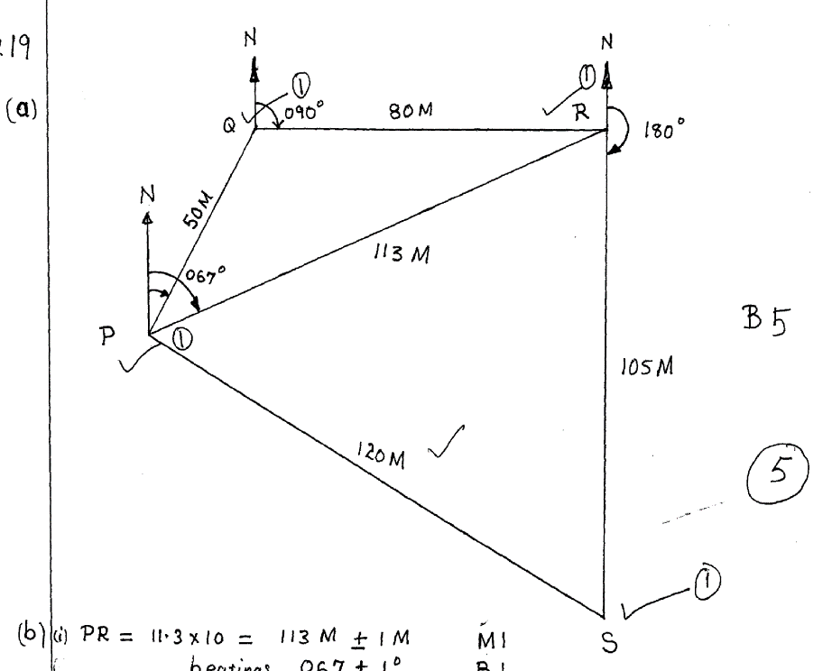  (a)  (b) (i) PR =11.3 x 10 = 113m$± 1m$  Bearing S67⁰W OR 247⁰  (ii)SR = 10.2 x10 = 102 $m$ $± 1m$  Bearing 180° | M1  M2  M2  B1  M1  A1  M1  A1 | Construction of the angle at P and locating Q.  Locating R at Q  Locating S.  Accuracy  Award 1 mark only if Northern lines are not parallel
18 | (a)  C  E  70 Q  R 25 P  A 100 160 B  M 120 200  50 N 80 O  D  F  (b)(i)$M→\frac{1}{2}×100×50=2500m^{2}$  $N→\frac{1}{2}×\left(50+80\right)=3900m^{2}$  $O→\frac{1}{2}×80×120=4800m^{2}$  $P→\frac{1}{2}×25×80=1000m^{2}$  $Q→\frac{1}{2}×\left(70+25\right)×80=3800m^{2}$  $R→\frac{1}{2}×700×120=4200m^{2}$  $Total Area=20,200m^{2}$  (ii)$= \frac{20200}{10000}=2.02 ha$ | M2  M2  M1  M1  M1  A1  M1  A1 | Drawing the base line and the off sets.  Labeling  Indicating the measurements correctly
19 | (a) total sales = sh 360 x 500  = sh.180, 000  Commission  = sh $\frac{20}{100}\left(180,000 – 100,000\right)$  = sh.16000  Total ernings=sh.16000+sh12000  =sh.28000  (i) New salary  = sh.(12000 + 12000 x ¹⁰/₁₀₀)  = sh. 13200  Commission paid  = sh(17,600 -13,200)  = sh.4400  Commission is paid on $\frac{100×4400}{20}$  = sh.22,000  Total sales = sh.22,000 + 100,000  =sh.122,000/=  (ii) no of handbags sold = $\frac{122,000}{500}$ = 244 Bags | M1  M1  B1  A1  M1  M1  M1  A1  M1  A1
20 | (a) C  8cm  A 7cm B  (b) (i) $=7.7cm ±0.1$  (ii)$={53}^{0} ±1^{0}$  (c)$=6.1cm±0.1$ | M1  M1  M1  M1  M1  A1  A1  M1 M1  A1 | -Construction of line AB  -Construction of angle ABC with compass &a ruler only.  Accuracy  Bisector
21 | Y-Axis  1600  1400  1200  12x + 4y =5600  1000  800  15x + 9y =7800  600  400  200  X-Axis  0 200 400 600 800 1000 1200 1400 1600  (b) (i) One Artisan=Sh. 400  (ii) One Apprentice = Sh. 200 | M1  M1  M1  M1  M1  M1 | Proper Scale  Plotting of two points.  Drawing & Labeling the lines

