NAME…………………………..………..……….ADM NO……….
SCHOOL………………………………………….DATE………….…
SIGN……………
312/2
GEOGRAPHY
PAPER 2
MARCH 2023
2½HOURS
MOMALICHE 2 CYCLE 10-2023
Kenya Certificate of Secondary Education (K.C.S.E)

INSTRUCTIONS TO STUDENTS
This paper has two sections A and B
Answer ALL the questions in section A in the spaces provided
Answer only THREE questions in section B in the spaces provided

FOR EXMINERS USE ONLY
SECTION | MAXIMUM SCORE | STUDENTS SCORE
A
B
TOTAL

1. (a) what is environment? (2mrks)
(b) State 3 reasons why we study Geography. (3mrks)

2. (a) Study the diagram of the seven folk dam power project provided below and use it to answer the question that follows.

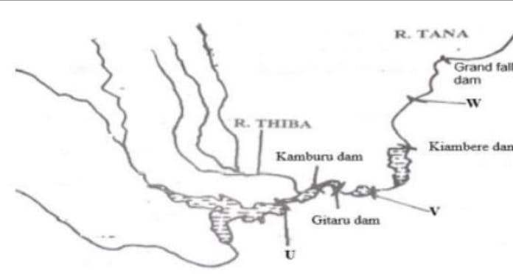
Identify the dam label U and V. (2mrks)

(b)State 3 physical factors that have favoured the establishment of the seven folk power project. (3mrks)

3) (a) Name two exotic breads of dairy cattle reared in Kenya. (2mrks)

(b)State 3 physical condition that favours dairy farming in Denmark. (3mrks)

4) (a) (i) The diagram below shows a fishing ground in Pacific Ocean.
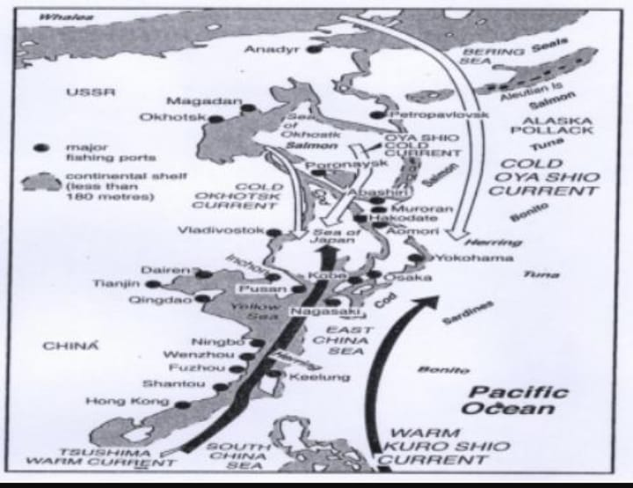
Identify the fishing ground shown above. (1mrks)
(ii)Name two types of fish species found in the fishing ground above. (2mrks)
(b) State two physical factors that have influenced the development of fishing in Japan. (2mrks).
5) Outline the stages through which land is reclaimed from the sea in the Netherland. (5mrks)

Section B
6) Answer question 6 and any other 2 questions.
The table below shows Kenya’s export between 1991 and 1994 in millions of shillings.
Crop | 1991 | 1992 | 1993 | 1994
Tea | 35 | 31 | 32 | 29
Coffee | 32 | 29 | 31 | 28
Wheat | 25 | 20 | 23 | 18
Sugarcane | 28 | 24 | 26 | 25

(a) (i) Using a scale of 1cm rep 10M, Draw a cumulative bar graph to represent the above data. (9mrks)
(ii) State three advantages of using cumulative bar graphs (3marks)
(b) Explain 4 reasons why Kenya import sugar. (8mrks).
(c) State five systematic stages in the processing of tea in a factory. (5mrks)

7) (a) i) Distinguish between eco-tourism and domestic tourism. (2mrks)
(ii) Explain 3 ways in which human factors have favored the existence of wildlife in Kenya. (6mrks)

(b)i) State how culture and tradition has contributed to tourism in Switzerland. (4mrks)
(ii) What efforts has Switzerland made in order to develop her tourism? (3mrks)

(c) (i) Explain 4 negative effects of tourism in Kenya. (8mrks).
(ii)Name two animals which make L. Nakuru a major tourist attraction. (2mrks)

8) Use the map of East Africa below to answer the question that follows.
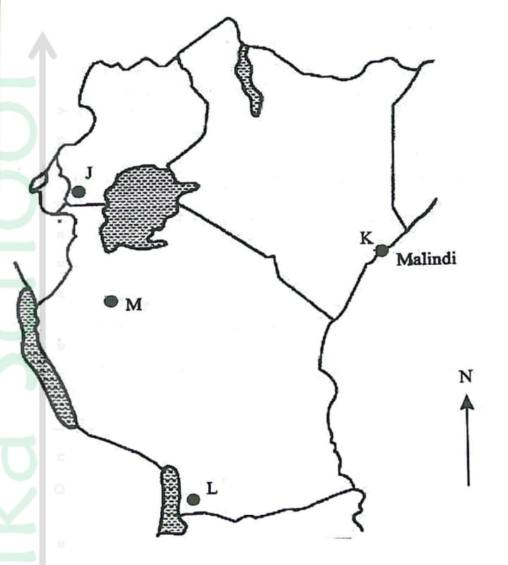
(a)i) Identify the minerals mined in the area marked W, X, Y and Z. (4mrks)
(ii) Name three methods of mining. (3mrks)
(iii)Name two sea port through which some of the minerals mined in East Africa are exported. (2mrks)
(b) State five factors that influence the exploitation of minerals. (5marks)
(c)Explain four ways in which soda ash contributes to the economy of Kenya. (8mrks)
(d)State three ways in which mining derelict can be reclaimed. (3mrks).

9) (a)i) What is forestry? (2marks)
(ii)Explain 3 factors that favours the growth of natural forest on the slope of Mt.Kenya. (6mrks)
(iii) State five factors that have led to reduction of the area under forest on the slope of Mount Kenya. (5marks)
(b) Explain four measures that the government of Kenya is taking to conserve forest in the country. (8mrks)
(c)Give the differences in the exploitation of softwood forest in Kenya and Canada under the following subheadings:
(i) Period of harvesting. (2mrks)
(ii)Transportation. (2mrks).
10) (a) (i) Define the term agriculture. (2mrks)
(ii) Name 3 wheat producing provinces in Canada. (3mrks)
(b)Describe the cultivation of wheat under the following.
(i) Processing of wheat. (5mrks)
(ii)Marketing of wheat. (2mrks)
(c) Give 5 reasons why the growing of flowers in green house is preferred in Kenya. (5mrks)
(d) (i) Name two exotic breed of beef cattle reared in Kenya. (2mrks)
(ii)Explain three physical conditions that favors beef farming in Argentina. (6mrks)

