TERM 2 YEAR 2022 MID TERM MS
FORM FOUR COMPUTER STUDIES
SECTION A
- Wanjiru is a manager in a financial institution. Give three reasons why you would advise Wanjiru to manage data using computers in he organization ( 6mks)
-Accuracy
- High storage capacity
-high speed
-diligence
-versatile
2. Wekesa is a counsellor, he moves to different places to offer guiding and counseling services to people.
i) Which type of computer would you recommend wekesa to use? (1mk)
laptop, notebook, IPAD
ii) Give two reasons why you would recommend Wekesa to use the computer in 2i) above (4mks)
-portable
-can be charged
3. (a) What is meant by the authenticity as used in software development? (2mks)
Genuiness, validity and originality of software

b) Distinguish between the terms single- tasking and multi- user as used in operating systems(2mks)
Single tasking – the O/S allows one program to be processed at a time
Multi – user an O/S that allows several tasks/ programs to be simultaneously

4. a Explain three ways by which computer users can protect their eyes from harmful emissions from the computer screen (3mks)
- Using a glare filter
- using an LCD screen (does not emit radiation)
- Not sitting in front of the computer for long hours
b) Give three examples of flat panel monitors in the market today (3mks)
- LCD
-GPD
-Electroluminicent

5. (a) What is a disk formatting? (2mks)
- To prepare storage medium by defining tracks and sectors where data will be placed in compliance with specific operating system requirements.

(b) Indicate whether the following devices are used for input or output
(2mks)
(i) Plotter - Output
(ii) Light pen Input
(iii) Mouse Input
(iv) Visual display unit

6. (a) Explain why the following controls c\should be implemented for computer based systems (4mks)
(i) Backups – To maintain a copy of original data in case the original one is lost or corrupted.

(ii) Passwords – To prevent unauthorized users from trying to access private data

(b) For each of the following give one reason why they are not allowed in a computer laboratory. (2mk)
(i) Smoking - Can start fire
- Can introduce dust through smoke particles
(ii) Eating foods- Can spill and spoil computer parts like keyboard

7. The first column in the table below contains the formulae as stored into the cell F10 of a spreadsheet. Enter the formulae, as they would appear when copied to the cell M20 of the same spreadsheet.

Formula in F10 | Formula in M20
= D10 * E10 | =K20*L20
=A$25 | =H$25
=$D$13 | =$D$13

8. Differentiate between COM ports and LTP ports (2mkS)
- COM port also known as a serial port transmits data bit by bit
- LTP port also known as a parallel port transmits multiple bits
Simultaneously at a time.
9. Jane has noticed the following problems in her computer:
- It is taking longer time to start up;
- It is often hanging
- Applications are taking longer to load.
State three possible causes of these problems and how they can be solved (3mks)
a) Disk is fragmented - Defragment the disk by running the defragment utility. "
b) Virus/bug infection - run the antivirus utility
c) Capacity of RAM is small- Increase the size by replacing the existing chip with a higher capacity RAM chip.
d) Processor speed is low - Replace processor with a high speed processor.

SECTIONB

10.A school has brought a computer system. The hardware items include: 800 MHz processor, 640 MB of RAM, a sound card, speakers, a monitor, a keyboard, a 120 GB hdd disk, a floppy disk drive, CDRW drive, a mouse, a modem, an inkjet printer and a joystick. The software supplied includes: an OS, a BASIC interpreter and the following packages: Spreadsheets, graphic, word processor, art database and games.
(a) List three input devices from the given specifications (3mks)
- Keyboard
- Mouse
- Joystick
(b) Explain the meaning of the following (3mks)
(i) 800 MHz- refers to the clock speed/ processor speed. The number of clock cycles per second at which the computer performs its basic operations

(ii) 640 MB- The size of the main memory installed inside main memory, which holds data and information waiting to be processed.

(iii) 120 GB hdd- The size of the fixed disk (hard disk) in the computer, it is a secondary storage medium.
(c) Some of the students in the school use the computer to do homework. Name the packages used to (3mks)
(i) Do calculations and draw graphs- Spreadsheets
(ii) Write an essy - word processor
(iii) Make a poster - publisher

(d) Students enjoy playing noisy computer games
(i) Which hardware items are needed to produce sound? (1mk)
- Soundcard, speakers
(ii) Which input device is used only for playing games? (1mk)
- Joystick
ei) What is multimedia capability?(1mk) ii) List three multimedia devices listed above(3mks)
-ability of a computer to process text, graphics and sound.
sound card,
speakers,
monitor,
CDRW drive
11. A multinational organization has offered to donate computers to your school. The Board of governors has requested you to advise on the operating system to be used by providing answer the following questions.

a) What is an operating system? (2mks)
-system software that controls the computer system (hardware and other
application software)
b) State and briefly explain three types of operating systems as classified according to human interface. (6mks)
graphical user interface-wimp
menu driven –list
c) Briefly explain the following functions of an operating system. (8mks)
- Task scheduling, arranging and organizing of tasks (jobs 0 under a
system of priority.
-Interrupt handling, a computer instruction that momentarily stops the
normal operation of a routine. The operation can usually be resumed later from the interruption

12. A head teacher keeps the following student details in a database: Name, Address, Town, Date of Birth, Marks scored, Fees paid.
i) Name the most appropriate primary key. Give a reason. (2 marks) Name
- Name alone is not unique though it is very rare that two or more students will share the same name.
ii) For each item in the student's details above, indicate its most appropriate data type as used in the database. (3 marks)
Name Text
Address Text
Town Text
Date of Birth Date/Time
Mark Scored Numeric
Fees Paid Numeric/Currency

iii) a) Explain why input screens are better data entry designs than entering data directly to a table. (2 marks)
- Most forms are bound to one or more tables and query in the database hence a user can design input fields linked to several tables/queries.
- Forms are also appealing to the eye. They have GUI features unlike a table.

b)Gives three ways of securing a database (3mks)
-passwords
-Hiding data
-encryption
-user level security.
c) Distinguish between:
i) A table in word-processing application and a table in a database application. (2 mks)
- A table in a database application is a data entry/storage object, while a table in a word processor is made up of rows and columns of cells that one can fill with text and graphics. Tables in word processors are often used to organize and present information
- In a database one defines the data type for a table in design stage/view but not the case in a word processor.

d) Outline the steps to be followed in order to merge cells in a word processing table. (3 marks)
i) Select/Highlight cells to be merged.
ii) Prom the menu bar clicks on table.
iii) Click on merge cells under the menu items.
13. 18. (a) Distinguish between the following sets of terms as used in Spreadsheets (4mk)
(i) Worksheet and workbook
Worksheet – The working area in an electronic spreadsheet on which a
user enters the spreadsheet data.
Workbook – A spreadsheet file. A workbook can obtain several worksheets

(ii) Filtering and sorting
Data filtering is a way of organizing spreadsheet data for ease of analysis. Often spreadsheet filters are used to “hide” rows of data that do not meet certain specified criteria. This allows you to analyze (e.g. count, observe etc) only certain “Filtering” groups of data.
Data sorting: Is a way of arranging record according to one of the fields in either ascending or descending order.

(b) State one way in which a user may reverse the last action taken in a spreadsheet package (1 mks)
- Use the undo command (ctrl + z)

(c) The following is a sample of a payroll. The worksheet row and column headings are marked 1, 2, 3, and A, B, C respectively
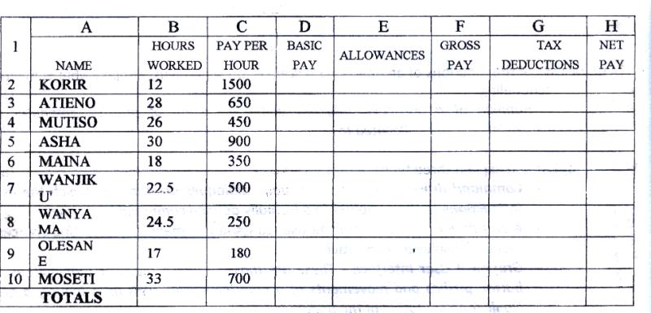

Use the following expressions to answer the questions that follow
- Basic pay- Hours worked x pay per hour
- Allowances are allowed at 10% of basic pay
- Gross pay- Basic pay + allowances
- Tax deductions are calculated at 20% of gross pay
- Net pay-= gross pay – tax deductions

Write formulae using cell references for the following cells (5mks)
- D2 = B2 * C2
- E4 = 10% * D4 or 10% * (B4 * C4)
- F10 = D10 + E10
- G7 = 20% * F7
- H5 = H5 – G5

(d) (i) State three ways of moving round the page in desktop publishing window
(3 mks)
- Use cursor keys
- use mouse scroller
- Use scroll buttons (horizontal and vertical)
(ii) State two ways on how information & communication technology (ICT) can be used to reduce the spread of HIV/ AIDS ( 2 mks)
- Through advertisements on the Internet
- Through creation of posters
- Through discussion groups on the internet

This is the last printed page

