NAME …………………………………………………………….. ADM NO. …………...........
CLASS ………………….. CANDIDATES SIGNATURE ……………………………
DATE ……………………………..

232/3
PHYSICS
PRACTICAL
FORM 4
END OF TERM 1
SEPTEMBER 2021
2 HOURS

INSTRUCTIONS TO STUDENTS
- Write your name and admission number in the spaces provided
- Answer all questions in this question paper.
- All your answers and working must be written in the spaces provided in this question paper.
- You are supposed to spend the first 15 minutes of the 2 ½ hours allowed for this paper reading the whole paper carefully.
- Marks are given for a clear record of the observation actually made, their suitability, accuracy and the use made of them
- This paper consists of 9 printed pages
- All questions must be answered in English

FOR EXAMINERS USE ONLY
QUESTION | SECTION | MAXIMUM SCORE | CANDIDATES SCORE
1 | A | 12
 | B | 08
2 |  | 20
TOTAL |  | 40

Question 1
You are provided with the following:
- a micrometer screw gauge (to be shared)
- a vernier calliper (to be shared)
- glass tube
- a wire labelled m
- some sellotape
- one 50 g mass
- some masses (totaling 40 g)
- a meter rule
- 100 ml beaker
- a stand boss and clamp
- a stop watch
- a source of light
- a screen
- some water
- a measuring cylinder

PART A
Proceed as follows:
- Using a micrometer screw gauge, measure and record the diameter of the wire labelled M. (1 mark)
d = …………………. mm
d = …………………. m

- Using wire M, make a spring as follows:
- Use some sellotape to fix one end of the wire M (about 2.5 cm) along the glass tube
- Hold firmly the part of the wire under the tape with one hand. Use the other hand to wind 30 turns as closely and tightly as possible.
(see figure 1)
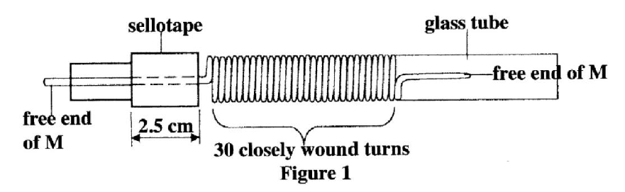
Figure 1

- Remove the sellotape and release the spring from the tube. (The spring will slightly unwind and some turns will disappear)
Bend the free ends as shown in Figure 2
Spring

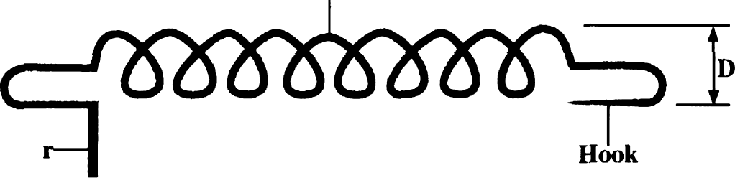
Pointe
Figure 2

- Using a Vernier callipers, measure and record the external diameter D of the spring. (1 mark)
D = ………………………………… cm
D = ………………………………… m

- Suspend the spring and 50g mass from a retort stand as shown in Figure 3.

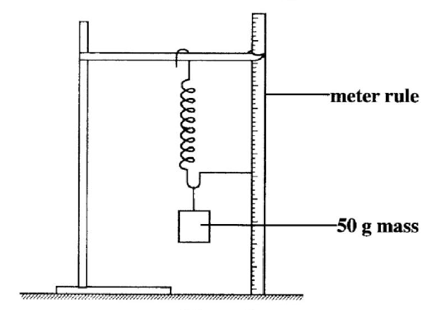
Figure 3

Count and record the number of turns N of the suspended spring. (1 mark)

N = ……………………..
- Add 40 g to the 50 g mass and record the extension X of the spring due to the 40 g.

X = ………………………….. cm (1 mark)
X = …………………………. .m

- Determine c given that $c=\frac{0.4}{X}$ (1 mark)
………………………………………………………………………………………………………………………………………………………………………………………………………………………………………………………………………………………………………………………………………………………………………………………………

- Determine n given that $n=\frac{{nd}^{4}}{{8ND}^{3}}$ (2 marks)
………………………………………………………………………………………………………………………………………………………………………………………………………………………………………………………………………………………………………………………………………………………………………………………………………………………………………………………………………………………………

- With the spring still loaded with the 90 g, pull the lower mass slightly downwards and let go so that the mass oscillates vertically. Record the time t for 20 oscillations. Hence determine the period T. (2 marks)

t = ……………..…….… s

T = …………..…………s

- Determine Z given that $T=2π\sqrt{\frac{m}{Z}}$ where m is the mass in kg on the spring. (2 marks)
………………………………………………………………………………………………………………………………………………………………………………………………………………………………………………………………………………………………………………………………………………………………………………………………………………………………………………………………………………………………………………………………………………………………………………………………

PART B
Proceed as follows:
- Place the 100 ml beaker on a metre rule and pour 80 cm³ of water into it. Arrange a lamp (source of light) and screen on either side of the beaker. (see figure 4)

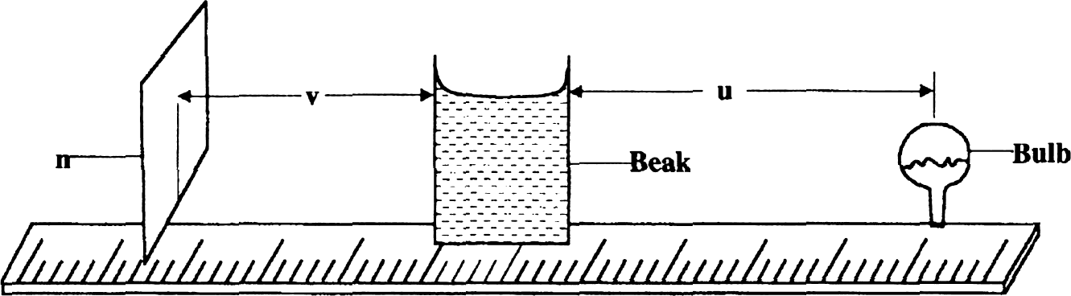
screen
.er
Figure 4

- Adjust the position of the lamp on the metre rule so that its centre is a distance u = 12 cm from the beaker. Switch on the light. Adjust the position of the screen until a well focused vertical line (the image of filament) is formed on the screen. Measure and record in Table 1 the image distance V between the screen and the beaker.

- Repeat part (l) for other values of u shown in Table 1 and complete the table

Table 1 (4 marks)

Distance u (cm) | 12 | 16 | 20
Distance v (cm)
$$y=\frac{uv}{u+v}$$

- (i) With the meter rule outside the beaker, measure the height h of the water meniscus above the bench. (1 mark)
h = ……………………….. cm

(ii) Determine the value of P given that $P=\frac{5}{\sqrt{h}}$ (1 mark)
………………………………………………………………………………………………………………………………………………………………………………………………………………………………………………………………………………………………………………………………………………………………………………………………

(iii) Hence determine the value of f given that $f=\frac{P}{2m}+1$ to one decimal place.
(2 marks)
………………………………………………………………………………………………………………………………………………………………………………………………………………………………………………………………………………………………………………………………………………………………………………………………………………………………………………………………………………………………

QUESTION TWO
You are provided with the following apparatus.
- Two dry cells.
- Nichrome wire 100cm on a mm scale.
- An ammeter.
- Cell holder.
- Voltmeter.
- Connecting wires with crocodile clips.
- Switch.

Proceed as follows;
- Measure the e.m.f of the cells, E.

E = ………………………………………… (1 mark)

- Connect the circuit as shown in the diagram.
- Connect the ends A and C where AC is the length L of the Nichrome wire across the terminals as shown. Close the switch and measure both current I and potential difference (P.d) across the wire AC when L = 100cm.

Current I = ………………………………… (1 mark)

P.d, V = …………………………………… (1 mark)

- Reduce the length L (AC) to the lengths shown in the table below. In each case record the current, I, and the corresponding P.d. (7 marks)

Length L (cm) | 100 | 70 | 60 | 50 | 40 | 20
I (A)
P.d (V)
E – V (v)

- Plot a graph of E – V against I(A) on x-axis in the grid provided. (5 marks)

- Determine the slope of the graph. (3 marks)

………………………………………………………………………………………………………………………………………………………………………………………………………………………………………………………………………………………………………………………………………………………………………………………………………………………………………………………………………………………………………………………………………………………………………………………………………………………………………………………………………………………………………………………………………………………………………………………………………………………………………………………………………………………………………………………………………………………………………………………………

- Given that E = V + Ir, determine the internal resistance, r, of each cell. (2 marks)

………………………………………………………………………………………………………………………………………………………………………………………………………………………………………………………………………………………………………………………………………………………………………………………………………………………………………………………………………………………………………………………………………………………………………………………………………………………………………………………………………………………………………………………………………………………………………………………………………………………………………………………………………………………………………………………………………………………………………………………………

