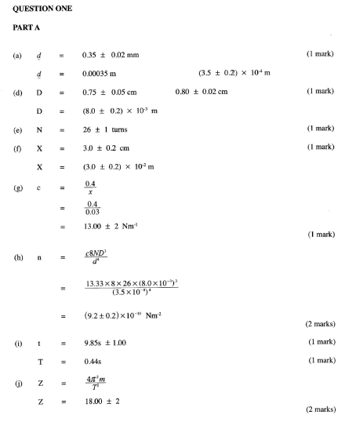
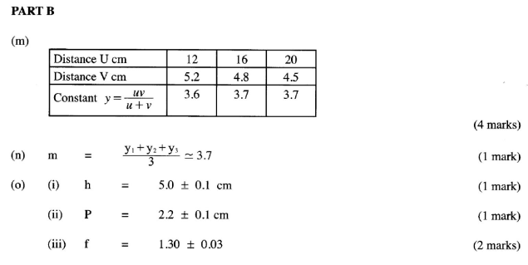

QUESTION 2
a) E = 3.0 V (2.9 – 3.1)
c) I = 0.12 (0.10 - 014)
V = 2.6 (2.4 – 2.8)

d)
Length L (cm) | 100 | 70 | 60 | 50 | 40 | 20
I (A) | 0.12 | 0.19 | 0.20 | 0.24 | 0.28 | 0.42
P.d (V) | 2.6 | 2.5 | 2.4 | 2.35 | 2.3 | 2.0
E – V (v)

- Current (I) 0.5 marks x 6 = 3 marks, Error of 0.02
- Pd (V) 0.5 marks x 6 = 3 marks, Error of 0.2
- E – V = 1 mark (all values must be correct)

e) Graph Axis – 1 mark
Scale – 1 mark
Plotting – 2 marks
Line – 1 mark (straight line with a positive gradient)

f) Slope - change in x 1 mk
- change in y 1 mk
- answer 1 mk

g) internal resistance (r) = slope 1 mk
Answer 1 mk

