MARKS HERE

TERM 2 YEAR 2022 MID TERM EXAM
FORM FOUR COMPUTER STUDIES Time: 2 hrs
NAME…………………………………………….ADMNO……....CLASS…....
INSTRUCTIONS: ANSWER ALL THE QUESTIONS
SECTION A
- Wanjiru is a manager in a financial institution. Give three reasons why you would advise Wanjiru to manage data using computers in the organization. ( 6mks)

2. Wekesa is a counsellor, he moves to different places to offer guiding and counseling services to people.
i) Which type of computer would you recommend wekesa to use? (1mk)

ii) Give two reasons why you would recommend Wekesa to use the computer in 2i) above (4mks)

3. (a) What is meant by the authenticity as used in software development? (2mks)

b) Distinguish between the terms single- tasking and multi- user as used in operating systems (2mks)

4. a) Explain three ways by which computer users can protect their eyes from harmful emissions from the computer screen (3mks)

b) Give three examples of flat panel monitors in the market today (3mks)

5. (a) What is a disk formatting? (2mks)

(b) Indicate whether the following devices are used for input or output (2mks)
(i) Plotter -
(ii) Light pen
(iii) Mouse
(iv) Visual display

6. (a) Explain why the following controls should be implemented for computer based systems (4mks)
(i) Backups –

(ii) Passwords –

(b) For each of the following give one reason why they are not allowed in a computer laboratory. (2mks)
(i) Smoking

(ii) Eating foods-

7. Give two functions of enter key on the keyboard (2 marks)

8. Differentiate between a page and a line printer (2mks)

9. Jane has noticed the following problems in her computer:
- It is taking longer time to start up;
- It is often hanging
- Applications are taking longer to load.
State three possible causes of these problems and how they can be solved (3mks)

SECTIONB
10. A school has brought a computer system. The hardware items include: 3.0 gHz processor, 2gb of RAM, a sound card, speakers, a monitor, a keyboard, a 120 GB hdd disk, a floppy disk drive, CDRW drive, a mouse, a modem, an inkjet printer and a joystick. The software supplied includes: an OS, a BASIC interpreter and the following packages: Spreadsheets, publisher, word processor, art database and games.
(a) List three input devices from the given specifications (3mks)

(b) Explain the meaning of the following (3mks)
(i) 3.0 GHz-

(ii)2 GB RAM-

(iii) 120 GB hdd-

(c) Some of the students in the school use the computer to do homework. Name the packages used to (3mks)
(i) Do calculations and draw graphs-

(ii) Write an essay –

(iii) Make a poster -

(d) Students enjoy playing noisy computer games
(i) Which hardware items are needed to produce sound? (1mk)

(ii) Which input device is used only for playing games? (1mk)

ei) What is multimedia capability?(1mk) ii) List three multimedia devices listed above (3mks)

11. A multinational organization has offered to donate computers to your school. The Board of governors has requested you to advise on the operating system to be used by providing answer the following questions.
a) What is an operating system? (2mks)

b) State and briefly explain three types of operating systems as classified according to human interface. (6mks)

c) Briefly explain the following functions of an operating system. (8mks)
- Task scheduling-

-Interrupt handling

12. Give 5 features of a multimedia system (5 marks)

iii) a) Explain why input screens are better data entry designs than entering data directly to a table. (2 marks)

b) Give three ways of securing a computer lab (3mks)

c) Distinguish between:
i) A cell and cell pointer as used in spreadsheets (2 mks)

d) List three types of paragraph formatting features (3 marks)

13. (a) Distinguish between the following sets of terms as used in Spreadsheets (4mks)
(i) Worksheet and workbook

(ii) Filtering and sorting

(b) State one way in which a user may reverse the last action taken in a spreadsheet package (1 mk)

(c) The following is a sample of a payroll. The worksheet row and column headings are marked 1, 2, 3, and A, B, C respectively
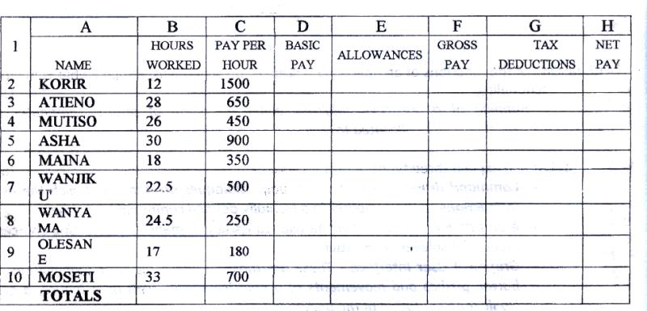

Use the following expressions to answer the questions that follow
- Basic pay- Hours worked x pay per hour
- Allowances are allowed at 10% of basic pay
- Gross pay- Basic pay + allowances
- Tax deductions are calculated at 20% of gross pay
- Net pay-= gross pay – tax deductions

Write formulae using cell references for the following cells (5mks)
- D2
- E4
- F10
- G7
- H5

(d) (i) State three ways of moving round the page in a computer program or application (3 mks)

(ii) State two ways on how information & communication technology (ICT) can be used to reduce the spread of HIV/ AIDS (2 mks)

This is the last printed page
{SUCCESS –MR. MAKORI}

