NAME……………………………………………………………………..ADM NO……………………
FORM FOUR
233/2
CHEMISTRY
QUESTION 1
(a) The grid below represents part of the periodic table. Study it and answer the questions that follow: The letters do not represent the actual symbols of the elements.
 |  |  |  |  |  |  |  | A
 |  |  |  | B
 | C |  | D |  |  | E
 | F
- What name is given to the group of elements to which C and F belong? (1mk)

- Explain the difference in reactivity between element C and D (2mks)

- Using( .) and cross (x) illustrate the bond between B and E (2mks)

- Write a balanced chemical equation for a reaction between element D and oxygen gas (1mk)

- On the grid indicate a tick(√) the position of element G which is in the third period of the periodic table and forms G³⁻ ions (1mk)
(b) Study the information in the table below and answer the questions that follow: (The letters do not represent the actual symbols of the substance)
Substance | Melting point ⁰C | Boiling points ⁰C | Solubility in water | Density at room temp in g/cm³
H | -117 | 78.5 | Very Soluble | 0.8
J | -78 | -33 | Very Soluble | 0.77x10⁻³
K | -23 | 77 | Insoluble | 1.6
L | -219 | -183 | Slightly Insoluble | 1.33x10⁻³
- Which substance would dissolve in water and could be separated from the solution by fractional distillation in the school laboratory (1mk)

- Which substance is a liquid at room temperature and when mixed with water two layers would be formed. (1mk)

- Which letter represents substance that is a gas at room temperature and which can be collected (density of air is 1.225x10⁻³ g/cm³)
- Over water (1mk)

- By downward displacement of air (1mk)

QUESTION 2
(a) Propane can be changed into methane as shown below:
2CH₃CH₂ CH₃ _{(g)} high temperature CH_{4 (g)} + C₂ H₄ _{(g)} + CH₃CHCH2 _{(g)} +H2 _{(g)}
- Name the process undergone by propane (1mk)

- Write the equation of reaction between ethene and chlorine gas and name the product.(2mks)

(b) The diagram below shows an incomplete set-up of the laboratory preparation and collection of Ethene gas:
Conc H₂SO₄
Ethene gas
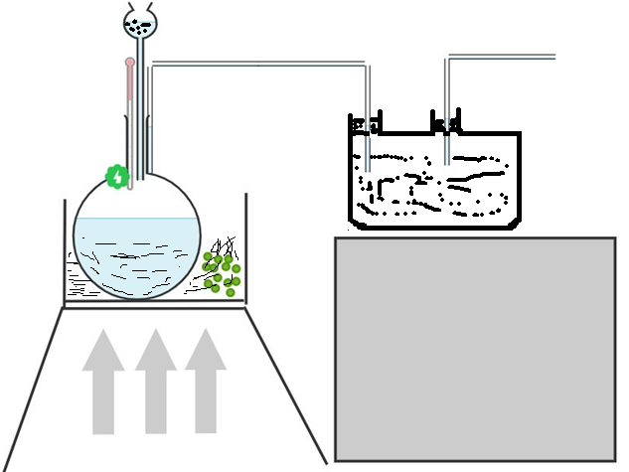
Substance Y
WOODEN
BOX
Thermometer
Substance x
HEAT

- Complete the diagram to show how Ethene gas is collected. (2mks)

- Name substances X and Y (2mks)

- Apart from being colourless and odourless, state another physical property of ethene.(1mk)

(c). the table below gives information about the major components of crude oil. Study it and answer the questions that follow.

Components | Boiling points⁰C
Gases | Below 40
Petrol | 40-175
Kerosene | 175-250
Diesel oil | 250-350
Lubricating oil | 350-400
Bitumen | Above 400

- Which of the compounds of crude oil has molecules with the highest number of atoms? Explain. (2mks)

- Explain the condition that could cause a poisonous gas to be formed when kerosene is burnt? (2mks)

QUESTION 3
(a) Air is a mixture of gases that can be classified as active and inactive part. The diagram below represents an experiment that can be carried out to determine the active part of air.
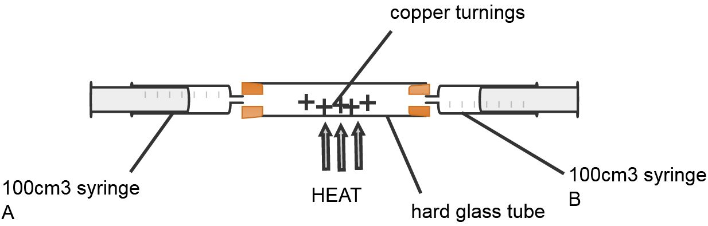
- Describe how this set-up can be used to determine the active part of air (4mks)

- When magnesium ribbon is heated in air the mass of the product is more than the mass of magnesium ribbon used. Explain (1mks)

- Carbon (IV) oxide and sulphur (IV) oxide are some of the gases that are common pollutant in the atmosphere. Explain two measures that are taken to reduce atmospheric pollution of the two gases. (2mks
- Oxygen is obtained on large scale by the fractional distillation of air as shown on the flow chart.
Expansion engine
Compress
air
Filtration and purification

-183⁰C
-186⁰C
-196⁰C
Liquid air

Fractional distillation

- Explain how carbon (IV) oxide and water are removed before liquification of air. (2mks)

- Identify the component that is collected at -186⁰C (1mk)

- State one commercial use of oxygen gas apart from its use in hospital by patient with difficult breathing (1mk)

QUESTION 4
- Rhombic and Monoclinic are allotropes of sulphur. They are interconvertible as shown below:
96⁰c
Rhombic Monoclinic
- What does the temperature 96⁰C represent (1mk)

- State the differences in crystalline appearances between rhombic and monoclinic crystals. (1mk)

(b) The chart below shows some process involved in large scale production of sulphuric (VI) acid. Use it to answer the question that follows: substance A
sulphur (iv) oxide
Oxygen Sulphur (vi) oxide oleum
Reaction chamber
Absorption chamber
oleum

Water

(2)(i) Name substance A (1mk)

(ii).Write an equation that takes place in the absorption chamber (1mk)

- Vanadium (V) oxide is commonly used as an catalyst in the contact process:
- Name another catalyst that can be used in this process.(1mk)

- Give two reasons why vanadium V oxide is the commonly used catalyst. (2mks)

- State and explain the Observation made when concentrated sulphuric (VI) acid is added to crystals of copper (II) sulphate in a beaker.(2mks)

(v). If 100kg of sulphur( IV) oxide is used in one day by this plant, determine the mass of oleum produced
in one day. (S=32. O=16 H=1) (3mks)

QUESTION 5
(a) Draw a well labeled diagram of set-up that can be used to prepare dry hydrogen gas in the laboratory. (3mks)

(b) The experiment below was carried out to investigate the reaction between steam and magnesium. Use it to answer the questions that follow:
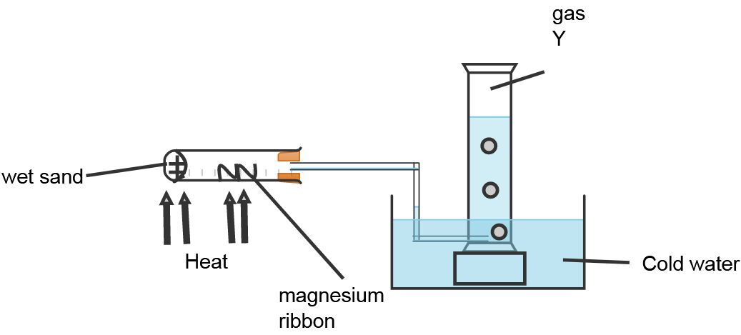

- Explain why wet sand is heated. (1mk)

- State and explain what was observed in the combustion tube. (2mks)

- Name the gas Y and state how it is tested in the laboratory. (1mk)

(c) Distinguish between:
Drying and dehydration. (2mks)

(d). A student found two liquids labeled A and B placed on the bench in the laboratory. The liquids were colourless and did not have a smell. One liquid was water.
Describe a test that you would carry out to determine the beaker that contained water. (3mks)

QUESTION 6
(a) Give the name of the process involved in each of the following:
(i) Crystals of hydrated sodium carbonate(Na₂CO₃.10H₂O) when left in open air change to white powder. (1 mk)

(ii When anhydrous calcium chloride is used to dry hydrogen gas for a long time, it changes to a solution. (1mk)

(b) Complete the table below by indicating the observations, type of change (permanent or temporary) and name of new compound formed. (6 mks)
Experiment | Observations | Type of change | Name of product
(i)Heating solid zinc oxide in a test tube.

(ii)Anhydrous cobalt (II) chloride is left exposed overnight.

(iii)Iron wool is soaked in tap water for two days

(c)The diagram below shows a sample of hard water being passed through a vertical column to remove its hardness.

- Write the formula of the two cations present in the sample of hard water. (2mks)

- What name is given to the above method of softening hard water. (1 mk)

- Write an ionic equation to show how the hard water is softened. (1 mk)

- Study the table below and answer the questions that follow.
Salt | Solubility (g/100g of water) at 20⁰ C | Solubility (g/100g of water) at 50^{0 C}
P | 10 | 20
Q | 15 | 12

A solution 9g of P and 14g of Q in 100g of water at 20⁰ C is warmed while stirring up to 5o⁰C. State and explain the observations made. (2 mks)

QUESTION 7
(a) A student set out to prepare iron (III) chloride using the apparatus shown in the diagram below:
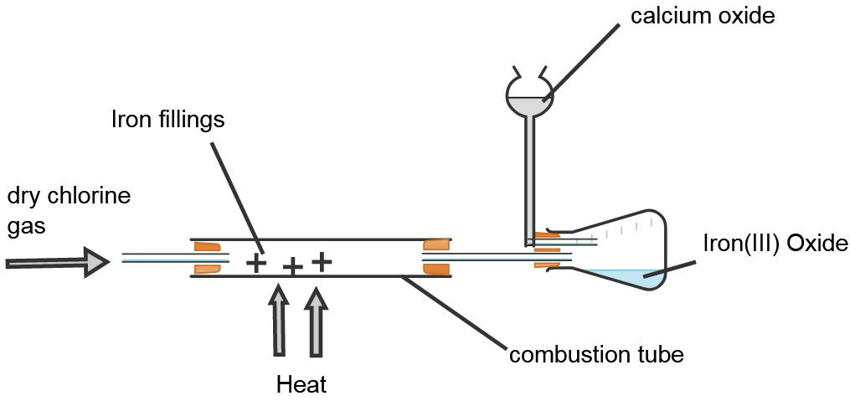
- Explain why
- It’s necessary to pass chlorine gas through the apparatus before heating begins. (2mks)

- Calcium oxide is used in the guard tube. (1mk)

- The total mass of Iron III chloride formed was found to be 0.5g. Calculate the volume of chlorine gas that reacted with Iron.
(Fe=56.0 Cl=35.5 and molar gas volume at 298k is 24,000cm³⁾ (3mks)

- What property of Iron (III) chloride makes it possible to be collected as shown in the diagram? (1mk)

- In the large scale production of hydrogen chloride gas, hydrogen gas burned in chlorine gas. State the source of the two gases. (1mk)

