Name_____________________________________ Index No. ____________________
Candidate’s signature __________
Date _________________________

231/1
BIOLOGY
PAPER 1
THEORY
TIME :2 HOURS

INSTRUCTIONS TO CANDIDATES
1. Write your name and index number in the spaces provided above.
2. Sign and write the date of examination in the spaces provided above.
3. Answer all the questions
4. Answers must be written in the spaces provided in the question paper
5. Additional pages must not be inserted
6. This paper consists of 11 printed pages
7. Candidates should check the questions paper to ascertain that all the pages are printed as indicated and no questions are missing

For examiner’s use only
Question | Maximum score | Candidate’s score
1 – 27 | 80

- Name the branch of biology that deals with the study of:
  - Classification of living organisms. (1mk)

  - Study of fungi. (1mk)

2. Study the diagram below which is an organelle from a cell and answer the questions that follow.

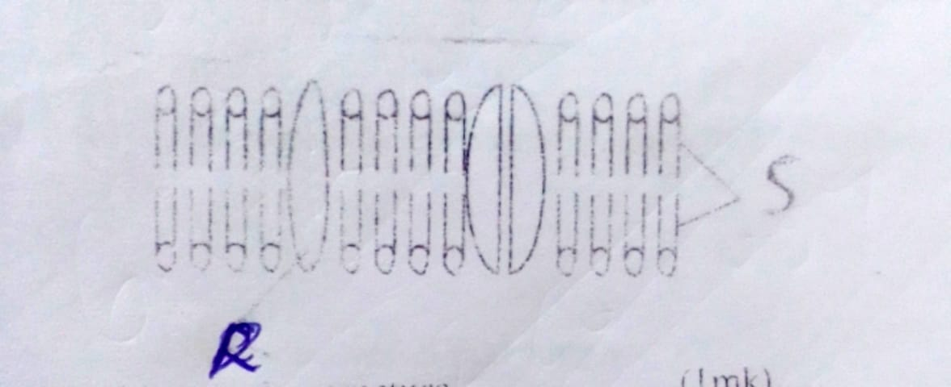

a) Identify the structure. (1mk)

b) Name the parts labeled R and S. (1mk)

c) What is function of the organelle named above? (1mk)

3.Name the blood vessel that supply:-
  - the heart with nutrients (1mk)

  - the foetus with oxygen (1mk)

4.The diagram below shows an experiment performed on oat coleoptiles. three potted seedlings labelled A, B, C where treated at following;
A Tip was covered with aluminum foil cap.
B tip of the coleoptile was decapitated.
C tip was left intact

The seedlings were covered with a box, which had a hole on one side and painted black on the side. The set-up was left for 3 days.

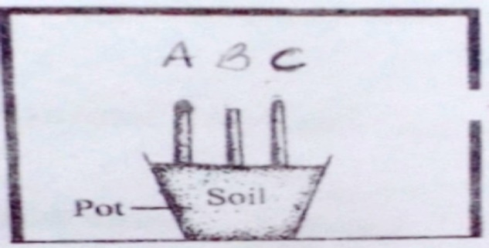

a) State the expected observations for each of the seedlings. (3mks)

b) If the aluminum cap were removed from A, what would be expected results if the experiment were continued? (1mk)

5.Name three characteristics of meristematic cells. (3mks)

6.The diagram below shows a stage in cell division.

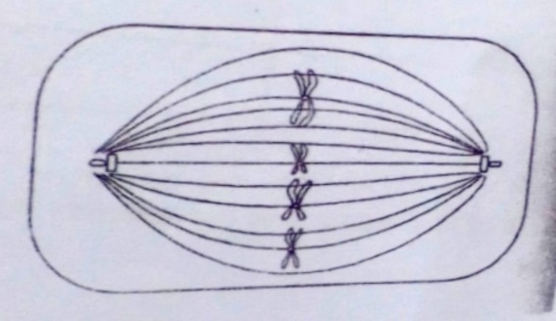

a) Name the part of the animal where this type of cell division is likely to take place. (2mks)

b) Name the stage of cell division. (1mk)

7.Blocking of pancreatic duct has no effect on blood sugar regulation. Explain.(2 mks)
………………………………………………………………………………………………………………………………………………………………………………………………………………………………………………………………………………………………………

8.a) State two differences between aerobic and anaerobic respiration. (2 mks)
………………………………………………………………………………………………………………………………………………………………………………………………………………………………………………………………………………………
b)Name one use of anaerobic respiration in industry. (1 mks)
………………………………………………………………………………………………………………………………………………………………………………………………………………………………………………………………………………………

9.a)Describe three homeostatic functions of the mammalian skin. (3 mks)
……………………………………………………………………………………………………………………………………………………………………………………………………………………………………………………………………………………………………………………………………………………………………………………
- Why do desert animals excrete nitrogenous wastes in form of uric acid?(1 mks)
……………………………………………………………………………………………………………………………………………………………………………………………………………………………………

10. Part of one strand of a DNA molecule was found to have the following base sequence.
G – A – C – A – G – T
(a) What is the base sequence on m-RNA strand copied from this DNA portion?(1mark)

………………………………………………………………………………………………………………………………………………………………………………………………………………

(b) State two roles of DNA molecule. (2marks)

………………………………………………………………………………………………………………………………………………………………………………………………………………

11.The diagram below represents a maize seedling
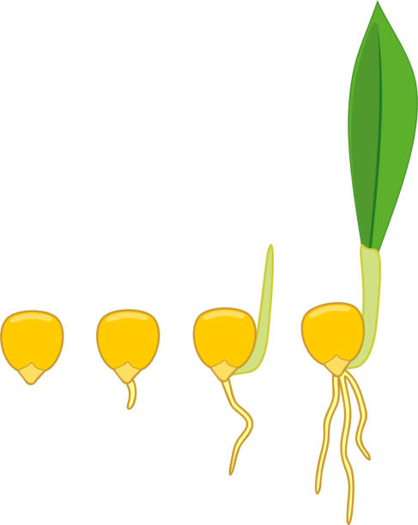
(a)(i) Name the type of germination exhibited by maize. (1mark)
…………………………………………………………………………………………………………………………………………………………………………………………………………

(ii) Give a reason for your answer in (a) (i) above. (1mark)
……………………………………………………………………………………………………………………………………………………………………………………………………………
………………………………………………………………………………………………………

12.What are the two functions of bile salts during the process of digestion? (2marks)
………………………………………………………………………………………………………………………………………………………………………………………………………………

13.
i) Name the hormone that stimulate milk secretion in female mammals (1mark)

…………………………………………………………………………………………………………
ii) State the function of lytic enzyme secreted by acrosome in the sperm (1mark)

…………………………………………………………………………………………………………

14.A student observed a specimen through a light microscope. He used the objective lens marked X40.If he indicated the magnification of the image as x 400, what was the eye - piece magnification?
(Show your working). (3 marks) ……………………………………………………………………………………………………………………………………………………………………………………………………………………………………………………………………………………………………………………………………………………………………………………………………………………………………………………………...
……………………………………………………………………………………………………………..

15.The following are diagrams of two pollen grains.

L
K

- State one observable difference between K and L. (1 mark)
……………………………………………………………………………………………………………………………………………………………………………………………………………………
- State the agent of pollination for each of them. (2 marks)
K
………………………………………………………………………………………………………
L
……………………………………………………………………………………………………….

16. Give a reason for the following during investigation of starch in a leaf
(a) Exposing the leaf to light for a few hours (1mk)

_____________________________________________________________________ _____________________________________________________________________ _____________________________________________________________________

(b) Dipping the leaf in boiling water (1mk)
_____________________________________________________________________ _____________________________________________________________________ _____________________________________________________________________

17. The following diagram represents a plant

(a) To which division does the above plant belong? (1mk)
_____________________________________________________________________ _____________________________________________________________________

(b) Give a reason for your answer in (a) above. (1mk)
_____________________________________________________________________ _____________________________________________________________________ _____________________________________________________________________
(c) State one economic importance of the plant above. (1mk)
_____________________________________________________________________ _____________________________________________________________________ _____________________________________________________________________
18. The following is a food chain that was presented by a pupil in a class

Grasshopper lizards chicken hawk

State errors that are in the food chain. (2mks)
_____________________________________________________________________ _____________________________________________________________________ _____________________________________________________________________

19 a). After four months of pregnancy, the ovaries of a woman can be removed without terminating pregnancy. However during the first four months of pregnancy the ovaries must remain intact if pregnancy is to be maintained. Explain these observations. (2mks)
_____________________________________________________________________ _____________________________________________________________________ _____________________________________________________________________ _____________________________________________________________________
b). What is the significance of chiasma formation during meotic cell division? (1mk)
_____________________________________________________________________ _____________________________________________________________________ _____________________________________________________________________
20. Below is an experiment set to investigate a factor necessary for photosynthesis

(a) Suggest the aim of the experiment above (1mk)
_____________________________________________________________________ _____________________________________________________________________ _____________________________________________________________________
(b) Give a reason for
(i) Using sodium hydroxide pellets. (1mk)
_____________________________________________________________________ _____________________________________________________________________ _____________________________________________________________________

(ii) Testing leaf B for starch (1mk)
_____________________________________________________________________ _____________________________________________________________________ _____________________________________________________________________
(iii) Sealing the mouth of the conical flask with petroleum jelly. (1mk)
_____________________________________________________________________ _____________________________________________________________________ _____________________________________________________________________

21. (a) Distinguish between predator and prey? (2mk)
_____________________________________________________________________ _____________________________________________________________________ _____________________________________________________________________ _____________________________________________________________________

(b) The figure above shows predator/prey relationship. Study the figure and answer the questions that follow
Describe the relationship between the predator and prey. (2mks)
_____________________________________________________________________ _____________________________________________________________________ _____________________________________________________________________ _____________________________________________________________________ ________________________________________
22. In a prolonged drought period, forage was scarce. It made animals reach out to higher forage and this way the giraffes got the stretched long necks.
(a) What is the term used for a characteristic such as long necks outlined. (1mk)
_____________________________________________________________________ _____________________________________________________________________ _____________________________________________________________________ ______________________________
(b) What theory is this? (1mk)
_____________________________________________________________________ _____________________________________________________________________
(c) State its limitation. Explain. (2mks)
_____________________________________________________________________ _____________________________________________________________________ _____________________________________________________________________ _____________________________________________________________________ ________________________________________
23. (a) What happens when a Rh⁺ blood is given to a Rh⁻ recipient. (2mks)
_____________________________________________________________________ _____________________________________________________________________ _____________________________________________________________________ ____________________________________________________________________
(b) Suggest what happens if the same recipient is given another dose of Rh⁺ blood in a period less than two weeks. (1mk)
_____________________________________________________________________ _____________________________________________________________________ _____________________________________________________________________ ______________________________
24. The table below shows the effect of temperature on the activity of amylase on starch. Six test – tubes each containing a mixture of starch and amylase were placed in water baths maintained at 0⁰c, 10⁰c, 20⁰c, 30⁰c, 40⁰c and 50⁰c and allowed to stand. Study the table and answer the questions that follow

Test –tube | Temperature 0⁰c | Time taken for starch digestion (minutes)
1 | 0 | Starch still present after 60 minutes
2 | 10 | 22
3 | 20 | 11
4 | 30 | 5
5 | 40 | 3.5
6 | 50 | Starch still present after 60 minutes

(a) How does temperature affect the action of amylase? (1mk)
_____________________________________________________________________ _____________________________________________________________________ _____________________________________________________________________ ______________________________
(b) Give one reason in each case for the results obtained in the tubes kept at:
(i) 0⁰c (1mk)
_____________________________________________________________________ _____________________________________________________________________ _____________________________________________________________________ ______________________________

(ii) 50⁰c (1mk)
_____________________________________________________________________ _____________________________________________________________________ _____________________________________________________________________ ______________________________
(c) Suggest the time it would take amylase to digest starch if the temperature is kept at 0⁰c (1mk)
_____________________________________________________________________ _____________________________________________________________________ _____________________________________________________________________ ______________________________

25. The diagram below represents an organ from the body of a fish. Study it and answer the questions that follow.

(a) Name the organ (1mk)
_____________________________________________________________________ _____________________________________________________________________

(b) State three ways in which part K is adapted to its function. (3mks)
_____________________________________________________________________ _____________________________________________________________________ _____________________________________________________________________ _____________________________________________________________________ _____________________________________________________________________ __________________________________________________

26. The diagram below illustrates the behaviour of a red blood cell when placed in solution X

(a) Suggest the nature of solution X (1mk)
_____________________________________________________________________ _____________________________________________________________________
(b) Name process A (1mk)
_____________________________________________________________________ _____________________________________________________________________

(c) Account for the appearance of the red blood cell (3mks)
_____________________________________________________________________ _____________________________________________________________________ _____________________________________________________________________ _____________________________________________________________________ ________________________________________

27. The diagram below illustrates the path way of water from soil into the plant

(a) Name the structures labeled C and B (2mks)
C _____________________________________
B ______________________________________
(b) State two ways in which the structure labelled A is adapted to its functions. (2mks)
_____________________________________________________________________ _____________________________________________________________________ _____________________________________________________________________ _____________________________________________________________________

231/1
BIOLOGY
PAPER 1
THEORY
september/october 2021
MARKING SCHEME

- (a) Taxonomy
(b) Mycology

- (a) cell membrane/plasma membrane
(b) R - protein layer
S - Phospholipid layer

- (a) Coronary artery
(b) Umbilical vein

4.(a) A - Coleoptile will grow straight upwards.
B - No growth takes places
C - the coleoptile will grow and bend towards the source of light.

(b) the coleoptile will curve towards the source of light.

5.- thin cell walls
- Have dense cytoplasm
- Have no vaenoles
- Small in size.

6.(a) Ovary
testes
(b) metaphase II

7.Blocking of pancreatic duct has no effect on blood sugar regulation. Explain.(2 mks)
- The hormones (insulin and glucagon); pass through blood and not through the duct;

8.a) State three differences between aerobic and anaerobic respiration. (3 mks)

Aerobic | Anaerobic
- Uses oxygen  - Produce large quantities of energy  - Water is produced  - Occur in mitochondria | - Oxygen not used  - Low energy produced  - Water is not produced  - Occur in cytoplasm

- Name two uses of anaerobic respiration in industry. (2 mks)

- Used in baking industry
- Used in brewing industry
- Used in dairy industry

9.Describe three homeostatic functions of the mammalian skin. (3 mks)

When hot, sweat is produced to cool
When not, erector pili muscle relax and hair fall to cool
When hot, blood vessels vasodilate to cool body and vasoconstricts when cold. Sweating increase when there excess water in blood.

10.Part of one strand of a DNA molecule was found to have the following base sequence.
G – A – C – A – G – T
(a) What is the base sequence on m-RNA strand copied from this DNA portion?(1mark)

C-U-G-U-C-A

(b) State two roles of DNA molecule. (2marks)

-Protein synthesis
-Carry genetic materials for inheritance

11.The diagram below represents a maize seedling
(a)(i) Name the type of germination exhibited by maize. (1mark)
- Hypogeal

(ii) Give a reason for your answer in (a) (i) above. (1mark)

Cotyledons left below the ground level

12.What are the two functions of bile salts during the process of digestion? (2marks)

-Fat emulsification
- Neutralises the acidic chyme and provide basic pH for the enzymes

13.i) Name the hormone that stimulate milk secretion in female mammals (1mark)

- Prolactin

ii) State the function of lytic enzyme secreted by acrosome in the sperm (1mark)

- Dissolves the membranes of the ovum allowing the sperm to penetrate

14.A student observed a specimen through a light microscope. He used the objective lens marked X40.If he indicated the magnification of the image as x 400, what was the eye - piece magnification?
(Show your working). (3 marks)
Total mg = eye piece magnification X objective lens magnification;
400 = 40 X x;
⁴⁰⁰/₄₀ = x;
10 = x
Eye magnification is X10;

15.The following are diagrams of two pollen grains.

L
K

- State one observable difference between K and L. (1 mark)
- K is smooth while L is rough

- State the agent of pollination for each of them. (2 marks)

K – wind
L – Insect

16. (a) For the leaf to photosynthesize hence form starch; (1mk)
(b) To kill the photoplasm of the leaf (1mk)

17. (a) Fungi; (1mk)
(b) It has mycelium; (1mk) acc. Example e.g. rhizoids
(c) Used as food for humans; (1mk)

18. (i) Do not have producer/producer missing; (1mk)
(ii) Lizard to chicken energy flow is reversed (1mk)

19 a). Corpus luteum in the ovary secretes progesterone which maintains pregnancy/development of foetus. After conception; after four months pregnancy is maintained by progesterone from placenta; (2mks)

b). Result in exchange of genetic material (crossing over) leading to variation; (1mk)

20. (a) To investigate necessity of carbon (vi) oxide in photosynthesis; (1mk)
(b) (i) To absorb carbon (ii) oxide gas; (1mk)
(ii) It was the control experiment leaf; (1mk)
(iii) To make it air – tight; (1mk)

21. (a) Prey – an animal that is caught by another animal and eaten; (1mk)
Predator – animal that kills and eats other animals; (1mk)

(b) Number of prey decrease with increase in number of predators; and vice varsa

22. (a) Acquired characteristics (1mk)
(b) Lamarkian /larmarck’s theory/theory of use and diuse; (1mk)
(c) Acquired characteristics are not passed to offsprings; as they do not affect the gametes; (2mks)

23. (a) The recipient responds by producing the corresponding rhesus antibodies; and nothing further happens; (2mks)
(b) Agglutination of red blood cells will occur; (1mk)

24. (a) Increase in temperature leads to increase in rate of amylase reaction upto optimum beyond which further increase in temperature causes decline in the rate of reaction; (1mk)

(b) (i) Enyzme amylase was inactivated (1mk)
(ii) Enzyme amylase was denatured (1mk)

2
(c) No digestion; (1mk)

25. (a) Gill ; (1mk)
(b) – Numerous to increase surface area for gaseous exchange;
- Thin walled for faster diffusion of respiratory gases;
- Highly vascularized/has dense net work of blood capillaries for quick transport of respiratory gases;
- Moist to dissolve respiratory gases;
Any 1st three correct 3mks

26. (a) Hypertonic solution/more concentrated solution; (1mk)
(b) Crenation; (1mk)
(c) Solution X is more concentrated/hypertonic to the contents of the red blood cells; the red blood cell loses water by osmosis; shrinks and becomes crenated; (3mks)

27. (a) C – Xylem vessel; (1mk)
B – Endodermis; (1mk)

(b) Narrow/elongated to increase surface area for absorption of water and mineral salts;
- Thin to reduce diffusion distance; (2mks)

