NAME _______________________________________________CLASS__________________________
ADM NO________________________
443/2
AGRICULTURE
FROM: FOUR
SECTION A 30 MARKS
Answer all the questions in this section
- State four features that distinguish indigenous breeds from exotic breeds (2 Marks)
…………………………………………………………………………………………………………………………………………………………………………………………………………………………………………………………………………………………………………………………………………………………………………………………………………………………………………………………………………………………………………………………………………………………………………………………………………………………………………………………………………………………………………………………………………………………………………………………………………………………………………………………………………………………………………………………………………………………………………………………………………………………………………………………………….

- Give four examples of heavy breeds of chicken (2 Marks)
…………………………………………………………………………………………………………………………………………………………………………………………………………………………………………………………………………………………………………………………………………………………………………………………………………………………………………………………………………………………………………………………………………………………………………………………………………………………………………………………………………………………………………………………………………………………………………………………………………………………………………………………………………………………………………………………………………………………………………………………………………………………………………………………………….

- State four reasons for carrying out maintenance practices on a wheelbarrow (2 Marks)
…………………………………………………………………………………………………………………………………………………………………………………………………………………………………………………………………………………………………………………………………………………………………………………………………………………………………………………………………………………………………………………………………………………………………………………………………………………………………………………………………………………………………………………………………………………………………………………………………………………………………………………………………………………………………………………………………………………………………………………………………………………………………………………………………….

- List any four farm tools and equipment that are complimentary in use (2 Marks)
…………………………………………………………………………………………………………………………………………………………………………………………………………………………………………………………………………………………………………………………………………………………………………………………………………………………………………………………………………………………………………………………………………………………………………………………………………………………………………………………………………………………………………………………………………………………………………………………………………………………………………………………………………………………………………………………………………………………………………………………………………………………………………………………………….

- Give 4 symptoms of the Newcastle disease (2 Marks)
…………………………………………………………………………………………………………………………………………………………………………………………………………………………………………………………………………………………………………………………………………………………………………………………………………………………………………………………………………………………………………………………………………………………………………………………………………………………………………………………………………………………………………………………………………………………………………………………………………………………………………………………………………………………………………………………………………………………………………………………………………………………………………………………………….

- State four factors which determine the amount of feeds given to an animal (2 Marks)
…………………………………………………………………………………………………………………………………………………………………………………………………………………………………………………………………………………………………………………………………………………………………………………………………………………………………………………………………………………………………………………………………………………………………………………………………………………………………………………………………………………………………………………………………………………………………………………………………………………………………………………………………………………………………………………………………………………………………………………………………………………………………………………………………….

- Give two functions of crop in poultry digestive system (1 Mark)
……………………………………………………………………………………………………………………………………………………………………………………………………………………………………………………………………………………………………………………………………………………………………………………………………………………………………………………………………………………………………………………………………………………………………………………………………………………………………………………………………………………………………………………………….

- A goat ate polythene papers accidentally name the stomach chamber where the papers will be found if slaughtered (1 Mark)
……………………………………………………………………………………………………………………………………………………………………………………………………………………………………………………………………………………………………………………………………………………………………………………………………………………………………………………………………………………………………………………………………………………………………………………………………………………………………………………………………………………………………………………………….

- Give two examples of zoonotic diseases (1 Mark)
……………………………………………………………………………………………………………………………………………………………………………………………………………………………………………………………………………………………………………………………………………………………………………………………………………………………………………………………………………………………………………………………………………………………………………………………………………………………………………………………………………………………………………………………….

- State 3 reasons why drenching is not an effective method of controlling internal parasites (1 ½ Mark)
…………………………………………………………………………………………………………………………………………………………………………………………………………………………………………………………………………………………………………………………………………………………………………………………………………………………………………………………………………………………

- Give four maintenance practices that should be carried out on a permanent calf pen (2 Marks)
……………………………………………………………………………………………………………………………………………………………………………………………………………………………………………………………………………………………………………………………………………………………………………………………………………………………………………………………………………………………………………………………………………………………………………………………………………………………………………………………

- Outline advantages of using ox-drawn plough over tractor- drawn plough (2 Marks)
…………………………………………………………………………………………………………………………………………………………………………………………………………………………………………………………………………………………………………………………………………………………………………………………………………………………………………………………………………………………………………………………………………………………………………………………………………………………………………………………………

- State four reasons for carrying out maintenance practices on a wheelbarrow (2 Marks)
………………………………………………………………………………………………………………………………………………………………………………………………………………………………………………………………………………………………………………………………………………………………………………………………………………………………………………………………………………………………………………………………………………………………………………………………………………………………………………………………………

- Name two non – chemical method of controlling ticks in cattle (1 Mark)

- State four practices carried out on the fish before preservation ( 2 Marks)
………………………………………………………………………………………………………………………………………………………………………………………………………………………………………………………………………………………………………………………………………………………………………………………………………………………………………………………………………………………………………………………………………………………………………………………………………………………………………………………………………

- Give four reasons why bees swarm from a hive (2 Marks)
…………………………………………………………………………………………………………………………………………………………………………………………………………………………………………………………………………………………………………………………………………………………………………………………………………………………………………………………………………………………………………………………………………………………………………………………………………………………………………………………………………

- Give the meaning of the following terms as used in livestock breeding
- Close breeding (½ Mark)
- Cross breeding (½ Mark)
- Hybrid vigour ( ½ Mark)
- Mothering ability ( ½ Mark)
- Name two methods of serving cows in dairy production (1 Mark

SECTION B (20 MARKS)
Answer all questions in the space provided
- The following illustration show behavior of chicks at different conditions in a brooder

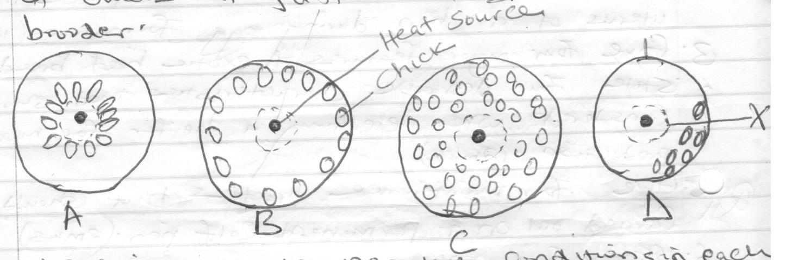

- Explain the conditions in each diagrams A,B,C and D (2 Marks)
………………………………………………………………………………………………………………………………………………………………………………………………………………………………………………………………………………………………………………………………………………………………………………………………………………………………………………………………………………………

- Name two other behavior observations on chicks when temperature is very high in the brooder (2 Marks)
………………………………………………………………………………………………………………………………………………………………………………………………………………………………………………………………………………………………………………………………………………………………………………………………………………………………………………………………………………………

- The diagram below represents practice of identifying livestock on a farm
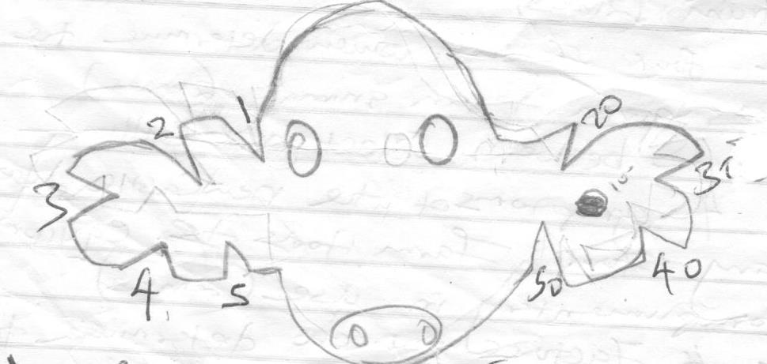

- Identify the practice (1 Mark)
…………………………………………………………………………………………………………………………………………………

- Determine the number that identifies the animal represented by the illustration (1 Mark)
…………………………………………………………………………………………………………………………………………………………………

- Draw a diagram of the animal identified by the number 148 on the farm (2 Marks)

- Give two reasons why this method of identification is discouraged in livestock rearing (2 Marks)
…………………………………………………………………………………………………………………………………………………………………………………………………………………………………………………………………………………………………………………………………

- The diagram below shows a plunge dip
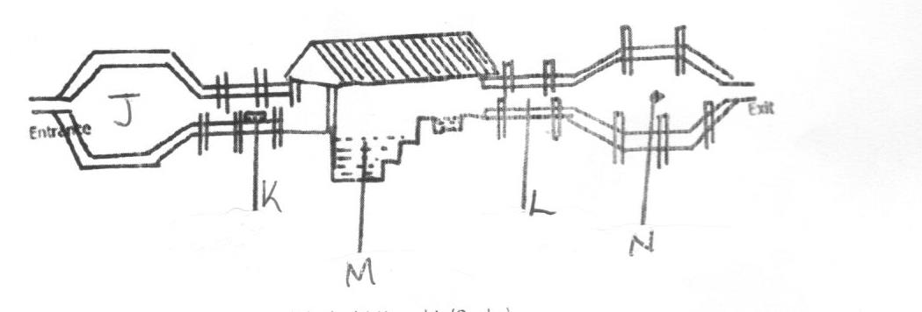
- State one sue of each of the parts labeled J,K and L (3 Marks)
……………………………………………………………………………………………………………………………………………………………………………………………………………………………………………………………………………………………………………………

- State two precautions a farmer should take on the dip to ensure effective dipping (2 Marks)
………………………………………………………………………………………………………………………………………………………………………………………………………………………………………………………………………………………………………………………………………………………………………………………………………………………………………………………………………………………

- The diagram below shows a type of silo.
- Identify the type of silo drawn above (1 Mark)
……………………………………………………………………………………………………………………………………………………………………………………………………………………………………………………………………………………………………………………

- Give two ways in which overheating can be avoided in the process of structure (2 Marks)
……………………………………………………………………………………………………………………………………………………………………………………………………………………………………………………………………………………………………………………

- State two causes of silage losses (2 Marks)
……………………………………………………………………………………………………………………………………………………………………………………………………………………………………………………………………………………………………………………

SECTION C ( 40 MARKS)
Choose and answer any two questions from this section
- a) Discus the causes of stress in poultry (8 Marks)
………………………………………………………………………………………………………………………………………………………………………………………………………………………………………………………………………………………………………………………………………………………………………………………………………………………………………………………………………………………………………
………………………………………………………………………………………………………………………………………………………………………………………………………………………………………………………………………………………………………………………………………………………………………………………………………………………………………………………………………………………………………
………………………………………………………………………………………………………………………………………………………………………………………………………………………………………………………………………………………………………………………………………………………………………………………………………………………………………………………………………………………………………
………………………………………………………………………………………………………………………………………………………………………………………………………………………………………………………………………………………………………………………………………………………………………………………………………………………………………………………………………………………………………
………………………………………………………………………………………………………………………………………………………………………………………………………………………………………………………………………………………………………………………………………………………………………………………………………………………………………………………………………………………………………
………………………………………………………………………………………………………………………………………………………………………………………………………………………………………………………………………………………………………………………………………………………………………………………………………………………………………………………………………………………………………

b) Discuss mastitis under the following sub headings
- animas affected (1 Mark)
…………………………………………………………………………………………………………………………………………………………………………………………………………………………………………………………………………………………………………

- causal organism (1 Mark)
……………………………………………………………………………………………………………………………………………………………………………………………

- symptoms ( 2 Marks)
……………………………………………………………………………………………………………………………………………………………………………

- predisposing factors (4 Marks)
………………………………………………………………………………………………………………………………………………………………………………………………………………………………………………………………………………………………………………………………………………………………………………………………………………………………………………………………………………………………………

- control measures (4 Marks)
………………………………………………………………………………………………………………………………………………………………………………………………………………………………………………………………………………………………………………………………………………………………………………………………………………………………………………………………………………………………………

- a) Explain factors that affect milk composition in dairy farming (10 Marks)
………………………………………………………………………………………………………………………………………………………………………………………………………………………………………………………………………………………………………………………………………………………………………………………………………………………………………………………………………………………………………
………………………………………………………………………………………………………………………………………………………………………………………………………………………………………………………………………………………………………………………………………………………………………………………………………………………………………………………………………………………………………
………………………………………………………………………………………………………………………………………………………………………………………………………………………………………………………………………………………………………………………………………………………………………………………………………………………………………………………………………………………………………
………………………………………………………………………………………………………………………………………………………………………………………………………………………………………………………………………………………………………………………………………………………………………………………………………………………………………………………………………………………………………
………………………………………………………………………………………………………………………………………………………………………………………………………………………………………………………………………………………………………………………………………………………………………………………………………………………………………………………………………………………………………
………………………………………………………………………………………………………………………………………………………………………………………………………………………………………………………………………………………………………………………………………………………………………………………………………………………………………………………………………………………………………

b) Describe factors considered when selecting breeding stock (10 Marks)
………………………………………………………………………………………………………………………………………………………………………………………………………………………………………………………………………………………………………………………………………………………………………………………………………………………………………………………………………………………………………
………………………………………………………………………………………………………………………………………………………………………………………………………………………………………………………………………………………………………………………………………………………………………………………………………………………………………………………………………………………………………
………………………………………………………………………………………………………………………………………………………………………………………………………………………………………………………………………………………………………………………………………………………………………………………………………………………………………………………………………………………………………
………………………………………………………………………………………………………………………………………………………………………………………………………………………………………………………………………………………………………………………………………………………………………………………………………………………………………………………………………………………………………
………………………………………………………………………………………………………………………………………………………………………………………………………………………………………………………………………………………………………………………………………………………………………………………………………………………………………………………………………………………………………
………………………………………………………………………………………………………………………………………………………………………………………………………………………………………………………………………………………………………………………………………………………………………………………………………………………………………………………………………………………………………

- a) Describe the four stroke of an internal combustion engine (16 Marks)
………………………………………………………………………………………………………………………………………………………………………………………………………………………………………………………………………………………………………………………………………………………………………………………………………………………………………………………………………………………………………
………………………………………………………………………………………………………………………………………………………………………………………………………………………………………………………………………………………………………………………………………………………………………………………………………………………………………………………………………………………………………
………………………………………………………………………………………………………………………………………………………………………………………………………………………………………………………………………………………………………………………………………………………………………………………………………………………………………………………………………………………………………
………………………………………………………………………………………………………………………………………………………………………………………………………………………………………………………………………………………………………………………………………………………………………………………………………………………………………………………………………………………………………
………………………………………………………………………………………………………………………………………………………………………………………………………………………………………………………………………………………………………………………………………………………………………………………………………………………………………………………………………………………………………
………………………………………………………………………………………………………………………………………………………………………………………………………………………………………………………………………………………………………………………………………………………………………………………………………………………………………………………………………………………………………

b) State 4 advantages of four stroke engine (4 Marks)
…………………………………………………………………………………………………………………………………………………………………
……………………………………………………………………………………………………………………………………………………………………………………………………………………………………………………………………………………………………………………………………
………………………………………………………………………………………………………………………………………………………………………………………………………………………………………………………………………………………………………………………………………………………………………………………………………………………………………………………………………………………………………
………………………………………………………………………………………………………………………………………………………………………………………………………………………………………………………………………………………………………………………………………………………………………………………………………………………………………………………………………………………………………
………………………………………………………………………………………………………………………………………………………………………………………………………………………………………………………………………………………………………………………………………………………………………………………………………………………………………………………………………………………………………

