NAME _______________________________________________CLASS__________________________
ADM NO________________________
443/1
AGRICULTURE
FROM: FOUR
Section A ( 30 MARKS)
Answer all questions in the questions in this section in space provided
- State four qualities considered when selecting seeds for planting (2 Marks)
…………………………………………………………………………………………………………………………………………………………………………………………………………………………………………………………………………………………………………………………………………………………………………………………………………………………………………………………………………………………………………………………………………………………………………………………………………………………………………………………………………………………………………………………………………………………………………………………………………………………………………………………………………………………………………………………………………………………………………………………………………………………………………………………………….
- State two classes of herbicides based on formulation (1 Mark)
…………………………………………………………………………………………………………………………………………………………………………………………………………………………………………………………………………………………………………………………………………………………………………………………………………………………………………………………………………………………………………………………………………………………………………………………………………………………………………………………………………………………………………………………………………………………………………………………………………………………………………………………………………………………………………………………………………………………………………………………………………………………………………………………………….

- State four practices which help in achieving minimum tollage (2 Marks)
…………………………………………………………………………………………………………………………………………………………………………………………………………………………………………………………………………………………………………………………………………………………………………………………………………………………………………………………………………………………………………………………………………………………………………………………………………………………………………………………………………………………………………………………………………………………………………………………………………………………………………………………………………………………………………………………………………………………………………………………………………………………………………………………………….

- Give four reasons why most farmers do not use green manure (2 Marks)
…………………………………………………………………………………………………………………………………………………………………………………………………………………………………………………………………………………………………………………………………………………………………………………………………………………………………………………………………………………………………………………………………………………………………………………………………………………………………………………………………………………………………………………………………………………………………………………………………………………………………………………………………………………………………………………………………………………………………………………………………………………………………………………………………….

- Give four policies that the government has instituted in order to regulate importation of agricultural goods. (2 Marks)
a) Give four methods of applying fertilizer to crops (2 Marks)
…………………………………………………………………………………………………………………………………………………………………………………………………………………………………………………………………………………………………………………………………………………………………………………………………………………………………………………………………………………………………………………………………………………………………………………………………………………………………………………………………………………………………………………………………………………………………………………………………………………………………………………………………………………………………………………………………………………………………………………………………………………………………………………………………….

b) Give three examples of straight fertilizers (1 ½ Marks)
…………………………………………………………………………………………………………………………………………………………………………………………………………………………………………………………………………………………………………………………………………………………………………………………………………………………………………………………………………………………………………………………………………………………………………………………………………………………………………………………………………………………………………………………………………………………………………………………………………………………………………………………………………………………………………………………………………………………………………………………………………………………………………………………………….

- State four pieces of information contained in a land title deed (2 Marks)
…………………………………………………………………………………………………………………………………………………………………………………………………………………………………………………………………………………………………………………………………………………………………………………………………………………………………………………………………………………………………………………………………………………………………………………………………………………………………………………………………………………………………………………………………………………………………………………………………………………………………………………………………………………………………………………………………………………………………………………………………………………………………………………………………….

- State four characteristics of small scale farming (2 Marks)
…………………………………………………………………………………………………………………………………………………………………………………………………………………………………………………………………………………………………………………………………………………………………………………………………………………………………………………………………………………………………………………………………………………………………………………………………………………………………………………………………………………………………………………………………………………………………………………………………………………………………………………………………………………………………………………………………………………………………………………………………………………………………………………………………….

- Suggest four ways that should be sought to get more land into agricultural production (2 Marks)
…………………………………………………………………………………………………………………………………………………………………………………………………………………………………………………………………………………………………………………………………………………………………………………………………………………………………………………………………………………………………………………………………………………………………………………………………………………………………………………………………………………………………………………………………………………………………………………………………………………………………………………………………………………………………………………………………………………………………………………………………………………………………………………………………….

- State four ways in which soil profile influence plant growth (2 Marks)
…………………………………………………………………………………………………………………………………………………………………………………………………………………………………………………………………………………………………………………………………………………………………………………………………………………………………………………………………………………………………………………………………………………………………………………………………………………………………………………………………………………………………………………………………………………………………………………………………………………………………………………………………………………………………………………………………………………………………………………………………………………………………………………………………….

- Name two conditions that encourage damping off disease in nursery (2 Marks)
…………………………………………………………………………………………………………………………………………………………………………………………………………………………………………………………………………………………………………………………………………………………………………………………………………………………………………………………………………………………………………………………………………………………………………………………………………………………………………………………………………………………………………………………………………………………………………………………………………………………………………………………………………………………………………………………………………………………………………………………………………………………………………………………………….

- State four factors a farmer will consider when choosing a jembe for primary tillage (2 Marks)
…………………………………………………………………………………………………………………………………………………………………………………………………………………………………………………………………………………………………………………………………………………………………………………………………………………………………………………………………………………………………………………………………………………………………………………………………………………………………………………………………………………………………………………………………………………………………………………………………………………………………………………………………………………………………………………………………………………………………………………………………………………………………………………………………….

- State four factors considered when classifying crop pest (2 Marks)
…………………………………………………………………………………………………………………………………………………………………………………………………………………………………………………………………………………………………………………………………………………………………………………………………………………………………………………………………………………………………………………………………………………………………………………………………………………………………………………………………………………………………………………………………………………………………………………………………………………………………………………………………………………………………………………………………………………………………………………………………………………………………………………………………….

- A farmer owns one hectare on which he can grow maize whose yield is 15 bags/ha, but he has chosen to grow sorghum whose yield is 20bags/ha. If maize is sold KSH 1,200.00 per bag while sorghum is sold at Ksh. 700.00 per bag. Calculate the opportunity cost (2 Marks)
…………………………………………………………………………………………………………………………………………………………………………………………………………………………………………………………………………………………………………………………………………………………………………………………………………………………………………………………………………………………………………………………………………………………………………………………………………………………………………………………………………………………………………………………………………………………………………………………………………………………………………………………………………………………………………………………………………………………………………………………………………………………………………………………………….

- Give three non-chemical factors affecting rooting of cuttings (1 ½ Mark)
…………………………………………………………………………………………………………………………………………………………………………………………………………………………………………………………………………………………………………………………………………………………………………………………………………………………………………………………………………………………………………………………………………………………………………………………………………………………………………………………………………………………………………………………………………………………………………………………………………………………………………………………………………………………………………………………………………………………………………………………………………………………………………………………………….

- List four features of plastic pipes a farmer should consider before buying a pipe (2 Marks)
…………………………………………………………………………………………………………………………………………………………………………………………………………………………………………………………………………………………………………………………………………………………………………………………………………………………………………………………………………………………………………………………………………………………………………………………………………………………………………………………………………………………………………………………………………………………………………………………………………………………………………………………………………………………………………………………………………………………………………………………………………………………………………………………………….

SECTION B
Answer all questions in the space provided
- The diagram below illustrates a final seed bed after a tertiary operation done during land preparation. Study it and answer questions that follow.
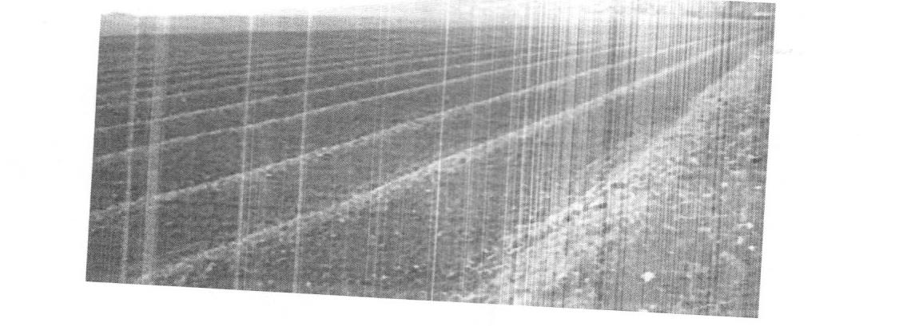
- Name the tertiary operation carried out on the seed bed (1 Mark)
……………………………………………………………………………………………………………………………………………………………………………………………………….

- Give two factors that may necessitate establishment of structure (2 Marks)
……………………………………………………………………………………………………………………………………………………………………………………………………………………………………………………………………………………………………………………………………………………………………………….

- Give two advantages of planting crops on the seedbed illustrated above (2 Marks)
………………………………………………………………………………………………………………………………………………………………………………………………………………………………………………………………………………………………………………………………………………………………………………………………………………………………………………………………………………………………………………………………………………………………………………………………………………………………………………………………………………………………………………………….

- Study the following diagrams and answer questions that follow.
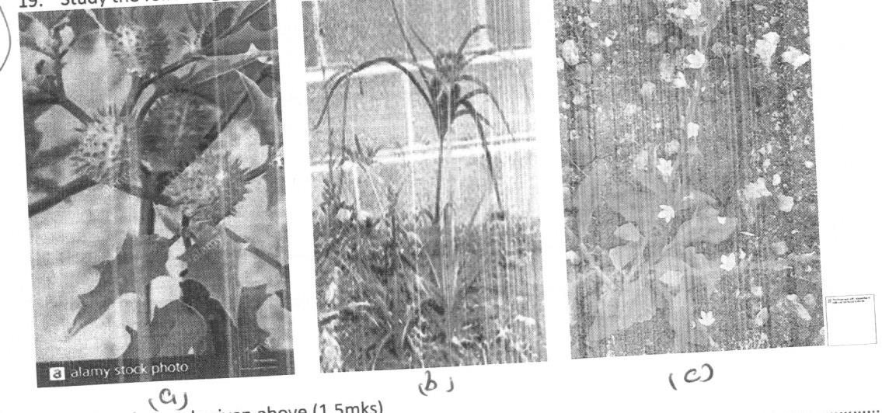

- Identify weeds given above (1 ½ Marks)

- State economic importance of weed A and B (2 Marks)
A
B
- State an example of herbicide for controlling weed A and B (1 Mark)

- The diagram below illustrates a method of training carried out in growing some crops. Study it and answer questions that follow

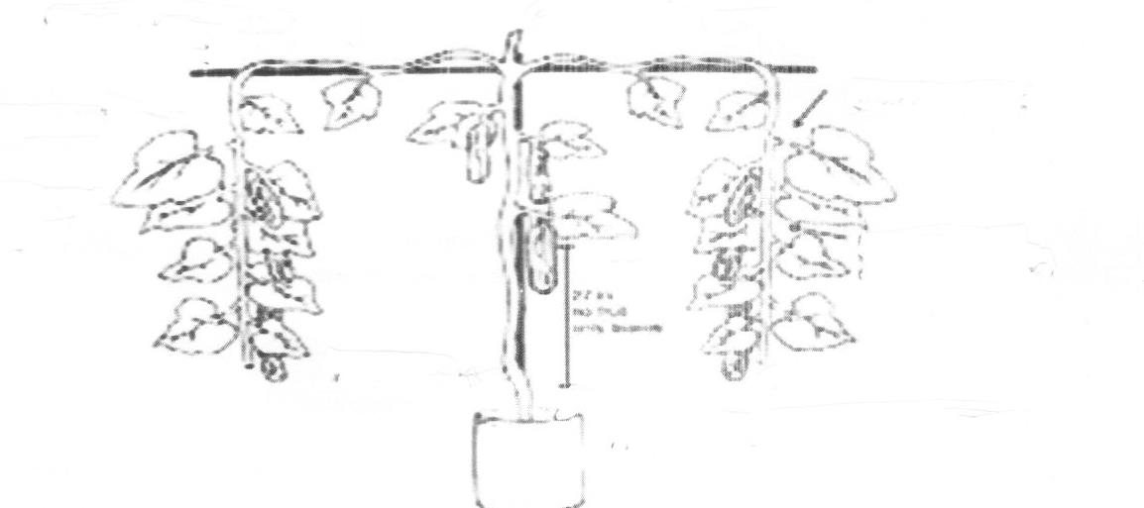
- Identify the method of training shown (1 Mark)

- Name two crops which the practice above can be carried out (1 Mark)

- Explain three reason for carrying out practice above (1 ½ Mark)

- Give two other methods of training crops (1 Mark)

- A farmer is advised to apply 30kg P₃O₅/ha. The available fertilizer is 20:15:10. Calculate the amount of fertilizer he will require for his three hectare piece of land (3 Marks)

- Give a reason for each of following practices
- Topping in pasture management

- Top dressing pasture crops

- Weeding in pasture

SECTION C (40 MARKS)
Answer only two questions in this section
- a) Explain six factors that contribute to competitive ability of weed (6 Marks)
b) Explain four maintenance practices done to a maize store before storage (4 Marks)
c) Describe safety measure one should observe when handling herbicides (10 Marks)
- a) Explain four properties of nitrogenous fertilizers that dictates this handling (8 Marks)
b) Outline six cultural activities that may be undertaken to control pests in beans (6 Marks)
c) Describe reasons for raising kales in nursery before transplanting (6 Marks)
- a) Explain how each of the following aspects of rain influence crop production. (4 Marks)
- rainfall amount
- rainfall reliability
- rainfall distribution
- rainfall intensity
b) Describe structural methods of conserving soil and water in a farm (8 Marks)
c) Describe methods used in preparing materials for planting (8 Marks)

