NAME: ………………………………………………………………………………… ADM.NO. …………………….

CLASS: …………………………

SIGNATURE: …..………………….
232/2
PHYSICS
FORM THREE DATE: …………………………..……
OCTOBER 2022
TIME: 2 HRS

MID TERM 3EXAM
PHYSICS PAPER ONE

Instructions

- Write your name, admission number, class, signature and date of examination in the spaces provided at the top of the page.
- This paper consists of two sections A and B.
- Answer all the questions in the two sections in the spaces provided after each question.
- Electronic calculators and mathematical tables may be used.
- All numerical answers should be expressed in decimal notations.

FOR EXAMINER’S USE ONLY

SECTION | QUESTION | MAXIMUM  MARKS | CANDIDATE’S SCORE
A | 1 – 12 | 25
B | 13 | 10
 | 14 | 10
 | 15 | 10
 | 16 | 10
 | 17 | 15
 | TOTAL | 80

SECTION A (25 MARKS)

  - The figure below shows a spherical ball placed between 2 wooden blocks and a meter
rule.

What is the volume of the ball? (3 mks)
………………………………………………………………………………………………………………………………………………………………………………………………………………………………………………………………………………………………………………………………………………………………………………………………………………………

  - A solid weighs 16.5N on the surface of the moon. The force of gravity on the moon is
1.7N/kg. Determine the mass of the solid. (2 Mks)

………………………………………………………………………………………………………………………………………………………………………………………………………………………………………………………………………………………………………………………………………………………………………………………………………………………..

  - The figure below shows an underground room ventilation system. It has two vents , one
at A and the other one at B. A fire was lit at point C.

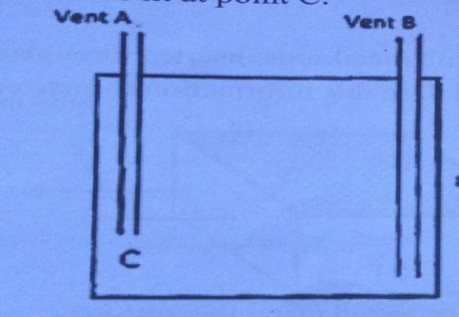

Explain what happened when the fire was lit. (3 mks)
………………………………………………………………………………………………………………………………………………………………………………………………………………………………………………………………………………………………………………………………………………………………………………………………………………………

  - 30cm³ of a liquid X was added to 70cm³ of water and the resulting mixture had a
volume slightly less than 100cm³, explain the observation. (2 mks)
………………………………………………………………………………………………………………………………………
………………………………………………………………………..……………………………………………………………..

  - Explain how heat loss by ;
- Radiation is minimized in a vacuum flask. (1 Mk)
………………………………………………………………………………………………………………………………………
……………………………………………………………………………………………………………………………………….

- Conduction is minimized in a vacuum flask. (1 Mk)
..............................................................................................................................................................................................
..............................................................................................................................................................................................

  - The figure below shows part of a scale of vernier caliper. Given the vernier caliper has a
zero error of -0.02 and has been used to measure the diameter of a ball.

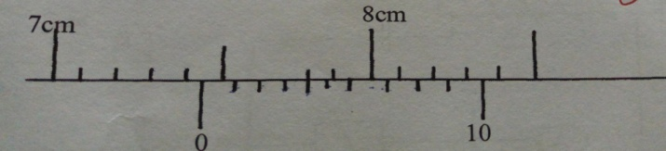
What is the radius of the ball? (2 Mks)
………………………………………………………………………………………………………………………………………
……………………………………………………………………………………………………………………………………….

  - A pipe of radius 6mm is connected to another pipe of radius 9mm. if
water flows in the wider pipe at 2m/s what is the speed in the narrower pipe? (3 Mks)
………………………………………………………………………………………………………………………………………
………………………………………………………………………………………………………………………………………
………………………………………………………………………………………………………………………………………
……………………………………………………………………………………………………………………………………….

  - The three springs shown below are identical and have negligible weight. The extension
produced on the system of springs is 20cm.

Determine the constant of each spring. (2 Mks)
…………………………………………………………………………………………………………………………….…………………
……………………………………………………………………………………………………………………………………………………………………………………………………………………………………………………………………………………………….

  - The figure below shows a uniform metre rule of weight 1N with two weights 0.18N and
0.12N suspended from its ends.
0 100cm

0.18N 0.12N

Determine how far from the 0.18N weight a pivot should be placed in order to balance
the meter rule. (3 mks)
………………………………………………………………………………………………………………………………………
………………………………………………………………………………………………………………………………………
………………………………………………………………………………………………………………………………………
………………………………………………………………………………………………………………………………………
………………………………………………………………………………………………………………………………………

  - Calculate the velocity at which water emerges from the hole on the side of the tank
50cm above the bottom of the tank as below. (3Mks)
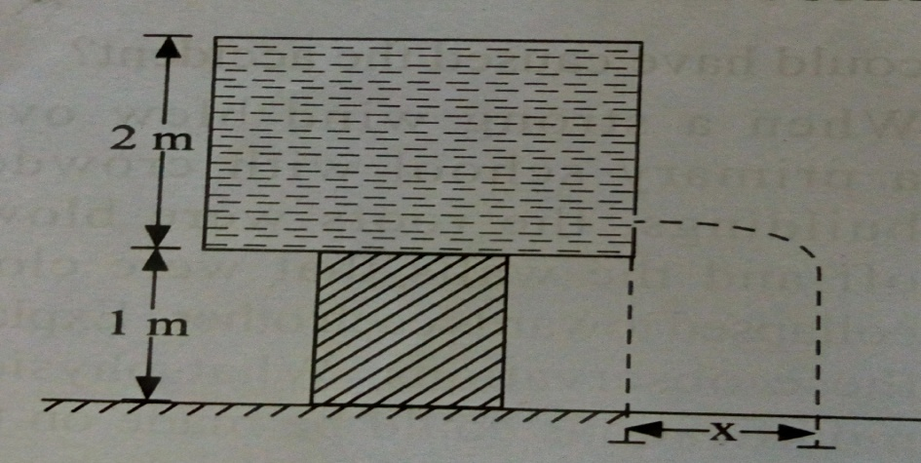

………………………………………………………………………………………………………………………………………
………………………………………………………………………………………………………………………………………
………………………………………………………………………………………………………………………………………
………………………………………………………………………………………………………………………………………
…………………………………………………………………………………………………………………………………….

SECTION B: 55 MARKS.

  - (a) A mass, 5kg moving with a velocity of 10m/s collides with a 10kg mass moving with
a velocity of 4m/s in the same direction along the same line. After collision, the 5kg mass moves with a velocity of 7.0m/s. Calculate the velocity of the 10kg mass. (3 Mks)
………………………………………………………………………………………………………………………………………
………………………………………………………………………………………………………………………………………
………………………………………………………………………………………………………………………………………
……………………………………………………………………………………….………………………………………………
………………………………………………………………………………………………………………………………………..
(b) a man of mass 75kg stands on a weighing machine in a lift. Determine the reading on
the weighing machine when the lift moves upwards with an acceleration of 2m/s².
(3mks)
………………………………………………………………………………………………………………………………………
………………………………………………………………………………………………………………………………………
………………………………………………………………………………………………………………………………………
……………………………………………………………………………………………………………………………………….
………………………………………………………………………………………………………………………………………..

(c) Explain why a steel ball falling through oil, will first accelerate after which the
acceleration falls to zero. (3 mks)

………………………………………………………………………………………………………………………………………
………………………………………………………………………………………………………………………………………
………………………………………………………………………………………………………………………………………
(d) State Newton’s first law of motion. (1mk)
………………………………………………………………………………………………………………………………………
……………………………………………………………………………………………………………………………………

  - (a) State one factor that affects the rate of evaporation. (1 Mk)
………………………………………………………………………………………………………………………………………
…………………………………………………………………………………………………………………………………….....

(b) A thin wire is passed round a large block of ice and two heavy weights are attached
to the ends. It is observed that the wire passes through and the ice remains as a single
block.

Explain the observation. (2 mks)
………………………………………………………………………………………………………………………………………
………………………………………………………………………………………………………………………………………
……………………………………………………………………………………………………………………………………
(c) The graph below shows the cooling curve of naphthalene.

A

B C
Temp (ºC)

Time (min)

State what is happening at points;
- A – B. (1 Mk)

- B –C. (1 Mk)
……………………………………………………………………………………………………….
…………………………………………………………………………………………………………

(d) Find the final temperature of water is a heater source rated 42W heats 50g of water
From 20⁰ in five minutes. (Specific heat capacity of water =4200J/kg/K) (4mks)
…………………………………………………………………………………........................................................
……………………………………………………………………………………………………………………………
……………………………………………………………………………………………………………………………….
………………………………………………………………………………………………………………………………
……………………………………………………………………………………………………………………………….

(e) Define the term specific latent heat of fussion. (1mk)
………………………………………………………………………………………………………………………………………………………………………………………………………………………………………………………………………………

  - (a) An air bubble of volume 0.5cm³ when released from the bottom of a lake rises to the
surface of the lake.
- Explain why the bubble rises up. (2 mks)
………………………………………………………………………………………………………………………………………………………………………………………………………………………………………………………………………………………………………………………………………………………………………………………………………………………

- Calculate the volume of the bubble at the surface of the lake given that the lake is
92.7m deep and the atmospheric pressure is equivalent to 10.3m of water pressure.
(Density of water 1000 kg/m³)
(4mks)
………………………………………………………………………………………………………………………………………………………………………………………………………………………………………………………………………………………………………………………………………………………………………………………………………………………………………………………………………………………………………………………………………………………………………………………………………………………………………………………………………………………………………………………………………………

- What assumption have you made in arriving at your answer? (1 mk)

……………………………………………………………………………………………………………………………………………………………………………………………………………………………………………………………………………….

(b) A fixed mass of gas at constant pressure has a volume of 600cm³ at 0ºC.
At what temperature will its volume be 1099 cm^{3.} (3 mks)
………………………………………………………………………………………………………………………………………
………………………………………………………………………………………………………………………………………
………………………………………………………………………………………………………………………………………
………………………………………………………………………………………………………………………………………
……………………………………………………………………………………………………………………………………….

  - The figure shows a crate of mass 70kg being pushed by a man with a force of 150N along
the plane AB.
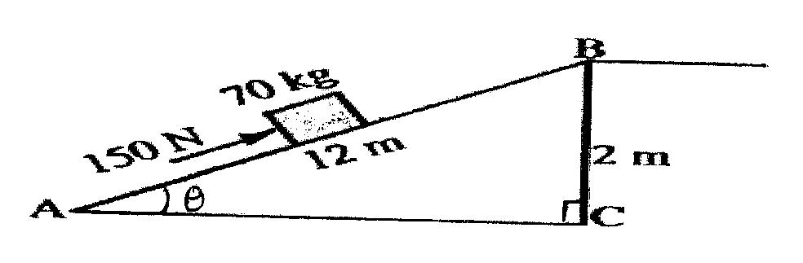
(a) Show that V.R of the inclined plane is given by $\frac{1}{Sinϴ}$ (2 marks)
.………………………………………………………………………………………………………………………………………………………………………………………………………………………………………………………………………………………………
(b) Determine the work done:
(i) By the force of the man. (2marks)
.……………………………………………………………………………………………………………………………………………………………………………………………………………………………………………………………………………………………………………………………………………………….………………………………………………………………………………………
(ii) On the mass. (2marks)
.…………………………………………………………………………………………………………………………………………………………………………………………………………………………………………………………………………………………………………………………………………………………………………………………………………………………………………….…
(iii) To overcome friction. (1mark)
.…………………………………………………………………………………………………………………………………………………………………………………………………………………………………………………..………………………………………….
(c) Determine the efficiency of the inclined plane. (2marks)
.……………………………………………………………………………………………………………………………………………………………………………………………………………………………………………………………………………………………….
(d) Suggest one method of improving the efficiency of an inclined plane. (1mark)

  - (a) The tape below was produced by a ticker timer with a frequency of 100Hz. Find the acceleration of the object which was pulling the tape in SI unit. (3mks)

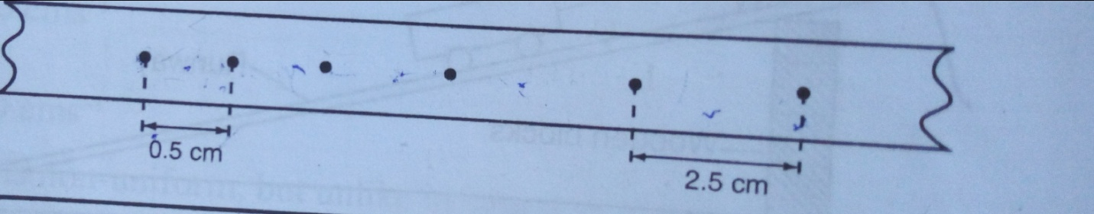

……………………………………………………………………………………………………………………………………………
…………………………………………………………………………………………………………………………………………….
……………………………………………………………………………………………………….……………………………………
…………………………………………………………………………………………………………….………………………………
(b) A hammer is thrown horizontally from the top of a roof 20m high with a horizontal
Velocity of 10m/s. Calculate :

- The time it takes to hit the ground (3mks)
………………………………………………………………………………………………………………………………………………………………………………………………………………………………………………………………………………………………………………………………………………………………………………………………………………………………………………………………………………………………………………………………………..……………………………………………………..
- The distance from the foot of the building to the point the hammer hits the ground.
(3mks)
……………………………………………………………………………………………………………………………………
………………………………………………………………………………………………………………………………………
………………………………………………………………………………………………………………………………………
………………………………………………………………………………………………………………………………………..

- If the hammer fell on sand and buried itself deep in the sand. How deep did it burry
Itself? (4mks)
…………………………………………………………………………………………………………………………………….
………………………………………………………………………………………….………………………………………………………………………………………………………………………………………………………………………………………………………………………………………………………………………………………………………………………………………………………………………………………………………………………………………………………………………………………………………………………………………………………………..…………………………….

- Distinguish between the terms displacement and distance as used in linear motion.
(2mks)
…………………………………………………………………………………………………………………………………………………………………………………………………………………………………………………………………………………………………………………………………………………………………………....…………………………………………………………………

SUCCESS

