NAME:………………………………………………………………………………… ADM. NO. …………………….

CLASS: ………………………… SIGNATURE:…………………….
232/2
PHYSICS
FORM THREE
OCTOBER 2022
TIME: 2 HRS
MID TERM EXAM
PHYSICS PAPER 1

Instructions

- Write your name, admission number, class, signature and date of examination in the
spaces provided at the top of the page.
- This paper consists of two sections A and B.
- Answer all the questions in the two sections in the spaces provided after each question.
- Electronic calculators and mathematical tables may be used.
- All numerical answers should be expressed in decimal notations.

FOR EXAMINER’S USE ONLY

SECTION | QUESTION | MAXIMUM  MARKS | CANDIDATE’S SCORE
A | 1 – 12 | 25
B | 13 | 10
 | 14 | 10
 | 15 | 10
 | 16 | 10
 | 17 | 15
 | TOTAL | 80

SECTION A (25 MARKS)

  - The figure below shows a spherical ball placed between 2 wooden blocks and a meter
rule.

What is the volume of the ball? (3 mks)

5.8-4.5=1.3
1.3/2=0.65
V=4/3x22/7x0.65³
1.151cm³

  - A solid weighs 16.5N on the surface of the moon. The force of gravity on the moon is
1.7N/kg. Determine the mass of the solid. (2 Mks)

M=w/g
M=16.5/1.7
9.706kg

  - The figure below shows an underground room ventilation system. It has two vents , one
at A and the other one at B. A fire was lit at point C.

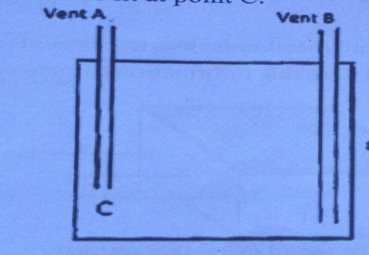

Explain what happened when the fire was lit. (3 mks)
The air around C was heated and began to rise up ( expand) , going out through A. The fresh and cold air came in to replace it through vent B and so the room gets ventilated.

  - 30cm³ of a liquid X was added to 70cm³ of water and the resulting mixture had a
volume slightly less than 100cm³, explain the observation. (2 mks)

this is because some of the particles of liquid X are able to fit in between water particles.

  - Explain how heat loss by ;
- Radiation is minimized in a vacuum flask. (1 Mk)

Silvered inner walls

- Conduction is minimized in a vacuum flask. (1 Mk)

Presence of a double wall with a vacuum in between

  - The figure below shows part of a scale of vernier caliper. Given the vernier caliper has a
zero error of -0.02 and has been used to measure the diameter of a ball.

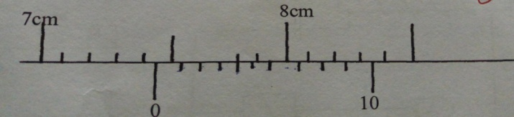
What is the radius of the ball? (2 Mks)

Diameter=7.44+0.02=7.46
Radius =3.73cm

  - A pipe of radius 6mm is connected is connected to another pipe of radius 9mm. if
water flows in the wider pipe at 2m/s what is the speed in the narrower pipe? (3 Mks)

A₁V₁ =A₂V₂
36 X V₁=81 X 2
V₁=4.5m/s

  - The three springs shown below are identical and have negligible weight. The extension
produced on the system of springs is 20cm.

Determine the constant of each spring. (2 Mks)
For parallel springs extension
= 40N
2K
For single spring, extension = 20N
k

total extension = 40N + 20N = 20cm
2k k

(40 + 40) N = 20cm
2k

80N = 20 cm
2k

K = 80N
20 x 2cm

= 2N/cm

Or 0.02N/M

  - The figure below shows a uniform metre rule of weight 1N with two weights 0.18N and
0.12N suspended from its ends.
0 100cm

0.18N 0.12N

Determine how far from the 0.18N weight a pivot should be placed in order to balance
the meter rule. (3 mks)

0.18Nx = 1NX (0.5 – X) m + 0.12 NX (1.0 – X)m
0.18NX = 0.5NM – XN + 0.12NM – 0.12XNM
0.18NX + 0.12 XNM = 0.62 NM
1.3 XN = 0.62NM
X = 0.62 NM
1.3N

X = 0.4769M

(X = pivot distance from 0.18N)

Calculate the velocity at which water emerges from the hole on the side of the tank
50cm above the bottom of the tank as below. (3Mks)
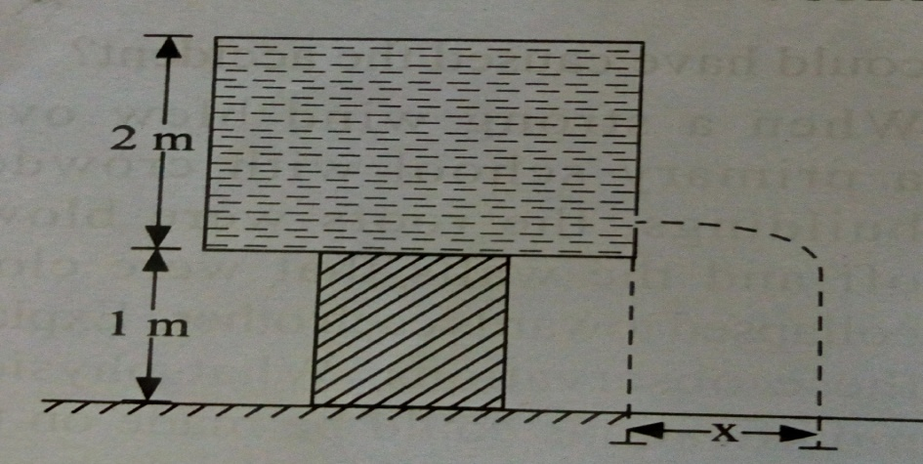

Mgh=1/2 x m x v²

gh=1/2 x v²

10 x 1.5 =1/2 x v²

V=5.477m/s

SECTION B: 55 MARKS.

  - (a) A mass, 5kg moving with a velocity of 10m/s collides with a 10kg mass moving with
a velocity of 4m/s in the same direction along the same line. After collision, the 5kg mass moves with a velocity of 7.0m/s. Calculate the velocity of the 10kg mass. (3 Mks)

Momentum before collision =momentum after collision

(b) a man of mass 75kg stands on a weighing machine in a lift. Determine the reading on
the weighing machine when the lift moves upwards with an acceleration of 2m/s².
(3mks)
75 X10+75 X2 =900N

(c) Explain why a steel ball falling through oil, will first accelerate after which the
acceleration falls to zero. (3 mks)

Resultant force = W – (u + F) which makes the ball to accelerate. As it accelerates its
velocity increases and so the viscosity on the ball.
This reduces the resultant force.
Eventually W = U + F and resultant force is zero so no acceleration of the ball instead it falls
at a constant velocity.

(d) State Newton’s first law of motion. (1mk)
A body will remain at rest or uniform motion along a straight line unless acted upon by an external force
  - (a) State one factor that affects the rate of evaporation. (1 Mk)

Wind/temperature/ area of exposure.

(b) A thin wire is passed round a large block of ice and two heavy weights are attached
to the ends. It is observed that the wire passes through and the ice remains as a single
block.

Explain the observation. (2 mks)
The masses make the wire exert increased pressure on the ice block lowering its melting point but immediately the wire has passed the block of ice refreezes in a process known as regelation

(c) The graph below shows the cooling curve of naphthalene.

A

B C
Temp (ºC)

Time (mn)

State what is happening at points;
- A – B. (1 Mk)
naphthalene cooling in liquid state

(ii)B –C. (1 Mk)

naphthalene solidifying.

(d) Find the final temperature of water is a heater source rated 42W heats 50g o water
From 20⁰ in five minutes. (Specific heat capacity of water =4200J/kg/K) (4mks)

(e) Define the term specific latent heat of fussion. (1mk)
It’s the quantity of heat energy required to change a unit mass from solid to liquid without change in temperature.

  - (a) An air bubble of volume 0.5cm³ when released from the bottom of a lake rises to the
surface of the lake.
- Explain why the bubble rises up. (2 Mks)

The bubble rises up since the density of air is less than that of water.
- Calculate the volume of the bubble at the surface of the lake given that the lake is
92.7m deep and the atmospheric pressure is equivalent to 10.3m of water pressure.
(4Mks)
Volume of air bubble at the bottom = V₁ and at the top = V₂
Pressure acting on bubble at the surface = 10.3m of water pressure.
Pressure acting on the bubble at the bottom = P₁ = 10.3 + 92.7

= 103.0m of water pressure 1

From Boyless law

P₁V₁ + P₂ V₂ 2

103.0 x 0.5 = 10.3 V₂

50 V₂ = 103 x 0.5
10.3

= 5cm³

- What assumption have you made in arriving at your answer? (1 Mk)

the temperature of the lake and that of the air bubble is constant

(b) A fixed mass of gas at constant pressure has a volume of 600cm³ at 0ºC.
At what temperature will its volume be 1099 cm^{3.} (3 mks)

  - The figure shows a crate of mass 70kg being pushed by a man with a force of 150N along
the plane AB.
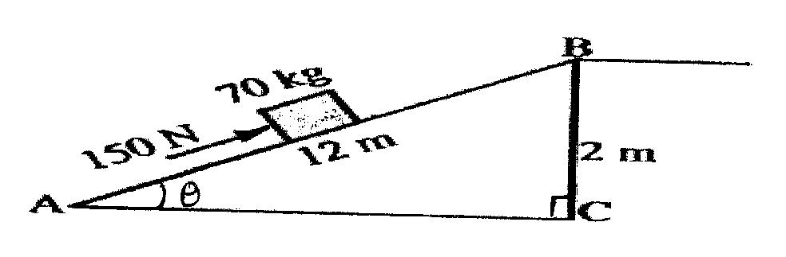
(a) Show that V.R of the inclined plane is given by $\frac{1}{Sinϴ}$ (2 marks)

V.R =12/2=6
Sin Ѳ=2/12=1/6
1/sin Ѳ=6=V.R
(b) Determine the work done:
(i) By the force of the man. (2marks)
W=fXd
150 x12
1800J
- On the mass. (2marks)
W=mgh
70x10x2
1400J
(iii) To overcome friction. (1mark)
1800-1400=400J.
(c) Determine the efficiency of the inclined plane. (2marks)
Efficiency = 1400/1800 x100=77.78J

(d) Suggest one method of improving the efficiency of an inclined plane. (1mark)
Lubrication / use of rollers

  - (a) The tape below was produced by a ticker timer with a frequency of 100Hz. Find the acceleration of the object which was pulling the tape in SI unit. (3mks)

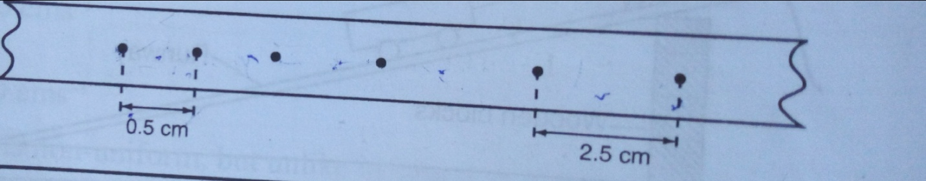

Initial velocity =50cm/s
Final velocity =250/s
Acceleration=(250-50)/0.04=5000cm/s²
=50m/s²
(b) A hammer is thrown horizontally from the top of a roof 20m high with a horizontal
Velocity of 10m/s. Calculate :

- The time it takes to hit the ground (3mks)
H=1/2gt²
20=1/2x10xt²
t=2s
- The distance from the foot of the building to the point the hammer hits the ground.
(3mks)
R= 10 X 2

20m
- If the hammer fell on sand and buried itself deep in the sand. How deep did it burry
Itself? (4mks)

v=u +gt=0+10 x2=20m/s
v²=u²+2as
0²=20²+2x10xs
s= -20m
2Om below the surface
- Distinguish between the terms displacement and distance as used in linear motion.
(2mks)
Displacement is distance in a specified direction while distance is the length of the path covered by a body in a given time

SUCESS

