NAME........................................................................................ADM NO........................CLASS...........

MID TERM THREE, 2022
PHYSICS FORM TWO
TIME: 2 hours 15 min.

SECTION A: (40 MARKS)
Answer all questions in this section in the spaces provided.

1. The figure below shows part of scale of a vernier caliper. Given the vernier caliper has a zero error of -0.02 and is has been used to measure the diameter of a ball. (2 mks)
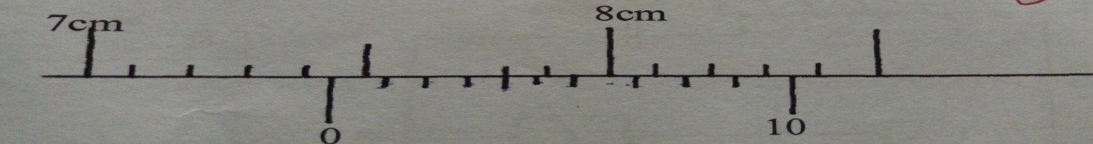
What is the radius of the ball? …………………………………………………………………………………………………………………………………………………………………………………………………………………………
……………………………………………………………………………………………………………
2. A pipe of radius 6mm is connected to another pipe of radius 9mm. If water flows in the wider pipe at 2m/s, what is the speed in the narrower pipe? (4mks)
.………………………………………………………………………………………………………………………………………………………………………………………………………………………………………………………………………………………………………………………………………
…………………………………………………………………………………………………………….
3. Distinguish between mass and weight of a body stating the SI unit for each. (2mks)
…………………………………………………………………………………………………………….…………………………………………………………………………………………………………….……………………………………………………………………………………………………………
…………………………………………………………………………………………………………….
4. KBC transmits at frequency 106Hz. Given the speed of the radio waves is 3.0 X 10⁸, calculate the wavelength KBC transmits at. (3mks)
………………………………………………………………………………………………………………………………………………………………………………………………………………………….
………………………………………………………………………………………………………………………………………………………………………………………………………………………….
5. Distinguish between streamline flow and turbulent flow in fluids. (2 marks)
.………………………………………………………………………………………………………………………………………………………………………………………………………………………………………………………………………………………………………………………………………
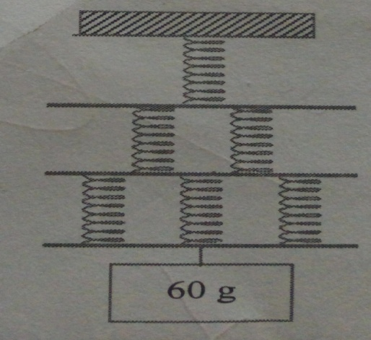
6. The figure shows six identical springs. If each spring stretches by 12mm when a mass of 60g hangs on it and that the connecting bars and springs have negligible masses, calculate the total extension in the set up (3 marks)

.…………………………………………………………………………………………………………………………………………………………………………………………………………………………………………………………………………………………………………………………………………………………………………………………………………………………………………….……
7. Define moment of a force and state its SI unit. (2 mark)
.…………………………………………………………………………………………………………………………………………………………………………………………………………………………
8. The speed of sound in air is 340m/s. A loud speaker placed between two walls A and B , but nearer wall A than wall B is sending out constant sound pulses. How far is the speaker from wall B if it is 200m form wall A and the time between the 2 echoes received is 0.176 seconds? (4mks)
………………………………………………………………………………………………………………………………………………………………………………………………………………………………………………………………………………………………………………………………………
9. State two conditions for equilibrium of a body which is acted upon by a number of forces. (2mks)
…………………………………………………………………………………………………………………………………………………………………………………………………………………………

10. Figure 3shows a uniform bar of mass0.8kg supported by a spring balance at its centre and the bar is at equilibrium.
////////////////////// support

Spring balance

0.8 m 0.6m

XN 24N

Figure 3
Determine the:
(a)value of X (3 marks)

.…………………………………………………………………………………………………………………………………………………………………………………………………………………………………………………………………………………………………………………………………………………………………………………………………………………………………………….……
(b) Reading of the spring balance (1mark)
.……………………………………………………………………………………………………………
11. Explain why the bottom of cooking vessels are usually blackened. (1mk)
……………………………………………………………………………………………………
12.A sphere of diameter 6.0 cm is moulded into a thin uniform wire of diameter 0.2mm. Calculate the length of the wire in meters. (3mks)
………………………………………………………………………………………………………………………………………………………………………………………………………………………….
……………………………………………………………………………………………………………
13. draw the magnetic field pattern in the diagram below. (2mks)
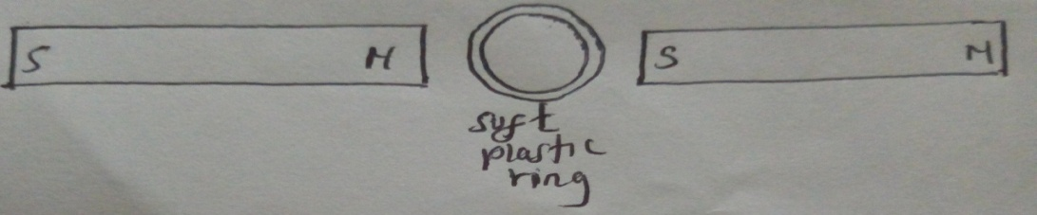
14. Distinguish between transverse and longitudinal waves giving an example of each. (2mks)
……………………………………………………………………………………………………………………………………………………………………………………………………………………………………………………………………………………………………………………………………..
15. Water is not a suitable thermometric liquid. State two reasons that justify the statement. (2mks)
………………………………………………………………………………………………………………………………………………………………………………………………………………………
16. The figure below shows a mercury barometer used to measure pressure.
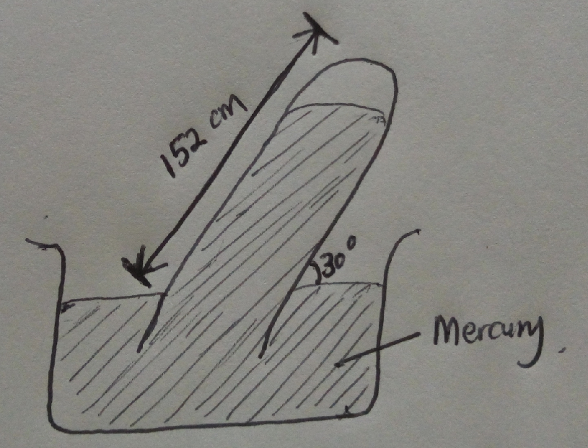

Using the information, determine the value of atmospheric pressure. (3mks)
……………………………………………………………………………………………………………………………………………………………………………………………………………………………………………………………………………………………………………………………………………………………………………………………………………………………………………………

SECTION B (60 marks)
17. a) the diagram below shows two plane mirrors placed at an angle of 60⁰ to each other. A ray is incident to one of the mirrors at an angle of 70⁰ to the mirror as shown

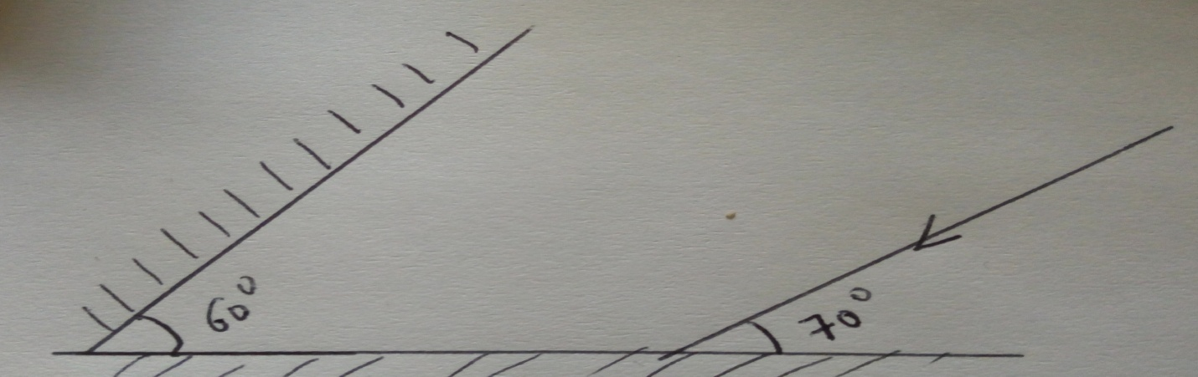

- State the laws of reflection (2mks)
………………………………………………………………………………………………………………………………………………………………………………………………………………………………………………………………………………………………………………
- Complete the path followed by ray show on the diagram above showing angles of incidence and reflection on the two mirrors. (3mks)
- State two properties of images formed by plane mirrors ( 2mks)
………………………………………………………………………………………………………………………………………………………………………………………………………………………………………………………………………………………………………………
- State the principle of reversibility of light. (1mk)
…………………………………………………………………………………………………………………………………………………………………………………………………………………………
b) If an object is placed in between the two mirrors, how many images will be formed. (2mks)
……………………………………………………………………………………………………………………………………………………………………………………………………………………………………………………………………………………………………………………………………………………………………………………………………………………………………………………
c) Why are plane mirrors not suitable for use as driving mirrors (1mk)
…………………………………………………………………………………………………………………………………………………………………………………………………………………………
d) a convex mirror of focal length 9cm produces an image on its axis 6cm from the mirror. Determine the position of the object. (3mks)
……………………………………………………………………………………………………………………………………………………………………………………………………………………………………………………………………………………………………………………………………………………………………………………………………………………………………………………

18 a) Define the term pressure stating its SI unit. (2mks)
…………………………………………………………………………………………………………………………………………………………………………………………………………………………
b) Explain why its not advisable to carry an ink pen with you to an aeroplane. (2mks)
…………………………………………………………………………………………………………………………………………………………………………………………………………........................
c) Calculate the pressure experienced by a diver 20 below a fresh water lake given the atmospheric
pressure above the lake surface is 103,000 N/m². (3mks)
…………………………………………………………………………………………………………………………………………………………………………………………………………………………………………………………………………………………………………………………………………………………………………………………………………………………………………………….

d) The figure below shows a U-tube filled with water, mercury and another liquid:
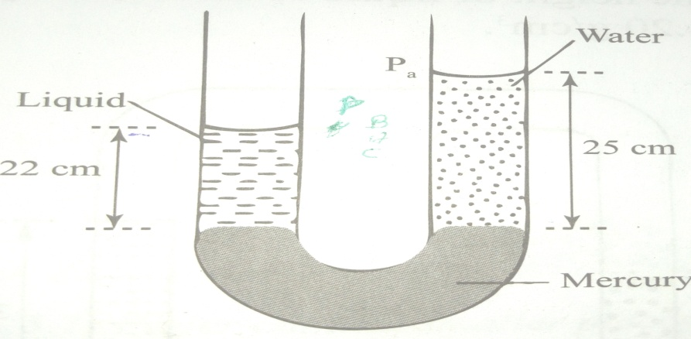

- Determine the density of the liquid (3mks)
…………………………………………………………………………………………………………………………………………………………………………………………………………………………………………………………………………………………………………………………………………………………………………………………………………………….

- State two factors affecting pressure in liquids (2mks)
………………………………………………………………………………………………………………………………………………………………………………………………………………………………………………………………………………………………………………………………………

19. The figure below shows the displacement-time graph for a wave:
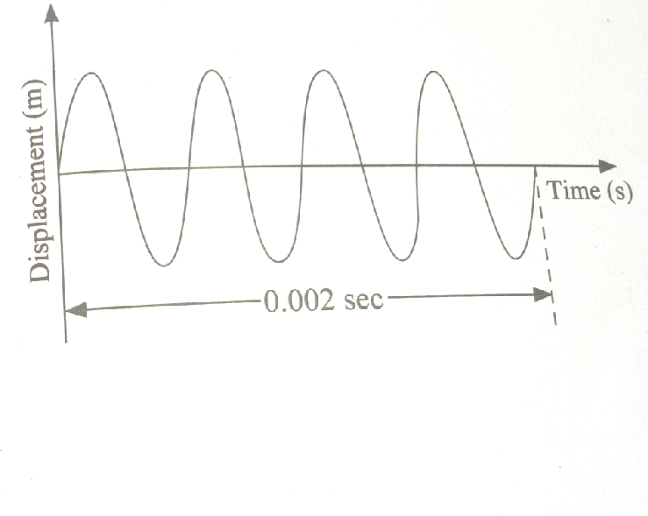

- What is the periodic time for the wave shown (2mk)
………………………………………………………………………………………………………………………………………………………………………………………………………………………….
- What is the frequency of the wave shown (3mks)
………………………………………………………………………………………………………………………………………………………………………………………………………….
- Draw on the same diagram, a wave form with twice the frequency and half the amplitude of the wave shown. (2mks)
- State two differences between electromagnetic and mechanical waves (2mks)
............................................................................................................................................................................................................................................................................................................................................................................................................................................................................................................................................................................................................................................................
e) Explain any 2 factors affecting velocity of sound in air (2mks)
……………………………………………………………………………………………………………………………………………………………………………………………………………………………………………………………………………………………………………………….
f) State two differences between sound and light waves (2mks)
…………………………………………………………………………………………………………………………………………………………………………………………………………………………………………………………………………………………………………………….

20.a) state Bernoulli’s principle (1mk)
…………………………………………………………………………………………………………………………………………………………………………………………………………
b) Explain why its dangerous to stand close to a railway line on which a fast moving train is passing. (2mks)
………………………………………………………………………………………………………………………………………………………………………………………………………….
…………………………………………………………………………………………………….

c) A bottle of soda stands on a bench. As the temperature of the surrounding rises the temperature of the bottle also rises. State and explain the effect of this on the stability of the bottle. (3 Mks)

………………………………………………………………………………………………………………………………………………………………………………………………………………………………………………………………………………………………………………………………………………………………………………………………………………………………………………………………………………………………………………………………………………………………………………………………………………………………

d) State the assumptions made in deriving the equation of continuity (3mks)
…………………………………………………………………………………………………
………………………………………………………………………………………………………………………………………………………………………………………………………….

21 a) state the right hand grip rule (1mk)
…………………………………………………………………………………………………………………………………………………………………………………………………………. …………………………………………………………………………………………………… b) explain how the magnetic strength of an electromagnet can be increased (4mks)
……………………………………………………………………………………………………………………………………………………………………………………………………………………………………………………………………………………………………………………………………………………………………………………………………………………

c) Draw the magnetic field patterns around the conductors shown indicating the direction of force. (3mks)

d) A solid weighs 16.5N on the surface of the moon. The force of gravity on the moon is
1.7N/kg. Determine the mass of the solid. (3 mks)
…………………………………………………………………………………….....
………………………………………………………………………………………..
…………………………………………………………………………………………

“SUCCESS”

