TERM 3 MIDTERM
PHYSICS FORM TWO
OCTOBER 2022
2 hours

SECTION A: (40 MARKS)
Answer all questions in this section in the spaces provided.

1. The figure below shows part of scale of a vernier caliper. Given the vernier caliper has a zero error of -0.02 and is has been used to measure the diameter of a ball. (2 mks)
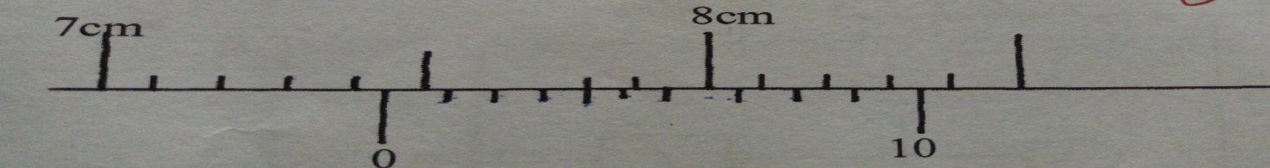
What is the radius of the ball?

Diameter=7.44+0.02=7.46
Radius =3.73cm

2. A pipe of radius 6mm is connected to another pipe of radius 9mm. If water flows in the wider pipe at 2m/s, what is the speed in the narrower pipe? (4mks)
A₁V₁ =A₂V₂
36 X V₁=81 X 2
V₁=4.5m/s

3. Distinguish between mass and weight of a body stating the SI unit for each. (2mks)
Mass is a measure of the quantity of matter in an object while weight is the measure of the pull of gravity on an object. SI unit of mass is kilogram and SI unit of weight is Newton
4. KBC transmits at frequency 106Hz. Given the speed of the radio waves is 3.0 X 10⁸, calculate the wavelength KBC transmits at. (3mks)

Wave velocity = wavelength x frequency
Wavelength =wave velocity / frequency = (3.0 x 10⁸)/106 000000=2.830m

5. Distinguish between streamline flow and turbulent flow in fluids. (2 marks)
Stream line flow is a fluid flow where every fluid particle passing through a given point has the same velocity and traces the same path while turbulent flow is a flow
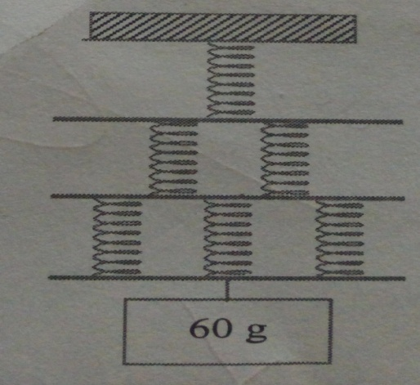
6. The figure shows six identical springs. If each spring stretches by 12mm when a mass of 60g hangs on it and that the connecting bars and springs have negligible masses, calculate the total extension in the set up (3 marks)

K=0.6/0.012=50N/m
Total extension= 12+6+4=22mm
7. Define moment of a force and state its SI unit. (2 mark)
It’s the product of force and the perpendicular distance from the pivot to the line of action of the force. SI unit is Nm
8. The speed of sound in air is 340m/s. A loud speaker placed between two walls A and B , but nearer wall A than wall B is sending out constant sound pulses. How far is the speaker from wall B if it is 200m form wall A and the time between the 2 echoes received is 0.176 seconds? (4mks)
T₁=(2 x200)/340, T₂=2x/340
T₂-T₁=0.176s
2x= 459.84
X=229.9m
9. State two conditions for equilibrium of a body which is acted upon by a number of forces. (2mks)
Sum of clockwise moments must be equal to sum of anticlockwise moments
Sum of upward forces must be equal to sum of downward forces
10. Figure 3shows a uniform bar of mass0.8kg supported by a spring balance at its centre and the bar is at equilibrium.
////////////////////// support

Spring balance

0.8 m 0.6m

XN 24N

Figure 3
Determine the:
(a)value of X (3 marks)

24 x 0.6 =0.8 x x
X= (24.6 x 0.6)/0.8 = 18N
(b) Reading of the spring balance (1mark)
18 +24+8= 50N
11. Explain why the bottom of cooking vessels are usually blackened. (1mk)
Dull surfaces are good absorbers of radiation
12.A sphere of diameter 6.0 cm is moulded into a thin uniform wire of diameter 0.2mm. Calculate the length of the wire in meters. (3mks)
Volume of sphere =4/3 x22/7 x3 x 3 x 3
Volume of wire = 22/7 x 0.001 x 0.001 x length
Length =3600m

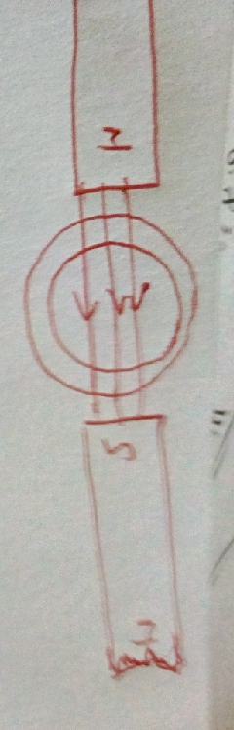
13. draw the magnetic field pattern in the diagram below. (2mks)

14. Distinguish between transverse and longitudinal waves giving an example of each. (2mks)
Transverse wave is a wave whose particles vibrate perpendicular to the wave motion e.g. water waves while longitudinal waves are waves whose particles vibrate parallel to wave motion e.g. sound waves
15. Water is not a suitable thermometric liquid. State two reasons that justify the statement. (2mks)
It wets glass
Its not easily visible
16. The figure below shows a mercury barometer used to measure pressure.
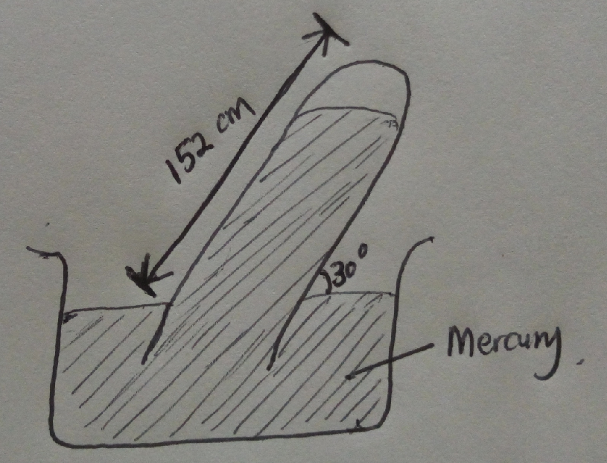

Using the information, determine the value of atmospheric pressure. (3mks)
P= height x density x gravity
P= 152/100 x sin 30 x 13600 x10= 103,360pa

SECTION B (60 marks)
17. a) the diagram below shows two plane mirrors placed at an angle of 60⁰ to each other. A ray is incident to one of the mirrors at an angle of 70⁰ to the mirror as shown

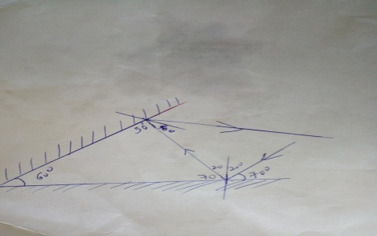

- State the laws of reflection (2mks)
At the point of incidence the incident ray the reflected ray and the normal all lie on the same plane.
The angle of incidence is equal to the angle of reflection
- Complete the path followed by ray show on the diagram above showing angles of incidence and reflection on the two mirrors. (3mks)
- State two properties of images formed by plane mirrors ( 2mks)
Virtual
Upright
- State the principle of reversibility of light. (1mk)
Light rays can trace back their own path

b) If an object is placed in between the two mirrors, how many images will be formed. (2mks)

n= (360/60)-1=5images
c) Why are plane mirrors not suitable for use as driving mirrors (1mk)
they have a narrow field of view

d) a convex mirror of focal length 9cm produces an image on its axis 6cm from the mirror. Determine the position of the object. (3mks)

V=-6,f=-9, 1/v=1/u+1/v, u=+18cm

18 a) Define the term pressure stating its SI unit. (2mks)

Pressure is force acting normally per unit area. SI unit N/m²
b) Explain why its not advisable to carry an ink pen with you to an aeroplane. (2mks)

at high altitudes pressure reduces and the increased ink pressure will make the pen spill its ink
c) Calculate the pressure experienced by a diver 20 below a fresh water lake given the atmospheric
pressure above the lake surface is 103,000 N/m². (3mks)

Pressure = height x density x gravity
20 x 1000 x10= 200,000N/m²
200,000+103,000
303,000pa
d) The figure below shows a U-tube filled with water, mercury and another liquid:
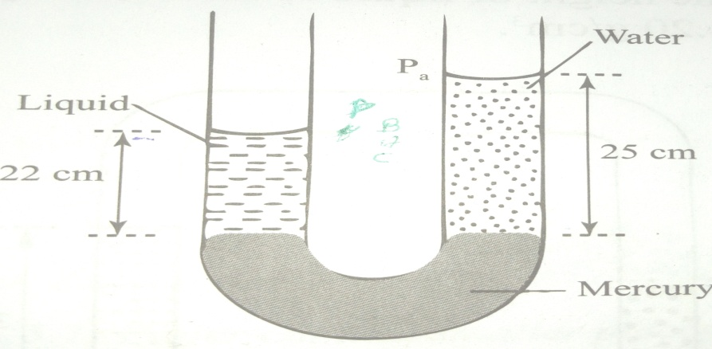

- Determine the density of the liquid (3mks)
Density of the liquid =25000/22

- State two factors affecting pressure in liquids (2mks)
Depth
Gravity
Density

19. The figure below shows the displacement-time graph for a wave:
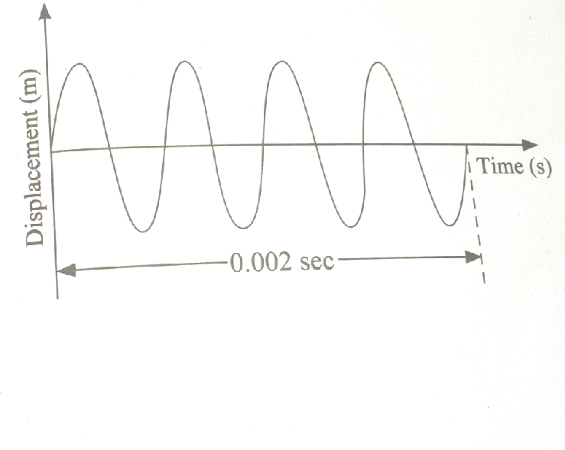

- What is the periodic time for the wave shown (1mk)
………………………………………………………………………………………………………………………………………………………………………………………………………………………….
- What is the frequency of the wave shown (2mks)
………………………………………………………………………………………………………………………………………………………………………………………………………….
- Draw on the same diagram, a wave form with twice the frequency and half the amplitude of the wave shown. (2mks)
- State two differences between electromagnetic and mechanical waves (2mks)
All Electromagnetic waves travel at the speed of light i.e 3.0 x 10⁸ but mechanical waves travel at varying speed.
Electromagnetic waves do not require a material medium for transmission while mechanical waves require medium for transimision
20. a) Explain any 2 factors affecting velocity of sound in air (2mks)
Temperature and humidity
At high temperatures sound travels faster than in low temperatures
The higher the humidity the faster the speed of sound.

b) state two differences between sound and light waves (2mks)
sound waves are longitudinal in nature while light waves are transverse in nature
sound waves are mechanical in nature while light waves are electromagnetic
- State the laws of reflection for sound (2mks)

21.a) state Bernoulli’s principle (1mk)
the sum of kinetic energy per unit volume, potential energy per unit volume and pressure is constant for a fluid

b) Explain why its dangerous to stand close to a railway line on which a fast moving train is passing. (2mks)
high velocity of air along the railway line results to low pressure hence high pressure from sorounding might push one to the railway line causing accidents

c) air flows over the upper surfaces of the wings of an aero plane at a speed of 12m/s. if the lift force on the aero plane is 2.97 x 10⁴ N, calculate the speed of the air past the lower surfaces of the wing. (take the total wing area to be 20.0m² and the density of air as 1.29kg/m³. (4mks)

d) State the assumptions made in deriving the equation of continuity (3mks)
flow is steady
fluid is non viscous
fluid is incompressible
22 a) state the right hand grip rule (1mk)
If a conductor carrying current is grasped in the right hand with the thumb pointing along the wire in the direction of the conventional current, the fingers will encircle the conductor in the direction of the magnetic field.
If a b) explain how the magnetic strength of an electromagnet can be increased (4mks)
Increasing number of turns
Increasing the current

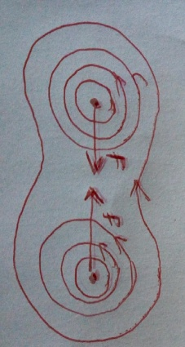
c) Draw the magnetic field patterns around the conductors shown indicating the direction of force. (3mks)

“SUCCESS”

