TERM 3 – 2022
121/1 MATHEMATICS FORM TWO PAPER 1
TIME: 2½ hours
Name: …………………………………………………… Adm No: ……………Class: ……………..
School: …………………………………………………. Date: ………………..Sign: ………………

Instructions
- Write your name, admission number and class in the spaces provided above.
- Sign and write the date of the examination in the spaces provided above
- This paper consists of two sections; Section I and Section II.
- Answer all the questions in Section I and any five questions from Section II
- Show all the steps in your calculations, giving your answers at each stage in the spaces provided below each question
- Marks may be given for correct working even if the answer is wrong.
- Non-programmable silent electronic calculators and Kenya National Examinations Council Mathematical tables may be used, except where stated otherwise.
- This paper consists of 16 printed pages.
- Candidates should check the question paper to ascertain that all the pages are printed as indicated and that no questions are missing.

For Official Use Only
Section I
1 | 2 | 3 | 4 | 5 | 6 | 7 | 8 | 9 | 10 | 11 | 12 | 13 | 14 | 15 | 16 | Total

Section II Grand Total
17 | 18 | 19 | 20 | 21 | 22 | 23 | 24 | Total

SECTION I (50 Marks)
Answer all the questions in this section
- George spends five-eighths of his salary on food, one-sixth of the remainder on school fees, two-thirds of what remains on contingencies and saves Kshs. 6,000. Calculate George’s monthly salary. (3 marks)

- (a) Find the GCD of 1240 and 860 (1 mark)

(b) Hence find the number of square tiles that can be used to cover a floor of dimensions 12.4 m by 8.6 m (2 marks)

- Without using a mathematical table or a calculator, find the values of $a$ and $b$ given that: (3 marks)
$$\frac{0.0168×2.46×7}{5.74×0.0112}=\frac{a}{b}$$

- Ten years ago, Mary was twice as old as her daughter Ruth. If the sum of their ages now is 56 years, calculate their present ages. (3 marks)

- Simplify the expression below (3 marks)
$$\frac{2x-3y+4x^{2}-6xy}{1-{4x}^{2}}$$

- A rectangular plot of land measures 120 m by 50 m. One of the longer sides has a wall already erected along it. The plot is to be fenced using chain link. One roll of chain link measures is 16 m long. A gate 6 m wide is left on one of the shortest sides. Calculate the number of rolls of chain link required to completely fence the plot. (3 marks)

- 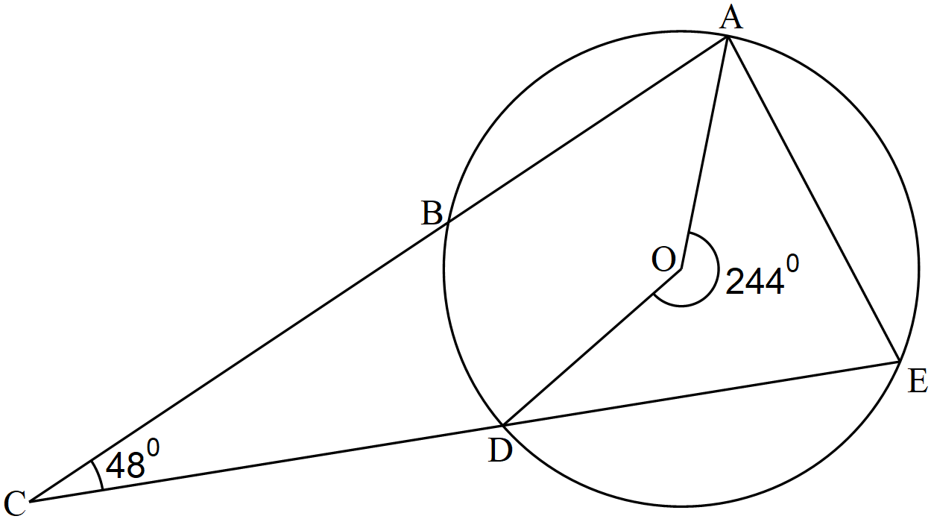In the figure below, O is the centre of the circle. The reflex ∠AOD=244⁰ and ∠BCD=480.

Calculate the size of ∠BDC (3 marks)

- The figure below shows a face and an edge of a triangular prism ABCDEF.

Complete the prism, labeling it accordingly and showing the hidden lines as broken. (2 marks)

- Use tables of logarithms only to evaluate (4 marks)
$$\sqrt[3]{\frac{0.2103\tan{{89.4}^{0}}}{{74.6}^{2}}}$$

- Evaluate without using mathematical tables (3 marks)
$${\left(125\right)}^{\frac{2}{3}}×{\left(\frac{625}{64}\right)}^{-\frac{1}{2}}$$

- A tourist arrived in Kenya with Great Britain Pounds (GBP) 8,640 all of which she exchanged into Kenya Shillings. He spend Kshs. 517,906 while in Kenya and converted the rest of the money into US dollars (USD). Use the exchange rates below to calculate the amount of money he received to the nearest USD. (3 marks)
Currency | Buying (Kshs.) | Selling (Kshs.)
1 GBP | 145.40 | 154.29
1 USD | 104.61 | 111.00

- Two similar cups have capacities of 1 litre and 343 cm³. The surface area of the smaller cup is 122.5 cm², calculate the surface area of the larger cup. (3 marks)

- The figure below shows the cross-section of a solid equipment used in a construction firm. It comprises of a circular hole of diameter 56 cm drilled on to a square of side 70 cm. The solid is 1.5 m long
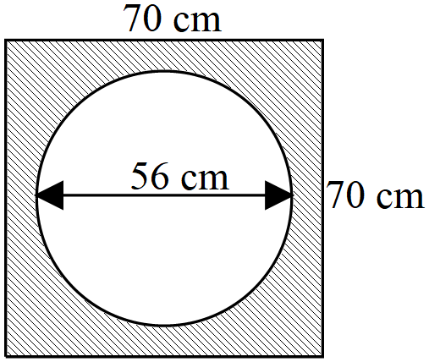

Calculate the volume of the solid in m³. Use $π=\frac{22}{7}$ (4 marks)

- Find the modulus of the $AB$ given that $a=-4i-7$j and $b=3i-8j$ correct to 2 decimal places. (3 marks)

- Use a ruler and pair of compasses only in this question.
Construct a trapezium PQRS such that PQ=7.4 cm, ∠PQR=105⁰, ∠SPQ=∠RSP=90⁰, PS=5.3 cm and PQ parallel to SR. (4 marks)

- Show on a number line the range of all integral values of x which satisfy the following pair of inequalities. (3 marks)
$$3-x≤1-\frac{1}{2}x$$
$$-\frac{1}{2}\left(x-5\right)<7-x$$

SECTION II (50 Marks)
Answer any five questions in this section
- Four schools, K, L, M and N are such that L is on a bearing of 055⁰ and a distance of 8.5 km from K. M is 7.2 km from L on a bearing of 144⁰. N is 5 km due south of M. A campsite P is due west of N and on a bearing of 159⁰ from K
- Using a scale of 1: 100,000 make a scale drawing to show the relative positions of K, L, M, N and P (5 marks)

- Use the scale drawing in (a) above to find:
- The distance between K and M (2 marks)

- The bearing on P from L. (1 mark)

- Show the position T of a communication mast installed such that it is equidistant from K, N and P. (2 marks)

- (a) The ratio $a: b = 2: 3$ and the ratio b: c = 2: 5. If the sum of the three quantities is 2,050, calculate the difference between quantities $c$ and $a$. (4 marks)

(b) Two business partners Eric and Bryan contributed Kshs. 100,000 and Kshs. 120,000 respectively to start a tech firm. They agreed that 30% of the proceeds from the firm would be shared in the ratio of their contributions and another 30% shared equally. At the end of the year, the business realized a profit of Kshs. 198,000
Calculate:
- The amount of money they shared (2 marks)

- The amount received by each. (4 marks)

- The figure below shows a solid drum that is in the shape of a frustum of a cone with top and bottom radii as 30 cm and 20 cm respectively. The drum is 45 cm high.
- Calculate the height of the original cone from which the drum was made. (2 marks)

- Calculate to 2 decimal places, the surface area of the drum. Use π = 3.142 (8 marks)

- Below are masses of students taken in a medical centre.
35 55 32 37 60 35 38
20 54 66 59 34 56 42
31 44 47 45 55 48 39
29 27 24 33 36 35 43
45 48 28 52 39 64 41

- Starting with the class 20 – 29 and class size of 10, make a frequency distribution table for the data. (2 marks)

- Calculate the mean mass (4 marks)

- (i) On the grid provided, draw a histogram to represent the data above (2 marks)

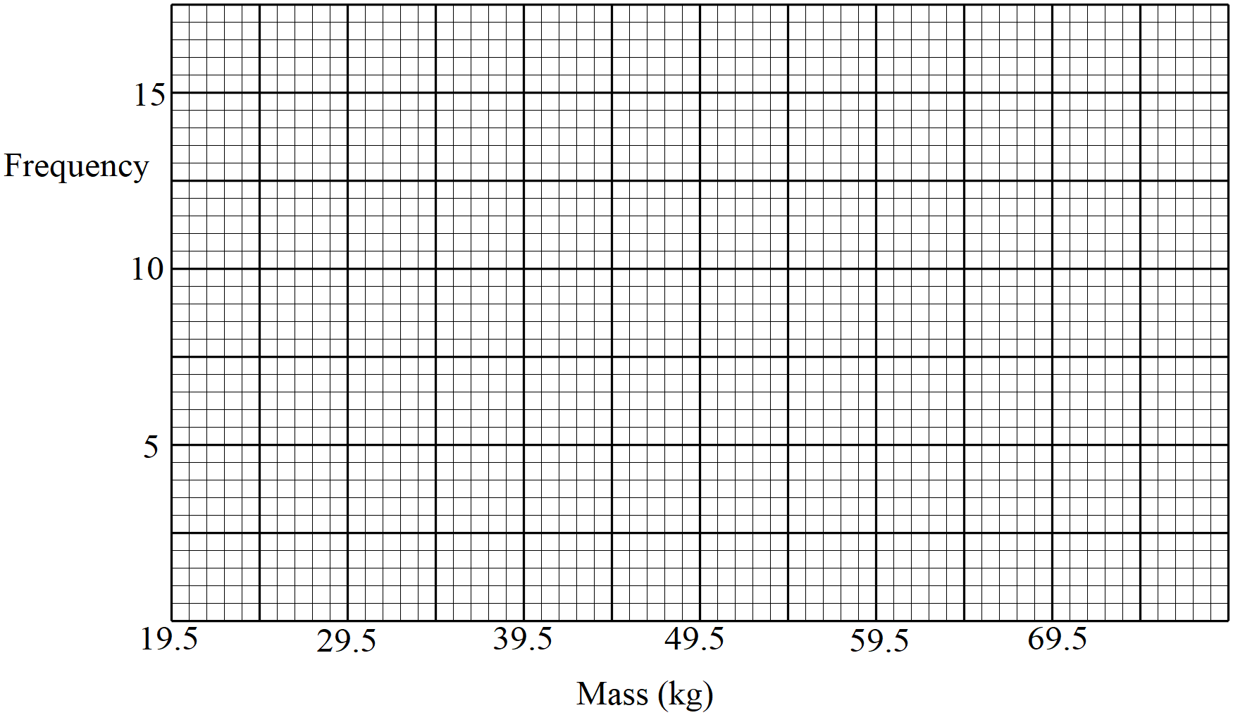

(ii) On the histogram, draw a line to estimate where the median mass lies. (2 marks)

- (a) Calculate the time in seconds it takes a bus 5 m long and moving with a speed of 60 km/h to go past a truck
15 m long and heading in the opposite direction with a speed of 50 km/h if the distance between the bus and the truck is 200 m (3 marks)

(b) A bus left Eldoret at 7.12 a.m. towards Nairobi at an average speed of 72 km/h. At 8.22 a.m., a car left Eldoret for Nairobi at an average speed of 100 km/h. The distance between Nairobi and Eldoret is 348 km.
Calculate:
- The time of the day when the car caught up with the bus. (4 marks)

- The distance from Nairobi where the car caught up with the bus. (3 marks)

- A youth group plans to buy a branding machine at a cost of Kshs. 72,000 by contributing equal amount of money. Before they contribute, 3 new members join the group, and as such each of the members has to contribute Kshs. 1,200 less.
- By taking $x$ as the original number of members of the group, write an expression for:
- The original amount to be contributed by each member (1 mark)

- The amount contributed by each member after the new members joined (1 mark)

- Find the total members who contributed. (6 marks)

- At the end of the year, the machine realized a profit Kshs. 337,500. The profit was shared equally among the members. Calculate the amount of money received by each member of the group. (2 marks)

- Triangle $T$ has coordinates $A(-2, -2)$, $B(-5, -5)$ and $C(0, -4)$. $T^{1}$ is the image of $T$ after a transformation $M$ such that $A'(2, 2)$, $B'(5, 5)$ and $C'(4, 0)$
- (i) On the same pair of axes, draw triangles $T$ and $T^{1}$ (2 marks)

(ii) Describe the transformation $M$ fully (2 marks)

- $T^{2}$ is the image of $T^{1}$after a rotation of +90⁰ about $(1, 1)$. Draw $T^{2}$ on the same axes and state its coordinates (3 marks)
- $T^{3}$ is the image of $T^{2}$ under a translation described by vector $\left(\begin{matrix}5 \\ -7\end{matrix}\right)$.
- Draw $T^{3}$ (2 marks)
- Which pair of the triangles exhibit opposite congruency? (1 mark)

- A straight line L₁ passes through the points $(-2, 8)$ and $(4, -4)$
- (i) Find the equation L₁ in the form $ax+by=c$, where $a$, $b$ and $c$ are integral values. (3 marks)

(ii) L₁ crosses the x-axis at point P, determine the coordinates of P. (2 marks)

- (i) Another line L₂ is perpendicular to L₁ through point P. Determine the y-intercept of L₂. (3 marks)

(ii) Determine the angle L₂ makes with the x-axis correct to 2 decimal places. (2 marks)

