TERM 3 – 2022
MATHEMATICS FORM 2
121/1
Paper 1
MARKING SCHEME

NO. | WORKING | MARKS | REMARKS
 | $$\frac{5}{8}→food$$  $$\frac{1}{6}×\frac{3}{8}=\frac{1}{16}→fees$$  $$1-\left(\frac{5}{8}+\frac{1}{16}\right)=\frac{5}{16}$$  $$\frac{2}{3}×\frac{5}{16}=\frac{5}{24}→contingencies$$  $$1-\left(\frac{5}{8}+\frac{1}{16}+\frac{5}{24}\right)=\frac{5}{48}$$  $$\frac{5}{48}→6,000$$  $$6,000×\frac{48}{5}$$  $$=Kshs. 57,600$$ | M1  M1  A1 | Fraction saved
 |  | 3
 | - GCD  $$1240=2^{3}×5×31$$  $$860=2^{2}×5×43$$  $$GCD=2^{2}×5=20$$  - Number of Tiles  $$\frac{12.4×8.6}{0.2×0.2}$$  $$=2,666 tiles$$ | B1  M1  A1
 |  | 3
 | $$\frac{0.0168×2.46×7×{10}^{6}}{5.74×0.0112×{10}^{6}}$$  $$\frac{168×246×7}{574×112}$$  $$\frac{2^{3}×3×7×2×3×41×7}{2×7×41×2^{4}×7}$$  $$\frac{2^{4}×3^{2}×7^{2}×41}{2^{5}×7^{2}×41}$$  $$\frac{3^{2}}{2}=\frac{9}{2}=4.5$$ | M1  M1  A1
 |  | 3

NO. | WORKING | MARKS | REMARKS
 | 10 years ago Now  Mary $$2x$$ $$2x+10$$  Ruth $$x$$ $$x+10$$  $$2x+10+x+10=56$$  $$3x+20=56$$  $$3x=56-20=36$$  $$x=12$$  $$Mary→2×12+10=34 years$$  $$Ruth→12+10=24 years$$ | M1  A1  B1 | Equating sum of current ages to 56  Value of $x$  Both ages correct
 |  | 3
 | $$\frac{2x+4x^{2}-3y-6xy}{1-{4x}^{2}}=\frac{2x\left(1+2x\right)-3y(1+2x)}{(1-2x)(1+2x)}$$  $$\frac{(2x-3y)(1-2x)}{(1-2x)(1+2x)}$$  $$\frac{2x-3y}{1+2x}$$ | M1  M1  A1 | Factorization of numerator  Factorization of denominator
 |  | 3
 | $$Perimeter=2×50+120-6=214 metres$$  $$Number of rolls=\frac{214}{16}$$  $=13.375$  $= 14 rolls$ | M1  M1  A1 | Expression for perimeter to be fenced  Expression for number of rolls  14 rolls seen
 |  | 3
 | $$ABD=\frac{1}{2}×{244}^{0}={122}^{0}$$  $$CBD={180}^{0}-{122}^{0}={58}^{0}$$  $$BDC={180}^{0}-\left({58}^{0}+{48}^{0}\right)={74}^{0}$$ | B1  B1  B1
 |  | 3

NO. | WORKING | MARKS | REMARKS
 |  | B1  B1  B1 | Completing the solid  Showing hidden lines  Correct labeling
 |  | 3
 | $$\sqrt[3]{\frac{0.2103\tan{{89.4}^{0}}}{{74.6}^{2}}}=\sqrt[3]{\frac{0.2103×95.49}{{74.6}^{2}}}$$  Number Std form Logarithm  $$0.2103$$ $$95.49$$ $$2.103×{10}^{-1}$$ $$9.549×10$$ $$\overline{1.}3228$$ $$1.9799$$  $$1.3027$$  $$74.6$$ $$7.46×10$$ $$1.8727×2$$ $$3.7454$$  $$\overline{3.}5573×\frac{1}{3}$$  $$0.1534$$ $$1.534×{10}^{-1}$$ $$\overline{1}.1858$$ | M1  M1  M1  A1 | Reject all if logs from calculator used  All logs correct i.e. $\overline{1.}3228$, $1.9799$ and $1.8727$ seen.  Correct addition and subtraction of logs i.e. $1.3027$and $\overline{3.}5573$ seen  Correct multiplication of logs by 2 and $\frac{1}{3}$ i.e. $3.7454$ and $\overline{1}.1858$ seen  $0.1534$ seen
 |  | 4

NO. | WORKING | MARKS | REMARKS
 | $${\left(125\right)}^{\frac{2}{3}}×{\left(\frac{64}{625}\right)}^{\frac{1}{2}}={\left(5^{3}\right)}^{\frac{2}{3}}×{\left(\frac{2^{6}}{5^{4}}\right)}^{\frac{1}{2}}$$  $$5^{2}×\frac{2^{3}}{5^{2}}$$  $$2^{3}=8$$ | M1  M1  A1 | Expressing in index form  Simplification
 |  | 3
 | $$145.4×8,640$$  $$=1,256,256$$  $$1,256,256-517,906=738,350$$  $$\frac{738,350}{111}=6,651.802$$  $$=USD 6,651$$ | M1  M1  A1 | Converting to Kshs.  Converting to USD  USD 6,651
 |  | 3
 | $$V.s.f=\frac{1000}{343}$$  $$A.s.f={\left(\sqrt[3]{\frac{1000}{343}}\right)}^{2}=\frac{100}{49}$$  $$\frac{100}{49}=\frac{x}{122.5}$$  $$x=\frac{100×122.5}{49}=250 {cm}^{2}$$ | M1  M1  A1 | Area scale factor
 |  | 3
 | $$Cross-sectional area=0.7×0.7-\frac{22}{7}×0.28×0.28$$  $=0.49-0.2464$  $=0.2436$  $$Volume=0.2436×1.5$$  $$Volume=0.3654 m^{3}$$ | M1  A1  M1  A1
 |  | 4
 | $$AB=b-a=\left(\begin{matrix}3 \\ -8\end{matrix}\right)-\left(\begin{matrix}-4 \\ -7\end{matrix}\right)=\left(\begin{matrix}7 \\ -1\end{matrix}\right)$$  $$\left|AB\right|=\sqrt{7^{2}+{(-1)}^{2}}$$  $=\sqrt{50}$  $=7.071$  $=7.07$ | B1  M1  A1 | $AB$ in column form or in terms of $i$ and $j$  Expression for modulus  7.07 seen
 |  | 4

NO. | WORKING | MARKS | REMARKS
 | 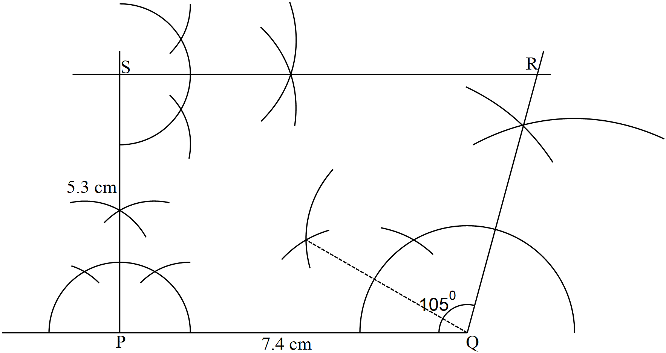 | B1  B1  B1  B1 | PQ = 7.4 cm ± 0.1 cm drawn  Construction of 90⁰ at P and S  Construction of 105⁰  Locating R/completing trapezium
 |  | 4
 | $$3-x≤1-\frac{1}{2}x$$  $$3-1≤-\frac{1}{2}x+x$$  $$2≤\frac{1}{2}x→4≤x$$  $$-\frac{1}{2}\left(x-5\right)<7-x$$  $$-\frac{1}{2}x+\frac{5}{2}<7-x$$  $$-\frac{1}{2}x+x<7-\frac{5}{2}$$  $$\frac{1}{2}x<\frac{9}{2}→x<9$$  $$4≤x<9$$  $$Integral values →4, 5, 6, 7 and 8$$ | B1  B1  B1
 |  | 3

NO. | WORKING | MARKS | REMARKS
 | - Scale drawing  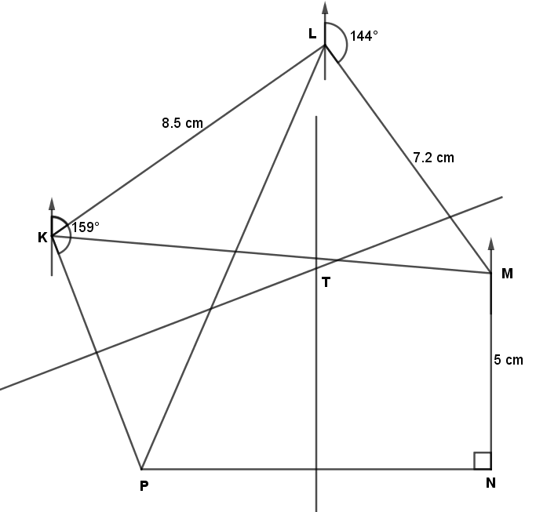  - Using scale drawing  - Distance K and M  $$11.2 cm±0.1$$  $$11.2 km±0.1$$  - Bearing P from L  $${204}^{0}±1^{0}$$  - Locating T | S1  B1  B1  B1  B1  B1  B1  B1  B1  B1 | Given scale  Locating L  Locating M  Locating N  Locating P  KM in cm  KM in km  Bearing (S24⁰W)  Bisecting PN and PK  Locating T
 |  | 10

NO. | WORKING | MARKS | REMARKS
 | - $a:b=2:3… ×2→4:6$  $$b:c=2:5… ×3→6:15$$  $$a:b:c=4: 6:15$$  $$\frac{15}{25}×2,050-\frac{4}{25}×2,050$$  $$1,230-328=902$$  - (i) Amount shared  $$\frac{30}{100}×198,000+\frac{30}{100}×198,000$$  $$59,400+59,400=118,800$$  (ii) Amount received  $$\frac{59,400}{2}=29,700$$  $$Ratio=100,000:120,000=5:6$$  $$Eric→29,700+\frac{5}{11}×59,400=56,700$$  $$Bryan→29,700+\frac{6}{11}×59,400=62,100$$ | M1  A1  M1  A1  M1  A1  M1  M1  A1  B1 | Multiplying $a: b$ by $2$ and $b: c$ by $3$  Ratio $a: b: c$ simplified  Sum of shared equally and shared in ratio  Amount received equally  Ratio of Eric: Bryan  Eric’s total  Bryan’s total
 |  | 10

NO. | WORKING | MARKS | REMARKS
 | - Height  $$\frac{h}{h+45}=\frac{20}{30}$$  $$30h=20h+900$$  $$30h-20h=900$$  $$10h=900→h=90 cm$$  $$Hence H=90+45=135 cm$$  - Surface Area  $$L=\sqrt{{135}^{2}+{30}^{2}}=15\sqrt{85}$$  $$l=\sqrt{{90}^{2}+{20}^{2}}=10\sqrt{85}$$  CSA=$3.142\left[\left(15\sqrt{85}×30\right)-(10\sqrt{85}×20)\right]$  CSA=3.142$\left[4148.795006-1843.908891\right]$  CSA=3.142×2304.886115  CSA=7241.95  Top = 3.142×30×30=2,827.8  Bottom = 3.142×20×20=1256.8  Total $= 7241.95+2,878+1256.8$  Total = 11,326.55 | M1  A1  M1  M1  M1  A1  M1, M1  M1  A1
 |  | 10

NO. | WORKING | MARKS | REMARKS
 | - Frequency distribution table  Mass Tally $$f$$ $$x$$ $$fx$$  20 – 29 //// 5 24.5 122.5  30 – 39 //// //// // 12 34.5 414  40 – 49 //// //// 9 44.5 400.5  50 – 59 //// / 6 54.5 327  60 – 69 /// 3 64.5 193.5  Ʃ$f$=35 Ʃ$fx$=1457.5  - Mean  $$Mean=\frac{Ʃfx}{Ʃf}=\frac{1457.5}{35}$$  $$Mean=41.64$$  - Histogram  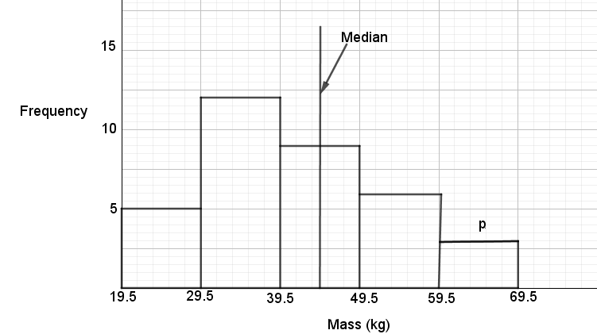  $$T. Area=10×5+10×12+10+10×9+10×6+10×3$$  Total area = 350 hecatres  $$Median=350÷2=175$$  $$50+120=170$$  $$175-170=5$$ | B1  B1  B1  M1  A1  B1  B1  B1  M1  A1 | All classes  All $f$ correct  All $fx$ correct  Expression of mean
 |  | 10

NO. | WORKING | MARKS | REMARKS
 | - Total distance $= 5+15+200=220 m$  $$Relative speed=60+50=110 km/h$$  $$Time=\frac{0.22 km}{110 km/h}×3,600$$  $=7.2 seconds$  - (i) 8.22 a.m. – 7.12 a.m. = 1 hr 10 minutes  $Bus→72×1\frac{1}{6}=84 km$  $Relative speed=100-72=28 km/h$  $$Time=\frac{84}{28}=3 hours$$  Time of the day = 8.22 a.m. + 3 hours = 11.22 a.m.  (ii) Bus distance$→3×100=300 km$  $$384-300=84 km$$ | M1  M1  A1  M1  M1  M1  A1  M1  M1, A1 | Total distance and relative speed  Expression for time  Time in seconds  Distance between them at 8.22  Relative speed  Duration to catch up
 |  | 10

NO. | WORKING | MARKS | REMARKS
 | - (i) – Before  $$\frac{72,000}{x}$$  (ii) – After  $$\frac{72,000}{x+3}$$  - Value of $x$  $$\frac{72,000}{x}-\frac{72,000}{x+3}=1,200$$  $$\frac{72000\left(x+3\right)-72000x}{x\left(x+3\right)}=1,200$$  $$\frac{72,000x+216,000-72,000x}{x^{2}+3x}=1,200$$  $$216,000=1,200(x^{2}+3x)$$  $$x^{2}+3x-180=0$$  $$x^{2}+15x-12x-180=0$$  $$x\left(x+15\right)-12\left(x+15\right)=0$$  $$\left(x-12\right)\left(x+15\right)=0$$  Either $x-12=0$ hence $x=12$  Or $x+15=0$ thus $x=-15$ (discriminate)  Hence number $= 12+3=15$  - Profit  $$\frac{337,500}{12+3}$$  $$= 22,500$$ | M1  M1  M1  M1  M1  A1  B1  M1  A1 | Amount before  Amount after  Expression for difference  Quadratic equation formed  Factorization  Both values seen  15 seen
 |  | 10

NO. | WORKING | MARKS | REMARKS
 | - (i) $T$ and $T^{1}$  (ii) $M$ described  - Rotation  $$T^{2}$$  $A^{''}\left(0, 2\right), B^{''}(-3, 5)$ and $C''(2, 4)$  - Translation  - $T^{3}$  - $T$ and $T^{1}, T^{1} and$ $T^{2}$, $T^{2} and$ $T^{3}$ | B1  B1  B1  B1  B1  B1  B1  B1  B1  B1 | Drawing $T$  Drawing $T^{1}$  Reflection  Along y+x=0  Rotation about (1, 1)  Drawing $T^{2}$  Coordinates of $T^{2}$  Translation  Drawing $T^{3}$  Pairs of opposite congruency
 |  | 10
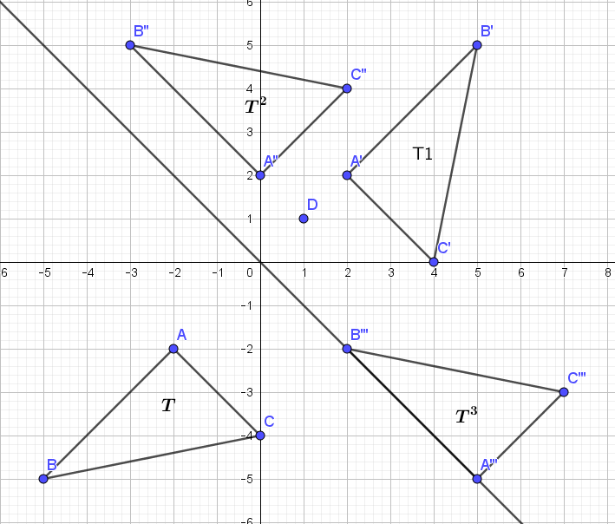
NO. | WORKING | MARKS | REMARKS
 | - Equation of L₁  - Equation of L₁  $$m_{1}=\frac{8-\left(-4\right)}{-2-4}=-2$$  $$-2=\frac{y-(-4)}{x-4}$$  $$-2=\frac{y+4}{x-4}$$  $$-2x+8=y+4$$  $$8-4=y+2x$$  $$2x+y=4$$  - Coordinates of P  At $P→y=0$  $$2x=4$$  $$x=2$$  Hence $P(2, 0)$  - (i) $y-$intercept of L₂  $-2m_{2}=-1$  $$m_{2}=\frac{1}{2}$$  $$Consider m_{2}=\frac{1}{2}, P\left(2, 0\right)$$  $$y=mx+c$$  $$0=\frac{1}{2}×2+c$$  $$0=1+c→c=-1$$  $$Hence→y=\frac{1}{2}x-1$$  $$y-intercept=-1$$  (ii) Angle of L₂ with x-axis  $$\tan{θ=\frac{1}{2}}$$  $$θ=\tan^{-1}\left(\frac{1}{2}\right)$$  $$θ={26.57}^{0}$$ | M1  M1  A1  M1  A1  M1  M1  A1  M1  A1 | Gradient of $L_{1}$  Equating $m_{1}$ to gradient  $2x+y=4$ seen  $$2x+0=4$$  In coordinate form  Gradient of $L_{2}$
 |  | 10

