NAME…………………………………………………………ADM….……….CLASS…..…….

PHYYSICS FORM 1
MID TERM 3, 2022
TIME: 2¹/₄ HOURS
Instructions to the student
- Answer all the questions in the spaces provided
- The paper consists of section A and B containing 50marks and 50marks respectively
Section A
- Explain one factor that affects heat transfer in solids. (2marks)

- a) The figure below shows a u-tube containing the liquids X and Y. Given that the density of liquid X is 1.8g/cm³, calculate the density of liquid Y in g/cm³. (3 Marks)
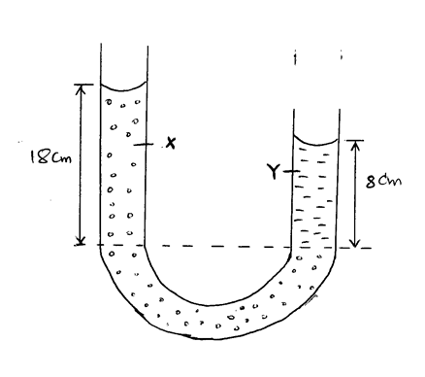

- Name one factor that affects surface tension. (1mark)

- When a liquid is heated in a glass flask, its level first falls and then starts rising. Explain this observation. (2 Marks)

- a) State two branches of physics. (2 Marks)

- 5 images are formed when two mirrors are inclined at an angle between them. Determine the angle of inclination. (2mks)

- The figure 1 below shows the image behind a mirror M
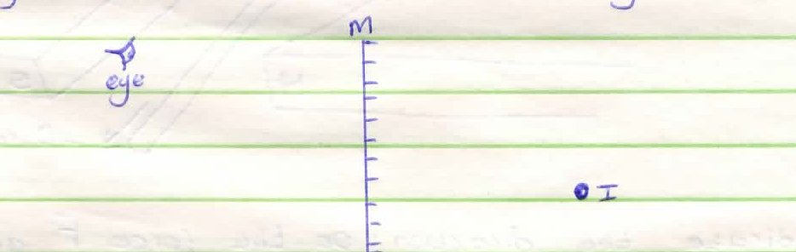
Using a ray diagram, locate the position of the object. (2mks)
- A negatively charged rod is brought near the cap of a leaf electroscope. The cap is then earthed momentarily by touching with a finger. Finally the rod is withdrawn. State and explain the observation made. (2mks)

6.a) State any two factors that determine the choice of instrument for measuring length. (2mks)

b) State how heat losses by convection and radiation are minimized in a thermos flask. (2mrks)

c) Use kinetic theory of matter to differentiate between solids and liquids. (2mks)

7. Sketch on the axes provided, a graph to show how mass per unit volume of water varies with temperature when water is heated from 0⁰C to 20⁰C (2mrks)
Mass per unit volume(g/cm³)

Temperature (⁰C)
8. Two identical spheres A and B each standing on an insulating base are in contact. A negatively charged rod is brought near sphere A as shown below
In what way will A differ from B if separated while the rod is near? Explain. (2mks)

9. Distinguish between a real and a virtal image. (2marks)

10. State the reading in seconds indicated on the digital stopwatch shown in the figure below.(2 marks)

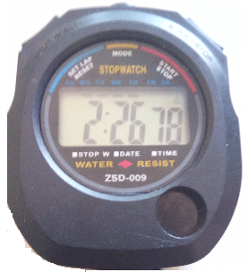

- a) A mixture consists of 80cm³ of water and 120cm³ of liquid X. If the density of water and liquid X are 1.0g/cm³ and 0.8g/cm³ respectively. Calculate the density of the mixture.(3 mks)

(b) (i) Why is mercury more suitable for use in a simple barometer than water. (2 mks)

(ii) Determine the pressure exerted at the bottom of a lake which is 60m deep, if the density of sea water is 1030kg/m³. (g=10N/Kg) (2 mks)

- The figure below shows a ray of light incident on a mirror.
42⁰
Mirror

Determine the angle of reflection when the mirror is rotated 10⁰ anticlockwise. (2 marks)

13a) State two characteristics of images formed by plane mirrors (2mks)

- Differentiate between a vector and a scalar quantity (2marks)

14. The figure below shows two plane mirrors inclined at an angle of 40⁰ to one another. A ray of light strikes the bottom mirror at an angle of 50⁰ to the horizontal as shown on the diagram.
40⁰
50⁰

On the same figure, sketch the path followed by the ray. (2 marks)

15. a) State three uses of a gold leaf electroscope (3marks)

b) State two methods of charging a body (2marks)

SECTION B (50marks)

- An elephant weighs 5000kg. Determine the pressure it exerts on the ground if its area of contact with the ground is 0.00025m³. (3 marks)

18a) Define matter (1mark)

b) Smoke particles in air when strongly illuminated were observed to describe continuous, random movements. State and explain what would be observed when temperature of air is decreased. (2 marks)

- The figure below shows an arrangement to demonstrate diffusion through solids:-

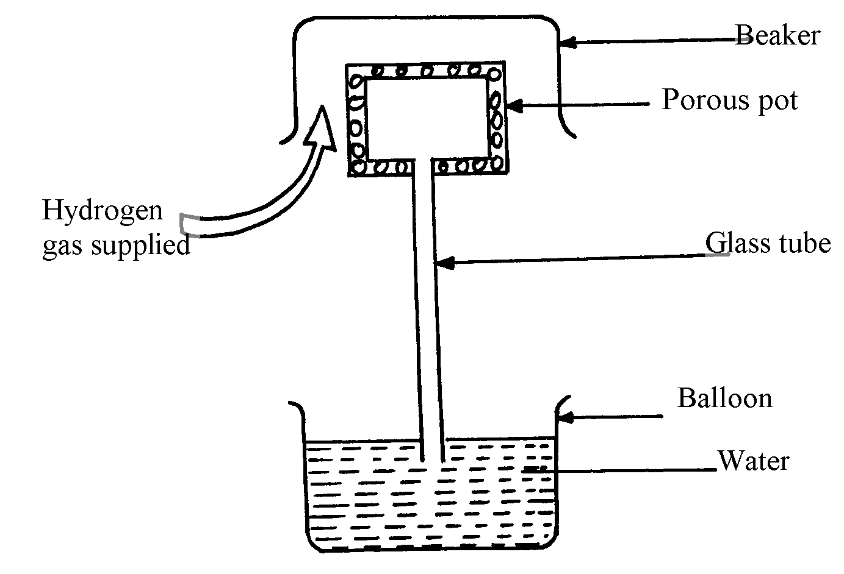

Beaker

The hydrogen gas is supplied for sometimes then stopped. State and explain what is likelyto be observed when the hydrogen gas supply is;
- turned on (2 marks)

ii) turned off (2 marks)

- The water level in a burette is 30.6cm³, 50 drops of water each of volume 0.2cm³ are added to the water in the burette. What is the final reading of the burette? (2 marks)

- Distinguish between temperature and heat as used in physics (2mrks)

19. a) Define the following terms giving their SI units (6mks)
- Density

- Area

- Pressure

b) Distinguish between Luminous and non-luminous sources of light (2mks)

c) Distinguish between the two types of reflection (2marks)

20. a) State the law of Electrostatics (1mark)

b) Briefly explain the following:
i) An atom is said to be electrically neutral (1mark)

ii) Dam walls are thicker at the bottom than at the top (1mark)

c)State the two laws of reflection (2mrks)

21. a) Distinguish between a basic physical quantity and a derived physical quantity giving an example of each. (4mrks)

b) An electric heater is placed at equal distances from two similar cans A and B filled with water at room temperature. The outer surface of can A is shiny while that of can B is dull black. State with reasons, which of the cans will be at higher temperature after the heater is switched on for some time (2mrks)

c) Define the term magnification as used in physics (1mrk)

d) A building standing 100m from a pinhole camera produces on the screen of the camera an image 5 cm high 10 cm behind the pinhole. Determine the actual height of the building.(3 marks)

22. a) Distinguish between cohesive and adhesive forces(2mrks)

b) The figure below is a simple hydraulic machine used to raise heavy loads.
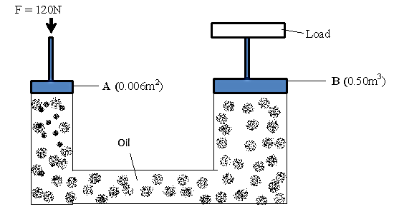

Calculate;
(i) The pressure exerted on the oil by the force applied at A (2marks)

(ii) The load raised at B (2marks)

(iii) Give two properties which make the oil suitable for use in this machine (2marks)

(c) The height of a mountain is 1360m. The barometer reading at the base of the mountain is 74cmHg. Given that the densities of mercury and air are 13,600Kgm⁻³ and 1.25Kgm⁻³ respectively, determine the barometer reading at the top of the mountain. (3marks)

