PHYSICS
FORM 1 MARKING SCHEME
MID TERM 3, 2022
- Length of the conductor
Cross sectional area,
Temperature difference of the source
Nature of the material making the conductor
- A) $ρ_{x}h_{x}g=ρ_{x}h_{x}g$
$ρ_{x}h_{x}$ =$ρ_{x}h_{x}$
$1.8g/cm^{3} ×18cm=ρ_{y}×8cm$
$$ρ_{y}=\frac{1.8×18}{8}$$
${ ρ}_{y}=4.05g/cm^{3 }$
- Temperature
- Impurities
- The level first dropped due to expansion of glass 1
The level then started rising when the heat reaches that of the water. 1
- a) Mechanics ,physics teacher
- 5 + 1 = 360
Ѳ

Ѳ = 360 = 60⁰
6
4.
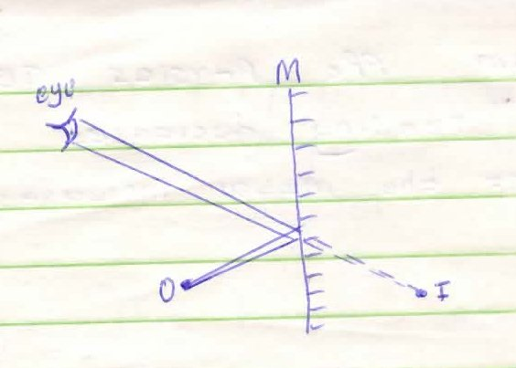
5. On earthing negative charges are repelled to the ground. When the rod is withdrawn, the leaf is left with a net positive charge. The leaf rises.

6a) Accuracy desired/or of the instruments
Size of the length to be measured

b) Convection- having a vacuum between double walls
Radiation – shinny/ silvery walls

- Solids have strong attractive force between its molecules in a regular close parking giving it a rigid structure while liquids have weak attractive forces holding particles hence far apart making them compressible.
Solid particles vibrate in a fixed position while liquid molecules are in Brownian motion hence diffuse and do work like dissolving a faster than solid molecules
7.

Mass per
Unit volume
(g/cm³)

4⁰C Temperature (⁰C)
8. A will have positive charge while B negative; when charged rod is brought near A positive charges are attracted towards it while the negative charges are repelled to B, on separation while strip is near A, B goes with negative charge and A remains with the positive;
9) Real image – formed on the screen. ½
Virtual image – cannot be formed on the screen. ½
10. Time = 2 x 60 + 26 + 0.78
= 146.78.75s
11a) m_{w} = 80 x 1 = 80g
M_{x} = 0.8 x 120 = 96g
Total mass = 176g
ρ_{mix} = $\frac{Total mass}{Total volume}$
= $\frac{176}{200}$ = 0.88g/cm³
b.i) Mercury is much denser than water.
Therefore the column supported by the atmospheric pressure is much shorter
(ii) p = ρhg
= 1030 x 60 x 10
= 6.18 x 10⁵ N/m²
12. Initial angle of incidence = 90⁰ – 42⁰ = 48⁰
Li = Lr = 48⁰ – Initial angle of reflection.
- New angle of incidence = 48⁰ + 10⁰= 58⁰
Angle of incidence = Angle of reflection = 58⁰
13a) Virtual, laterally inverted, same size as the object
b) Vector- Has both magnitude and direction
Scalar- Has only magnitude
14.
40⁰
50⁰

15. a)To identify the charge on a body
Testing insulating properties of a material
Testing the quantity of charge on a body
- Induction, Contact, Separation and rubbing/friction
SECTION B (50Marks)
17. P= F/A
P=50000 ;
0.00025
P= 2.0 x10⁸pa
18. a) Anything that occupy space and has weight/mass;
b) The speed of the particles decreases; this is due to reduced kinetic energy;
i) Gas bubbles are observed; hydrogen gas diffuses into the porous pot driving air out through glass tube;
ii) Water rises up the glass tube; Partial vacuum is created as hydrogen gas diffuses out faster than the diffusion of the air into the porous pot.;

- Volume of water added
= 0.2 × 50 = 10
= 30.6 + 10
= 40.6 cm³
- Degree of hotness or coldness of a place while heat is a form of energy transferred form one body to another by temperature difference
19. a) Define the following terms giving their SI units (6mks)
- Density
Mass per unit volume SI unit (kilogram per cubic metre)
- Area
Extent of a surface- SI unit -square metre (M²)
- Pressure
Force acting perpendicularly per unit area. SI unit Newton square metre N/m²
b) Distinguish between Luminous and non-luminous sources of light (2mks)

Sources that produce their own light while non- luminous are sources that rely on bounced source of light.
c) Distinguish between the two types of reflection (2marks)
Regular the rays of light strike a smooth surface while irregular rays strike a rough source.
20. a) State the law of Electrostatics (1mark)
Like charges repel while unlike charges attract.
b) Briefly explain the following:
i) An atom is said to be electrically neutral (1mark)
Numbers of positive charges are equal to the number of negative charges in an atom
ii) Dam walls are thicker at the bottom than at the top (1mark)
A thicker base provides a large area thus low pressure at the bottom preventing the dam from bursting.
c) Angle of incidence equals angle of reflection
Reflected ray, incidence ray and the normal all lie in the same plane.
21. a) Basic quantity cannot be obtained by other means eg mass, length while derived are obtained by either multiplication or division area density
b) Can B dull materials absorb heat will shiny reflect away heat
c) Ratio of size of image to the size of the object
d)u =100m
hi= 0.5cm
v=10cm
v/u = hi/h₀∴ho = hi x u/v
= 5m x ^{100m}/_{10cm}
h₀=50m
22a) Cohesive force of attraction of molecules of same kind while adhesive force is the force of attraction of molecules of different kind (2mrks)

b) (i) P = ^{F}/_{A} = ¹²⁰_{/0.006 = 20,000Nm}⁻²
(ii) F = P x A = 20,000 X 0.50
= 10,000N
(iii)
- Should be incompressible
- Should be non-corrosive
- Should have high boiling point and low melting point
(c) h₁ρ₁g =h₂ρ₂ g
1360 x 1.25 = ^{(74 – x)}/₁₀₀X 13600
x = 61.5cm

