**CHEM FORM 3 PP1 MARKING SCHEME**

1.a)Ionization energy is the energy required to remove an election from ✓ 1 atom in gaseous

state while electron affinity is the energy required by an atom ✓ 1 to require an electron in gaseous state.

b)B is higher / greater ✓ ½ than A because A is smaller atom therefore its nuclear attract electrons strongly ✓ ½

2. i)

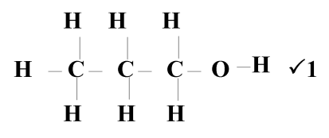

ii) Dehydration ✓1

iii) C6H12 ✓1

3.a) Covalent bond ✓1

b) Giant atomic structure ✓1

c)Hard ✓1 high density // high melting points Silicon and oxygen ✓1 atoms are compactly held by strong covalent bonds throughout its structure

4. Add ✓ ½ excess lead (II) carbonate to dilute nitric (V) acid

- Filter ✓ ½ to remove excess ✓ ½ unreacted lead (II) carbonate

- Add ✓ ½ dilute hydrochloric acid to the filtrate

- Filtre ✓ ½ and dry✓ ½ the residue

5a) The rate of diffusion of a gas is inversely ✓1 proportional to the square root of its density

provide temperature and pressure are kept constant

b) 

6.

|  |  |
| --- | --- |
| Fe | O  **2:3**  **Fe2O3** |
| 7 | 3      ½  1.5 |

2 Fe2 O3(s) + 3 C(s) 4 Fe(s) + 3 CO2(g)🗸

7a)A: Sublimation🗸

B: Deposition🗸

8.a)Measure of acidity or basically of an aqueous solution🗸 (1mk)

b) B🗸 ( 1mk)

c) 10 ( 1mk)

10. (a) (i) Ionic bond ✓1

(ii) Covalent bond ✓1

(b) T ✓ ½ and W ✓ ½ (a)

11.2H2O2(aq) 2H2O(l) + O2(g) ✓1

- U.B eqn. – zero mk

- Penalise ½ mk for wrong or missing s.s

(b) Manganese (IV) oxide ✓1

(c) - Used in welding and cutting metals as oxyacetyline/ oxyhydrogen.

- Used to remove Iron impurities during steel making (Any 1 x 1mk) a)

12.a)On the diagram ( left hand electrode)

b) Pb(s) Pb2+(aq)+2e 2e- Pb2+(l) + 2e- Pb(s)

c) Extraction of metals

13.(a) CO2

(b) 2NaHCO3(s) Na2CO3(s) + CO2(g) + H2O(g)

(c) making glass, softening hard water

14.(i) Yellow lead (II) oxide turned to red then grey.

(ii) I. H2(g) + PbO(s)  H2O(l) + Pb(s)

II. 2H2(g) + O2(g)  2H2O(l)

(iii) Reducing properties of hydrogen

Combustion nature of hydrogen

15.(a) Physical change ½ mk

(b) Chemical change

(c) physical change

(d) chemical change

16.a) Rusting

b)has water of crytalization

c) painting,electroplating,anodizing,Gavaization

16.(i) U

(ii) Molecular

(iii) X is smaller than W

17.. i) a) D 1mark

b) C 1mark

ii) B 1mark

19..a) A – fumes of colourless gas observed. Green solid turns black

B – White precipitate is observed 1mark

b) CuCO3 (g) CUO(s) + CO2(g) ✓1

20.

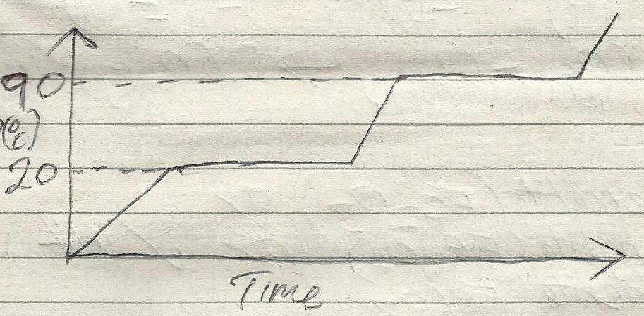

21i) A: carbon reacts with excess air to form carbon(iv) oxide ½ mark

C(s) + O2 (g) CO2(g) ½ mark

B: Carbon (iv) oxide is reduced to

Carbon (ii) oxide by hot carbon ½ mark

C(s) + CO2 (g) 2CO(g) ½ mark

ii) Carbon (iv) oxide causes global warming 1mark

22.

|  |  |  |  |
| --- | --- | --- | --- |
|  | Na2SO4 | H2O | ½  ½  ½ |
| Mass  RFM  Moles  Divide by smallest No. | 1.42  142      1 | 1.8✓  18  ✓  ✓  10 |

X = 10 ✓ ½ (2 mks)

23.(a) (i) S16 = 2.8.6 (1 mk)

(ii) S12 = 2.8.2 (1 mk)

(b) (i) Neutron – 14 ( 1 mk)

(ii) Electron - 10 ( 1 mk)

24.(i) At constant temperature the volume is inversely proportional to the pressure Formula

Vd  (1 mk)

(ii) P1V1 = P2V2 ✓ ½

12 X1 = 2.5 X V2 ✓ ½

V2 = ✓ ½ = 4.8 litres ✓ ½ (2 mks)

25a) Sample I is a pure substance since pure substance have a sharp melting and boiling points. (1mk)

Sample II is impure since the melting point is lower than that of a pure substance and its boiling point is higher than that of pure substance which is characteristic phenomena of an impure substance. (1mk)

b) Since ice causes skidding, common salt becomes an impurity to water (ice) causing it to melt at a lower temperature. .(1mk)

26a)

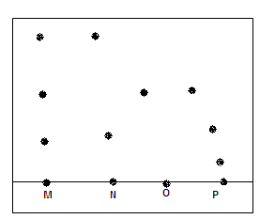

b) M has N and O (1)

a) P

27.a) X- fractionating column (1mk)

Y- Liebig condenser

b) to condense back the component of higher boiling point. (1mk)

c) shown on the diagram (1mk)