PANGANI POST MOCK EXAMINATION
2022
MARKING SCHEME

INSTRUCTIONS TO CANDIDATES
- Write your name and index number in the spaces provided above.
- Sign and write the date of examination in the spaces provided above.
- Answer ALL the questions in the spaces provided.
- Mathematical tables and electronic calculators may be used.
- All working MUST be clearly shown where necessary.

FOR EXAMINERS USE ONLY

Questions | Maximum Score | Candidate’s Score
1 – 28 | 80

This paper consists of 14 printed pages.
Candidates should check the question paper to ensure that all the
Pages are printed as indicated and no questions are missing.

1. a) A hydrocarbon consists of 92.3% carbon. Its molecular mass is 26. Calculate it’s
Molecular formula. (2mks)
C H
92.3 77 E.F = CH ½
12 1
7.69 7.77 ½(CH)n = 26 13n=26
7.69 7.69 n=2
1 MF=C₂H₂√½

b) Draw the structure of the hydrocarbon. (1 mk)

H-C=C-H

2. a) Explain why melting point of chlorine gas is greater than that of Argon. (lmk)
Chlorine has stronger Van der waals forces than argon which is mono-atomic
b) Using dot() and cross (×) to represent electrons draw a diagram to show bonding in
carbon (iv) oxide. (lmk)

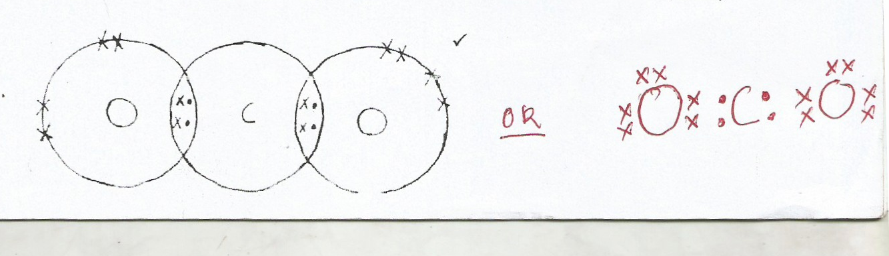

c) In terms of structure and bonding.Explain why Graphite is used as a lubricant. (1 mk)
It has layers in its structures joined by weak ‘van der waals forces which slide over
each other.
3. a) What is observed when a few drops of phenolphthalein indicator is added to a solution
whose pH value is 3.0? (lmk)
The solution is colourless.

b) Write an equation for the reaction between Lead (ii) oxide and dilute Nitric acid.
(lmk)
PbO_{(s)} + 2HNO_{3(aq)}Pb(NO₃)_{2(aq)} + H₂O_{(l)}

4. State and explain the observation that would be made when zinc powder is heated with
copper (II) oxide. (2 mks)
Colour changes from grey to yellow
Colour changes from black to brown.
Zinc oxidized to ZnO//CuO reduced to Cu// Zinc is higher in reactivity,
Reject displacement.

5. Why is it dangerous to run a motor car engine in a closed garage? (2mks)
Due to incomplete combustion CO is produced √1 This gas is poisonous√1
6. 2 grams of sodium hydroxide is added to 30 cm3 of IM sulphuric (VI) acid. What volume
of 0. 1M potassium hydroxide solution will be needed to neutralize the excess acid.
(Na23,016,H1) (3 mks) 1 mole of NaOH => 40g
2g
1 x 2
40 0.05 mole
Original concentration of H₂SO₄
1000cm³=> 1 mole
30cm = 30x1
1000
=0.03 moles
Moles of acid reacted with NaOH
Mole ratio of NaOH: H₂SO₄
2 : 1
But 2 => 0.05 moles
1 =1x 0.05
2
=0.025 moles
Moles of acid reacted with KOH
0.03-0.025 =0.005 moles
Mole ratio KOH: H₂SO₄
2:1
But I mole => 0.005 moles
2 =>2x0.005
1
=0.01 moles
KOH reacted 0.01 moles
But 0.1 mole of KOH => 1000cm³
0.01 mole =>0.01 x 1000
0.1
=l00cm³

7. An aqueous solution of hydrogen chloride gas reacts with manganese (IV) oxide to form chlorine gas while a solution of hydrogen chloride gas in methylbenzene does not react with manganese (iv) oxide. Explain (2marks)
Because in water HCl gas forms HCl acid which ionizes to form H⁺ which reacts with MnO₂ to form chlorine gas $√$
-In methylbenzene, HCl gas has No H⁺ but it remains as discrete molecules hence no reaction with MnO₂$√$

8. A small piece of potassium Manganate (VII) was placed in a glass of water and was left
standing for 6 hrs without shaking. State and explain the observations made. (2marks)
The solution turned purple KMnO₄ particles diffuse in water hence spreading to all the parts making the water turn purple $√$
9. Magnessium reacts with both dilute and concentrated sulphuric (VI) acid. Write a
balanced equation for the two reactions. (2marks)
Mg_{(s)} + H₂SO_{4(aq)} MgSO_{4(aq) +} H_{2 (g)}$√$
Mg_{(s)} + 2H₂SO_{4(aq )}MgSO_{4(aq)} + H₂O _{(g)} +SO_{2(g)} $√$
10. The table below gives the atomic numbers of elements W, X, Y and Z.

Element | W | X | y | Z
Atomic number | 14 | 17 | 16 | 19

a) Name the type of bonding that exist in the compound formed when X and Z reacts.
(1mark)
ionic bonding or Electrovalent bonding $√$
b) Select the letter representing the strongest reducing agent. Give a reason for your answer.
(2marks)
Z $√$
Because it losses electrons most readily$√$

11. Ethyne reacts with hydrogen as shown below
H H
H C$≡$ C H+ H H C =
H H

Use the bond energies below to calculate the enthalpy changes for the above reaction (3marks)
BOND | ENERGY
H-H | 435
C-H | 413
C $≡$ C | 835
C=C | 611

H H

H C$≡$C H+ H H C =C

H H
413 835 413 435 4(-413) + -611
-1652-611
-2263
2086-2263
= -177kJ

12.a) Explain the role of common salt in defrosting ice on roads in ice cold countries.
(1mark)
Addition of NaCl serves as an impurity that lowers the melting point $√$ ½ of ice
making it move easily and leave the road. $√$ ½
b) Explain why the long term effects of use of common salt is costly to motorists
(1mark)
it makes parts of the vehicles rust faster.$√$
13. Given the equation below
NH_{3(aq)} + H₂O_{(l)} NH₄⁺_{(aq)}+ OH⁻_{(aq)}
Identify the species that acts as

i) A base. Explain (1mark)
NH₃$√$
Because it accepts a proton $√$(H⁺) forming NH₄⁺

ii) An acid.
( ½ mark)
H₂O$√$
14. a) State Grahams law of diffusion. (1mark)
The rate of diffusion of a gas is inversely proportional to the square root of its
Density, temperature and pressure kept constant.
b) The rate of diffusion of sulphur(IV)oxide gas through a porous material is 40cm3s ⁻¹.
Calculate the rate of diffusion of carbon(IV)oxide gas through the same porous
material(S=32,O=16,C=12) (2marks)
CO₂=12 + 2 x 16=44 $√$
SO₂=32+ 2 x 16=64 $√$
Or
$$\frac{RCO_{2}}{40}\sqrt{\frac{64}{44}}=\frac{RCO_{2}}{RSO_{2}}\sqrt{\frac{RMMSO_{2}}{RMMCO_{2}}}$$
$\sqrt{1.45}$ = 1.204 $√$
RCO₂ = 40 x 1.204
=48.167cm³ 5⁻¹$√$
15. Describe how a solid sample of lead(II) chloride can be prepared using the following
reagents : dilute nitric acid, dilute hydrochloric acid and lead carbonate (3 mks)
-Add dilute HNO₃ to the lead (II) carbonate to obtain lead (II) nitrate solution
-Allow the reaction to go to completion
Add excess dilute HCl to the mixture to precipitate insoluble lead (II) chloride.
-Filter to obtain lead (II) chloride as the residue
16. The production of ammonia is given by the equation
(i) State and explain the effect of addition of dilute hydrochloride acid on equilibrium.
(2mks)
Reacts with ammonia , equilibrium will shift to the right , forward r x n favoured.

(ii) Explain the effect of increase in temperature on the yield of ammonia. (2mks)

Since the reaction is exothermic , increase in temperature would lead to decomposition
of(NH₃(a) to form more of H₂ and N₂(g) yield of ammonia decreases.

17. Cr₂O₇²⁻ + 14 H⁺ (aq) + 6Fe²⁺ Cr₂³⁺ + 7H₂O(l) + 6Fe³⁺.
The above equation show a redox reaction
- Calculate the oxidation staste of chromium in Cr₂O₇²⁻ (2mks)
2(Cr) + 7(-2) = -2
2(Cr) + -14 = -2.
2Cr = -2 +14
Cr = +6.

- What is the role of H⁺ in the above reaction. (1mk)
Facilitate the visibility of colour changes during the reversible reactions.
- a) Define the standard heat of formation. (1mark)
Energy involved in the formation of a compound from its elements in their standard state
at standard conditions .

b) Draw energy cycle diagram to show how the standard heat of formation of ethanol (C₂H₅OH) can be determined from standard heats of combustion of its elements. (2mks)
∆H_{f}
2C + 3H₂ + ½ O₂ C₂H₅OH

∆H_{c} ∆H_{c}
∆H_{c}

2CO₂ + 3H₂O

c) Given that ∆H_{C}(C) = - 393kJmole⁻¹, ∆H_{C}(H₂) = -286kJmole⁻¹ and ∆H_{C}(C₂H₅OH) = -1368kJmole⁻¹. Calculate the enthalpy of formation of C₂H₅OH. (2marks)
∆H_{f(ethanol)} +∆ H_{c(ethanol)} = ∆H_{c(Carbon)} + ∆H_{c(hydrogen)}

∆H_{f} + -1368 = 2(-393) + 3(-286)

∆H_{f} = - 276kJmole⁻¹

- 3.78g of a hydrated salt of iron (II) sulphate, FeSO₄, in H₂O were heated until all the water of crystallization was driven off. The anhydrous salt left had a mass of 1.52g.
Determine the formula of the hydrated salt.
(Fe = 56, S = 32, H = 1, O = 16) (3 marks)
Mass of water contained in the salt = 3.78
- 1.52
1.26g
Present FeSO₄ H₂O
Masses 1.52 1.26
RFM 152 18
Moles

Mole ration

Ratio of cpds FeSO₄ – H₂O = 1:7

Formula of the cpd is FeSO₄. 7H₂O
- A steady current of 0.2 Amperes was passed through molten silver bromide for 80 minutes.
  - Calculate the quantity of electricity that passed through the set up. (1 mark)
Q = IA
= 0.2 x 80 x 60 ½ Mark
= 960 coulombs ½ Mark
  - Calculate the mass of product deposited at the cathode. (1F = 96500C; Ag = 108,
Br = 80) (2 marks)
Cathode:
Ag⁺(l) + e Ag (s)
96500C deposits 108g of Ag
960 C deposits

= 1.074 g
  - If a sample of cobalt has an activity of 1000 counts per minute, determine the time it would take for its activity to decrease to 62.50 if the half-life of the element is 30 minutes.
(2 marks)

1000 500 250 125 62.5 1 Mark

Total half times = 4 x 30 1 Mark
= 120 minutes

- The apparatus set up below was used to prepare an anhydrous solid P
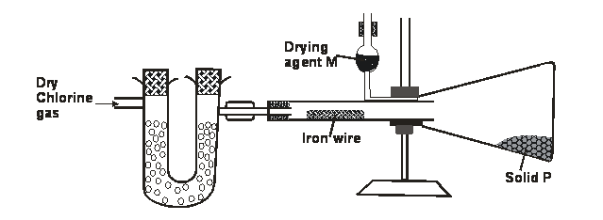
  - Write an equation for formation of solid P (1 mark)
      - Marks

2 Fe(s) + 3Cl₂(q) 2 FeCl₃ (s) 1 Mark

Equation must be balanced award 0 if not balanced, state omission of symbols give ½ Mark

  - Suppose the gas used in the set up was dry hydrogen chloride gas; what would be the product obtained after the reaction? Give a reason for your answer (1 mark)
FeCl₂ ½ Mark
Accept iron (II) chloride
Reasons: HCl gas is not a strong oxidizing agent hence may not oxidize Fe to its highest oxidation state.

- Aluminium is obtained from the ore with the formula Al₂O₃. 2H₂O. The ore is first heated and refined to obtain pure aluminium oxide (Al₂O₃). The oxide is then electrolysed to get Aluminium and oxygen gas using carbon anodes and carbon as cathode.

  - Give the common name of the ore from wherealuminium is extracted from (1 mark)
Baunxite

  - What would be the importance of heating the ore first before refining it? (1 mark)
It drives out water ½ from the Al2O3 2H2O leaving Al2O3, thus reducing it.

  - The refined ore has to be dissolved in cryolite first before electrolysis. Why is this necessary? (1 mark)
- It has a very high melting ½ point (2054) ºC hence its lowered by cryolite to 900ºC
The molten Al₂O₃ has a high covalaricytendancy ½ hence not very good in electrical conductivity
Therefore cryolite improves its electrical conductivity ½
  - Why are the carbon anodes replaced every now and then in the cell for electrolysingaluminium oxide? (1 mark)
The graphite (C) react with the oxygen liberated there forming CO₂ and CO escapes hence wearing out

- Use the cell representation below to answer the questions that follow
V(s) / V³⁺ (aq) //Fe²⁺ (aq) /Fe(s)
    - Write the equation for the cell reaction (1 mark)
2V(s) + 3Fe²⁺(aq) 2V³⁺(aq) + 3Fe(s)

    - If the E.M.F of the cell is 0.30 volts and the E^{θ} value for V³⁺aq / V (s) is -0.74V, calculate
theE^{θ}of Fe²⁺(aq)/ Fe(s) (2 marks)
Emf = E_{red} - E_{oxid}
+0.30 = x - ⁻0.74
x= -0.44V
- When 50cm³ 1M potassium hydroxide was reacted with 50cm³ of 1M hydrochloric acid, the temperature rose by 8⁰C. When the same volume of Potassium hydroxide was reacted with 50cm³ of 1M Pentanoic acid, the temperature rose by 3⁰C.
- Give reasons for the above difference in temperature. (2 marks)
- The reaction between KOH and HCl gives a higher temperature change because
HCL is ½ releasing more H⁺ ions which combines with OH⁻ ions to form water
The reaction between KOH and pentanoic acid gives a lower temperature change
because the acid is Partially dissociated ½ releasing fewer H⁺ ions which will react
with the OH⁻ ions hence part of the energy released goes to ionize the acid ½
- Write an equation to show dissociation of pentanoic acid? (1 mark)
C₄H₉COOH_{(aq)} C₄H₉COO⁻ _{(aq)} + H⁺_{(aq)}

Reversible sign must appear

- The following is structural formula of polyester.
- Draw the structural formula and name the alkanoic acid and alkanol that react to form the polymer. (2marks)

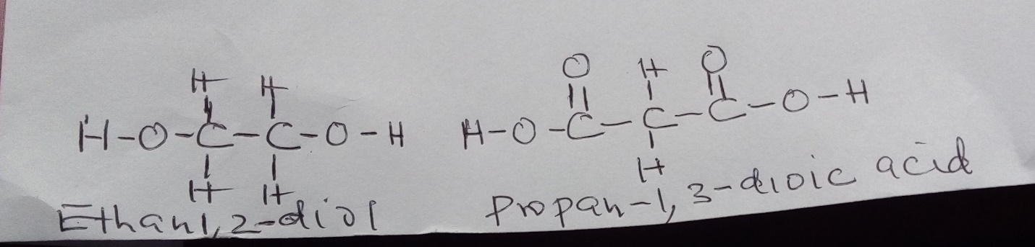

b) Give one use of polyester. (1mark)
– making clothing
- making ropes
- plastic model kits

- A heavy metal P was dissolved in dilute nitric acid to form a solution of compound P(NO₃)₂. Portions of the resulting solution were treated as follows:
  - To the first portion a solution of dilute hydrochloric acid is added, where a white precipitate (S) is formed, which dissolves on warming.
  - The second portion is treated with two drops of 2M Sodium hydroxide solution where a white precipitate T is formed. The white precipitate dissolved in excess sodium hydroxide to form a colourless solution.
  - A solution of potassium iodide is added to the third portion where a yellow precipitate (U) is formed.
  - When the resulting solution is evaporated to dryness and heated strongly a yellow solid (V) is formed and a brown gas (W) and a colourless gas (X) are formed.
    - Identify the substances P, S, T, U, V, W (3 marks)
P – Pb
S – PbCl_{2(aq)}
T – Pb(OH)₂ (ppt)
U – PbI_{2(s)}
V – PbO
W – NO₂ ( ½ Mark ) each NB Accept the name of the respective answers also

- The graphs below were drawn when 15g of marble chips in different physical states were reacted with 50cm³ of 2M Hydrochloric acid. They are drawn by measuring the volume of carbon (iv) oxide produced with time.

  - Which curves corresponds to the reactions involving powdered calcium carbonate and large sized marble chips with the dilute acid?
    - Powdered calcium carbonate (½ mark)

Curve A

    - Large sized calcium carbonate (½ mark)

Curve C

  - All the graphs eventually flatten out at the same level but at different time. Why do the graphs flatten out at the same level? (1 mark)
One of ½ the reactants has been used up in the reaction and the total amount of CO₂
produced will be the same ½ since all reactants remained same in each case.

  - Why is curve A very steep at any given point compared to the other curves
(1 mark)
The powdered CaCO3 offers a very great surface ½ area in contact with the acid
hence the rate of ½ reaction is very high at any given point

- Sodium thiosulphate was reacted with dilute hydrochloric acid in a round bottomed flask as shown below. The gas evolved was collected by downward delivery in a gas jar.

  - Write an equation to show the reaction going on in the reaction in vessel.
        - mark)

Na₂S₂O_{3(s)} + 2HCl _{(aq)} 2NaCl _{(aq)} + H₂O_{(l)} + S_{(s)} + SO_{2(g)}
Equations must be balanced otherwise award zero
State symbols missing

  - State the observation noted on the filter paper. Give a reason for your answer
(1 mark)
The filter paper is noted to turn to green in colour( ½ ) the sulphur (IV) oxide
produced reduces the chromium (VI) ions from oxidation number of (+6) to Cr3+
ions which are green in colour

  - Give a reason why the filter paper soaked in the acidified potassium chromium (VI) is used at the top of the flask (1 mark)
To show when the gas jar is filled with ½ gas, hence ensuring the gas does not
escape ½ to the environment.

