451/1
COMPUTER STUDIES
PAPER 1
THEORY
NOV/DEC 2021
TIME: 2½ HOURS
LANJET JOINT EVALUATION NOV/DEC 2021
MARKING SCHEME

1. Two practices that ensure the safety of the computer user
- All cables should be insulated
- Cables should be laid away from user pathways.
- Providing standard furniture
- Use antiglare screens on CRT monitors
- Avoid overcrowding of computers and users.
- Adjust the display lighting.
(First 2x1)
2. Definition of portability as used in software selection
- Ability of a software to be copied or installed in more than one computer.
(first 1x1)
3. a) How OS manage computer memory
- OS manage the memory by organizing it into blocks of sizes called page frames. Task are equally divided into pieces that can fit into the frames.
- OS swaps the tasks between the main memory and the virtual memory on the hard disk.
(first 1x2)
b) i) What is meant by disk partitioning?
- Process of diving a large physical disk into two or more partitions called logical drives.
(First 1x1)
ii) Purpose of disk partitioning
- For the purpose of installing more than one OS on the same disk.
- For the purpose of backup on the same disk but different partitions.
(first 1x1)
4. a) Four stages in data processing cycle
- Data collection
- Data input
- Data processing
- Data output
(In correct sequence) (first 4x ½ )
b) i) Reference file
- A file that contain data used for lookup purposes e.g. price list. (first 1x1)

ii) Master file
- Contains relatively permanent data (first 1x1)
5. a)
- Body scanners will replace security guards by scanning travellers as they enter to detect prohibited items.
- Online booking will replace clerks at booking offices
- Payments using plastic cards (electronic) will replace receipt inspectors and conductors.
(first 2x1)
b) One role of:
i) Webmaster
- Develop websites for organization and individuals
- Install web pages information
- Maintain, update and modify information on webpages.
(first 1x1)
ii) Network administrator
- Controls and monitors Network resource usage
- Sets up a computer network
- Maintain and troubleshoot network related problems
- Maintain and enforce network security measures.
(first 1x1)

6. a) One reasons why parallel cables are faster than serial cables in data transmission
- Parallel cables transmit many bits of data simultaneously using set of conductors while serial cables transmit only one bit at time. (first 1x1)
b) Two ways that may be used to represent a negative number in a number
- Ones complements
- Twos complement
- Prefixing an extra sign bit
(first 2x1)
7. a) Distinguish between autocomplete and the autocorrect feature
- Autocomplete is a feature that automatically displays a complete word when the user types the first few characters.
- Autocorrect is a feature that automatically detects wrongly capitalized or spelt word and replaces it with the correct one.
(first 1x2)
b) What is thesaurus?
- A tool that helps the user find words or phrases with similar meaning or opposite meaning to the one selected (first 1x1)
8. Definition of:
i) Internet
- Interconnection of computer networks globally to facilitate flow of information world widely. (first 1x1)
ii) Piconet - A network of bluetooth enabled devices.
- A device / software that enable Bluetooth – enabled devices to communicate. (first 1x1)
9. Reasons why DTP is preferred over word processors
- Items can be edited independently since every item on a page is contained in a frame.
- Frames need not to flow in logical sequence e.g. a story on pages I can be continued on page 5.
- DTP has a wide range of templates that can be used to create a document first
- Master pages are used to set a common layout which may be repeated on several pages. (first 2x1)
10. Symbols of some keyboard keys:
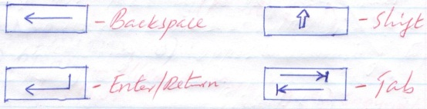
4 x ½ = 2 mks
11. Factors to consider when buying input devices
- Initial cost of the input device
- Volume of data to be input (Speed of the device)
- Reliability of the device
- Mode of operation
- Appropriateness of the device.
(first 4x1)
12. a) Distinguish between workbook and a worksheet
i) - Workbook – An excel file that consists of several worksheet
- Workbook – a group of worksheets
ii) Worksheet – a work area made up of rows and columns into which data is entered. (1x2)
b) Meaning of “what if analysis”
- A feature used to predict / forecast an outcome if a value used in a formula or function are changed. (1x1)
13. Reason why HTML is not considered as a true programming language
- HTML does not have declaration part and control structures (first 1x1)

14. Definition of:
i) Piracy – Illegal copying of copyrighted software. (First 1x1)

ii) Industrial espionage
- Involves spying on a competitor to get information that can be used to cripple the competitor. (First 1x1)
15. Types of relationships as used in database design
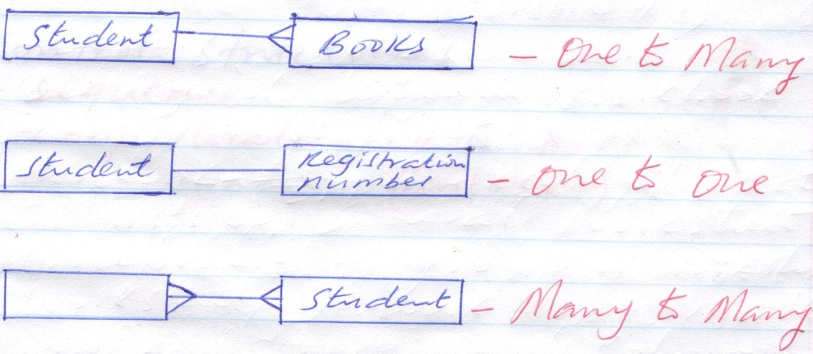
3 x 1 = 3 marks

16. - The CPU can easily understand low – level languages without or with little translation
- The program instructions can be executed by the processor much faster as complex instructing are already
broken down into smaller simpler ones .
- They have a close control over the hardware, are highly efficient and allow direct control of each operation
- They require less memory space
- They are stable i.e. do not crash once written
- Not commonly used, hence can be used to code secret programs (Each 3 correct @ 1 mk x 3= 3 mks)
b.
Interpreters | Compilers
Translates the source program one instruction at a time. | Translates the entire source code at once before execution
Translates the program each time it runs hence  slower than the compiler | Executes faster than the interpreter since the object code can be stored and retrieved when required
Interpreted object code occupies less space than the compiled one | Since compiled object files are larger than the  interpreted ones, they thus occupy large space

Start
N = 1, sum= 0, C = 1
Sum = sum + N
N = N + 2, C=C +1
Is c >50?
AVg = Sum / c
Sum, Avg
Stop
c.

PSEUDOCODE
Begin
Set C= 1
Sum = 0
N= 1
Repeat
Sum = Sum+ N
N= N + 2
C= C + 1
Until c= 50
Avg= Sum/ C
Print Sum, Avg
End
17. a) i) 15₁₀
= 1111₂
12₁₀= 1100₂ 1 mk
Ones complement of = 1100₂ = 0011₂ (1mk)
2^{c}₅ of 0011 = 0011+ 1 = 0100 mk
Therefore:
1111₂
+ 0100₂
Overflow bit 1011₂
0011 +
= 0011₂ 1 mk
ii) 10111₂ - 1011₂
Ones complement of 01011₂ = 10100₂ 1 mk
2^{c}₅ = 10101 1
Therefore 10111
10101 1
1 01100

01100 1
b) 1011 -ve number
0100 +ve number 1

= 1 x 2² = 4
1 1 1
c) Whole numbers
10/2 = 5 R 0
5/ 2 = 2 R 1 read upward. 1 mk
2/2 = 1 R 0
½ = 0 R 1
0 . 375 x 2 = 0.75
. 75 x 2 = 1.50 read the whole number downwards 1 mk
. 5 x 2 = 1.00
= 0.011

Combine the two
= 1010₂ + 0.011₂ 1mk
= 1010.011₂ 1 mk

a) Base five numbers
0, 2, 3, 4 1mk
18. a)
- New opportunities – new technology/ a chance to improve services.
- Problems – undesired situations that prevent the organization from meeting its goals.
- Directives from the management or government. (First 3x1)
b)
- Improvement in technology
- Change in user requirement
- New management policies
(3x1)
c)
- Flowcharts
- Pseudcodes
- Data flow diagrams
(First 2x½ )
e) Advantages of questionnaire over interview
- Where sincere responses are required
- Where responses are not urgent
- When the area to be covered is large (geographically) and respondents are scattered
(First 2x1)
f) Reasons why users may resist introduction of information system in place of work
- Fear of losing job
- Fear of being displaced by computer literate people
- Fear of side effects on their health.
(First 3x1)
19. a) Explain why a computer is able to display the correct time and date when it has just be switched on. (2mks)
Because it is set and stored in a special memory known as the complementary metal – oxide semiconductor
(cmos) chip which is powered by cmos battery
b) Discuss two types of special memories found in computer system. (4 mks)
i) Cache – Fast type of RAM found in the processor.
ii) Buffers – Special memories found in the input / output devices.
iii) Register - Hold one piece of date at a time and are found in the ALU
c) i) Define a bus with reference to a computer system. (1 mk)
- Bus – This are electronic pathways or links
ii) List two examples of buses (2 mks)
i) Address bus ii) Data bus iii) Control bus
d) Distinguish between a power cable and interface cable. (2 mks)
- A power cable is used to transmit data from the source (socket) to the computer while interface cables are
special cables used to connect peripheral cables to the system unit.
e) Differentiate between the different types of RAM. (4 mks)
- Static RAM – is a fast type of RAM located inside the microprocessor
- Dynamic RAM – is a relatively slow type of RAM. It has the tendency for the stored charge to leak a way
even with constant power supply hence requires periodic recharging.
20. a) i) Avoid smoke
Keep flammable substances away
Have fire exists and fire extinguishers
ii) Use passwords
Change passwords frequently
Keep password safe
iii) Install latest updated antivirus program
Disable floppy disk drives
Scan storage devices
iv Encrypt data
b) Data that belongs to particular person that requires permission to be accessed
Confidential data is that which is held by a country or an organisation about people and must be accessed by only authorised persons.
c) Downloads
Pirated software
Fake games
Infected software
E – mail attachments

