MARKING SCHEME
FORM THREE END OF TERM 3 - 2022

1. State the two functions of the control unit. (2 marks)
Decoding signals
Sending timing and controls to all the components of the computer
2. Explain four reasons which make microcomputers suitable for personal computing work. (2 marks)
- Reduced cost, i.e. are cheaper than the minicomputers and mainframe computers
- Have high processing speeds
- Are small in size (occupy less office space).
- Consume less power
- Are versatile (i.e. can be used for many different tasks).
- Are more reliable in doing various functions than the early mainframe computers.
3. State the functions of the following keyboard key combinations. (3mks)
a) CTRL + ESC:
- Opens the START menu
b) ALT + F4:
- Close the currently active program
c) CTRL + ALT + DEL:
- Restart the computer or End task
4. Mambo leo the CEO of Chai tea factory wishes to computerise activities in the factory. He asked his system analyst to advise him on the areas that needed to be computerised. State three reasons why an organisation may opt to develop a new information system. (3mks)
- New opportunities – a change to + improve performance and service delivery in an organization may arise.
- New systems invented to replace existing ones
- Problems – the user may encounter some difficulties in using existing system.
- Directive – requirements imposed by the management or government
5. a) Give a reason for enforcing referential integrity. (1mk)
- Ensures that data in both tables are consistent
b) List two main characteristics of a primary key. (2mks)
- Cannot be null (blank)
- Should be unique
- Never accepts duplicates (reduces data redundancy)
6. List any four types of computer crimes. (2mks)
- Trespass, hacking and cracking, tapping, piracy, fraud, sabotage, alteration.
7. Most supermarkets use bar codes extensively, explain two reasons why this is the case. (2mks)
- Bar codes eliminate the possibility of human error since bar code scan is fast and reliable and infinitely less time than entering data by hand.
- Bar codes are inexpensive to design and print.
- Bar codes are extremely versatile. They can be used for any kind of necessary data collection. This could include pricing or inventory information.
- Inventory control improves becoz barcodes make it possible to track inventory so precisely, inventory levels can be reduced.
- ¨ Barcodes provide better data since they can be customized to contain other relevant information as needed. They provide fast, reliable data for a wide variety of applications.
- ¨ Data obtained through bar codes is available rapidly since the information is scanned directly into the central computer. They provide fast, reliable ready almost instantaneously.
- ¨ Bar codes promote better decision making. Because data is obtained rapidly and accurately, it is possible to make more informed decisions. Better decision making ultimately saves both time and money.
7. List any two examples of publications designed using DTP software. (1mk)
Cards, certificates, newspapers, books, calendars, business cards, journals, flyers and posters, newsletters etc

8. a) Explain how a computer system can be protected from intruders. 22 (2mks)
- Install security alarms
- Use CCTV cameras
- Employ security officers
- Use passwords and user access security level
b) State any two laws governing protection of information. (2mks)
- Data should be not transferred to other countries without the owner’s permission.
- Data and information should be kept secure against loss or exposure.
- Data and information should be accurate and up to date.
- Data and information be collected used and kept for specified lawful purposes.
9. a) What is the meaning of graphics as used in word processing? (1mk)
- Any non-text images
b) Give two sources of graphics in the computer. (2mks)
- Clip art
- Scanners
- Drawing using drawing tools
- From a file
10. State the cursor action when the following keyboard keys are pressed. (4mks)
i. Delete key
- Remove a character to the right of the cursor
ii. Insert key
- A newly typed character will replace the character at the cursor position
iii. Pgup (page up) key
- Will move the cursor one screen towards the beginning of the document
iv. Pgdn (page down) key
- Will move the cursor one screen to the end of the document
11. a) What is a search engine? (1mk)
- A special program that collects and stores links to information websites allowing users to search its database for them.
b) Give four examples of search engines you know. (2mks)
google.com
yahoo.com
Hotmail.com
12. a) Define the following terms as used in a worksheet. (2mks)
i) Columns
These are fields that make up the worksheet of a spreadsheet, and are identified by letters. They run vertically from top downwards.
ii) Rows
These are the records that form a worksheet, and are identified by numbers. They run horizontally from left to right.
b) Distinguish between absolute cell reference and relative cell reference (2mks)
Relative Referencing
- When you copy a formula from one place to another in the same or different worksheet, Excel adjusts the cell references in the formula relative to their new positions in the worksheet
Absolute referencing;
- An absolute cell reference displays the exact address of the cell regardless of the position of the cell that contains the value using the absolute cell references. A formula does not change when copied to a new location like how relative cell reference adjusts the formula while it is copied.
13. a) State two data processing file. (1mk)
- Master file
- Transaction file
- Reference file
- Backup file
b) Explain any file named above in a). (2mks)
- Master file, main file that contain permanent records of a particular entry.
- Transaction (movement) file, used to hold input data during transaction processing.
- Reference file, mainly used for reference or look-up purposes.
- Backup file, used to hold copies (backups) of data or information from the computers fixed storage (hard disk).
15. Give one reason to the growth of communication industry in Kenya. (1mk)
- Technological and scientific advancement
- Civilization
- Growth of economy
- Good governance

16. (a) (i) Outline chronologically the 6 stages of program development life cycle. (6*1=6mks)
- Problem recognition
- Problem definition
- Program design
- Program coding
- Program testing and debugging
- Implementation and maintenance
b) State and explain the 2 main errors made during program development. (2mks)
-Syntax- The errors that emanate from improper use of language rules
-Logical errors- They are not detectable but results to wrong output.
C) Study the pseudo-code below and draw a flowchart from it. (7mks)

START
PRINT ENTER CAR NUMBER
INPUT CAR NUMBER
PRINT ENTER NUMBER OF DAYS
INPUT NUMBER OF DAYS
IF NUMBEROFDAYS>=7 THEN
AMOUNT=(NUMBER OF DAYS X 2500) – (NUMBER OF DAYS X 2500) * 25%
ELSE
AMOUNT=NUMBER OF DAYS * 2500
END IF
DISPLAY CAR NUMBER, NUMBER OF DAYS, AMOUNT
STOP

17. a) Explain three parameters that determines the magnitude of a number (6mks)
- Absolute value: Magnitude of a digit in the number line. For example, digit 2 in 423 has an absolute value of 2 according to its value in a number line.
- Place value: Position of a digit in the number, whether ones, tens, hundreds and so on. For example, digit 2 in 423 has a place value of tens hence the total value is 20.
- Base value: Radix of the number system that is being used. For example, 3₂ and 3₁₀ mean three base two and three base ten respectively, and have different values.
b) Using two’s complement, show how the arithmetic below would be carried out on a 8 - bit computer system. (+54) - (+29) (5mks)
Solution;
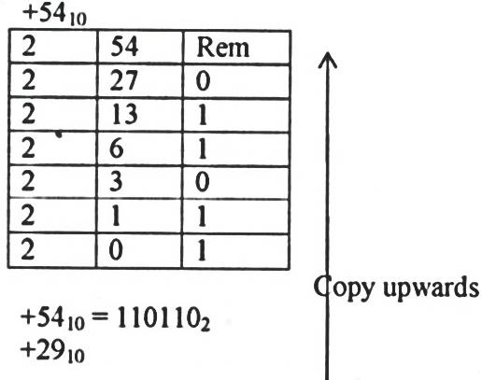
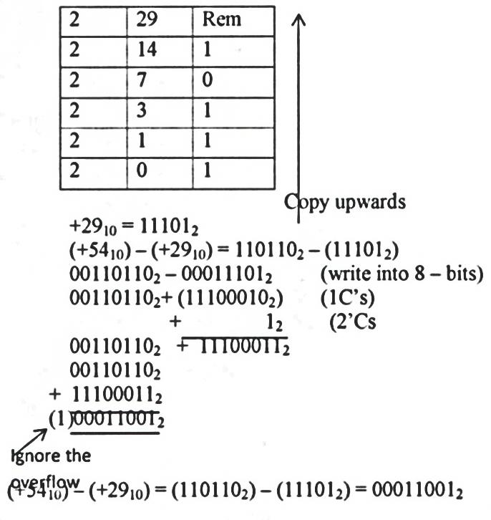

c) State and explain any two strategies that may be employed to mitigate threats to data integrity. (4mks)
- Backup data preferably on external storage media.
- Control access to data by enforcing security measures
- Design user interfaces (e.g. forms) that minimizes chances of invalid data entry.
- Using error detection and correction software when transmitting data.
- Using devices that directly capture data from the source such as bar code readers, scanners, biometric devices, digitizing tablets, digital cameras, web cameras and micro phones .
18. a) What is the meaning of integrated software? (2mks)
- It is a set of related programs combined in a unified package that allows data to be transferred easily between the programs e.g. Microsoft Office—which consists of MS-Word, Excel, Publisher, Access, Outlook etc.
b) State and explain three advantages of using robots to perform tasks. (6mks)
- They are more precise and consistent than human beings or workers.
- Robots also allow for increased production and profit margin because they can complete tasks faster.
- Robots have the ability to work around the clock since they do not require vacations, sick days or breaks.
- They also make fewer mistakes than human beings, saving company’s time.
- Robots eliminate dangerous jobs for humans because they are capable of working in hazardous environments.
- They can handle lifting heavy loads, toxic substances and repetitive tasks. This has helped companies to prevent many accidents also saving time and money.
- In the medical field robots are used for intricate surgeries such as prostrate cancer surgery.
c) Differentiate between toggle keys and home row of the keyboard giving examples: (4mks)
- Toggle keys—keys that switch back and forth between computer operations each time they are used while home row on a computer keyboard that contains the keys (home keys) to which four fingers of each hand return as a base.
- Toggle keys— caps lock, NUM lock, scroll lock, insert
- Home row—A, S, D, F, J, K, L and ;
d) What is proofreading? Give an example of proofreading tools used in word processors. (3mks)
- It refers to checking whether the document has typographical or grammatical errors. Examples: spelling and grammar checker, thesaurus, auto correct, auto-complete
19. a) Distinguish between a computer drive and computer driver. (2mks)
- A computer drive is a hardware component that facilitates storage and retrieval of data on a removable storage device while a computer driver is sets of instructions installed/ incorporated to the operating system the controls the functionality of their specific peripheral devices.
- State any four factors to consider when selecting an operating system. (4mks)
- The hardware configuration of a computer e.g. memory capacity, processor speed and hard disk capacity.
- The type of computer in terms of size and make. For example, some earlier Apple computers would not run on Microsoft Operating systems
- The application software intended for the computer
- User – friendliness of the operating system
- The documentation available
- The cost of the operating system
- Reliability and security provided by the operating system
- The number of processors and hardware it can support
- The number of users it can support.
- Explain any four factors that dictate how the operating system organizes data in a computer.
(4mks)
- Rapid access: The organization method should allow quick access to stored data
- Ease of update: - The organization method should allow ease of update and the operating system must be able to keep a record of the date of modification
- Economy of storage : - the organization method should use the least storage possible because memory is a scarce resource
- Simplicity of maintenance: - The organization method should enable quick navigation through the file system and make it easy for it to be maintained.
- Reliability: - the file organization method must be reliable.

- Define the term file in relation to the operating system. (2mks)
This is the smallest unit of data storage in a computer. Every user document in a computer is stored in files of specified formats depending on the program used to create it.
Files can also be defined as a collection of related data items given unique name for ease of access, manipulation and storage.
- The operating system stores details of a file for easy identification and retrieval of files. Explain any three file details the operating system uses to search and identify a file. (3mks)
- A unique name and an optional extension; the name and extension are separated by a period (.).
- The file size
- The date and time the file was created or modified.
- The file type

