COMPUTER STUDIES PAPER 2 QUESTION PAPER
QUESTION 1 (50 Marks)

- The information below was extracted from CMC vehicle selling business
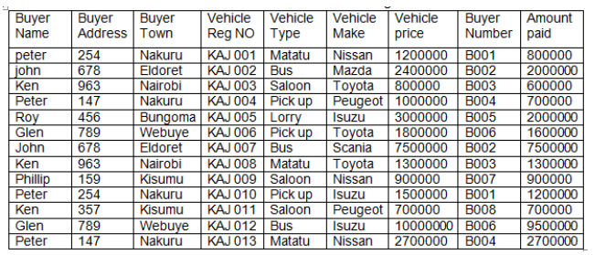
a) Create a database file named CMC (2 marks)
b) Using the information in the table, create a table to hold vehicle detail and another to hold
buyer details. Name them tbl vehicle and tbl buyer respectively (4 marks)
c) Enforce referential integrity between two tables. (2 marks)
d) Create different input screen for each table, giving them appropriate title. Name them
frm vehicle and frm buyer. Use them to enter data into the tables. (12 marks)
e) Display a report only showing the details of the buyers who have cleared paying for the vehicle.
Name the report rpt cleared with ‘’CLEARED BUYERS’’ as the title of the report. (10 marks)
f) Using the two tables create an outlined report showing the customer details, the total amount
paid by each customer and the total amount received by CMC during this time. Name the report
rptnilbal and the title as ‘SUMMARY REPORT PER BUYER.’’ (8 marks)
g) Create a query to display the vehicle details with balances of less than 500,000 but not less
than 300,000. Name the query as qrymidbal. (7marks)
h) Create a report showing the vehicle type, the total sales for each type and the grand total. (3
marks)
i) Print tblvehicle, tblbuyer, rptcleared, and rptnilbal and qrymidbal landscape orientation with
footers being your last name and index number at the centre of the page. (2 marks).

QUESTION 2 (50 Marks)
- Use a spreadsheet to manipulate data in the table below.
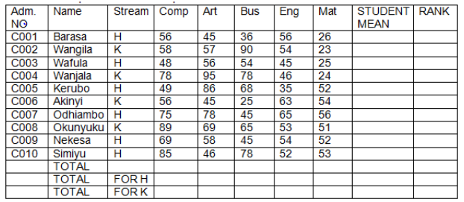
a) Enter the data in all bordered worksheet and auto fit all columns. Save the workbook as mark1
(15 mks)
b) Find the total marks for each subject (3 mks)
c) Find total for each subject per stream using a function. (5 mks)
d) Find mean mark for each student using a function (5 mks)
e) Rank every student in descending order using the mean (5 mks)
f) Create a well labeled colum chart on a different sheet to show the mean mark of every student.
Save the workbook as mark2. (7 mks)
g) Using mark1, use subtotals to find the average mark for each subject per stream. Save the
workbook as mark3 (7 mks)
h) Print mark1, mark2, and the chart (3 mks)

