Name………………………………………………………. Index No…………………/…….
School………………………………………………… Date ………………………….…
Candidate’s Signature………………………
451/1
COMPUTER STUDIES
PAPER 1
(THEORY)
OCT/NOV 2021
TIME: 2 ½ HRS

ACK JOINT EVALUATION EXAM
Kenya certificate of secondary education (K.C.S.E)

451/1
COMPUTER STUDIES
PAPER 1
(THEORY)
TIME: 2 ½ HRS

Instructions to candidates
- This paper consists of TWO sections; A and B
- answer all questions in sections A.
- Answer question 16 and any other three questions from section B.

for examiners use only

section | Question
A | 1 – 15
B | 16
 | 17
 | 18
 | 19
 | 20
Total marks

This paper consists of 11 printed pages.
Candidates should check to ensure that all
pages are printed as indicated and no question(s) is missing
- Name two factors that determine the quality of a scanner (1 mark)
………………………………………………………………………………………………………………………………………………………………………………………………………………………………
- Differentiate between freeware and shareware (2 marks)
………………………………………………………………………………………………………………………………………………………………………………………………………………………………………………………………………………………………………………………………………………………………………………………………………………………………………………………………
- Name and explain three types of system maintenance (3 marks)
………………………………………………………………………………………………………………………………………………………………………………………………………………………………………………………………………………………………………………………………………………………………………………………………………………………………………………………………………………………………………………………………………………………………………………
- Describe briefly the functions of a modem for transmitting data between two computers through a standard telephone line (2 marks) ………………………………………………………………………………………………………………………………………………………………………………………………………………………………………………………………………………………………………………………………………………………………………………………………………………………………………………………………
- Define the term Biometrics and explain how it could be used to enforce security in computer systems (2 marks)
………………………………………………………………………………………………………………………………………………………………………………………………………………………………………………………………………………………………………………………………………………………………………………………………………………………………………………………………
- Describe any three integrity constraints in a database ( 3 marks)
………………………………………………………………………………………………………………………………………………………………………………………………………………………………………………………………………………………………………………………………………………
………………………………………………………………………………………………………………………………………………………………………………………………………………………………………………………………………………………………………………………………………………
- Explain the following basic operations of the machine cycle in the control unit (3 marks)
- Fetching
……………………………………………………………………………………………………………………………………………………………………………………………………
- Decoding
……………………………………………………………………………………………………………………………………………………………………………………………………
- Execution
……………………………………………………………………………………………………………………………………………………………………………………………………

- Write the following acronyms if full (2 marks)
- HDMI…………………………………………………………………………
- SATA…………………………………………………………………………
- PnP…………………………………………………………………………
- WORM…………………………………………………………………………
- Ministry of Lands prefers to use hard copy output over soft copy when handling documents for land matters. Give two reasons for this preference (2 marks)
………………………………………………………………………………………………………………………………………………………………………………………………………………………………………………………………………………………………………………………………………………
- Joan needs to send 15 photos to her friend Jean. She chooses to send all the photos together as a single email attachment. Each photo is 1.5 MB in size ,but the maximum possible attachment size is 20 MB.State how Joan can solve this problem (2 marks)
………………………………………………………………………………………………………………………………………………………………………………………………………………………………………………………………………………………………………………………………………………
b) Differentiate between a word wrap and a text wrap (2 marks)
………………………………………………………………………………………………………………………………………………………………………………………………………………………………

- a) Define the term ergonomics (2 marks)
………………………………………………………………………………………………………………………………………………………………………………………………………………………………
b) State and explain three examples of ergonomics (3 marks) ………………………………………………………………………………………………………………………………………………………………………………………………………………………………………………………………………………………………………………………………………………
- Name and explain three functions of operating system (3 marks)
………………………………………………………………………………………………………………………………………………………………………………………………………………………………………………………………………………………………………………………………………………
b) Explain the term Pen Computing (2 marks)
………………………………………………………………………………………………………………………………………………………………………………………………………………………………
- As regards to communication within a computer network, what do you understand by the following terms: (2 marks)
- Ethernet topology
………………………………………………………………………………………………………………………………………………………………………………………………………………
- Token ring topology
………………………………………………………………………………………………………………………………………………………………………………………………………………
- Explain the following terms as used in Desktop Publishing (2 marks)
- Cropping
………………………………………………………………………………………………………………………………………………………………………………………………
- Master page
………………………………………………………………………………………………………………………………………………………………………………………………
- Change case is where a user applies so that the text can have some contrast in size .Write the word(2 marks)
Corona VIRUS
- Title case…………………………………………………………………………
- Toggle case ………………………………………………………………………...

SECTION B (60 MARKS)
Answer question 16 and any other three questions from this section
- a) state two qualities of a pseudo code (1 mark)
………………………………………………………………………………………………………………………………………………………………………………………………………………………………………………………………………………………………………………………………………
b) Explain two methods of testing the program for errors (2 marks)
………………………………………………………………………………………………………………………………………………………………………………………………………………………………………………………………………………………………………………………………………………

The Figure below shows a flowchart. Use it to answer the questions that follow.
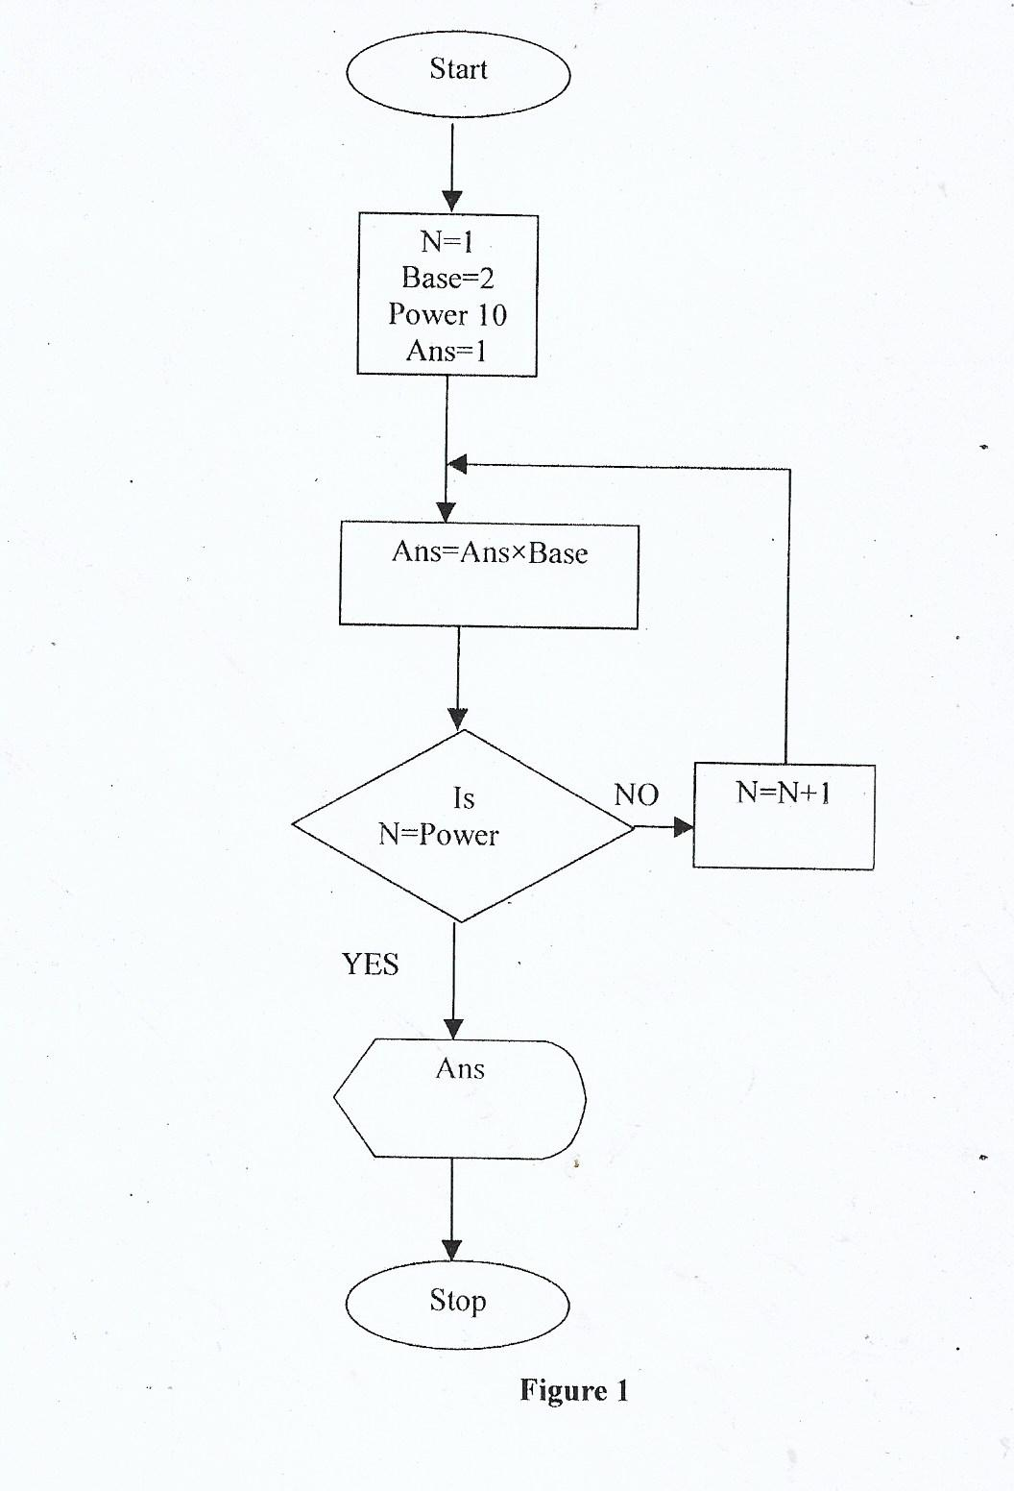
a) Interpret the flowchart (7marks)

b) Write a pseudo code for the flowchart (5 marks)

- Seal Honey sells computer accessories and needs to order supplies. A spreadsheet program is used to calculate the orders as shown below.
 | A | B | C | D
1 | ITEM | Price per unit | Number ordered | Cost(Ksh)
2 | Flash Disk | 1200 | 50
3 | Memory card | 1000 | 15
4 | Modem | 3000 | 20
5 |  |  | TOTAL
- Using absolute cell reference, write an expression to calculate the total cost in cell D3 (1 mark)

- Write down the data type that is stored in cell (2 marks)
- C4
- D3

- Write a function to display the number of cells in which the price per unit is greater than 2,000 (1 mark)
…………………………………………………………………………………………………………………………………………………………………………………………………………………….
- State three ways by which threats to data integrity can be minimized (3 marks)
………………………………………………………………………………………………………………………………………………………………………………………………………………………………………………………………………………………………………………………………
ii) Differentiate between logical file and physical file (2 marks)
………………………………………………………………………………………………………………………………………………………………………………………………………………………………………………………………………………………………………………………
e) Explain the following concepts as used in telecommunication systems. (3 Marks)
(i) Attenuation
………………………………………………………………………………………………………………………………………………………………………………………………………………………………
(ii) Bandwidth
………………………………………………………………………………………………………………………………………………………………………………………………………………………………
(iii) Repeater
………………………………………………………………………………………………………………………………………………………………………………………………………………………………
f.Explain any three functions of UPS (3 marks)
………………………………………………………………………………………………………………………………………………………………………………………………………………………………………………………………………………………………………………………………………………

- a)With the aid of a diagram, describe the Hierarchical Database Model. (4 marks)

(b) List three factors that should he considered when developing a database application and
give reasons why each should be considered. (6 marks)
………………………………………………………………………………………………………………………………………………………………………………………………………………………………………………………………………………………………………………………………………………………………………………………………………………………………………………………………………………………………………………………………………………………………………………………………………………………………………………………………………………………………………………………………………………………………………………………………………………………………………………………………………………………………………………………………
(c) (i) Name three types of validation checks during data entry in data processing.(3 marks)………………………………………………………………………………………………………………………………………………………………………………………………………………………………………………………………………………………………………………………………………………………………………………………………………………………………………………………………
(ii)Differentiate between primary key and index, key as used in databases. (2 marks)
………………………………………………………………………………………………………………………………………………………………………………………………………………………………………………………………………………………………………………………………………………

19a) Explain any two coding schemes used in data representation (2 marks)
………………………………………………………………………………………………………………………………………………………………………………………………………………………………………………………………………………………………………………………………………………………………………………………………………………………………………………………………
B i) Using 8 bit representation, give the ones complement of -35₁₀ (3 marks)
………………………………………………………………………………………………………………………………………………………………………………………………………………………………………………………………………………………………………………………………………………………………………………………………………………………………………………………………

ii) What is the seven –bit of twos complement of 0110₂ (2 marks)
………………………………………………………………………………………………………………………………………………………………………………………………………………………………………………………………………………………………………………………………………………
c)Perform the following calculation ( 3 marks)
110001₂+100111₂-01111₂
………………………………………………………………………………………………………………………………………………………………………………………………………………………………………………………………………………………………………………………………………………………………………………………………………………………………………………………………
d)(i) Convert the binary number 110.101₂ to decimal (2 marks)
………………………………………………………………………………………………………………………………………………………………………………………………………………………………………………………………………………………………………………………………………………………………………………………………………………………………………………………………

ii) Convert 9.625 ₁₀ to binary (3 marks)
………………………………………………………………………………………………………………………………………………………………………………………………………………………………………………………………………………………………………………………………………………………………………………………………………………………………………………………………
20(a) Despite the introduction of the ATM cards, human resource is still necessary in banks. Give two reasons why human beings are still needed. (2mks) ………………………………………………………………………………………………………………………………………………………………………………………………………………………………
………………………………………………………………………………………………………………………………………………………………………………………………………………………………
(b) State three advantages of the using the ATM card. (3mks) ……………………………………………………………………………………………………………………………………………………………………………………………………………………………………………………………………………………………………………………………………………...
(c) What is virtual reality? (2mks)
……………………………………………………………………………………………………………………………………………………………...................................................................................................
(d) List three areas where virtual reality is used. (3mks)
………………………………………………………………………………………………………………………………………………………………………………………………………………………………………………………………………………………………………………………………………………
(e) What is GPS in air traffic control? (2mks ) ………………………………………………………………………………………………………………………………………………………………………………………………………………………………
(f) Outline three ways computers can be used to enhance marketing. (3mks)………………………………………………………………………………………………………………………………………………………………………………………………………………………………………………

