OCT/NOV ACK JOINT EVALUATION EXAM, 2021 - COMPUTER STUDIES
PAPER 1 MARKING SCHEME

- Name two factors that determine the quality of a scanner (1 mark)
- Resolution -sharpness and clearness of an image
- Colour depth – number of bits used to store information about each pixel.
- Differentiate between freeware and shareware (2 marks)
- Free ware-is copyrighted software that is free for use.
- Shareware- is copyrighted software that is free for a trial period of time.
- Name and explain three types of system maintenance (3 marks)
- Perfective –is done on a system that is working well to improve its speed, user interface etc.
- Adaptive- adopting the system to changes in its working environment e.g. change in government policy, hardware upgrade.
- Corrective –is carried out to fix bugs (errors) that show up past system implementation.
- Describe briefly the functions of a modem for transmitting data between two computers through a standard telephone line (2 marks)
- Modem of the sending computer converts digital signal into analog signal so that the signal can be transmitted through the telephone line.
- Modem of the receiving computer converts analog signal picked up from telephone line to digital signal so that the signal can be understood by the computer.

- Define the term Biometrics and explain how it could be used to enforce security in computer systems (2 marks)
- This is the science and technology of measuring and analyzing biological data. In security, it is used to analyze human body characteristics such as DNA, finger prints, eye retina, voice pattern, facial pattern for authentication purposes.
- Describe any three integrity constraints in a database ( 3 marks)
- Validity integrity-checks if the data entered in the database matches the field data type
- Entity integrity –ensure that there is no duplication of data in the database/there are no null value s in the database
- Referential integrity-establishes a parent child relationship between tables.
- Explain the following basic operations of the machine cycle in the control unit (3 marks)
- Fetching

- The process of obtaining a program instruction or data from main memory.
- Decoding
- This is the process of translating the instructions into commands that the computer understands.
- Execution
- The process of carrying out the commands.
- Write the following acronyms if full (2 marks)
- HDMI
- High Definition Multimedia Interface
- SATA
- Serial Advanced Technology Attachment
- PnP
- Plug and Play
- WORM
- Write Once Read Many
- Ministry of Lands prefers to use hard copy output over soft copy when handling documents for land matters. Give two reasons for this preference (2 marks)
- One may need to read work away from a computer
- One may need to sign a document
- One may want to scan, photocopy or fax a document
- Hardcopies are important backups in case the softcopy gets corrupted/computer crashes.
- Joan needs to send 15 photos to her friend Jean. She chooses to send all the photos together as a single email attachment. Each photo is 1.5 MB in size ,but the maximum possible attachment size is 20 MB.State how Joan can solve this problem (2 marks)
- Compress the photos
- Send the photos using JPEG format
b) Differentiate between a word wrap and a text wrap (2 marks)
- Word wrap- this is a feature that automatically takes cursor to the next line if there is no sufficient space on the current line.
- Text wrap –this feature determine how text surrounds an object.
- Define the term ergonomics (2 marks)
- Is the science of designing equipment and work places to maximize the safety, comfort and efficiency of the people who use them.
b) State and explain three examples of ergonomics (3 marks)
- Computer monitors are equipped with glare reduction screens to prevent eye strain
- Some computer keyboards are curved to prevent wrist strain
- Work benches and desks are designed to be adjustable so that workers of many different sizes can be comfortably accommodated.
- Name and explain three functions of operating system (3 marks)
- Memory management
- Processor scheduling
- Input /output management
- Error handling
b) Explain the term Pen Computing (2 marks)
- This is a computer that utilizes an electronic pen (stylus)rather than a keyboard for data input.
- As regards to communication within a computer network, what do you understand by the following terms: (2 marks)
- Ethernet topology
All the computers listens to the network media and a particular computer can only send data when non of other computers is sending whileToken ring the data to be transmitted is placed in a special packet which goes round the network and only computer whose address is on the data held in the token will pick the token to read it.
- Explain the following terms as used in Desktop Publishing (2 marks)
- Cropping
This is the process of cutting/trimming unwanted part of publication
- Master page
This is a feature used to design a general layout that needs to be applied in all other pages of a publication.
- Change case is where a user applies so that the text can have some contrast in size .Write the word (2 marks)
Corona VIRUS
- Title case
Corona Virus
- Toggle case -cORONAvirus

SECTION B (60 MARKS)
Answer question 16 and any other three questions from this section
16.a) state two qualities of a pseudo code (1 mark)
- The statements must be short, clear and readable
- The statements must not have more than one meaning
- Pseudo code lines should be clearly outlined and indented clearly
- The input, output and processing statements should have key words like Print, Read, Input
b) Explain two methods of testing the program for errors (2 marks)
- Use of dry run method
- Use of test data
- Use of debugging utilities

The Figure below shows a flowchart. Use it to answer the questions that follow.
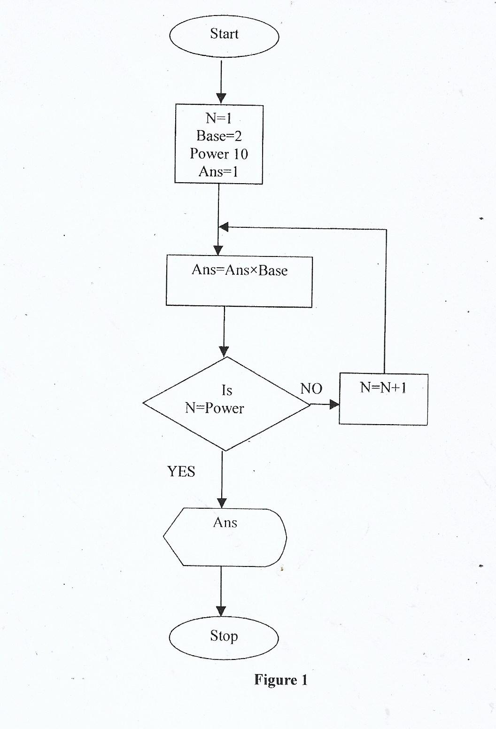
Indicates display symbol
1mark
Processing symbol where Ans is being manipulated
1mark
Direction flow
of arrows show flow chart LOGIC 2marks
Indicates end of a flow chart ½ mark
Shows start of a flowchart ½ mark
Indicates decision symbol 1 mark
- Initializing N to 1
Base to 2
Ans to 1 1mark
Symbol indicate processing
a) Interpret the flowchart (7marks)

b) Write a pseudo code for the flowchart (5 marks)
Start½ mark
N=1
Base=21mark
Power 10
Ans=1
Repeat 1mark
Ans=Ans*Base1mark
N=N+1
Until N=Power 1mark
Display Ans
Stop ½ mark

17. a)Seal Honey sells computer accessories and needs to order supplies. A
Spreadsheet program is used to calculate the orders as shown below.
 | A | B | C | D
1 | ITEM | Price per unit | Number ordered | Cost(Ksh)
2 | Flash Disk | 1200 | 50
3 | Memory card | 1000 | 15
4 | Modem | 3000 | 20
5 |  |  | TOTAL
- Using absolute cell reference, write an expression to calculate the total cost in cell D3 (1 mark)
=Product ($B$3,$C$3)
- Write down the data type that is stored in cell (2 marks)
- C4 -Value
- D3 –Formula/Function

- Write a function to display the number of cells in which the price per unit is greater than 2,000 (1 mark)
=CountIF(B2:B4,”>2000”)
- State three ways by which threats to data integrity can be minimized
(3 marks)
- Back up preferably on external storage media
- Control access to data by enforcing security measures
- Design user interface that minimizes chances of invalid data entry
- Using error detection and correction software when transmitting data
- Using devices that directly capture data from the source.
ii) Differentiate between logical file and physical file (2 marks)
- Logical files are viewed in terms of what data items it contains and details of what processing operations may be performed on data item. While Physicalfile is viewed in terms of how data is stored on a storage media and how the processing operation are made possible.
e) Explain the following concepts as used in telecommunication systems. (3mks)
(i) Attenuation
- this is the decrease in magnitude and energy as a signal progressively moves along transmission media
(ii) Bandwidth
- this is the maximum amount of data that a transmission media can carry at any one time

(iii) Repeater
- this is a device when receives a signals from one segment of a network, cleans it to remove any distortion, boosts it and then stands it to another segment.
F.Explain any three functions of UPS (3 marks)
- Alert the user incase of power failure
- It temporarily provides power to the computer in case of sudden power failure
- Regulate from unstable power source to stable power for computer use

18.a)With the aid of a diagram, describe the Hierarchical Database Model. (4 marks)

Root
C:
My documents
Desktop

Correct diagram 2marks

Nodes

- Data are arranged in a tree format, to access an item in level 2, level 1 data items have to be accessed
E explanation 2marks

(b) List three factors that should he considered when developing a database application and
give reasons why each should be considered. (6 marks)
- Security –data and information must be secured
- Cost- DBMS program should be cost effective
- Ease of updating the database.
- Integration-the DBMS should integrate with others.
- Should be user friendly ie ease to learn and use.
(c) (i) Name three types of validation checks during data entry in data processing.(3 marks)
- Type check- checks if the correct data type merges with data entered in a field
- Range check – confirms if data entered in a field is within the set range
- Presence check –checks the field not to be empty
(ii)Differentiate between primary key and index, key as used in databases. (2 marks)
- Pk a field that uniquely identifies records within a database while an index is a property that is used to speed up access of data in a database
19a) Explain any two coding schemes used in data representation (2 marks)
- Binary Coded Decimal –this is a 4 bit coding used to represent numeric data only
- ASCII-is a 7 bit coding scheme used to represent numeric and non numeric data
- EBCDIC-Is an 8 bit coding scheme used mainly in International Business Machine
B i) Using 8 bit representation, give the ones complement of -35₁₀ (3 marks)
2 | 35 | REM
2 | 17 | 1
2 | 8 | 1
2 | 4 | 0
2 | 2 | 0
2 | 1 | 0
 | 0 | 1
=00100011₂ To 8bit
=11011100₂ ones complement
ii) What is the seven –bit of twos complement of 0110₂ (2 marks)
0000110 To 7-bit
1111001 To ones complement
+ 1 Add one to get Twos complement
1111010₂

c) Perform the following calculation ( 3 marks)
110001₂+100111₂-01111₂
110001
+100111
1011000
-0001111
1010001₂

d)(i) Convert the binary number 110.101₂ to decimal (2 marks)
(1*2²)+(1*2²)+(1*0²) (1*2⁻¹) + (0*2⁻²) + (1*2⁻³)
4 + 2 + 0 0.5 + 0.25 + 0.125
=6 0.875
=6.875₁₀

ii) Convert 9.625 ₁₀ to binary (3 marks)
9=1001
0.625*2=1.25
0.25*2=0.5
0.5*2=1
9.625₁₀ =1001.101₂
20(a) Despite the introduction of the ATM cards, human resource is still necessary in banks. Give two reasons why human beings are still needed. (2mks)
- -for assistance when enquiries are needed
- for security purposes
- for cash deposits
- for servicing of machines
(b) State three advantages of the using the ATM card. (3mks)
- It allows for personal enquiries
- It is convenient since services are available to customers at any time.
- It is secure
(c) What is virtual reality? (2mks)
- This is a condition in which a person becomes psychologically immersed in an artificial environment generated by a computer

(d) List three areas where virtual reality is used. (3mks)
- entertainment
- exploring of landscapes
- simulation
- study of human anatomy
(e) What is GPS in air traffic control? (2mks )
- This is the computer technology used to direct aircraft to follow the shortest path between two locations.
(f) Outline three ways computers can be used to enhance marketing. (3mks)
- E – commercial /e – Business
- electronic presentation
- advertisements

