FORM 4 END TERM 2 -2021-MARKING SCHEME

1 |  | State three Computer Laboratory precautions and measures necessary to protect the computer user. | [3 marks]
 |  | - Installation of anti-glare screens  - Seats with straight backrest  - Computer screens should be on level with user’s eyes  - Proper cabling  - Proper ventilations  - No overcrowding  - Installation of fire alarms | $$@1 mark ×3=3 marks$$
2 |  | State two reasons for system reboot. | [2 marks]
 |  | - Recover from a problem such as system hung, grub  - So that the computer can handle maintenance services such as backing up and restoring data  - Due to power outage  - Add or remove hardware  - Customize CMOS settings or Change Kernel parameters  - Repair system configuration files  - Allow auto update files to run | $$@1 mark ×2=2 marks$$
3 |  | State any five uses of computers in a university. | [5 marks]
 |  | - Typesetting  - Publishing newsletters, tutorials and modules  - Running of security systems such as CCTV, biometric entry/exit points and alarms  - Research work such as gathering information  - E-learning (distance learning)  - Running of lifts and elevators in tall buildings  - Used in laboratories and workshops to run air conditioning systems and control machines  - Used in library to run catalogue systems  - Used for communication purposes  - Making of university timetables  - Producing academic reports  - Keeping records of workers, students and assets  - Communications such as use of e-mails | $$@1 mark ×5=5 marks$$
4 |  | State the purpose of the following parts of the CPU
 | A | Control Unit; | 1 mk
 |  | Coordinates all the activities in the CPU by issuing instructions
 | B | ALU; | 1 mk
 |  | Manipulates numerical and logical data
 | C | Main Memory; | 1 mk
 |  | Provides temporary storage
5 |  | - Initial cost  - Running cost  - Size of the screen  - Warranty  - End user licence agreement (EULA)  - User manual  - Power consumption  - Colour enhancements  - Quality of image | 3 marks
6 |  | - Graphic adaptors  - TV Card  - Random Access memory  - Hard Disk Drive  - Processor  - Data cables  - Power supply unit  - Motherboard  - CD/DVD/Flash Drives
7 | a | Differentiate between Batch processing and real time processing modes. | [2 marks]
Batch processing is where data is first collected and data collected is processed/at once (1mk)
Real-time —data is processed so quickly such that the results (output) produced are able to influence, control, or affect the outcome of the activity currently taking place (1mk)
8 | a | Define the term normalization as used in data base design | [2 marks]
Normalization is the process of trying to eliminate storage of duplicate values of data in a database
 | b | State three objectives of normalization. | [3 marks]
- Relate different tables in a database
- Ease the retrieval of data from a relational database
- Breaking up multi theme tables into smaller workable tables 1x3=3mks
9 |  | A worksheet contains the data shown below  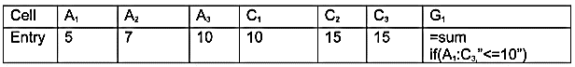  State the values displayed in G₁ | [2 marks]
$$5+7+10+10=32$$
10 | a | Name two methods of paper orientation as used in DTP | [2 marks]
- Portrait
- Landscape
 | b | i.)  Kerning refers to fixing particular pairs of letters that are to close or to far apart from each other (1mk)  Tracking refers to changing visual denseness or openness of characters in a line (1mk) | [2 marks]
 |  | ii)  Margins marks text areas on the page along the edges (1mk)  Column guides divide the pages into several fields, used to define the printable areas (1mk) | [2 marks]
11 |  | Explain one role of a computer technician | [1 marks]
- Trouble shooting computer software / hardware related problem
- Assembling and upgrading computer components
- Servicing and maintaining of all computer related accessories
2 mks for any two correct answers
12 |  | What is disk partitioning? | [1 marks]
Process of dividing a large physical disk into two or more partition called logical drives
13 |  | What is the meaning of the phrase ‘semantics’ as used with computer programming? | [1 marks]
Meaning attached to every command in a particular programming language
14 |  | What is internet? | [1 marks]
This is a global network of computers.
15 |  | Explain the function of a bridge in computer networking. | [1 marks]
- A network device that selectively determines the appropriate network segment for which a message is meant to be delivered or
- A bridge is a device that connects and passes packets between two network segments that use the same communications protocol.
16 | a | State two qualities of a good pseudocode.
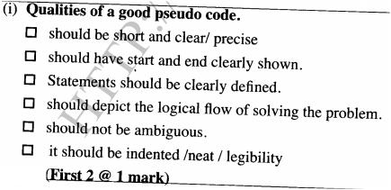
 | b | With the aid of flowchart diagrams, describe each of the following programme control structures:
 |  | - Sequence | 3 marks
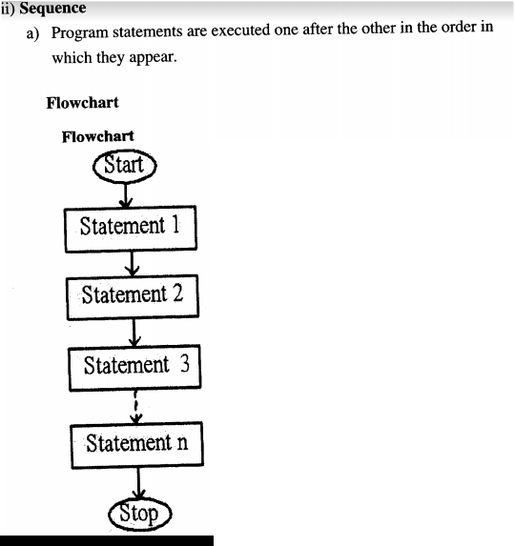
 |  | - Selection | 3 marks
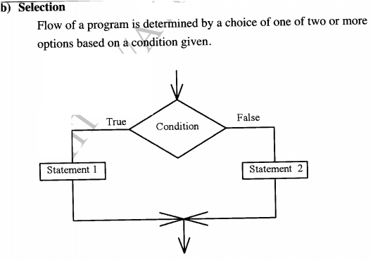
 | c | Draw a programme flowchart that would accept three numbers and find their sum. If the sum is greater than 200. It adds 30 to the sum, otherwise subtracts 20 from the sum. The programme should then display the results. | 7 marks
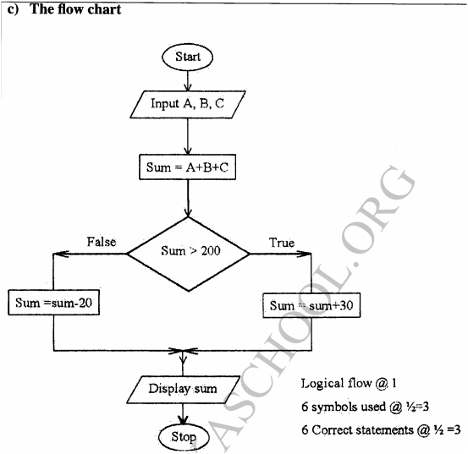
17 |  | 17. a) What is the hexadecimal equivalent of 767₈  ✓Step1 convert 767₈ to decimal  ✓7x 8² + 6x8¹ +7x8⁰  ✓448+48+7=503₁₀  Step2  Convert 503₁₀ to hexadecimal  16 503 Rem  16 31 7  16 1 15  1 1  767₈=IF 7₁₆  Correct method/ step and answer give a mark  b) Use one’s compliment to solve the following sum:-5₁₀ (2mks)  2 5 Rem  2 2 1  2 1 0  1 1  -5₁₀ = 11111010₂  c) State two reasons for using binary in digital technology.  ✓It is easier to develop devices that understand binary language  ✓Devices designed using binary logic are simple  ✓Digital devices are more reliable and consume less energy.  1mark for any two  d) Explain the role of a modem in data communication (2mks)  ✓A modem converts (modulates) data signal from digital to analogue to be transmitted over the telephone line. At the destination (receiving end) the modem attached to receiving computer converts (demodulate) the analogue signal back to the original digital form  e) Describe each of following computer terminologies as used in data representation. (4mks)  (i) Word  ✓Total number of bits that a single register of a particular machine can hold  (ii) Bit  ✓The smallest binary unit of either a ‘0’ or ‘1’.  (iii) Byte  ✓A group / collection of 8 bit used to represent a character.  (iv)Nibble  ✓A group of four binary digital usually representing a numeric value.  1mark for correct description  f) Convert 7.125₁₀ to binary  2 7 Rem  2 3 1  2 1 1  1 1  111₂ .125x2= .250 0  .250 x2 = .500 0  .500 x 2 = 1.000 1  =0.001₂  = 111.001₂
18 |  | 19. (i) Describe three ways in computers have positively impacted on education (3mks)  ✓Enabled distance learning hence education is made available to the mass  ✓Standardized learning through sharing of materials on the internet as well as research.  ✓Has ensured quality output  ✓Brought the need for retaining staff in aspects of computing  (ii) Simulation is one of the application areas of computers. What is meant by the term simulation? (1mk)  ✓Is the designing of models of either an actual or theoretical physical item or analyzing / testing the execution output using a computer?  (b) State three advantages of computer based simulation. (6mks)  ✓Save cost- cheap way of testing models before actually building them  ✓Reduce risks- it allows some activities that would otherwise be expensive & dangerous in real life situation to be put under test.  ✓It is faster  ✓It enables the manufacturer identify weakness of the real situation hence put correct reinforcement to their designs.  ✓It is convenient  (iii) Differentiate between a software engineer and a computer engineer  - Software engineer develops software programs as per requirements; computer engineer designs computer hardware and improves on existing ones. *1 mk every correct answer\  (v) Name three responsibilities that are carried out by a web administrator  - develop and test websites  -Down load information needed by the firm from the internet  - Monitor access and use of the internet by enforcing security  - Modify, update, and maintain information on the website to meet new demands  * 1 Mk for any three correct
19 |  | A school computer laboratory is scheduled to undergo major renovations. The lab is schedule to receiver new computer whose specifications are given below:-  Pentium IV 2.8GHz processor  40GB HDD  3 ½ FDD  256MB RAM  56CD Rom  17” SVGA TFT monitor  The computers are going to be networked and will be able to browse the internet.  - Explain what is meant by the terms:- (2marks)  - FDD  - An acronym for floppy disk drove which the computer possesses for 3 ½ size disks  - HDD  - An acronym for hard disk which the computer possess and its storage size is 40GB  - SVGA  - An acronym for thin film transistor monitor type  - TFT  - An acronym for thin film transistor monitor type  - The computer is to be networked, name one extra device that should be fitted on every computer to enable this to happen (1mark)  - NIC (network interface Card)  - The computer is to receive internet facilities through the server on a dial; up system. Name and describe the function of a special device that needs to be connected to the server to complete the connection. (1mark).  - A modem  - (i) The school has to apply he star topology to link up the computer. List two advantages of this type of topology. (1mark)  - Easy to configure  - Allows centralization of key networking resources like concentration and servers  - Gives network administration focal point for network  - Name the central device used to connect the computers in this topology. (1mark)  - Hub  - List two other types of topologies that the school could have opted for (1mark)  - Bus topology  - Ring topology  - Mesh topology  - Tree/ hierarchical topology  - List four advantages of using a network (2marks)  - Improves reliability e.g. in case one computer breaks down, users can still access data and information from other computer on network  - Resources sharing i.e. data/ information, files, printers, modems, programs etc can be attached to the network for access by all users  - Distributed processing facilities  - Remote communication i.e. transfer of data signals between two communication devices located differently  - Cost effectiveness. Although initial cost of laying down the network components may be expensive the savings experienced and the value added to service delivery make them a  - (i) Data transmission via the internet is done using a mode known as packet switching. Describe this data transmission mode (1mark)  - Refer to the process over the network of breaking down into discrete systematic steps the data transmission process and at each step a certain action takes place.  - Name two other modes of transmission (2mark)  Simplex Mode  Half Duplex and Full Duplex  h) (i) The school’s LAN is done using UTP cable. List two advantages of using this type of cable. (1mark)  - They are readily available (EMI)  - Cheap (not costly)  - List two advantages of using fibre cable in networking (1mark)  - Hard to tap (security)  - Immune to effects of moisture and light.  - Does not suffer from E.M.I  - Flexible in size.  iii) Data flows in the school’s LAN in a duplex manner. Discuss two other types of data transmission in  network giving examples (2marks)  - Hard duplex (Bi – directional)  - Data flows in both direction but only one direction at a time.  - Simplex  Data flows in one direction on the communication media.
20 |  | a)(i) Explain three communication services offered through internet (3marks)  - Chatting  - E-mails  - Video conferencing  (ii) Describe the following internet terms (2mks)  Links – A text or picture that when clicked causes other web pages to be opened.  URL – A special internet address made up of organization name and an extension explaining the type of organization and country.  b) The following is a spreadsheet relating to a farmer.  A B C  1 Crop Amount Not viable  2 Maize 150 Not viable  3 Bean 300 Not viable  4 Cashew nuts 850 Moderate  5 Cabbages 1036 viable  A function =IF(B2<200 “Not Viable”), IF(B2>300,” Moderate”), IF (B2>1000, “Viable”))). Give the appropriate result returned in cells C2, C3, C4 and C5 (2 mks)  c) Text can easily be selected using a mouse in word processing. How do you select  i) Multiple paragraph  Triple click on the left margin (2mks)  ii) Vertical block of text  Hold down Ctrl as you drag the mouse pointer  (d) List three areas where virtual reality is used (3 mks)  - entertainment  - exploring of landscapes  - simulation  - study of human anatomy  (e) Outline three ways computers can be used to enhance marketing. (3mks  -E-commerce  -Electronic presentation  -Advertising

