PAVEMENT FORM 4 TRIAL 1 EXAMINATION 2021/2022
Kenya certificate of secondary education (K.C.S.E)

CHEMISTRY PAPER TWO MARKING SCHEME

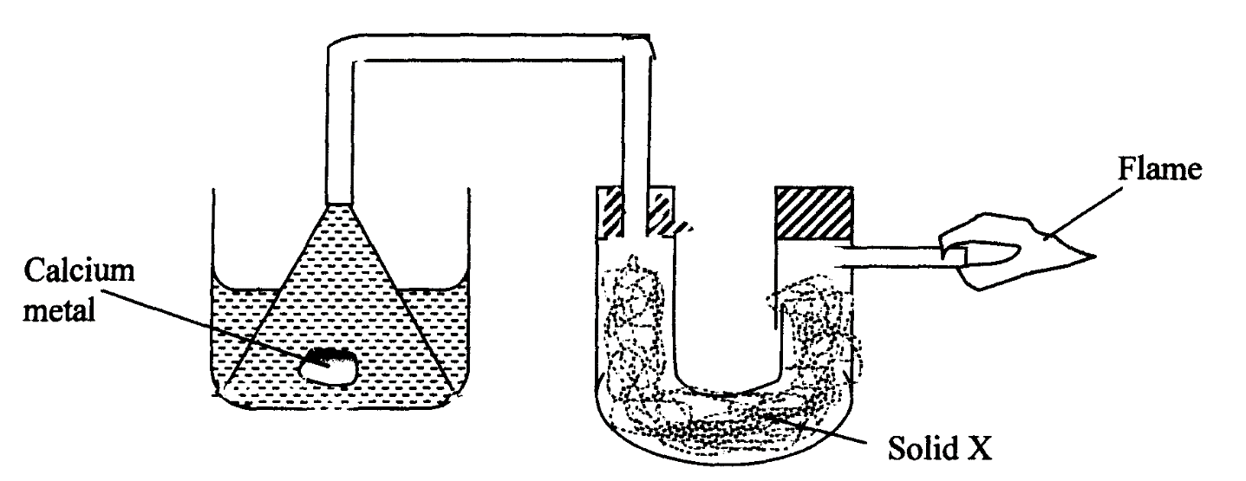
- i) The setup below was used to investigate the reaction between metals and water.

water
- Identify solid X and state its purpose.
Solid X anhydrous calcium chloride …………. (½ mark)

Purpose …drying agent……………………………… (½ mark)

b) Write a chemical equation for the reaction that produces the flame. (1 mark)

H + O₂…………H₂O
ii) The set-up below was used to investigate the properties of hydrogen.
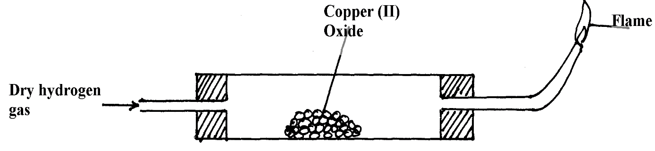

HEAT

- On the diagram, indicate what should be done for the reaction to occur. (1 mark)

- Hydrogen gas is allowed to pass through the tube for some time before it is lit. Explain. (1 mark)

To drive out air that occupied the tube
…………………………………………………………………………………………………
- Write an equation for the reaction that occurs in the combustion tube. (1 mark)
CuO_{(g)} + H_{2(g)} H₂O + CU_{(g)}
…………………………………………………………………………………………………
…………………………………………………………………………………………………
- When the reaction is complete, hydrogen gas is passed through the apparatus until it cools down. Explain. (2 marks)
to avoid de-oxidizing the copper

…………………………………………………………………………………………………
- What property of hydrogen is being investigated? (1 mark)
Reducing agent
…………………………………………………………………………………………………

- What observation confirms the property stated in (v) above? (1 mark)
Copper is reduced from copper oxide
…………………………………………………………………………………………………
vii) Why is zinc oxide not used to investigate this property of hydrogen gas?(1 mark)

Zinc is more reactive than hydrogen

………………………………………………………………………………………………………

- I. The diagram below represents an incomplete set-up of apparatus that can be used to prepare and collect dry carbon (iv) oxide gas. Complete the diagram and answer the questions that follow.
Water
Liquid R
Marble chips
Flask S

a) Complete the above diagram. (3 marks)
b) Identify liquid R. Dilute sulphuric/ hydrochloric acid … (1mark)
c) Write the equation for the reaction taking place in the flask S. (1 mark)

…… Hcl + Caco₃ Cacl₂ + H₂O + CO₂
…………………………………
d) Explain why it is not advisable to use lead (II) carbonate in place of marble chips. (1 mark)
…… H₂SO + PbCO₍₄₎ will for Pbso₍₄₎ which is insoluble
II. The diagram below is used to investigate the effect of carbon (II) oxide on lead (II) oxide. Study it and answer the questions that follow.

Combustion tube M
CO
Lead (II) oxide
L
Liquid K
Glass wool
Glass
wool

a) Write an equation for the laboratory preparation of carbon (II) oxide. (1 mark)

…………………………… PbO + CO Pb + CO₂
………………………………………
b) State and explain the observation in the combustion tube M. (2 marks)

Red/Yellowish poweder changed to grey solid
………………………………………………………………………………………………………………..
c) Identify liquid K and state its function. (1 mark)
lime water, test for CO2
…………………………………………………………………………………………………………………..
d) Why is it necessary burn excess gas at L. (1 mark)

CO is poisonus, causes suffocation
…………………………………………………………………………………………………………………..
- Name the following organic compounds.
i) CH₃COOCH₂CH₃ (1mark)

……ETHYL ETHANOATE………………………………………………………
ii) CH₃CH₂CHCCHCH₂CH₃ (1mark)
2 pentene
- a) The fermentation of glucose is catalysed by enzymes from yeast. Yeast is added to aqueous glucose, the solution starts to bubble and becomes cloudy as more yeast cells are formed.
C₆H₁₂O_{6(aq)} 2C₂H₅OH_{(aq)}+2CO_{2(g)}
The reaction is exothermic. Eventually the fermentation stops when the concentration of ethanol is about 12%.
On a large scale, the reaction mixture is cooled. Suggest a reason why this is necessary. (1mark)
C₆H₁₂O_{6(aq)} 2C₂H₅OH_{(aq)}+2CO_{2(g} …… It causes heating high temperature …………………………………………………………………………………………………………………
(ii) Why does the fermentation stop? Suggest one reasons. (1mark)
Kill the yeast, high temperatures destroy the yeast ………………………………………………………………………………………………………………………………………………………………………………………………………
(iii) What technique is used to concentrate the aqueous ethanol? (1mark)
….………………distilation………………………………………………………………………………………………

b) A compound X contains carbon, hydrogen and oxygen only. X contains 54.54% of carbon by mass, 9.09% of hydrogen by mass and 36.37% of oxygen by mass. (C=12, O=16, H=1)

Determine the empirical formula of compound X. (2marks)

 | C | H | O
MASS | 54.54 | 9.09 | 36.37
RAM | 12 | 1 | 16
NO OF MOLES | 4.545 | 9.09 | 2.27
 | 2 | 4 | 1

(C₂H₄O)n

Compound X has a relative molecular mass of 88. Draw the structural formula of compound X. (2marks)

c) The table below gives formulae of three organic compounds A, B and C
Compound | Formulae
A | C₂H₄O₂
B | C₂H₆O
C | C₂H₆
Giving a reason in each case, select the letter(s) which represent a compound that
Decolourises acidified potassium manganate (VII). (1mark)
B……………………………………………….
.Gives effervescence with sodium hydrogen carbonate. (1mark)
A
Undergoes substitution reaction with chlorine gas. (1mark)
C
d) The following is a small reaction of polystyrene polymer. Study it and answer the questions that follow.

H H H H

C C C C

H C₆H₅ H C₆H₅

(i) Draw the structure of the monomer unit of polystyrene. (1mark)

H H

C C

H C₆H₅

(ii) Calculate the number of monomers used to form the polystyrene of relative molecular mass of 18096. ( H = 1, C = 12 ) (1mark)
(12X8) +8
104
18096/104 =174 MONOMERS
- An experiment was carried out using magnesium ribbon and dilute hydrochloric acid of different concentrations. The time needed to produce 50cm³ of the gas for every experiment was recorded in a table.

Concentration of HCl (moles per litre) | 2.0 | 1.75 | 1.50 | 1.25 | 1.00 | 0.75 | 0.50 | 0.25
Time (seconds) | 8.8 | 10.0 | 11.7 | 14.0 | 17.5 | 18.7 | 35.0 | 70.0
( Sec⁻¹)

Complete the table above for ¹/_{time}. (4marks)
Plot a graph of rate i.e ¹/_{time} against concentration. (3marks)

- When lead (II) Carbonate is reacted with dilute sulphuric (VI) acid, the reaction takes place for a short time and then stops. Explain. (2marks)
There is the formation of a insoluble coat of lead ii sulphate that lead to the reaction to stop

- Study the following information and answer the questions below.
Number of carbon atoms per molecule | Relative molecular mass of hydrocarbon
2 | 26
3 | 40
4 | 54
a) Determine the general formula of the hydrocarbons and the homologous series they belong to. (2marks)
C_{n}H_{2n-2}

(b) Draw the structure formula of the fourth number of the series. (1mark)

H H. H. H
HC=C-C-C-C-H
H H. H. H

(b) Draw the structure formula of the fourth number of the series. (1mark)

- A hydrocarbon undergoes the process represented by the equation below to produce two other hydrocarbons. C10H22 X + C6H14 (a) Name the process undergone by the hydrocarbon. (1mk) CRACKING
(b) State one condition necessary for the process. (1mark)

HIGH TEMPERATURES
(c) To which homologous series does substance X belong? (1mark)
ALKYNES

- Complete the diagram to show how a sample of dry ammonia gas can be prepared in the laboratory.
(3marks)
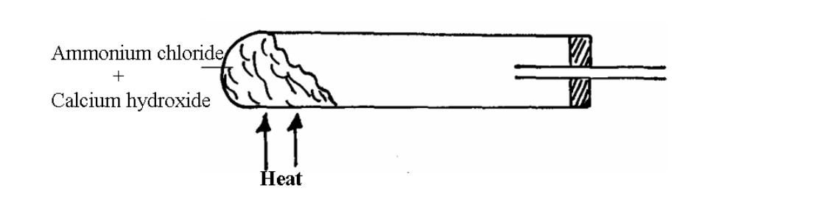

Na2CO3 + NH4OH → H2O + NaOH + CO2 + NH3

- In an experiment to study the properties of concentrated nitric acid, a mixture of the acid and wood charcoal was heated in a boiling tube.
(a) What observations were made? Explain your answer (2mks)
TURNED TO BLACK, Concentrated Sulfuric acid a is strong dehydrating agent. When it falls on wood, which is basically cellulose which is a sugar, it removes water from wood. Not only that, it takes away hydrogen and oxygen in the cellulose and converts then into water. This leaves back the third element in the wood, which is carbo
(b) Write an equation for the reaction that took place in the boiling tube (1mark)

C + 2 H2SO4 → CO2 + 2 SO2 + 2 H2O

- Three nitrates Q,R, and S were each heated and the products formed were tabulated as shown below. Nitrate Products Q R S Metal Nitrite + Oxygen Metal , Nitrogen IV Oxide + Oxygen, Nitrogen I Oxide + water
a) Identify S …Sodium…………………………… (1mark)
R…Magnesium …………………………………………………… (1mark)
- What is the name given to elements in the same group as Q? (1mark)
Alkali earth metals

- a) An oxide of nitrogen contains 30.4% nitrogen. Its density at s.t.p is 4.11g/dm3. Determine the molecular formula of the compound. (N=14; O=16; moles gas volume = 22.4dm3) (3marks)
Density ==mass/volume
- Magnesium ribbon was burnt in a gas jar of nitrogen. A few drops of water were added to the solid formed in the jar. Write an equation for the second reaction. (1mark)

MgN+ H2O
MgO + H2O. Mg(OH)2

- In an experiment, 10.6g of a mixture of Anhydrous Sodium Carbonate and Sodium Chloride were dissolved in water to make 100cm3 of a solution required 20.0cm3 of 0.5M Hydrochloric acid solution for complete neutralization. What is the mass of Sodium Carbonate in the mixture? (Na = 23.0, C = 12.0, O = 16.0, Cl = 35.5) (3marks)
##**

- The table below gives some properties of compounds P, Q, R and S
Compound M.p (0C) b.p (0C) Conductivity in water
P -23 77 Does not conduct
Q -19 74 Does not conduct
R -85 -61 Conducts
S 714 1407 Conducts

(a) Which one of the compounds in the table is ionic? Explain. (1mk) S High temperature of MP and BP…………………………………………………………………………………………………………….. …………………………………………………………………………………………………………………
(b) Which one of the compound (s) in the table is/are liquid(s) at room temperature? Give reasons. (2mks) P & Q..(COMPOUND) 2 elements …………………………………………………………………………………………………
(c) Which of the compound(s) is / are gas(s) at room temperature? Explain. (1mark)
R

15. Given that element A,B and C have atomic numbers 14, 11 and 17 respectively,
draw and name the bonding in the compounds formed using dots (.) and (X), when the following element react.

Name the type of bond formed between B and C
ionic

(a) B and C (2marks)

(b) A and C (2marks)
covalent

