PAVEMENT FORM 4 TRIAL 2 EXAMINATION 2021/2022
Kenya certificate of secondary education (K.C.S.E)

CHEMISTRY PAPER ONE MARKING SCHEME
1 (a) Increase in mass. Copper metal combines with oxygen in air to form copper (II) oxide
(b) Decrease in mass. Copper (II) nitrate decomposes to form copper (II) oxide, nitrogen (IV) oxide and oxygen gas. The gaseous products escape to the atmosphere.
2 (a) Graham’s law states that the rate of diffusion of a gas is inversely proportional to the square root of its density given that the temperature and pressure are kept constant.
(b)
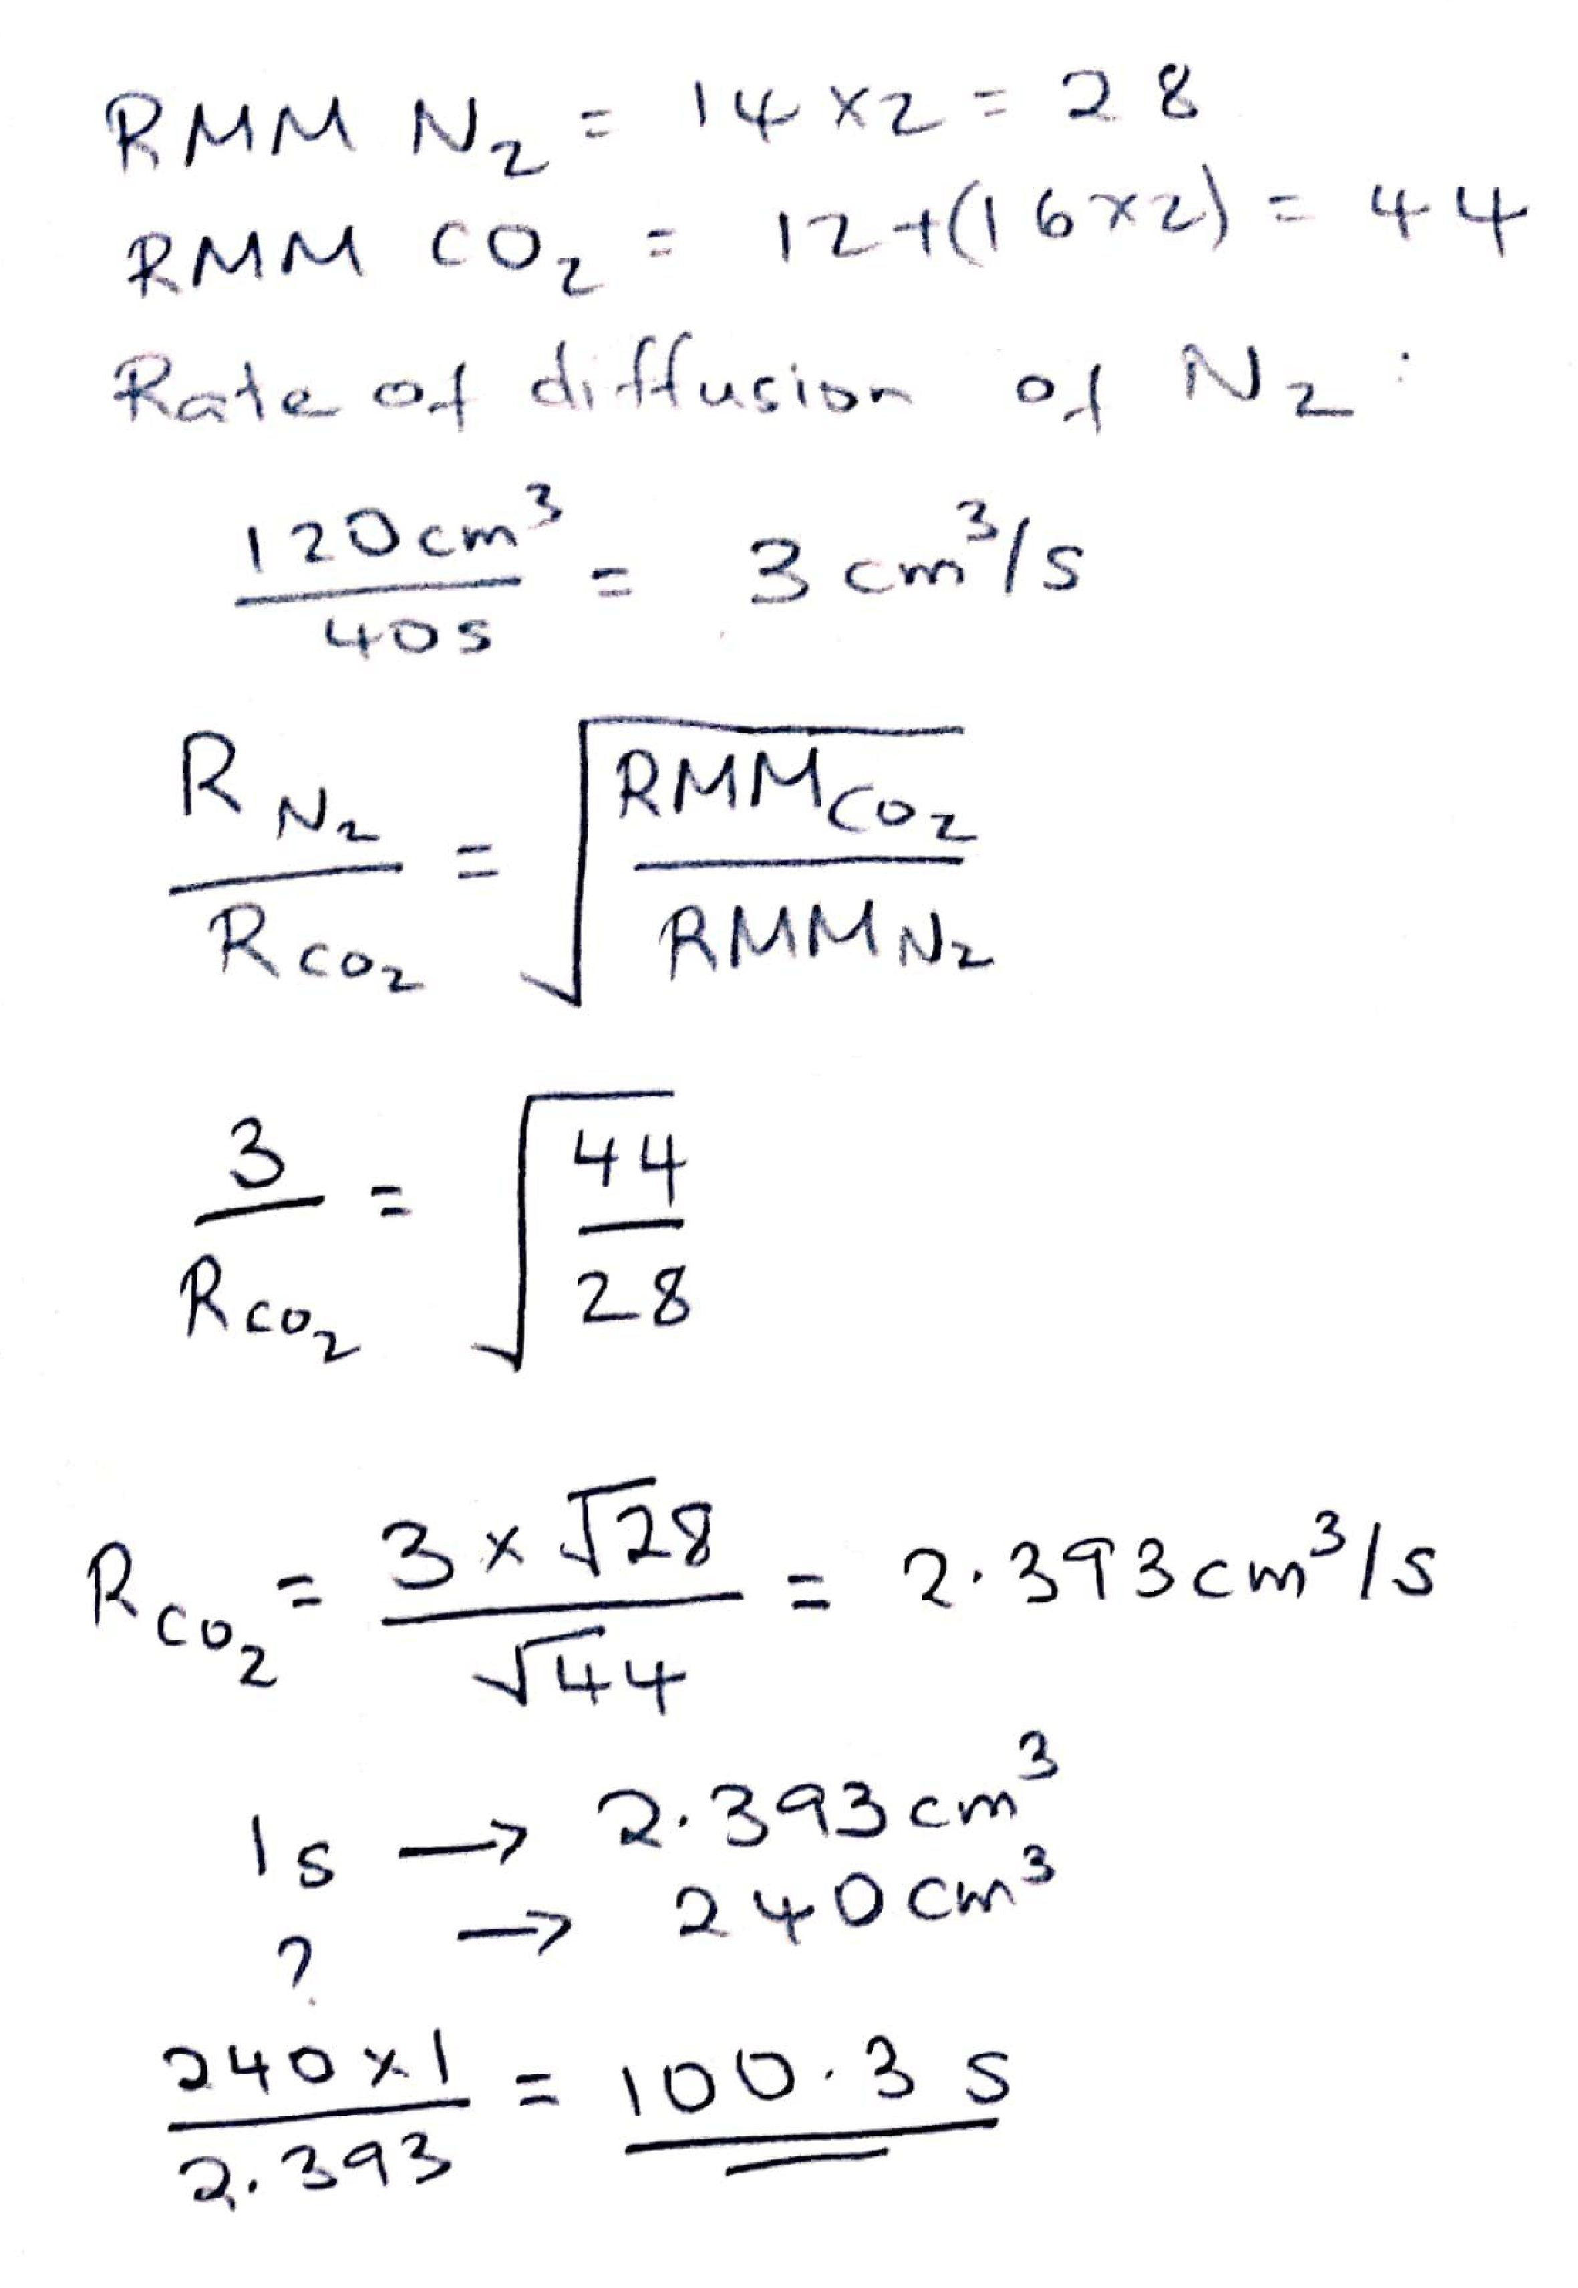
3 (a) UV light or sunlight
(b)
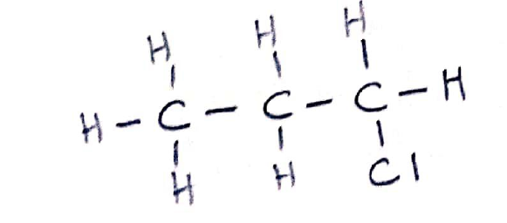
4. Acetylene or ethyne
5. (i) C and E. They have the same atomic number.
(ii) 7 – 4 = 3 neutrons
6.
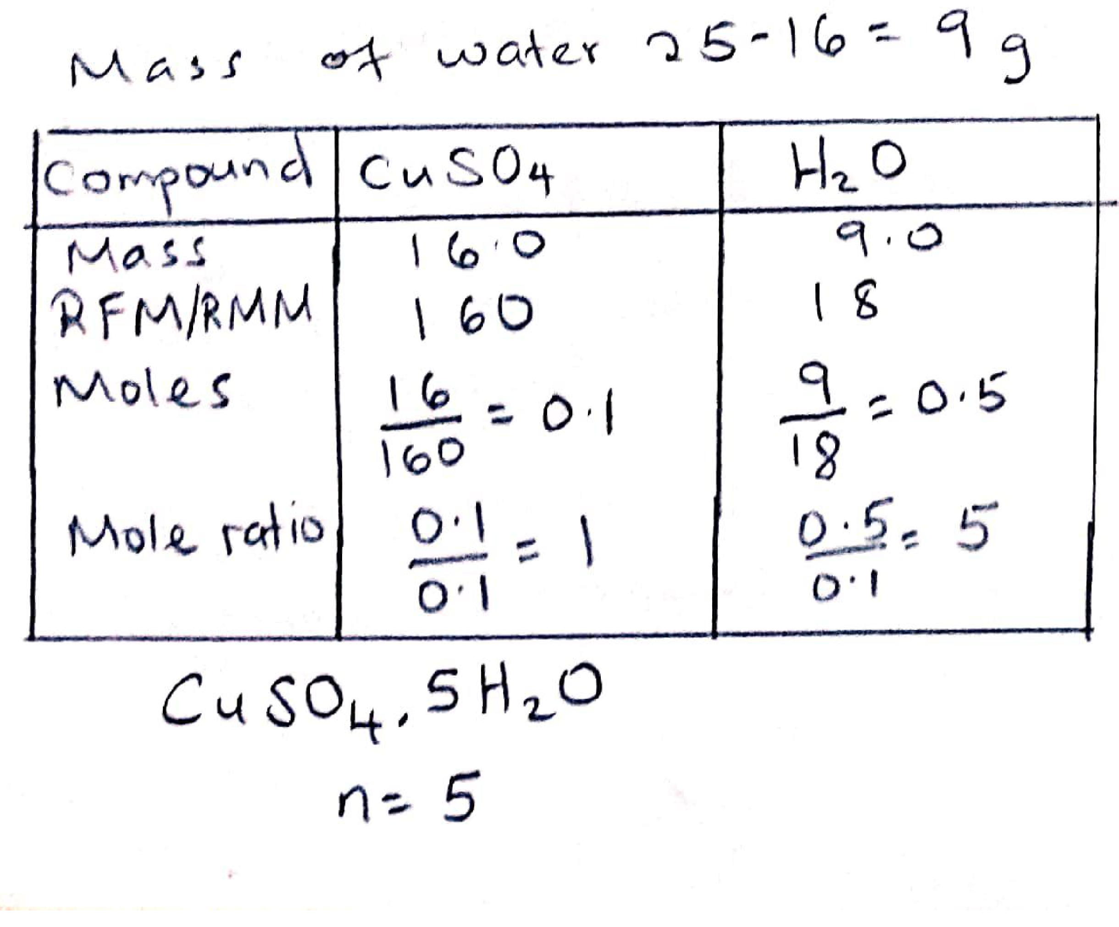
7. (a) III
(b) I and IV. Aluminium oxide is amphoteric.
(c) I and IV
8. Sodium chloride has strong ionic bonds in a giant ionic structure that require more energy to break compared to the weak Van der Waals forces of attraction between hydrogen chloride molecules.
9. (i) K
(ii) M
(iii) L
(iv) J
10. (a) (i) Downward delivery or upward displacement method
(ii) Upward delivery or downward displacement method
(b) (i) the gas is denser/heavier than air (ii) the gas is less dense/lighter than air.

11.
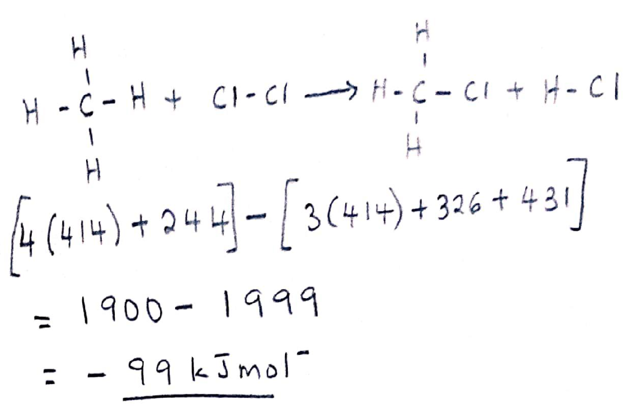
12. (a) There is no heating in the set up.
(b) The formation of aluminium oxide coating that prevents further reaction.
13.
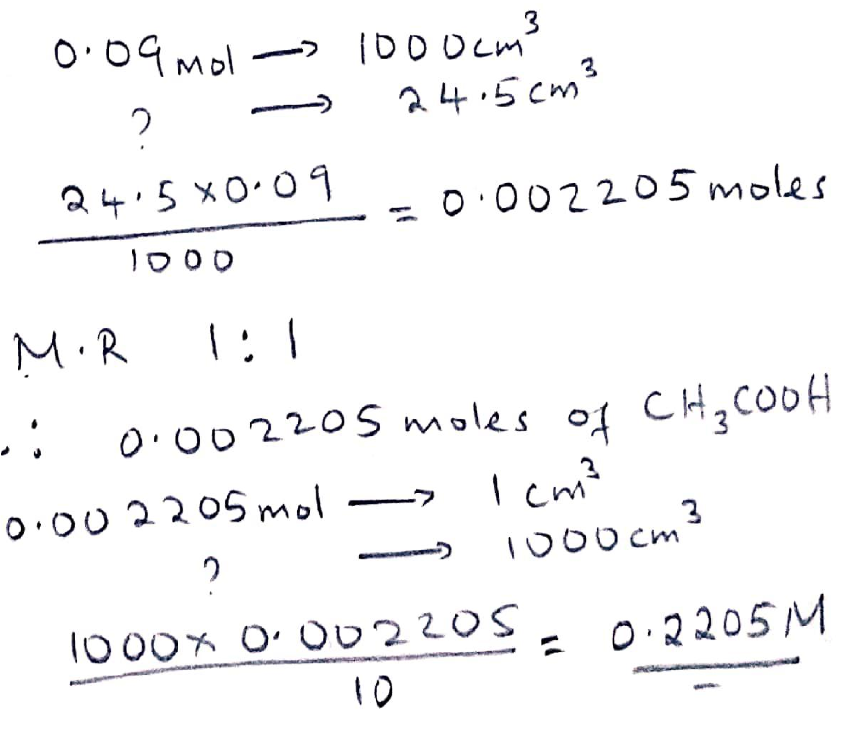
14. (a) carbon (IV) oxide / CO₂
(b) C (s) + O₂ (g) CO₂ (g) Carbon (charcoal) reacts with sufficient air to form carbon (IV) oxide.
15. Add water to the mixture and stir. Sodium chloride dissolves but not copper (II) oxide. Filter the mixture to obtain sodium chloride solution as the filtrate. Heat the filtrate to evaporate the water and remain with sodium chloride.
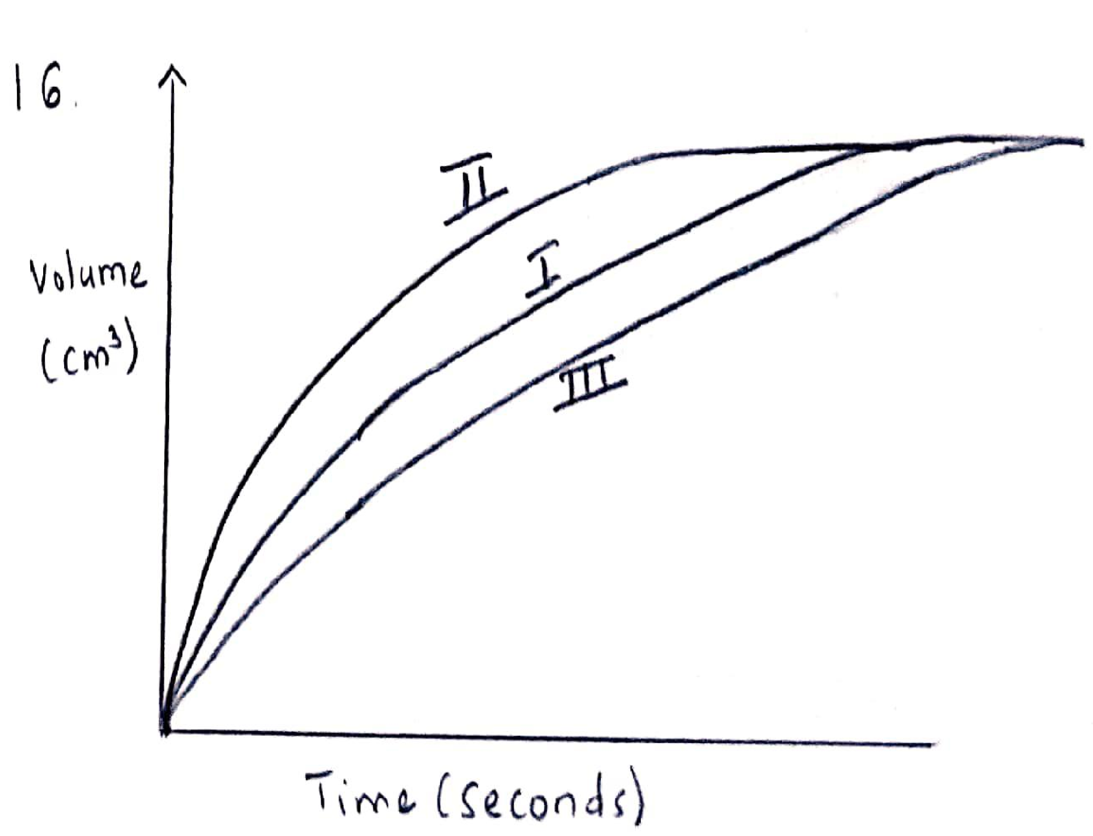
17. (i) Gas N – sulphur (IV) oxide ; gas M – oxygen OR gas N – oxygen ; gas M – sulphur (IV) oxide.
(ii) Platinum
(iii) Sulphur (VI) oxide crystals are readily hydrolyzed by water.

18. A brown solution is formed. Chlorine displaces iodide ions from the solution to form iodine.
19. (i) Al₂Cl₃
(ii)
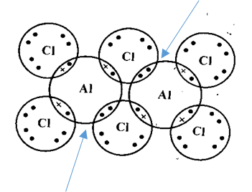
20. 2Mg (s) + O₂ (g) 2MgO (s) and 3Mg (s) + N₂ (g) Mg₃N₂ (s)
21.
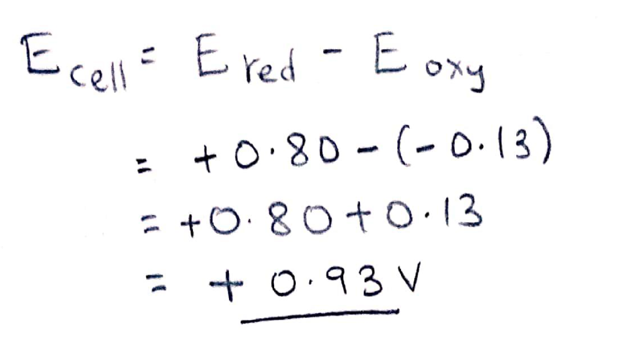
22. (i) 6HNO₃ (aq) + S (s) H₂SO₄ (aq) + 6NO₂ (g) + 2H₂O (l)
(ii) concentrated nitric (V) acid
(iii) - acid rain
- Eutrophication
23.
(a)
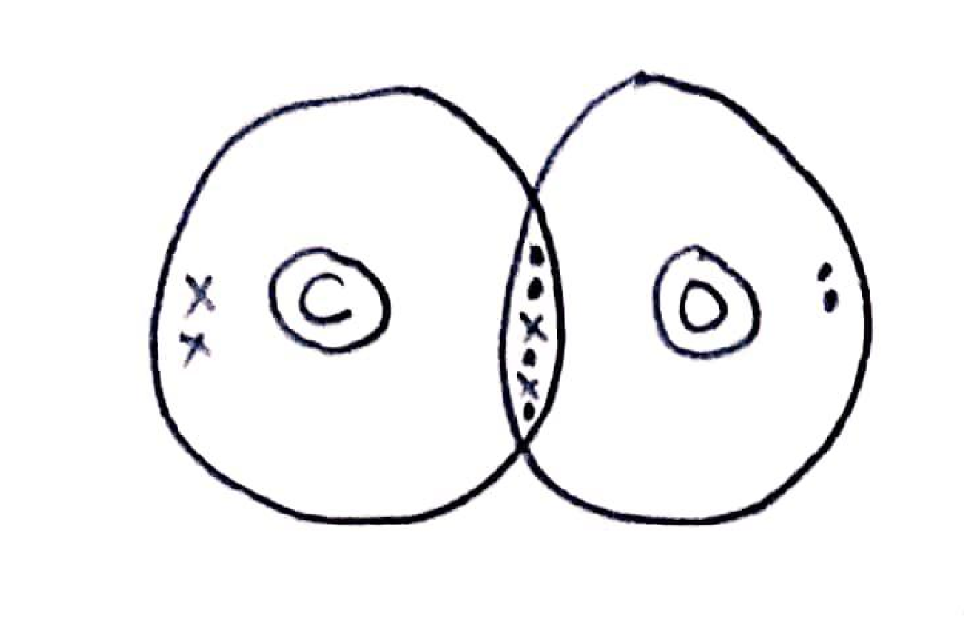
(b)
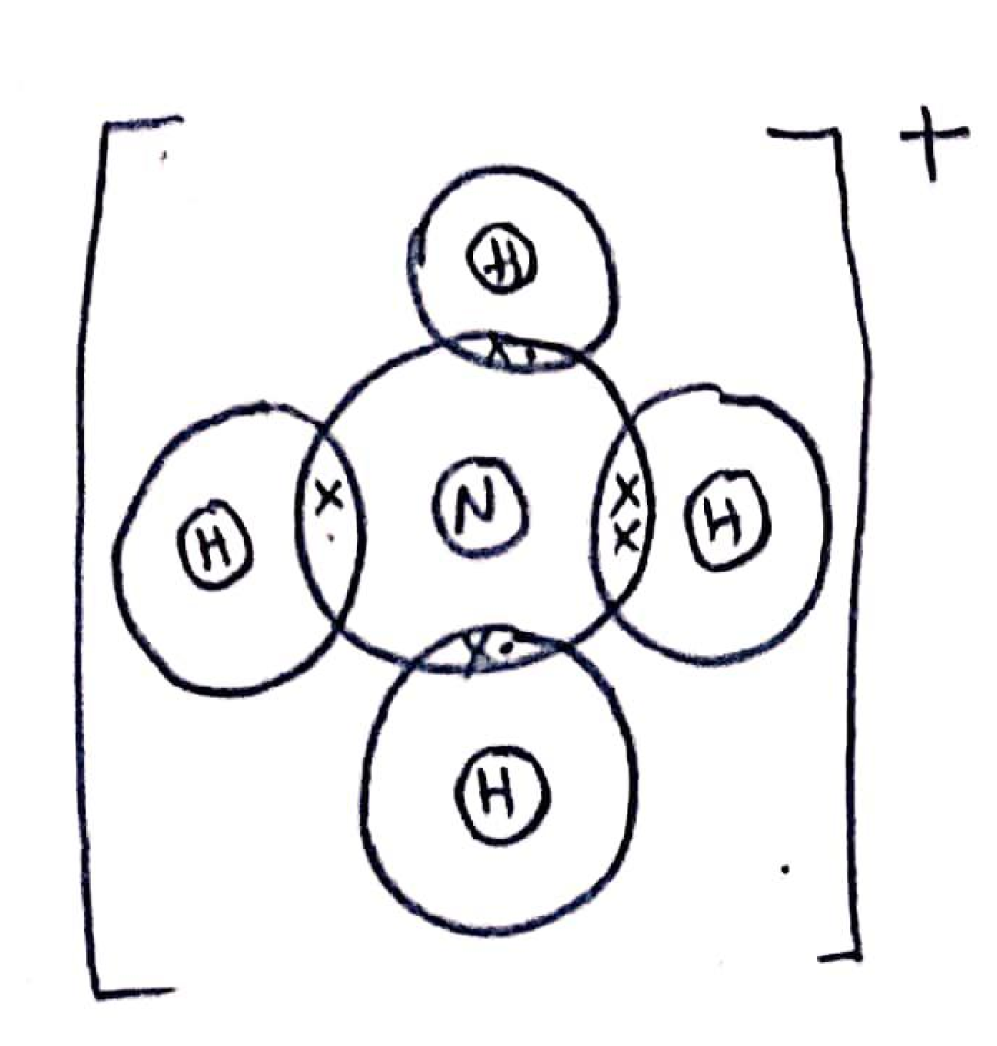
24. Add sodium hydroxide drop wise until in excess to separate test tubes with solutions containing copper (II) ions and iron (II) ions. A green precipitate is formed in the test tube with iron (II) ions while a pale blue precipitate is formed in test tube containing copper (II) ions.
25. (a) White sugar crystals are charred into a black mass. Concentrated sulphuric (VI) acid is a strong dehydrating agent and removed elements of water from sugar.
(b) Blue crystals turn white. . Concentrated sulphuric (VI) acid is a strong dehydrating agent and removed the water of crystalisation from the copper (II) sulphate crystals.

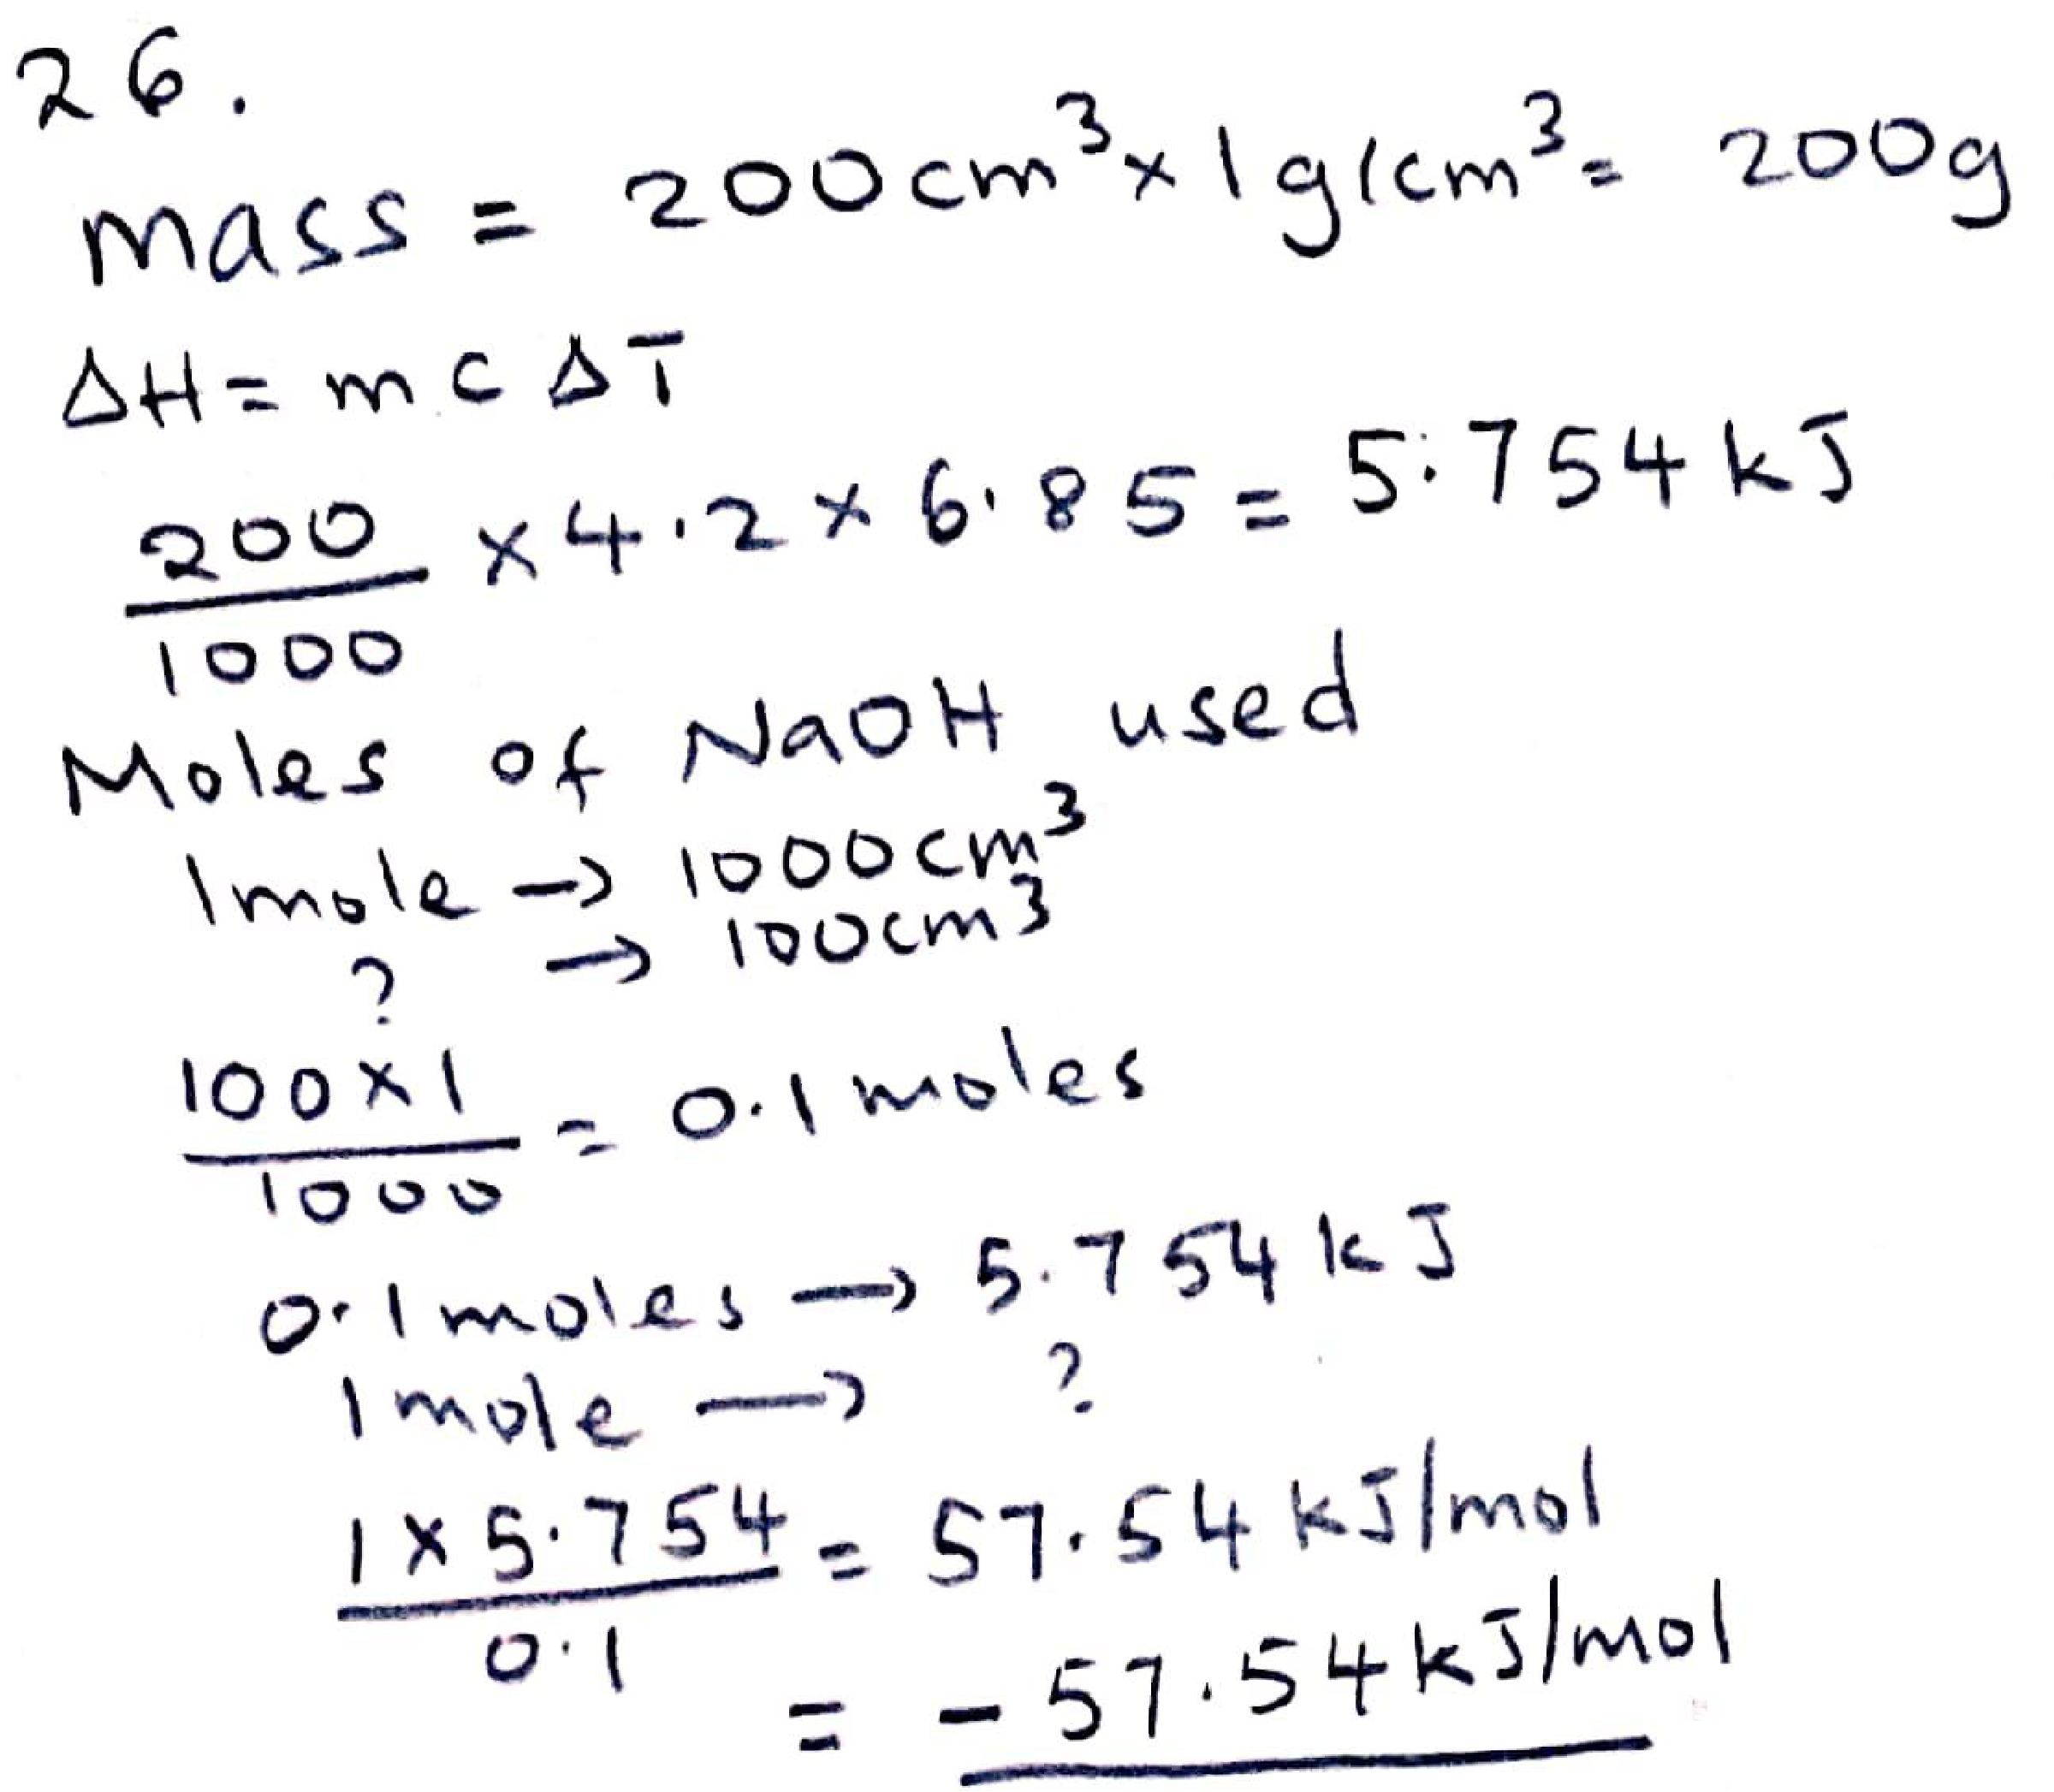

27. (a) residue
(b) Immiscibility

28. (a) S + 3(-2) = -2
S – 6 = -2
S = +4

(b) S + 3(-2) = 0
S – 6 = 0
S = +6

(c) 2S + 3(-2) = -2
2S – 6 = -2
2S = +4
S = + 2

