FORM 4 ENTRANCE EXAMS 2023
NAME……………………………………………..………...INDEX NUMBER…………………..

CLASS…………CANDIDATE’S SIGNATURE…………….…… DATE……………………….
233/2
CHEMISTRY
THEORY
Paper 2
Time: 2 Hours
Kenya Certificate of Secondary Education
233/2
CHEMISTRY
THEORY
Paper 2
Time: 2 Hours
INSTRUCTIONS TO CANDIDATES:
- Write your name and index number in the spaces provided above.
- Sign and write the date of examination in the spaces provided.
- Answer all the questions in the spaces provided.
- All working must be clearly shown where necessary.
- Mathematical tables and electronic calculators may be used.
For Examiner’s Use Only:

Question | Maximum score | Candidate’s score
1 | 12
2 | 12
3 | 11
4 | 11
5 | 13
6 | 10
7 | 11
Total | 80

This paper consists of 13 printed pages. Candidates should check to ascertain that all pages are printed as indicated and that no questions are missing.

1. The grid below shows part of the periodic table. Use it to answer the questions that follow. The letters do not represent actual symbols.

 |  |  |  |  |  | S | U | V
P | R |  |  |  |  | T | X | W
Q

(a) Which of the elements has the highest atomic radius? Explain. (2 marks)
…………………………………………………………………………………………………………………………………………………………………………………………………………………………………………………………………………………………………………………………………………………………………………………………………………
(b) Identify the most reactive Oxidizing agent. Explain. (2 marks)
…………………………………………………………………………………………………………………………………………………………………………………………………………………………………………………………………………………………………………………………………………………………………………………………………………
(c) Compare the atomic radius of P and R. Explain (2 marks)
……………………………………………………………………………………………………………………………………………………………………………………………………
…………………………………………………………………………………………………..
(d)Give the formula of one stable ion with an electron arrangement of 2.8 which is:
- A Negatively charged divalent ion. (2 marks)
………………………………………………………………………………………
- A Positively charged monovalent.
………………………………………………………………………………………
(e) Given that the mass number of W is 40. Write down the composition of its nucleus.
(2 marks)
………………………………………………………………………………………………………………………………………………………………………………………………………………………………………………………………………………………………………

(f) Write the formula of the compounds formed between.
(i) Element R and X. (1 mark)
………………………………………………………………………………………
(ii) Give one property of the structure formed when R and X bond. (1 mark)
………………………………………………………………………………………… ………………………………………...........................................................................
2. a) Sodium hydroxide pellets were accidentally mixed with sodium chloride-18.2g of the mixture was dissolve in water to make one liter of solution. 100cm3 of the solution was neutralized by 50cm³ of 0.45M Sulphuric acid.
i) Write an equation for the reaction that took place. (1mark)
…………………………………………………………………………………………
…………………………………………………………………………………………
ii) Calculate the;
I. Number of moles of the substance that reacted with sulphuric acid. (1 mark)

II. Number of moles of the substance that would react with sulphuric acid in the one litre of solution. (1 mark)

III. Mass of the unreacted substance in the one litre of solution. (2 marks)
(H = 1.0, Na 23.0, Cl 35.5, 0 = 16.0)

b) The diagram below shows an incomplete set-up used to prepare and collect ammonia gas.
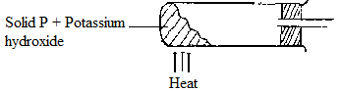

i) Name solid P. (1mark)
………………………………………………………………………………………
………………………………………………………………………………………
ii) Complete the diagram to show how a dry sample of ammonia gas can be collected.
(3 marks)
c) In an experiment, excess ammonia gas was passed over heated copper (II) oxide in a
combustion tube.
i) State the observation that was made in the combustion tube at the end of the experiment. (1 mark)
………………………………………………………………………………………………..
…………………………………………………………………………………………………
ii) What property of ammonia is shown in the above reaction? (1mark)

………………………………………………………………………………………………
iii) Give one use of ammonia. (1mark)
………………………………………………………………………………………………… …………………………………………………………………………………………………

3. (a) The scheme below was used to prepare a cleansing agent. Study it and answer the
questions that follow.
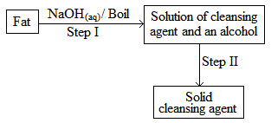
(i) What name is given to the type of cleansing agent prepared by the method above?
(½ mark)
……………………………………………………………………………………………
(ii) Name one chemical substance added in step II. (1 mark)
……………………………………………………………………………………………
(iii) What is the purpose of adding the chemical substance named in a (ii) above? (1 mark)
………………………………………………………………………………………………… ………………………………………………………………………………………………….
(iv) Name any other suitable substance that can be used in step I. (1 mark)
……………………………………………………………………………………………
(v)Explain how an aqueous solution of the cleansing agent removes oil during washing. (2 marks)
……………………………………………………………………………………………………………………………………………………………………………………………………………………………………………………………………………………………………………………………………………………………………………………………………………………………………………………………………………………………………………………….……………………………
…………………………………………………………………………………………………………………………………………………………………………………………………………………………………………………………………………………………………………………….... ………

(b) Study the scheme below and answer the questions that follow.

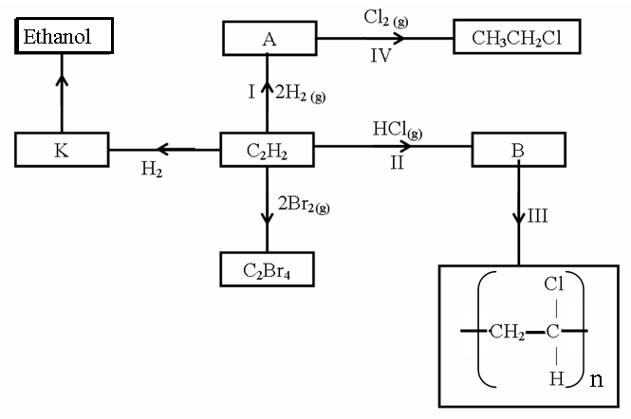
(i) Identify the catalyst used in step I (½ mark)
……………………………………………………………………………………………….
(ii) Name the compounds A and B (1 mark)
A…………………………………………….B……………..……………………………
(iii) Give one disadvantage of compound formed in step III (1 mark)
…………………………………………………………………………………………
…………………………………………………………………………………………
(iv) Name the reactions taking place at steps: (1 mark)
I…………………………………………IV...........................................................

(v) Describe how substance K is converted to ethanol (2 marks)
………………………………………………………………………………………………… ………………………………………………………………………………………………… …………………………………………………………………………………………………
…………………………………………………………………………………………………

4. The set-up below can be used to generate a gas.
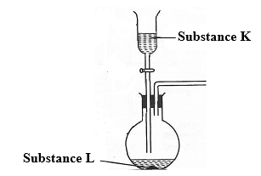
(a) (i) Complete the table below giving the names of substance K and L if the gases generated are carbon (IV) oxide and carbon (II) oxide. (2 marks)
Substance | Carbon (IV) oxide | Carbon (II) oxide
K
L
(ii) Complete the diagram to show how a sample of carbon (II) oxide can be collected.
(2 marks)
(iii) State two ways that can be used to distinguish carbon (IV) oxide from carbon (II)
oxide? (2 marks)
……………………………………………………………………………………………………
…………………………………………………………………………………………………….
……………………………………………………………………………………………….........
……………………………………………………………………………………………………..
(b) (i) In an experiment, carbon (IV) oxide gas was passed over heated charcoal held in a
combustion tube. Write a chemical equation for the reaction that took place in the
combustion tube. (1 mark)
…………………………………………………………………………………………………
(ii) State one use of carbon (II) oxide. (1 mark)
……………………………………………………………………………………………….

(c) The following set ups were used by Form Two students. Study and use them to answer the
questions that follow.
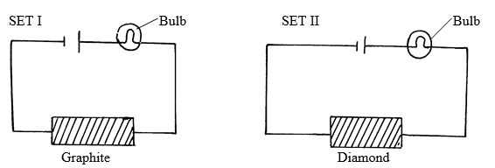
State and explain the difference in observation made in set up I and II above. (3 marks)
………………………………………………………………………………………………
………………………………………………………………………………………………
………………………………………………………………………………………………
5. (a) Define the term solubility. (1 mark)
………………………………………………………………………………………………… ………………………………………………………………………………………………… …………………………………………………………………………………………………
(b) In an experiment to determine the solubilities of two salts X and Y at different temperatures, a candidate recorded her observations as shown below.

Temperature (ºC) | 0 | 10 | 20 | 30 | 40 | 50 | 60 | 70 | 80 | 90
Solubility of X in g/100 g of H₂O | 14.3 | 17.4 | 20.7 | 25.0 | 28.5 | 33.3 | 40.0 | 47.0 | 55.0 | 64.0
Solubility of Y in g/100 g of H₂O | 25.0 | 27.5 | 30.0 | 32.5 | 35.0 | 37.6 | 40.1 | 42.4 | 45.0 | 48.0

(a) On the same axes plot the solubility curves of X and Y. (4 marks)

(b) From your graph to determine;
(i) The solubility of X and Y at 47 ºC
Solubility of X (1 mark)
……………………………………………………………………………..
Solubility of Y (1 mark)
………………………………………………………………………………
(ii) The temperature at which the two salts are soluble in water. (1 mark)
………………………………………………………………………………… (c) If 60g of X is dissolved in 100 g of water and heated to 90ºC, calculate the amount of salt that crystallized out if cooled to 20 ºC. (1 mark)
………………………………………………………………………………………… ……………………………………………………………………………………….. …………………………………………………………………………………………
(d) State what would happen if a mixture salt X in 100 g of water and 30 g of Y in 100 g of water were cooled from 90 ºC to 70 ºC. (3 marks)
………………………………………………………………………………………… ………………………………………………………………………………………… …………………………………………………………………………………………
(e) State one application of solubility. (1 mark)
……………………………………………………………………………………
6. (a) An ore is suspected to contain Lead metal. Describe the process that can be used to confirm the presence of Lead in the ore. (3 marks)
……………………………………………………………………………………….
………………………………………………………………………………………
………………………………………………………………………………………
……………………………………………………………………………………...
……………………………………………………………………………………….

(b) The diagram below shows students set-up for the preparation and collection oxygen Gas

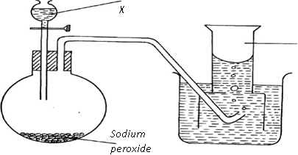
Oxygen

(i) Name substance X used (1mark)
……………………………………………………………………………………….
………………………………………………………………………………………
(ii) Write an equation to show the reaction of sodium peroxide with the substance named
(1mark)
……………………………………………………………………………………….
……………………………………………………………………………………….
(iii) Name a two other reagents that can be used to prepare oxygen gas in the laboratory using the apparatus shown above. (1 mark)
…………………………………………………………………………………………
………………………………………………………………………………………..
(iv) How would you confirm that the gas produced was oxygen. (1 mark)
………………………………………………………………………………………..
…………………………………………………………………………………………
(c) Apiece of cleaned magnesium ribbon was burnt in air to form a residue P which was then dissolved in water to form solution Q and a colourless gas R. A blue and red litmus paper was
(i) State the components of residue P. (1 mark)
………………………………………………………………………………………
………………………………………………………………………………………

- Identify colourless gas R …………………………………………................... (1 mark)

- Write an equation for the formation of solution Q and gas R. (1mark)
……………………………………………………………………………………….
………………………………………………………………………………………
………………………………………………………………………………………
7. The diagram below shows a set-up of apparatus that can be used to prepare nitrogen (IV) oxide. Study it and use it to answer the questions that follow
Lead(II)nitrate
boiling tube
Gas A
Liquid B
water
ice
Heat

(a) (i) Write the equation for the reaction that takes place in the boiling tube. (1 mark)
………………………………………………………………………………………
(ii) State the observations made in the boiling tube. (2 marks)
…………………………………………………………………………………… …………………………………………………………………………………….. ……………………………………………………………………………………..
……………………………………………………………………………………… (iii) Explain why lead (II) nitrate is preferred over other metal nitrates in this experiment. (1 mark)
………………………………………………………………………………………..
……………………………………………………………………………………….

(iv) Describe how gas A can be identified. (1 mark)
………………………………………………………………………………………… …………………………………………………………………………………………
(b) (i) Name liquid B (1 mark)
………………………………………………………………………………………..
(ii) Write a chemical equation to show how liquid B is formed in this experiment. (1mark)

(c ) (i) In another experiment, excess aqueous lead (II) nitrate solution was reacted with a solution which contained 2.34g of sodium chloride. Calculate the mass of precipitate formed in this reaction. (Pb = 207, Cl = 35.5, Na = 23) (3 marks)
………………………………………………………………………………………………………………………………………………………………………………………………………………………………………………………………………………………………………………………………………………………………………………………………………………………………………………………………………………………………………………………………………………………………………………………………………………
(ii) Write an ionic equation for the reaction that takes place when nitrogen (IV) oxide
reacts with aqueous sodium hydroxide. (1 mark)

……………………………………………………………………………………………………………………………………………………………………………………………………..

THIS IS THE LAST PRINTED PAGE

