
FORM 4 ENTRANCE EXAMS 2023

Name ………………………..………………………… Index No. ..………………..…….….
School ………………………………………………... Candidates Sign: …………....…..…
Date: ………………………………..

233/1
CHEMISTRY
Paper 1
THEORY

Time: 2 Hours

MARKING SCHEME

Kenya Certificate of Secondary Education (K.C.S.E)

INSTRUCTIONS TO CANDIDATES
- Write your name and index number in the spaces provided above.
- Sign and write the date of examination in the spaces provided above.
- Answer ALL the questions in the spaces provided.
- Mathematical tables and electronic calculators may be used.
- All working MUST be clearly shown where necessary.

FOR EXAMINERS USE ONLY

Questions | Maximum Score | Candidate’s Score
1 – 31 | 80

This paper consists of 12 printed pages.
Candidates should check the question paper to ensure that all the
Pages are printed as indicated and no questions are missing.

- State and explain the observation made when excess ammonia gas reacts with chlorine gas.(2mks)
Observation – white fumes (1mk)
Ammonia is ignited in chlorine to form hydrogen chloride. ½mk. The hydrogen chloride reacts with excess ammonia to form ammonium chloride (½mk)

- Hydrogen gas reacts with ethene to form ethane. Calculate the volume of hydrogen required to convert 14g of ethene to ethane at S.T.P. (3 mks)
C₂H_{2 (g)} + H_{2 (g)} C₂H₆
(C = 12, H = 1, molar gas volume at S.T.P. is 22.4 litres)
R.A.M of ethene = 28 ✓ ½
Moles of ethene = 14 = 0.5 ✓ ½
28
Moles of hydrogen = 0.5 ✓ ½ (3 mks)
Volume of hydrogen = 0.5 x 22.4 ✓ ½
= 11.2 liter ✓ ½

- The table below shows the relative molecular masses and boiling points of propan-l-ol and
Ethanoic acid.
 | Relative Molecular Mass | Boiling point (ºC)
Propan –l-ol | 60 | 36
Ethanoic acid | 60 | 118

Explain why the boiling point of Ethanoic acid is higher than that of propan –l-ol and yet they
have same molecular mass. (2mks)

Ethanoic acid has ability to form hydrogen bonds which are stronger than those of
Propan-1-ol. Hence requires more energy to break hydrogen bond in ethanoic acid. (2mks)

4. In an experiment an equal amount of iron fillings and sulphur powder was heated in a test tube. The mixture was left to cool then dilute hydrochloric acid added to it.
a) State the observations that were made;
(i) In the test tube. (1 mk)
– Red glow ✓ ½
- Black /grey solid formed ✓ ½

(ii) Dilute hydrochloric acid was added to the mixture after cooling. (1 mk)
– Ggas with a smell of a rotten ✓ ½ egg
- Effervescence ✓ ½ (3mks)

b) Write an equation for the reaction which occurred in a) (ii) above. (1 mk)
FeS_{(s)} + 2 HCl_{(aq)} 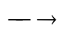FeCl_{2(aq)} + H₂S_{(s)} ✓1

5. a) What is meant by double decomposition? (1 mk)
It is a reaction between two soluble salts to give one soluble and one insoluble (precipitate) ✓1

b) Starting with 1M sodium sulphate solution, describe how you would prepare dry lead II sulphate. (2 mks)
Add solution of 1M sodium sulphate to an equal volume of 1M to lead (II) nitrate solution ✓1
- Filter ✓ ½ to obtain Lead sulphate as a residue and sodium nitrote as a filtrate
- Dry ✓ ½ the residue with filter papers to obtain the solid lead (II) sulphate (2mks)

6. 6.84g of aluminium sulphate were dissolved in 200cm³ of water. Calculate the Molar
concentrations of the sulphate ions in the solution.(Relative formula mass of aluminium
sulphate is 342) (3mks)

Moles of aluminium sulphate = ^{6.84}/₃₄₂ ( ½ mk)
= 0.02moles ( ½mk)
Concentration of Aluminium sulphate = 0.02 x 1000
200cm³
= 0.01moles ½mk
Conc. of sulphate ions = 0.01x 3 = 0.03M ½

7. The diagram below shows the set-up that was used to prepare and collect sulphur (iv) oxide gas.
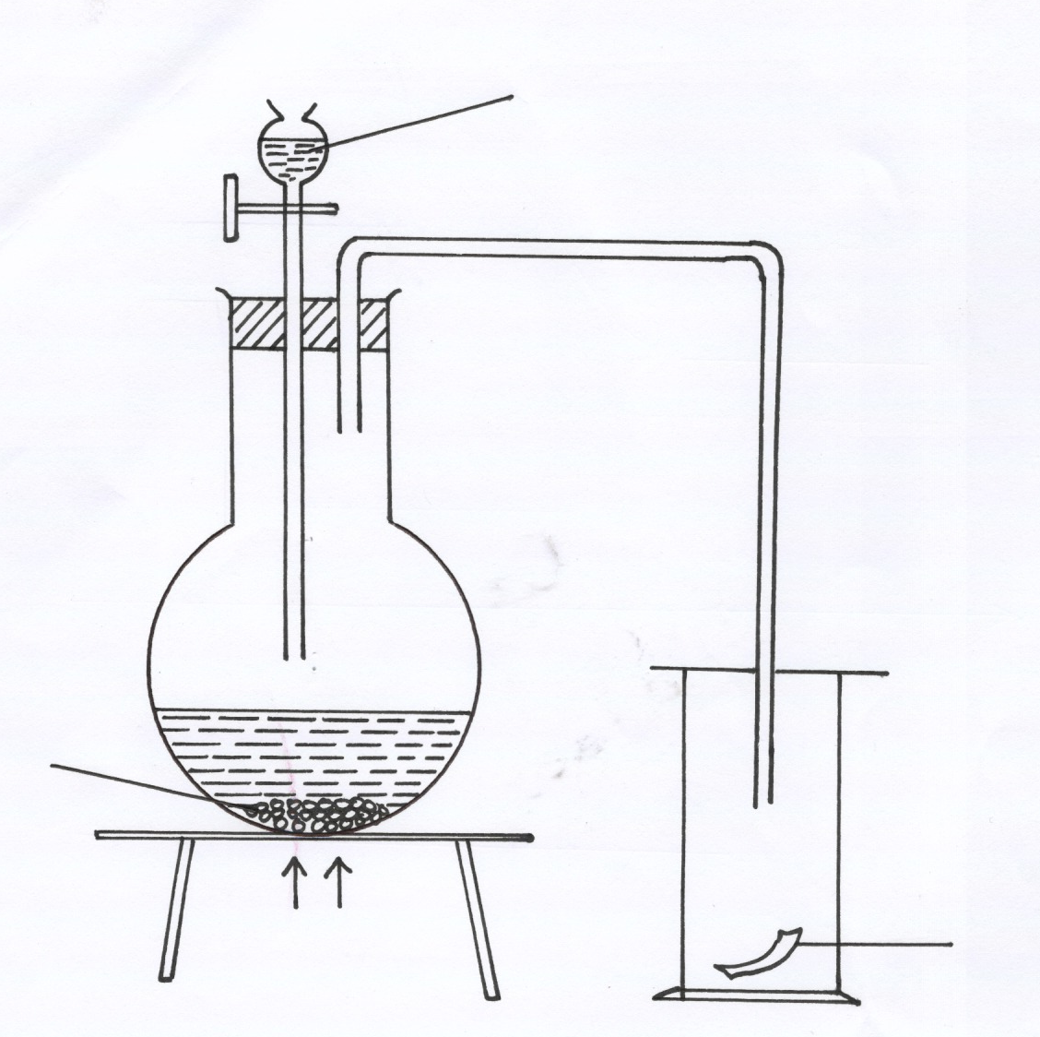
Hydrochloric acid
moist red flower
Solid P
Heat

(a) Identify solid P (1mk)

Sodium sulphite (√1mk)
(b) (i) Why is it possible to collect sulphur (IV) Oxide as shown? (1mk)

Sulphur (IV) oxide is denser than air.
(ii) What happened to the red flower. (1mk)
It was bleached / turn white(√1mk)

8. The set-up show how small pieces of red phosphorous are heated in Nitrogen (I) Oxide.
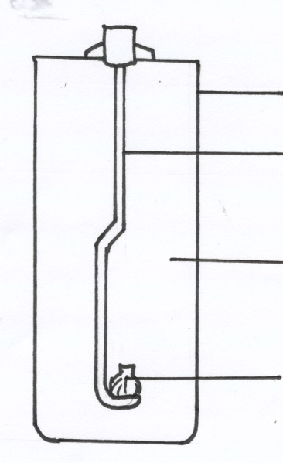
Gas jar
Deflagrating spoon

Nitrogen (I) oxide

Burning Phosphorous

a) Write an equation for the reactions which occur in the gas jar. (1mk)

P_{4(s)} + 10N₂O_{(g)} → 2P₂O_{5(s)} + 10N_{2(g)} (1mk)

Penalize: - ½ mk wrong/missing state symbols
- Fully unbalanced equation
- Fully wrong symbols /formula

b) Give one use of Nitrogen (I) oxide. (1mk)
– Manufacture of HNO₃ acid (1mk)
- Manufacture of explosives, Nylons and plastics

9. Study the following reactions scheme and answer the questions that follow.
Drops of

NH_{3 (aq)}
Drops of

NaOH _{(aq)}
SOLUTION C

White ppt. E
White ppt. D

Excess NH_{3 (aq)}
Excess NaOH _{(aq)}

Colourless solution
F
Colourless solution
G

a) Identify
(i) The cations in solution C. (1 mk)
Zn²⁺ ions ✓ 1

(ii) The white precipitate E. (1 mk)
Zinc Hydroxide /zn(OH)₂✓ 1

b) Why does precipitate E dissolve in excess sodium hydroxide solution. (1 mk)
its atmospheric ✓ ½ and it reacts with both acids and bases
c) Write the formula of the complex ion formed. (1 mk)
[Zn(NH₃)₄]²⁺ ✓ 1mk
10. Starting with copper metal, describe how a sample of crystals of copper (II) sulphate is
prepared in Laboratory. (3mks)
– Heat copper metal in air to form oxide of (CuO)
- Add excess CuO (Copper (II) oxide) to dilute sulphuric (VI) acid to ensure all acid has reacted.
- Warm to speed up the reaction
- Filter to obtain copper (II) sulphate solution as the filtrate.
- Evaporate the filtrate over water bath
- Filter and dry the crystals at s.t of between two pieces of filter papers. (accept any correct alt. method)

11. The Set up below shows an experiment where hydrogen gas was passed over heated copper (II)
Oxide.
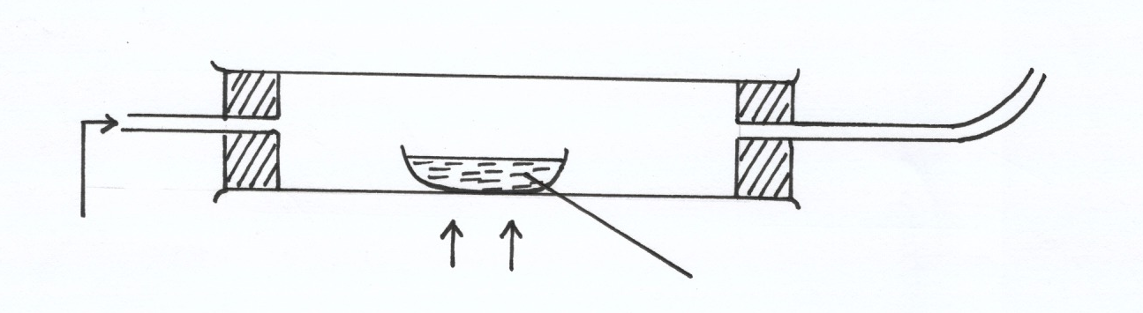
Dry hydrogen
Heat
Copper (II) oxide

a) State and explain the observations made in the combustion tube during the experiment. (3mks)

The hot black CuO turn Red-brown (√ ½mk)
Colourless liquid condenses and collects on cooler parts of combustion tube. (√ ½mk)
CuO is reduced by hydrogen to Cu metal (√1mk) While hydrogen is oxidized to water(√1mk)

b) Explain why heat is necessary in this experiment. (1mk)
To drive out the air which might cause reoxidation of Cu. (√ 1mk)

12. a) State Boyle’s law (1 mk)
The volume of a fixed mass of a gas is inversely proportional to its pressure at constant
temperature ✓ 1

b) 3 litres of oxygen gas at one atmosphere pressure were compressed to two atmospheres at constant temperature. Calculate the volume occupied by the oxygen gas . (2 mks)
P₁V₁ = P₂V₂
1 x3 = 2 x V₂
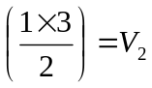
1.5 = V₂
V₂ = 1.5 litres

13. The table below gives some information about elements J,K,L,M which are in the same group of
The periodic table. Use the formation to answer the question that follow.

Element | 1st Ionization energy kJmol-1 | Atomic radius (nm)
J  K  L  M | 520  500  420  400 | 0.15  0.19  0.23  0.25

- What is meant by ionisation energy. (1mk)

Ionization energy is the minimum energy required to remove an electron from the outermost energy level of an atom in the gaseous state. (√1mk)

- State and explain the relationship between the variations in the first ionization energies and the
atomic radii. (2mks)
1st ionization energy decrease with increase in atomic radii. (√ 1mk)
When atomic radius increases the outermost electron gets further from the nucleus less
energy is thus required to remove it. (√ 1mk)

14. When a hydrocarbon fuel burn, one of the main products is acidic gas R.
(a) Identify gas R. (1mk)
R is CO₂ or carbon (IV) oxide✓1
(b) What two effects does gas R have when its concentration in the atmosphere exceeds its
acceptable levels. (1mk)
R leads to global warming / green house effect or acid rain ½

15. The graph below shows a curve obtained when water at 22ºC was heated for 10 minutes.
Sodium Chloride crystals were added and strongly heated for 15 minutes.
| | | | | |
0 5 10 15 20 25 30
22ºC
100ºC-
120ºC-
Time (min)
C

B
Temperature
ºC
A

a) What happened to water molecular between points A and B? (1mk)
They gain energy and more faster or the gains K.E hence intermolecular
distance increases.

b) Explain why the temperature rise is not steady between points B and C. (2mks)
Sodium chloride is an impurity, (√ 1mk), impurities raises the boiling point of water (√ 1mk)
if impure water boils 100ºC over a range of temperature (accept any one which is correct)

16. Use the table below to answer the questions that follow.

Substance | A | B | C | D | E
Symbol | R-COO-Na⁺ | CH₂OH  |  CHOH  |  CH₂OH | --CH₂ – CH₂ –  n | R-COOCH₂  |  R- COOCH  |  R- COOCH₂ | R-OSO₃-Na⁺

- Which substances is:
I ) A soapless detergent. (½mk)
C (√½mk)
II) An ester (½mk)
B (√½mk)
b) Give name to substance B (1mk)
Propane - 1, 2, 3 –triol (√1mk)

c) Write an equation for the reaction between the structure of substance D and Sodium hydroxide
solution. (2mks)
R-COOH + 3NaOH_{(aq)} → 3R-COO-Na⁺ + 3H₂O
OR
R-COOCH₂
|
R – COOCH + 3NaOH →3R – COO-Na++3H₂O
|
R – COOCH₂ ₍Ignore the state symbols)

17. When hydrated sample of iron (II) sulphate FeSO₄.nH₂O was heated until there was no further change in mass, the following data was recorded
Mass of evaporating dish = 78.94 g
Mass of evaporating dish + hydrated salt = 84.14 g
Mass of evaporating dish + residue = 81.78 g
Determine the empirical formula of the hydrated salt. (Relative Formula Mass of FeSO₄ = 152, H₂O = 18) (3mks)

Mass of FeSO₄ = 81.68 - 78.94 = 2.84
Mass of H₂O = 84.14 – 81.78 = 2.36

FeSO₄ | H₂O
Mass 2.84  RFM 152  Moles 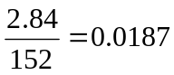 ½  Mole ratio 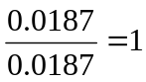 ½ | 2.36  ½  18  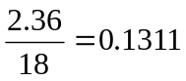 ½  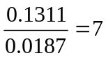 ½
E.F = FeSO₄. 7H₂O

18 Study the flow chart below and answer the questions that follow;
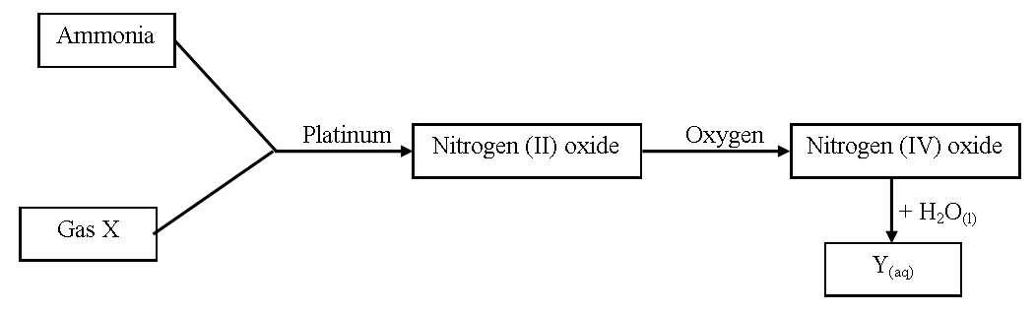
(a) Write an equation for the reaction between gas X and ammonia. (1mk)
4NH₃ (g) + 5O₂ (g) 4NO(g) +6H₂0(g)

(b) Write the formulae of the substances present in the mixture Y_{(aq)}. (1mk)
HNO₃  ½
HNO₂  ½

19. When hydrogen sulphide gas was bubbled into an aqueous solution of iron (III) chloride, a yellow precipitate was deposited.
(a) State another observation that would be made. (1mk)
The solution turned from yellow to pale green . ✓1

(b) Write an equation of the reaction that took place. (1mk)
2FeCl_{3(aq)} + H₂S_{(g)} 2FeCl_{2(aq)} + S_{(s)} + 2HCl_{(aq)} ✓ 1

20. The table below shows the atomic numbers of elements P, Q and R.

Element | P | Q | R
Atomic | 13 | 7 | 12

(a) Explain why P and R would not be expected to form a compound. (1mk)
Both are metals would only react by losing electrons. ✓1.

(b) Write an equation to show the effect of heat on the carbonate of R. (1mk)
RCO_{3(s)} RO_{(s)} + CO_{2(g)}
21. Element T consists of two isotopes ⁶²T and ⁶⁴T in the ratio 7 : 3 respectively. Calculate the relative atomic mass of element T. (3mks)
RAM = 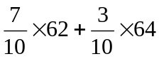
= 43.4 + 19.2
= 62.6

22. Name the process which takes place when:
(a) Solid carbon (IV) oxide changes directly into gas. (1mk)
Sublimation
(b) An alcohol reacts with alkanoic acid in the presence of sulphuric acid to form a sweet
smelling compound. (1mk)
Esterification

23. Briefly explain how you would obtain pure sample of lead (II) chloride from a mixture of lead (II) chloride and silver chloride. (2mks)
Add warm water to the mixture and stir  ½
PbCl₂ dissolves while AgCl does not  ½
Filter to obtain PbCl₂ as filtrate and AgCl as residue  ½
Evaporate the filtrate to obtain solid PbCl₂  ½

24. Explain the following observations; very little carbon (IV) oxide is evolved when lead carbonate reacts with dilute hydrochloric acid. (2mks)
PbCO₃ reacts with dilute HCl_{(aq)} to form an insoluble coat of PbCl₂ on the carbonate which
stops further reaction

25. The table below gives some properties of compounds P, Q, R and S
Compound | B.P. (ºC) | M.P. (ºC) | Conductivity in water
P | 77 | -23 | Does not conduct
Q | 74 | -19 | Does not conduct
R | -161 | -185 | Conducts
S | 2407 | 714 | Conducts

(a) Which one of the compounds in the table is ionic? Explain. (1mk)
S ½
It has high mp and bp due to strong ionic bonds/is a good conductor in
aqueous form

(b) Give the compound that is liquid at room temperature. (1mk)
P or Q (Any one) ✓ 1
26. When butan – 1 – ol is oxidized by acidified potassium dichromate, a weak organic acid is formed.
Draw and name the structural formula of the acid obtained from the above reaction. (2mks)
H H H O
| | | ||
H – C – C – C – C 
| | | |
H H H OH
Butanoic acid

27. Air was passed through several reagents as shown in the flow chart below.
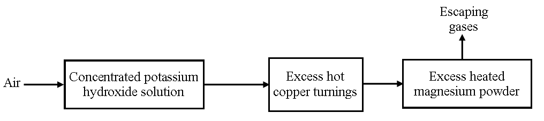
(a) Write an equation for the reaction that took place in the chamber with the magnesium
powder. (1mk)
3Mg_{(s)} + N_{2 (g)} Mg₃N_{2 (s)} 
(b) Name one gas that escapes from the chamber containing magnesium powder. Give a
reason for your answer. (1mk)
Argon – It is inert 

28. A sisal farmer found that when pricked by a sisal thorn, application of a little solution of ash
helped to relieve the pain from the affected area. Explain. (2mks)
Sisal thorns contain an acid  ½ which causes pains  ½. Ash solution being alkaline ½ neutralizes the acid lessening the pain ½

29. Explain why aluminium metal is not extracted from aluminium chloride. (2mks)
AlCl₃ is largely covalent ✓ 1
It is made of molecules which don’t conduct electricity

30. Distinguish between a strong acid and concentrated acid. (2mks)
A strong acid is one which ionizes completely in water to produce higher concentration of hydrogen ions. While concentrated acid is one which contains higher number of acid molecules per given volume of water.

31. In an experiment to determine the solubility of potassium nitrate at 30ºC, a saturated solution was heated in an evaporating dish until there was no further change in mass. The following data was obtained.
Mass of dish + solution = 128.9 g
Mass of dish + dry salt = 103.9 g
Mass of empty dish = 94.3 g
Determine the solubility of potassium nitrate at 30º C. (3mks)
Mass of solution = 128.9 – 94.3g = 34.6g ½
Mass of dry salt = 103.9 – 94.3 = 9.6g ½
Mass of solvent = 34.6 – 9.6 = 25g ½
25.0g of solvent contain 9.6g of solute
100g of solvent contain = 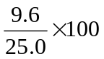 1
Solubility = 38.4g/100g water ½

