Name:…………………………………………….Index No. ……………………………Class:………….
Adm No: …………………..… Date: ……………………………….
Candidate’s Signature…………………….
233/2
CHEMISTRY
Paper 2
APRIL 2023
Time:2 HOURS
ARISE AND SHINE
FORM 4 TRIAL1 EXAMINATION- 2023
Kenya Certificate of Secondary Education (KCSE)
- Write your full name and admission number in the spaces provided above.
- Sign and write the date of examinations in the spaces provided above.
- Answer all questions in the spaces provided
- All working must be clearly shown where necessary
- Scientific calculators may be used
FOR EXAMINER’S USE ONLY
QUESTION | MAXIMUM SCORE | CANDIDATE’S SCORE
1 | 12
2 | 10
3 | 10
4 | 10
5 | 13
6 | 12
7 | 13
Total score | 80
- Use the grid below to answer the questions that follow. The letters do not represent the actual symbols of elements.

 |  |  |  |  | G |  | J
A | D |  | E | F |  | H | K | L
B
C

a Give the family name of the group in which elements B and C are members. (1 mark)
…………………………………………………………………………………………………………….
b State and explain the difference in reactivity between
i. A and D (1 mark)
………………………………………………………………………………………………………………………………………………………………………………………………………………………………
ii. J and K (1 mark)
……………………………………………………………………………………………………………………………………………………………………………………………………………………………..
c How does the atomic radius of E compare with that of F? Explain. (2 marks)
………………………………………………………………………………………………………………………………………………………………………………………………………………………………………………………………………………………………………………………………………………………………………………………………………………………………………………………………d Element R forms an oxide of the formula RQ₂ and belongs to period two. Indicate in the grid
the position of R. (1mark)
………………………………………………………………………………………………………………
e Identify an element with the lowest first ionization energy. (1 mark)
………………………………………………………………………………………………………………
f Give the formula of the compound formed between E and K. (1 mark)
………………………………………………………………………………………………………………
g Name of type of bond formed when A reacts with K. Explain. (2 marks)
………………………………………………………………………………………………………………………………………………………………………………………………………………………………………………………………………………………………………………………………………………
h Give one use of element L. (1 mark)
………………………………………………………………………………………………………………
i Give the electron arrangement of an ion of
C- (¹/₂ mark)
........................................................................................................................................................................
G- (¹/₂ mark)
........................................................................................................................................................................
2 a) State Hess’s law. (1 mark)
……………………………………………………………………………………………………………..
b) Use the information to answer the questions that follow
C_{(s)} + O_{2 (g)} $→$ CO_{2 (g)} $∆$H = -393kJ/mol
H_{2 (g)} + ½ O_{2 (g)} $→$H₂O _{(g)} $∆$H = -296KJ/mol
C₄H₁₀ + ¹³/₂ O_{2 (g)} $→$4CO_{2 (g)} + 5H₂O $∆$H = -2877KJ/mol
i Draw an energy cycle diagram relating heat of formation and combustion of butane. (2 marks)

ii Define enthalpy of formation. (1 mark)
………………………………………………………………………………………………………………………………………………………………………………………………………………………………
iii Calculate the heat of formation of butane (2 marks)
………………………………………………………………………………………………………………………………………………………………………………………………………………………………………………………………………………………………………………………………………………………………………………………………………………………………………………………………
iv Draw the energy level diagram of combustion of butane. (2 marks)

c The diagram below shows an energy level diagram for the formation of magnesium chloride.
Study it and answer the questions that follow.

Mg²⁺_{(g)} + 2Cl⁻_{(g)}

$∆$H_{B}
Energy MgCl_{2(s)} $∆$H_{C}

$∆$H_{A}
Mg²⁺_{(aq)} + 2Cl⁻_{(aq)}
Reaction path
i State the enthalpy changes represented by
A ………………………………………………………………………………………. (¹/₂ mark)
B ………………………………………………………………………………………. (¹/₂ mark)
C ……………………………………………………………………………………… (¹/₂ mark)
ii What is the relationship between $∆$H_{A} and $∆$H_{B} and $∆$H_{C}. (¹/₂ mark)
……………………………………………………………………………………………………………………………………………………………………………………………………………………………..
3. a) Study the flow chart below and answer the questions that follow.
Colourless solution 1
White precipitate 1
V
Residue
Colourless solution II
White precipitate II
Colourless solution III
Few drops of NaOH_{(aq)} Filter
of NaOH_{(aq)} and heat

Dilute hydrochloric acid

Pb(NO₃)_{2(aq)}

Residue V was yellow when hot and white when cold
- Identify
I white precipitate I (1 mark)
………………………………………………………………………………………………………………
II Solution II (1 mark)
………………………………………………………………………………………………………………
III Residue V (1 mark)
………………………………………………………………………………………………………………
- Write an ionic equation for the reaction of solution II with Pb(NO₃)_{2(aq)} (1 marks)
........................................................................................................................................................................
- Write observations that would be made when ammonia solution is added drop wise till in excess to the colourless solution II (1 ark)
……………………………………………………………………………………………………………..
b. The diagram below represents a set up for large scale manufacture of hydrochloric acid.
Study it and answer the questions that follow.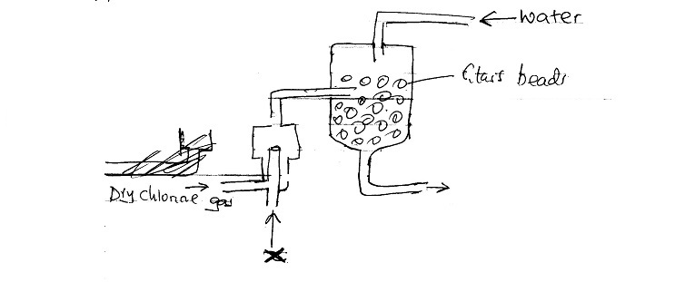
- Name substance X ( 1mark)
………………………………………………………………………………………………………..
- What is the purpose of glass beads? (1 mark)
……………………………………………………………………………………………………………
- Give one source of substance X used in the above process. (1 mark)
…………………………………………………………………………………………………………..
- Give two uses of hydrochloric acid. (2 marks)
………………………………………………………………………………………………………………
……………………………………………………………………………………………………………
4.a) Define solubility. (1 mark)
b). The saturated point of sodium nitrate in 100g of water is given for various temperature in ºC.
Temperature ºC | 0 | 20 | 40 | 60 | 80 | 100
Saturation point (g/100g of H₂0) | 73 | 88 | 104 | 124 | 148 | 180

- Plot a graph of saturation point of sodium nitrate against temperature. (3 marks)

- Using the curve determine the solubility at 70ºC (1 mark)

- 100g of solution of sodium nitrate is in saturated conditions of 10ºC. How many grams of the salt will have to be added to make the solution just saturation point at 80ºC. (2 marks)
………………………………………………………………………………………………………………………………………………………………………………………………………………………………………………………………………………………………………………………
- State two uses of solubility curve. (2 marks)
……………………………………………………………………………………………………………………………………………………………………………………………………………………
- Name a method of separating salts with different solubilities in the same solvent. (1 mark)
…………………………………………………………………………………………………
5. a. Give the names of the following compounds.
i. CH₃
H₃C C CH₃ (1 mark)
CH₃
ii. CH₃C$≡$CCH₂CH₃ (1 mark)

b. Describe a chemical test that can be carried out to distinguish between the compounds. (2 marks)
CH₃

H₃C C CH₃ and CH₃C$≡$CCH₂CH₃

CH₃

c. Study the flow chart below and answer the questions that follow.
Methanoic acid
Conc.H₂SO₄

Polymerization Step 1 Warm step 2
Ethene
Ethanol
M
L

Hydrogen nickel 150ºC
N

- Excess Cl₂
P
- UV tight
Step 3
i Name the compounds (2 marks)
I L …......................................
II N …………………………
ii. Draw the structural formula of compound M showing three repeating units. (1 mark)

iii. Give the reagent and condition used in step I. (2 mark)
………………………………………………………………………………………………………………………………………………………………………………………………………………………………
iv. State the type of reaction that takes place in (2marks)
I Step 2 …………………………………………

II Step 3 ………………………………………….

V The molecular formular of compound P is C₂H₂Cl₄. Draw the two structural formulae of compound P.
(2 marks)
6. a. The diagram below represent part of the structure of a sodium chloride crystal, the position of one of the sodium ions in the crystal is as shown as +
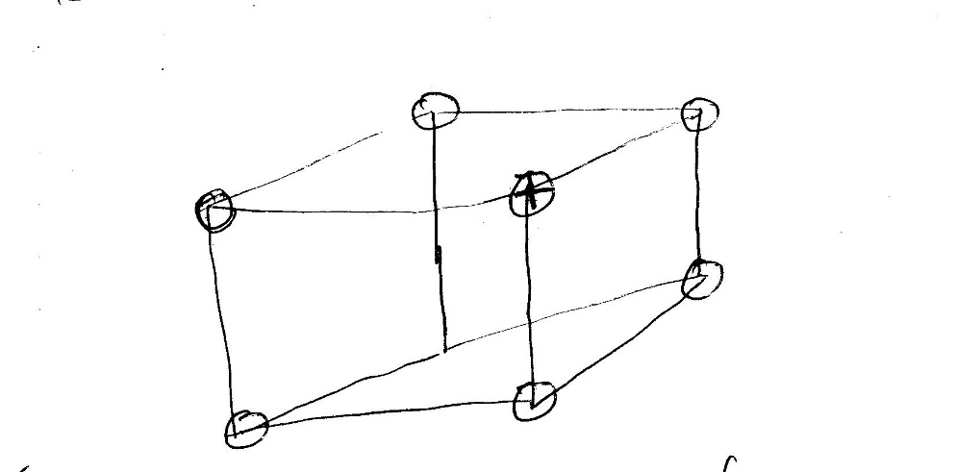
- On the diagram mark the positions of the other three sodium ions. (3 marks)
- The melting and boiling points of sodium chloride are 801ºC and 1413ºC respectively. Explain why sodium chloride does not conduct electricity at 25ºC but does at temperature between 801ºC and 1413ºC. (2 marks)
......................................................................................................................................................................................................................................................................................................................................................................................................................................................................................................b. Give a reason why ammonia gas is highly soluble in water. (1 mark).
…………………………………………………………………………………………………………………………………………………………………………………………………………………….
c. The structure of an ammonium ion is shown below.
H + X
N Y
H
H H

Name the types of bonds represented by the letters x and y. (1 mark)
…………………………………………………………………………………………………………….
d. Carbon exist in different crystalline forms some of these forms were recently discovered in soot and are called fullerenes.
i. What name is given to different crystalline forms of the same elements? (1 marks)
……………………………………………………………………………………………………………..
ii.Fullerenes dissolves in methyl/benzene while other forms of carbon do not. Given that soot is a mixture of fullerenes and other solid forms of carbon, describe how crystals of fullerenes can be obtained from soot. (3 marks)
………………………………………………………………………………………………………………………………………………………………………………………………………………………………………………………………………………………………………………………………………………
……………………………………………………………………………………………………………..
iii. The relative molecular mass of one of the fullerenes is 720. What is the molecular formula of this fullerene (C=12). (1 mark)
………………………………………………………………………………………………………………………………………………………………………………………………………………………………
7. Use the flow chart below to answer the questions that follow.
Q
T
R
Slaker
S
Kiln
P
Ammonia Ammoniated brine
Ammonia NH₄Cl + NaHCO₃
CaCl₂
Substance y NaHCO₃
Water
CaO
CaCO3 Substance x
Na₂CO₃
(a). Name the substance labeled . (2 marks)
X …………………………………………………………………………………………..
Y ……………………………………………………………………………………………
(b). Identify two substances that are recycled in the process (1 mark)
……………………………………………………………………………………………………………………………………………………………………………………………………………………………..
(c). Name the process that takes place in chamber
S…………………………………………………………………………………… (1 mark)
R………………………………………………………………………………….. (1 mark)

(d). Write an equation for the reaction taking place in the chamber labeled
Q …………………………………………………………………………………………. (1 mark)
T …………………………………………………………………………………………. (1 mark)
(e). Give any two uses of calcium chloride. (2 marks)
………………………………………………………………………………………………………………………………………………………………………………………………………………………………
(f). With the aid of an ionic equation, explain how sodium carbonate can be used to soften hard water.
(2 marks)
………………………………………………………………………………………………………………………………………………………………………………………………………………………………………………………………………………………………………………………………………………………………………………………………………………………………………………………………
(g). Other than softening of hard water, state two other uses of sodium carbonate. (2 marks)
………………………………………………………………………………………………………………………………………………………………………………………………………………………………………………………………………………………………………………………………………………………………………………………………………………………………………………………………

