MARKING SCHEME
CHEMISTRY PAPER 2
ARISE AND SHINE
FORM 4 TRIAL 1 EXAMINATION

MARCH/APRIL 2023
- (a). Alkali metals √¹
(b). (i) A is more reactive than D√¹ the outermost energy level electron in D is more firmly
held than in A
(ii). J is more reactive than√^{1/2} K the nuclear electron attraction is higher in J than in K ½

(c). F has a larger atomic radius than F√¹ nuclear change increases across the period√¹
(d). Before G OR
√ | G
F
(e) C√¹

(f) EK₃√¹ or AlCl₃√¹

(g). ionic/electrovalent bond√¹ it is formed through transfer of electrons from metal to a non-
metal√¹
(k) Use in light bulbs

(i) C - 2,8,8,8, √^{1/2}
G - 2,8 √^{1/2}
- (a). The enthalpy change of a reaction is the same regardless of the reaction happening in one
or many steps provided that the initial reactants and products are the same √¹
OR
The energy change in converting reactants to products is the same regardless of the route followed. √¹

(b)(i) √^{1/2} √^{1/2}
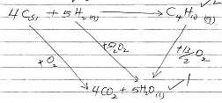

(ii). It’s the energy change when a compound is formed from its constituent element

(iii). ∆H₊ = 4 (-393) + 5 (-296) – (-2877) √¹
= -1572 – 1480 + 2877
= -3052 + 2877
= -175KJ/mol √¹
C (i) A - hydration energy√^{1/2}
B - Lattice energy√^{1/2}
C - Heat of solution√^{1/2}

(ii) ∆H_{C} = ∆H_{A} + H_{B}√^{1/2}

3. (a).(i) I Zn(OH)₂ (1mk) / Zinc hydroxide√¹
II Zinc chloride (1mk) / ZnCl₂√¹
III Zinc Oxide 1mk /ZnO√¹

(ii). Pb²⁺_{(aq)} + 2Cl⁻_{(aq)}$→$ PbCl_{2(s)} (1mk) penalize ½ for missing or wrong state symbols

(iii). A white precipitate which dissolves in excess ammonia solution observed√¹ (1mk)

(b).i) Hydrogen√¹
ii). To provide a large surface area one which the gas dissolves in water√¹

iii). - From electrolysis of aqueous sulphuric (VI) acid
- Form electrolysis of brine
- cracking of alkanes
- A by-product of petroleum industry any(1mk)

iv). Removing rust from iron/decaying of Iron before galvanizing and other metals before
Electroplating
- Sewage treatment
- Making dyes
- Manufacture of silver chloride used on photographic films (any 2 for 1 mark each)

4. (a). Solubility is the maximum amount of solute that can dissolve in a solvent at a particular temperature

4.(ii)

4.(b)i)

ii) 136($±1$) g/100g

iii) Saturation at 10ºC = 80g√^{1/2}
at 80ºC = 148g√^{1/2}
Salt added is 148 - 80√^{1/2} = 68g√^{11/2}

iv. - Use to determine the mass of crystals obtained when saturated solution cools
- Used to separate substances of different solubilities
- - used to know the effect of temperature on solubility of salts(Any 2 for 2 mk each)

v. Fractional crystallisation√¹

5.a) (i) 2,2 – dimethyl/propane√¹
(ii). Pent – 2 – yne √1

b). Ignite each, 2, 2 - dimethyl/Propane burns with a non-sooty flame while pent -2-yne burns
with a sooty flame
- Pass each through H⁺/KMnO₄ i. does not decolourise H⁺/KMnO₄ while (ii) decolourise
- Use bromine water in the dark.
C (i). L – Ethylmethanoate√¹
N – Ethane√¹
(ii) H H H H H H
C C C C C C √¹
H H H H H H
iii). Reagent - water hydrolysis Reagent-steam√¹
Condition conc.H₂SO₄ (liquid) condition H₃PO₄

iv Step 2 – Extrication
Step 3- Substitution

v CI CI CI CI
H C C H H C C CI
CI CI H CI

6.
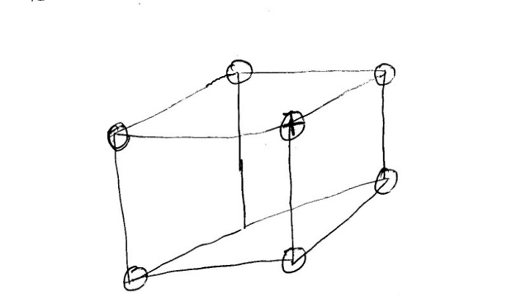
ii. At 25ºC-solid the ions are at fixed position while at above 801oc the ions are mobile√¹

b. It is polar√¹ due to hydrogen bonding

c x - covalent√^{1/2}
y - coordinate/Dative√^{1/2}

d.i) Allotropes√¹
ii). Add methylbenzene and swirl√¹ (stir) to dissolve fullerenes filter√¹ to obtain a solution of
fullerene in methylbenzene leave the solution in the solution for methylbenzene to
evaporate√¹
√¹
iii. n = $\frac{720}{12}$ = 60 (C₆₀√^{1/2})

7. (a). x - Carbon (IV) oxide√¹
y - Calcium hydroxide√¹
(Penalize fully if formula is given)
(b). Ammonia gas/NH₃
Carbon (IV) oxide/CO₂
Water/H₂O
(Any two for ½ mark each)

c). S - Thermal decomposition√¹
R - Filtration√¹

(d). Q – NaCl _{(aq)} + NH_{3 (g}) + CO_{2 (g)} + H₂O _{(l)} $→$ NH₄cl _{(aq)} + NaHCO_{3 (s)}
T - Ca(OH)_{2 (aq)} + 2NH₄c l_{(aq}) $→$ CaCl_{2 (aq)} + 2NH_{3 (g)+}2H₂O_{(l)}
(Penalize ½ mk for missing /wrong state symbols)

e). - Used in extraction of sodium metal
used in road surfacing due to its deliquescent nature
- Used for de-frosting snow in cold countries during winter.
(Any two for 1mk each)
(f) Mg²⁺ _{(aq)} + CO²⁻_{3 (aq)} $→$MgCO_{3 (s})
OR
Ca²⁺ _{(aq}) + CO²⁻_{3 (aq)} $→$ CaCO_{3 (s)} √¹
Carbonate ions react with either calcium ion or magnesium ions present in hard water to form insoluble calcium carbonate or magnesium carbonate which is precipitated out √¹

(g). - Used in paper industry
- Use in glass making
- Manufacture of detergents.
(Any two)

