MARKING SCHEME

CHEMISTRY
Paper 1

MARCH/APRIL 2023

- (a) X 2.8.1 √½
Y 2.8.2 √½
W 2.8.5 √½

(b) W Y X √½
Atomic radius decrease with increase in number of protons √1 /nuclear charge

- (a) When the air hole is open √1
(b) Slip a white manila paper or wooden splint √½ and quickly √½ remove before it catches fire. The middle part burns uniformly. √1
Accept the diagram which is well labeled.

- (a) Property Nacl Alcl₃
Bond ionic √½ covalent √½
Structure giant ionic √½ molecular √½
(b) There is effervescence √½ Aluminium chloride hydrolyses in water forming acidic solution. √½
- (a) Molten magnesium chloride has mobile ions √½ while sugar solution has molecules √½ /lack mobile ions.
(b)
 | Anode | Cathode
Observations | Green-yellow gas | Grey solid
Half-equations | 2Cl$\begin{matrix}- \\ (l)\end{matrix}$ Cl_{2(g)} + 2e | Pb²⁺_{(l)} + 2e Pb_{(s)}
Penalize ½ for missing or wrong stare symbols.

- (a) Ammonia gas/NH_{3(g)} √1
(b) White precipitate formed that dissolves in excess. √1
Ammonia gas dissolves in aqueous solution to form ammonium hydroxide √½ which react with zinc ions forming zinc hydroxide √½ that dissolves in excess to form tetra ammine zinc (II) ion.

- $\frac{\left(54 x 6\right)+\left(56x 92\right)+(57 x 2)}{100}$ √1
= 55.9 √1
No units
Penalize fully when units are shown.
- (a) The volume of a fixed mass of a gas is directly proportional to its absolute temperature at constant pressure. √1
(b) Increase in volume reduces the number √1. Collisions of gas molecules and the walls of the container causing a decrease in pressure. √1

- (a) Sodium ethanoate √1/CH₃ COONa
(b) (i) Ultra-violet light /sunlight.√1
(ii) CH_{4(g)} + 4Cl_{2(g)} CCl_{4(g)} + 4Hcl_{(g)}√1

- (a) Test (i) SO$\begin{matrix}2- \\ 3\end{matrix}$, SO$\begin{matrix}2- \\ 4\end{matrix}$ and CO$\begin{matrix}2- \\ 3\end{matrix}$ √1 present. at least two
Test (iii) A1³⁺ √1 only penalize Pb²⁺

(b) A1³⁺ √½ penalize Pb²⁺
SO$\begin{matrix}2- \\ 4\end{matrix}$ √½
- Potassium hydroxide is a strong base √½ and dissociate /ionizes fully √½ giving more OH⁻ ion √½
Ammonia is a weak base √½ hence ionizes partially in water.

- (a) Iron (II) sulphide
Dilute hydrochloric acid mark as a pair for 1 mark.
NB: Any sulphide and dilute acid.

(b) Hydrogen sulphide
Acidified potassium manganite (VII) is decoloured √½ and yellow deposit. √1
Sulphur (IV) oxide
Acidified potassium manganite (VII) is decolourised. √½

- Mass of carbon in CO₂ = $\frac{12}{44}$ x 5.28 = 1.44g √½
Mass of hydrogen in H₂O = $\frac{2}{18}$ x 1.62 = 0.188 √½
Mass of oxygen = 2.58g – (1.44 + 0.18) = 0.96g √½

C | H | O
$\frac{1.44}{12}$  $\frac{0.12}{0.06}$  2 | $\frac{0.18}{1}$  $\frac{0.18}{0.06}$  3 | $\frac{0.96}{16}$ √½  $\frac{0.06}{0.06}$ √½  1
C₂ H₃ O₁ √½

- (a) Calcium oxide √1 Reject any other
(b) (i) Black Copper (II) oxide changes to brown copper metal √1
(ii) Reducing agent √1
- (a) Water √1
(b) Ethane √1
(c) (i)
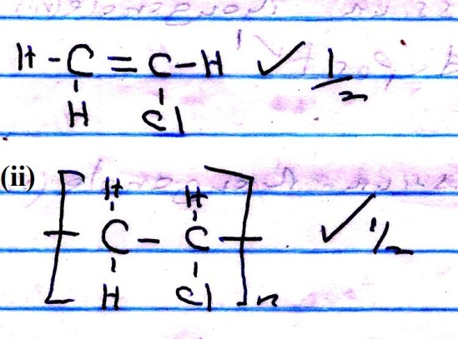

- Drop a piece of sodium metal in distilled water √1 in a beaker, to the resulting solution add dilute nitric (IV) acid. √½ Evaporate √½ the resulting mixture to saturation and cool √½ for crystals to form, dry √½ crystals between filter papers.

- (a) (i) Cold √½ and dilute √½ sodium hydroxide.
(ii) Sodium hypochlorite (NaOCl) dissociates √½ giving out nascent oxygen √½ to the dye causing it to bleach.
(b) Introduce a glass rod dipped in concentrated ammonia solution, √½ white fumes formed. √½

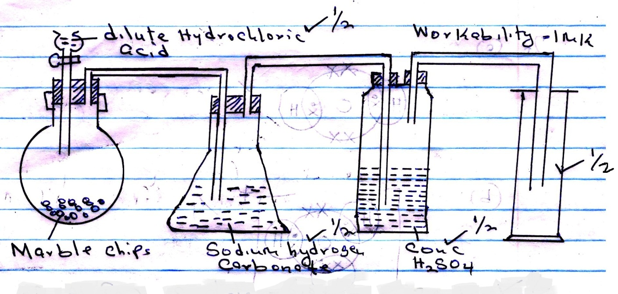

- Moles of Al₂ (SO₄)₃ sulphate = $\frac{6.84}{342}$ = 0.02 moles √½
Molarity = $\frac{0.02 x 1000}{400}$ = 0.05m √½
Al₂ (SO₄)_{3(a)} 2 Al$\begin{matrix}3+ \\ (aq)\end{matrix}$ + 3 SO₄$\begin{matrix}2- \\ 09\end{matrix}$ √½
Molarity of SO$\begin{matrix}2- \\ 4\end{matrix}$ = 0.05 x 3 = 0.15m √½
Number of SO$\begin{matrix}2- \\ 4\end{matrix}$ = 0.15 x 6.0 x 10²³ √½
= 9.0 x 10²² ions √½
Accept alternative method

- Burning magnesium √
Continues to burn, √½ a mixture of white solid and black specks formed. √½ Heat √½ produced decomposes carbon (IV) oxide to carbon and oxygen. √½

Burning splint
It extinguished/put off √½ carbon (IV) oxide does not support combustion. √½

- (a)
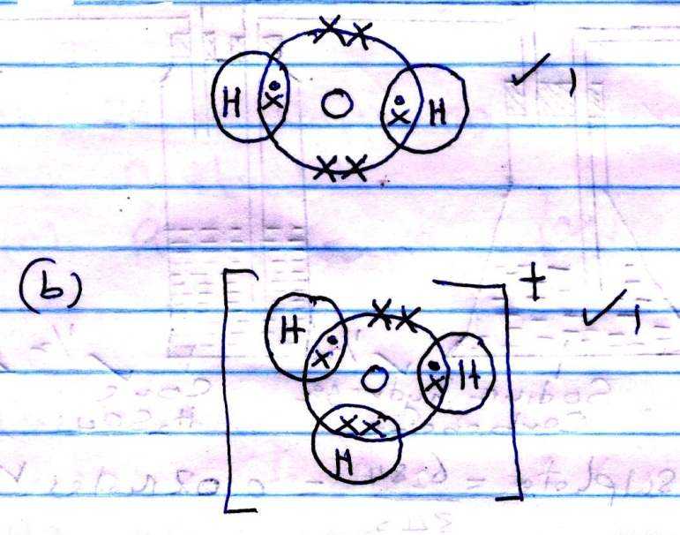
(c) Water molecule has lone pair of electrons which it can dissolve to H⁺ √1

- Heat zinc sulphate to saturation √½ and allow saturated solution to cool √½ for crystals to form.

- 2 C₂H_{6(g)} + 5 O_{2(g)} 4 CO_{2(g)} + 6 H₂O_{(l)} √1
Volume of Ethane burned = $\frac{2 x 40}{5}$ = 16cm³ √½
Volume of ethane remaining = 120 – 16 = 104cm³√½
Volume of carbon (IV) oxide formed = $\frac{4 x 40}{5}$ = 32cm³

- Brown fumes evolved, √1 carbon reduces nitric (V) acid to Nitrogen (IV) oxide √½ and water and carbon is oxidized to carbon (IV) oxide √½

- (a) Mg(H CO₃)₂ √½
Ca (HCO₃)₂ √½
(b) Contain calcium ions √1 required in bone formation and strengthening of teeth/ improve taste.

(c) Mg(H CO₃)_{2(aq)} Mg CO_{3(s)} + CO_{2(g)} + H₂O_{(l)}
Or
Ca (HCO₃)_{2(aq)} COCO_{3(s)} + CO_{2(g)} + H₂O_{(l)}
Penalize ½ mark for missing or wrong symbol.

- (i) No effervescence /No bubbles √½
Hydrogen chloride gas in methylbenzene is not ionized. √½

(ii) Effervescence/ Bubbles of gas √½
Hydrogen chloride gas in methylbenzene ionizes and it is acidic. √½

- (a) It is the heat change when one mole of a substance dissolves in water to form infinitely dilute solution / very dilute. √1
(b) Heat change = $\frac{50}{1000}$ x 4.2 kJ/Kg/K x 7 √½
= 1.47KJ √½
Moles of copper (II) sulphate = $\frac{50 x 0.2 }{1000}$ √½
= 0.01 moles √½
Molar heat of displacement of Copper (II) ions
$\frac{1 x 1.47}{0.01}$ √½ = -147 KJ/mole√½

- ΔH(-) sign must be shown and units must be correct.
- Penalize fully if missing.
- (a) Vanadium (V) oxide √1 or
Platinum
(b) Reaction between Sulphur (VI) oxide and water is highly exothermic √1 and hence boil the acid
- (a) Heat absorbed is used to weaken the forces √1 of attraction between the particles resulting in change of state.
Accept intermolecular forces.
(b) (i) Latent heat of vaporization √½
(ii) It is negative √1

- Mass of saturated solution = (26.8g – 15.86g)
= 10.94g √½
Mass of a solute = (16.86 – 15.86)g
= 1g √½
Mass of solvent = 10.94g – 1g = 9.94g √½

If 1g 9.94g of water
? 60g of water

=$\left(\frac{60 x 1}{9.94}\right)$ = 6.03g √½
Mass of saturated solution = (60 + 6.03)g √½ = 66.03g √½

