Name: _______________________________________ Index No: ___________________

School: __________________________________Candidate’s Sign______________________

Date: ____________________________________

233/1
CHEMISTRY
Paper 1
THEORY

March/April, 2023
Time: 2 Hours

ARISE AND SHINE TRIAL EXAMINATIONS
Kenya Certificate of Secondary Education (KCSE)

Instructions to Candidates:
- Write your Name and Index Number in the spaces provided.
- Sign and write the date of examination in the spaces provided above.
- Answer ALL questions in spaces provided in the question paper.
- ALL working must be shown clearly where necessary.
- Mathematical tables and silent non-programmable calculators may be used.

For Examiner’s Use Only

Questions | Maximum Score | Candidate’s Score
1 -29 | 80

- The electron arrangement of ions X⁺, Y²⁺ and W³⁻ are 2.8, 2.8 and 2.8.8 respectively.
- Write the electron arrangement of their atoms. (1½ marks)

- Arrange the atoms in the order of increasing atomic radius starting with the smallest. Give a reason for the order. (1½ marks)
…………………………………………………………………………………………………………………………………………………………………………………………………………………………………………………………………………………………………………………………………………………………………………………………………………………………………………………………………………………………………………………………………………………………………………………………………………………………………………………………………………………………………………………………………………………………………………
- The diagram below shows a Bunsen burner when in use.
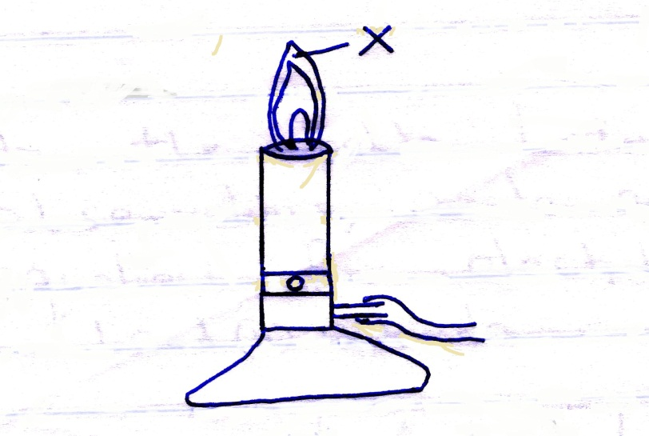
- State the condition under which the Bunsen burner produces the flame shown in the diagram above. (1 mark)
………………………………………………………………………………………………………………………………………………………………………………………………………………………………………………………………………………………………………………………………………………………………………………………………………………………………………………………………
- Describe an experiment that can be carried out to confirm that the region labeled X is the hottest. (2 marks)
………………………………………………………………………………………………………………………………………………………………………………………………………………………………………………………………………………………………………………………………………………………………………………………………………………………………………………………………
- (a) Chlorides of Sodium and aluminium are given in the table below. Complete the table by writing the properties of the chlorides. (2 marks)

Property | NaCl | AlCl₃
Bonding
Structure
(b) Sodium carbonate powder were added to aqueous solution of aluminium chloride. State and explain the observation made. (1 mark)
………………………………………………………………………………………………………………………………………………………………………………………………
- (a) Explain why molten Magnesium Chloride conducts electric current while sugar solution do not. (1 mark)
………………………………………………………………………………………………………………………………………………………………………………………………
- Complete the table below by writing the observations, anode and cathode half-equations for electrolysis of molten Lead (II) Chloride. (2 marks)
 | Anode | Cathode
Observations
Half-equations

- The set-up below was used during a class experiment. Study it and answer the questions that follow.
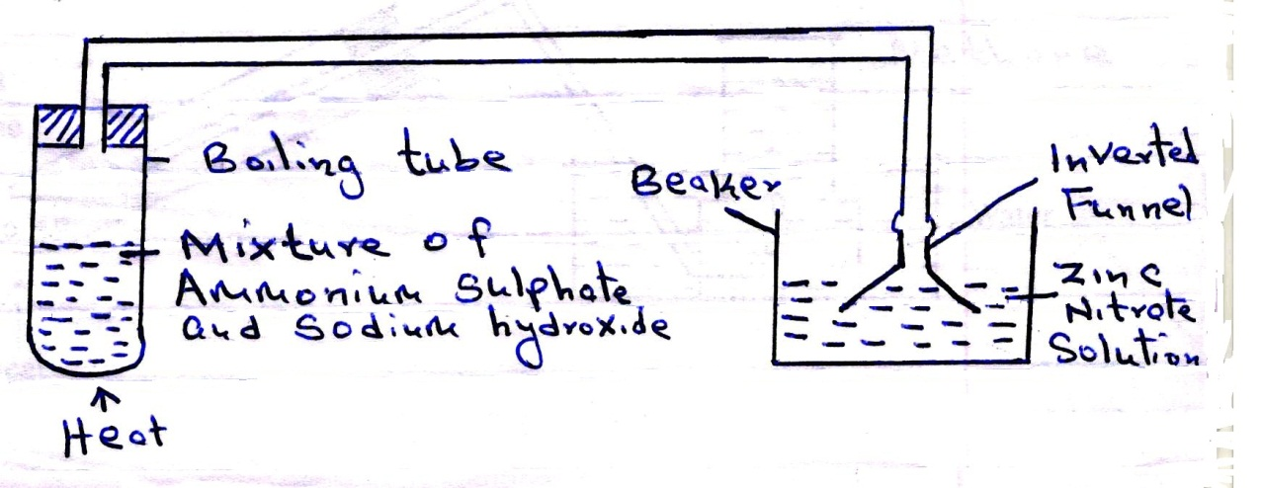
- Identify the gas produced in the boiling tube. (1 mark)
………………………………………………………………………………………………………………………………..………………………
- State and explain the observation made in the beaker. (2 marks)
………………………………………………………………………………………………………………………………………………………………………………………………………………………………………………………………………………………………………………………………………………………………………………………………………………………………………………………………………………
- The following data refers to element X.
Isotope | X₁ | X₂ | X₃
Mass of isotope | 54 | 56 | 57
% abundance | 6 | 92 | 2
Calculate the relative atomic mass of X. (2 marks)
……………………………………………………………………………………………………………………………………………………………………………………………………………………………………………………………………………………………………………………………………………………………………………………………………………………………………………………………………………………………………………………………………………………………………………………………………………………
- (a) State the Charles’ Law (1 mark)
………………………………………………………………………………………………………………………………………………………………………………………………
(b) Using Kinetic Theory, explain why the pressure of a fixed mass of a gas decreases with increase in volume at a constant temperature. (2 marks)
………………………………………………………………………………………………………………………………………………………………………………………………………………………………………………………………………………………………………………………………………………………………………………………………
- The set up below was used to prepare a sample of methane gas. Study it and answer the questions that follow.
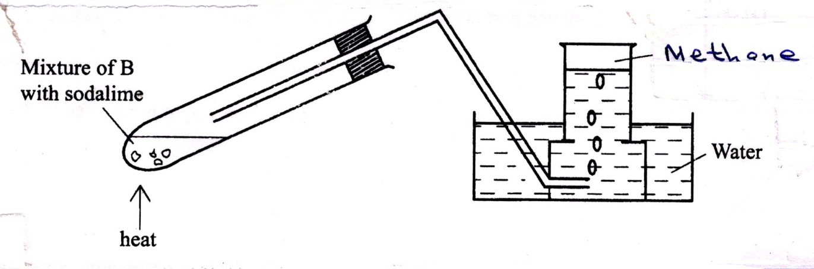

- Identify substance B (1 mark)
……………………………………………………………………………………………………………………………………………………
- (i) Give one condition that is necessary for methane to react with chlorine gas. (1 mark)
…………………………………………………………………………………………………………………………………………………….
(ii) Write an equation for the reaction that occurs when methane react with excess chlorine gas. (1 mark)
……………………………………………………………………………………………………………………………………………………………………………………………..
- Chemical tests were carried out on separate samples of water from the same river. The observations made were recorded as shown in the table below.
 | Test | Observation
 | Addition of few drops of barium chloride | White precipitate formed
 | Addition of sodium hydroxide dropwise until in excess | White precipitate dissolves
 | Addition of aqueous ammonia until in excess | White precipitate insoluble
 | Addition of acidified barium chloride | White precipitate
- State the inference in;
Test (i) …………………………………………………………………………. (1 mark)
Test (ii) ………………………………………………………………………… (1 mark)
- Identify the cation and anion present in the sample of water. (1 mark)
…………………………………………………………………………………………………………………………………………………………………………………………………………………………………………………………………………………………………………………….
- 2M potassium hydroxide has higher pH value as compared to 2M ammonia solution. Explain. (2 marks)
………………………………………………………………………………………….….……………………………………………………………………………………………….….…………………………………………………………………………………………………………….
- (a) Name two reagents used to prepare hydrogen sulphide gas. (1 mark)
……………………………………………………………………………………………………………………………………………………………………………………………………
(b) Hydrogen Sulphide and Sulphur (IV) oxide were separately bubbled into acidified potassium manganite (VII) solution. State and explain the observation made in each case. (2 marks)
Hydrogen sulphide
……………………………………………………………………………………………………………………………………………………………………………………………………………………………………………………………………

Sulphur (IV) oxide
……………………………………………………………………………………………………………………………………………………………………………………………………………
- An organic compound Y was analysed and found to contain carbon, hydrogen and oxygen only. 2.58g of Y on complete combustion produced 5.28g of carbon (IV) oxide and 1.62g of water. Determine the empirical formula of Y. (C = 12.0 H = 1.0 O = 16.0) (3 marks)
………………………………………………………………………………………………………………………………………………………………………………………………………………………………………………………………………………………………………………………………………………………………………………………………………………………………………………………………………………………………………………………………………………………………………………………………………………………………………………………………………………………………………………………………………………………………………………………………………………………………………………………………………………………………………………………
- The set-up below was used to investigate the properties of ammonia gas.
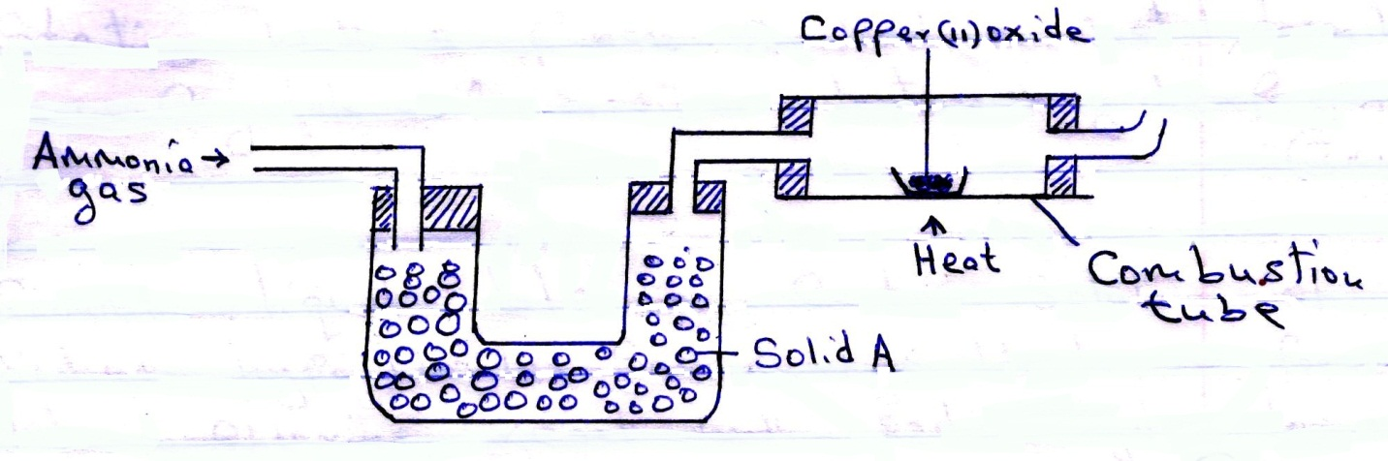
(a) Identify solid A. (1 mark)
………………………………………………………………………………………………
(b) State
- The observation made in the combustion tube. (1 mark)
…………………………………………………………………………………………………………………………………………………………………………………………………………………………………………………………………………………………………………
- Property of ammonia gas shown in this experiment. (1 mark)
………………………………………………………………………………………………………………………………….……………………………………………………………………………………………………………………………………………………………………….

- Study the flow chart below and answer the questions that follow.
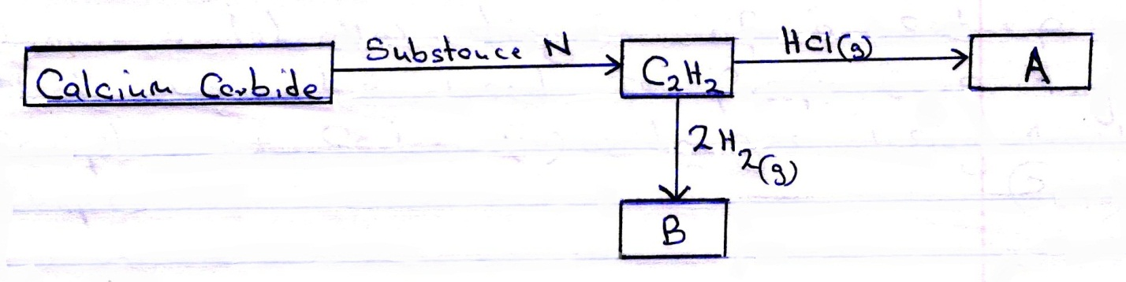

- Identify substance N (1 mark)
…………………………………………………………………………………………………………………………………………………………………………………………………………………………………………………………………………………………………………
- Name substance B (1 mark)
…………………………………………………………………………………………………………………………………………………………………………………………………………………………………………………………………………………………………………
- (i) Draw the structural formula of substance A. (½ mark)
…………………………………………………………………………………………………………………………………………………………………………………………………………………………………………………………………………………………………………
(ii) Draw one repeat unit of polymer formed by substance A. (½ mark)

- Starting with a piece of sodium metal, describe how crystals of sodium nitrate may be prepared. (3 marks)
………………………………………………………………………………………………………………………………………………………………………………………………………………………………………………………………………………………………………………………………………………………………………………………………………………………………………………………………………………………………
- (a) Common liquid bleaches contain solution of sodium hypochlorite is formed when chlorine react with sodium hydroxide solution.
(i) Give two conditions under which sodium hypochlorite is formed. (1 mark)
………………………………………………………………………………………………………………………………………………………………………………………………………………………………………………………………………………………………………….
(ii) Explain how sodium hypochlorite works as a bleaching agent. (1 mark)
………………………………………………………………………………………………………………………………………………………………………………………………………………………………………………………………………………………………
(b) Describe a test for hydrogen chloride gas. (1 mark)
………………………………………………………………………………………………………………………………………………………………………………………………
- Draw a well labeled diagram of a set-up that can be used to prepare a dry sample of carbon (IV) oxide gas using marble chips. (3 marks)

- 6.84g of aluminium sulphate were dissolved in 400cm³ of water. Determine the number of sulphate ions in the solution.
………………………………………………………………………………………………………………………………………………………………………………………………………………………………………………………………………………………………………………………………………………………………………………………………………………………………………………………………………………………………………………………………………………………………………………………………………………………………………………………………………………………………………………………………………………………………………………………………………………………………………………………………………………………………
- Burning magnesium and a burning splint were separately introduced into a gas jar full of carbon (IV) oxide. State and explain the observations made.
Burning Magnesium (2 marks)
………………………………………………………………………………………………………………………………………………………………………………………………
Burning splint. (1 mark)
………………………………………………………………………………………………………………………………………………………………………………………………

- Using dot (•) and cross (X) diagram, show bonding in the following substances.
- Water molecule (1 mark)

- Hydroxonium ion (H₃O⁺) (1 mark)

- Give a reason why water molecule can combine with hydrogen ion. (1 mark)

- Describe how you can obtain zinc sulphate crystals from zinc sulphate solutions. (1 mark)
………………………………………………………………………………………………………………………………………………………………………………………………………………………………………………………………………………………………………….
- 120cm³ of ethane were mixed with 40cm³ of oxygen and the mixture exploded to complete reaction. Calculate the volumes of the resulting gaseous mixture when measured at room temperature and pressure. (3 maarks)
……………………………………………………………………………………………………………………………………………………………………………………………………………………………………………………………………………………………………………………………………………………………………………………………………………………………………………………………………………………………………………………………………………………………………………………………………………………………………………………………………………………………………………………………………………………………………………………………………………………………………………………………………………………………………………………………………………………………………………………………………………………………………………………………………………………………………………………………………………
- In an experiment to study properties of carbon, a mixture of concentrated nitric (IV) acid and wood charcoal was heated in a boiling tube. State and explain the observation made. (2 marks)
……………………………………………………………………………………………………………………………………………………………………………………………………………………………………………………………………………………………………………………………………………………………………………………………………………………………………………………..……………………………………………………………………………………………………………………………………………………………………………………………
- (a) Write formulas of two substances that causes temporary hardness in water. (1 mark)

…………………………………………………………………………………………………………………………………………………………………………………………………………………………………………………………………………………………………………………………
(b) Give one advantage of hard water in brewing industry. (1 mark)
………………………………………………………………………………………………………………………………………………………………………………………………………………………
(c) Write an equation to show how boiling removes hardness of water. (1 mark)
…………………………………………………………………………………………………………………………………………………………………………………………………………………………………………………………………………………………………………………………
- Clean magnesium ribbon was dropped into a solution of hydrogen chloride gas in methylbenzene.
- State and explain the observations made. (1 mark)
…………………………………………………………………………………………………………………………………………………………………………………………………………………………………………………………………………………………………………………………
- The experiment was repeated using solution of hydrogen chloride in water. State and explain the observation made. (1 mark)
…………………………………………………………………………………………………………………………………………………………………………………………………………………………………………………………………………………………………………………………
- (a) Define molar heat of solution. (1 mark)
…………………………………………………………………………………………………………………………………………………………………………………………………………………………………………………………………………………………………………………………
(b) 1.0g of zinc powder was added to 50cm³ of 0.2m copper (II) sulphate solution and the mixture stirred gently. The temperature of the mixture rose from 20⁰C to 27⁰C. Calculate the molar heat of displacement of copper (specific heat capacity = 4.2KJ/Kg/K, density of solution = 1g cm⁻³) (2 marks)
…………………….…………………………………………………………………………………………………………………………………………………………………………………………………………………………………………………………………………………………………………………………………………………………………………………………………………………………………………………………………………………………………………………………………………………………………………………………………………………
- The following equation represents the reaction that occurs during contact process.
2SO_{2(g)} + O_{2 (g)} ↔ 2SO_{3(g)}
- Name the catalyst used in this reaction (1 mark)
……………………………………………………………………………………………………………………………………………………………
- The sulphur (VI) oxide is normally absorbed in concentrated sulphuric (VI) acid and not in water. Explain. (1 mark)
……………………………………………………………………………………………………………………………………………………………
……………………………………………………………………………………………………………………………………………………………
- (a) When ice is heated, temperature remains constant at 0⁰C until all the ice has melted. Explain this explanation. (1 mark)
…………………………………………………………………………………………………………………………………………………………………………………………………………………………………………………………………………………………………………………………
(b) The scheme below shows the energy changes that are involved between ice, water and steam. Study it and answer the questions that follow.
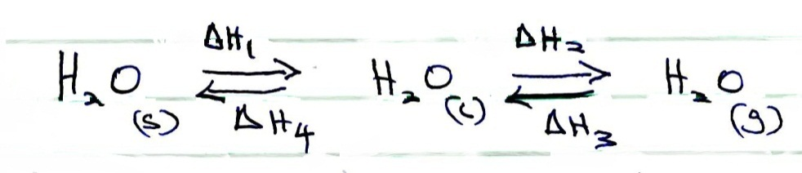
(i) What name is given to the energy change ΔH₂ (1 mark)
…………………………………………………………………………………………………………………………………………………………..
(ii) What is the sign of ΔH₄ (1 mark)
………………………………………………………………………………………………….
- The following results were obtained during an experiment to determine the solubility of potassium chlorate (V) in water at 30⁰C.

Mass of evaporating dish = 15.86g.
Mass of evaporating dish + saturated solution at 30⁰C = 26.8g.
Mass of evaporating dish + solid potassium chlorate (V) after evaporating to dryness = 16.86g.

Calculate the mass of the saturated solution containing 60.0g of water at 30⁰C. (3 marks)

