Name ………………………………… ADM Number……………………

Signature ……………………………….. Date …………………/…….………/…………

**FORM 4**

**PAPER 2**

**END OF TERM 2 EXAM**

**INSTRUCTIONS TO CANDIDATES**

1. *Write your name and index no in the spaces provided above.*
2. *Sign and write the date of exam in the spaces provided above.*
3. *Answer all the questions in the spaces provided after each.*
4. *All working must be clearly shown where necessary.*
5. *Candidates should check to ensure that all pages are printed as indicated and that no questions are missing.*
6. *All answers should be written in English.*

1.(a)The following table gives the standard electrode potentials for some half cell reactions

**Half cell reations Eθ(v)**



i)Identify the strongest reducing agent. (1mk)

ii)Calculate the EMF of a cell made by combining the half cells of A and B. (1mk)

(iii).Identify the substances that can oxidize C- ions to C2. (1mark)

(iv) Draw an electrochemical cell comprising half cells I and IV. (3marks)

b). The apparatus below shows the set up that was used in the electrolysis of 2M Sulphuric (VI) acid. Study it and answer the questions that follow

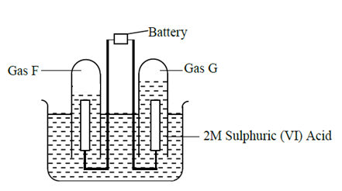

c)Write an equation for the reaction that produce gas F. (1 mark)

(ii) Describe how gas G can be identified (1 mark)

c)1.9g of a metal F was deposited when its aqueous salt was electrolysed by passing a current of

0.6A for 1.5hours. Determine the charge on the ion of F.(RAM of F = 113, 1F = 96500C) (3mks)

3.The diagram below shows a blast furnace which is used for the extraction of iron. Study it and answer the questions that follow.

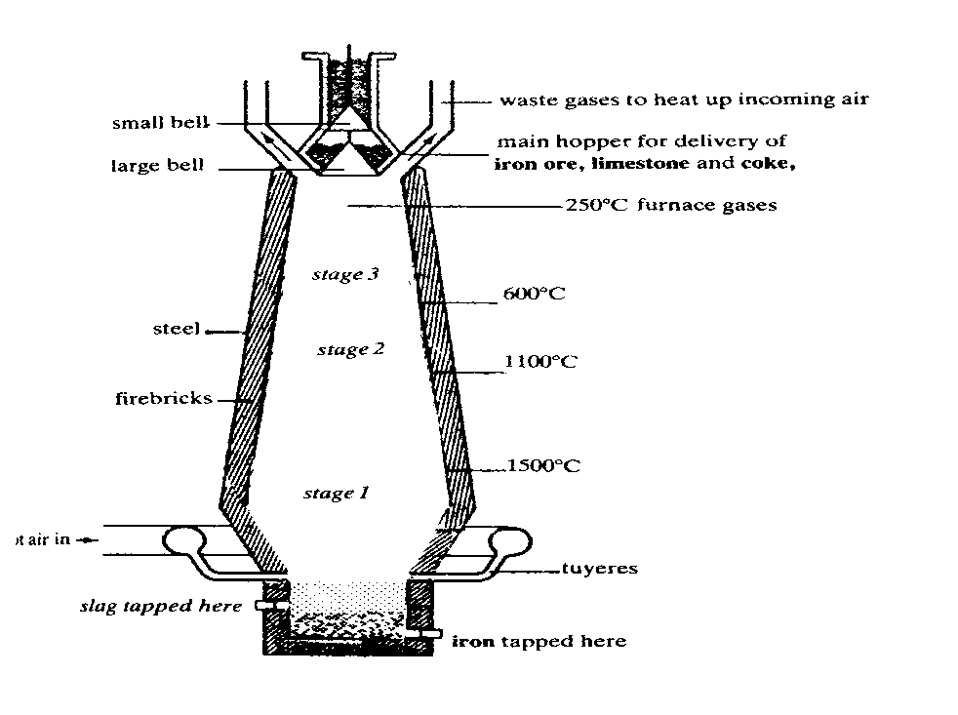

a) Name two major ores from which iron can be extracted from (1mk)

1. Give a reason why the temperature at the bottom of the furnace is very high (1mark)

c)State two properties of slag that allows it to be separated from molten iron. (2mark)

d)Write an equation for the reaction responsible for the fall in temperature at stage 2. (1mark)

e)Write an equation in which iron is formed. (1mk)

f)State two uses of iron (1mark)

g)State the effect of iron extraction on the environment (1mark)

h)Sulphuric (VI)acid is manufactured by the contact process .The equation below shows one step involved in the contact

2SO2(g) + O2(g) ⇌ 2 SO3 (g) ∆H= -97kJ/mol

I. State giving reasons how an increase in temperature would affect the amount of sulphur

VI) oxide gas. (2MK)

II.Name the catalyst used in the above process (1mark)

III.State any two uses of sulphuric(VI) acid (1mark)

3. The table below shows some elements in the periodic table. Use it to answer the questions that follow. The letters are not the actual symbols of the elements.

|  |  |  |  |  |  |  |  |  |
| --- | --- | --- | --- | --- | --- | --- | --- | --- |
|  |  |  |  | | | | |  |
|  |  |  |  |  |  |  | **F** |
| **A** | **G** | **E** |  | **B** |  | **D** |  |
| **C** |  |  |  |  |  |  |  |  |

1. (i) Show the electron arrangement of elements:

**A** ( ½ mk)

**D** ( ½ mk)

(ii) Using dots (.) and crosses (X) to represent electrons, draw diagrams to show how elements C and oxygen combine to form a compound.( O= 8) (1mk)

1. Show on the grid above an element **Y** belonging to Period 4 and group (VI). (1mk)

(c). Compare the following with explanations:

(i) The reactivity of **A** and **C** (2mks)

(ii) Atomic radii of elements **A** and **B** (2mks)

(iii) **The melting point** point of the oxide of element **G** and and the oxide of **D** (2MKS)

1. Calculate the volume of the gas produced when 0.92g of element A is reacted with excess dilute hydrochloric acid at room temperature and pressure. (MGV= 24dm3 , A= 23). (3MKS)

4.The diagram below shows a set-up of apparatus that was used to prepare hydrogen gas.

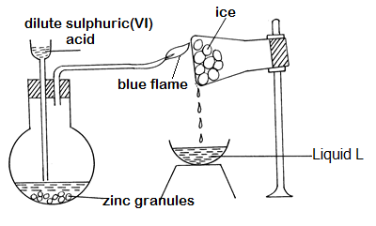

a) Explain the observations that would be made if calcium turnings were used instead of zinc granules in the above experiment. (2mk

b) (i) Explain how liquid L can be identified by chemical means. (2mks

(ii) How could the purity of liquid L be confirmed? (1mk

(d) When magnesium is heated in steam it reacts rapidly forming a white solid and gas X.

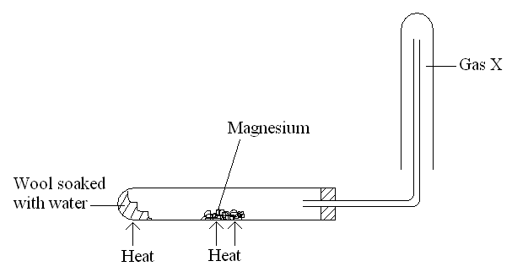

(i)Write an equation that took place in the heated test tube. (1mk)

**(ii).**Why is the gas X collected as shown in the diagram above? (1mk)

5. Study the flow diagram below and answer the questions that follow:

HCl (aq)

MnO2

Gas **L**

Cold dilute NaOH

Salt **M**

NaCl(aq)

(a) Write a balanced equation for the reaction between hydrochloric acid and manganese (IV) oxide that produces gas L (1mk)

(b)State and Explain what happens to a blue litmus when dropped into a solution of gas L **(3mk)**

(c) Name the salt that will be formed if the experiment was repeated with hot concentrated NaOH (1mk)

(d).A student carried out an experiment to prepare iron III chloride using the apparatus shown in the diagram below

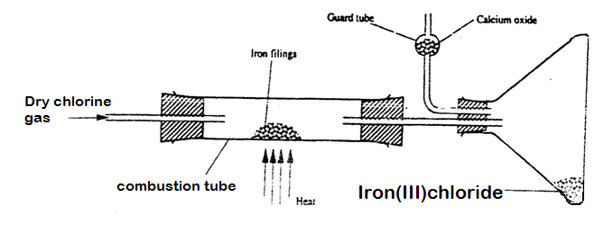

i) Explain why:

I. It is necessary to pass chlorine gas through the apparatus before heating begins.(1mk)

II) Calcium oxide would be preferred to calcium chloride in the guard tube. (1mk)

III. The iron iii chloride is collected away from the reaction point. (1mk)

(ii)Calculate the mass of the product that would be formed when 4000cm3 of chlorine gas reacts completely with excess iron fillings ( Fe= 56.0, C1 = 35.5, MGV 24 litres at room temperature and pressure.). (2MKS)

6. Study the decay series below and answer the questions that follow.

 

a)Define the term radioactivity.(1mk)

b)(i).Identify the particles emitted in

steps (I) (1mk)

steps (IX) (1mark)

(ii).Write the nuclear equation for the reactions which take place in step(V) (1mark)

iv) Calculate the mass of a radioactive element W that would remain after 30 days if it has a half life of 6 days and the original mass is 48gramms. (2mks)

c)Explain any two applications of radioactivity in medicine.(2mks)

7. In an experiment to study the rate of the reaction ,1gram of lamps of calcium carbonate was added to 300cm3 of 2M hydrochloric acid at 250 c. The volume of the carbon( iv) oxide produced was measured at 10 second intervals . The results obtained were recorded in the table below.

|  |  |  |  |  |  |  |  |  |  |
| --- | --- | --- | --- | --- | --- | --- | --- | --- | --- |
| TIME (SECONDS) | 0 | 20 | 40 | 60 | 80 | 100 | 120 | 140 | 160 180 |
| VOLUME  (CM3 ) | 0 | 120 | 180 | 210 | 224 | 232 | 236 | 240 | 240 240 |

1. Plot a graph of volume of the gas produced against time . (3mks)



1. Use the graph to find the ;

i)Volume of gas produced **after** 50 seconds. (1mk)

ii)Time needed to produce 155 cm3 of carbon (iv) oxide. (1mk)

1. EXPLAIN why the volume of carbon (iv) oxide produced does not exceed 240cm3 (2mk)

d)Calculate rate of the reaction at the 55th minute. ( 3mks)

1. LIST any two ways in which the reaction above can be fastened.(2mk)

8.Study flow chat below and answer the questions that follow.

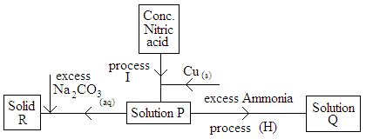

(i).Write a chemical equation to show how solid R is formed. (1mk)

ii)State the observation that would be made in process H if ammonia solution was replaced with excess sodium hydroxide solution.(1mk)

iii)State any two observations made in process I (2mk)

iv)Write the two ionic equations that led to the formation of solution Q (2MK)

v)State any two uses nitric (v) acid (2mk)