FORM FOUR END TERM 2 - PAPER 2 MARKING SCHEME
CHEMISTRY FORM 4.
- (a) (i) A
(ii) -0.44- -0.76{ ½ )
=0.32V { ½ )
(iii)
A B,E NB/ all 1mk, any 2 ½
(iv)

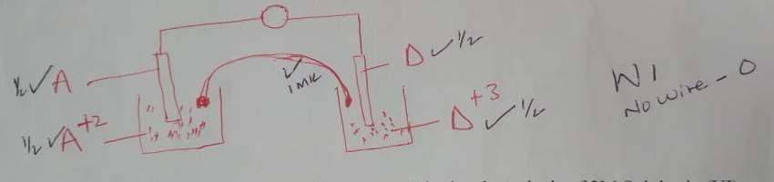
(b) (i)
2H_{(aq)}⁺+2e$→$H_{2(g}
(ii)Introduce a glowing splint and it will relight.
(c) Mass deposited=QRAM/FC
Let charge be C
1.9=[0.6x1.5x60x60] x113/[96500*C]
C=[0.6x1.5x60x60x113]/[1.9x96500]
C=1.9968 or ~ +2
OR
Q= IT
0.6X1.5X60X60=3240
If 3240=1.9_{g}
_{? =113}
_{[3240X113]/1.9=192694.73c}
_{192694/96500=1.9968}
_{~+2}
2.(a)
- Haematite
- Magnetite
(b) reaction of coke with oxygen is highly exothermic
(c)
- Low density.
- Immiscible with iron.
(d) CO₂ + C ……… 2CO
(e) 2Fe₂O₃ + 3C ……….4Fe + 3CO₂
f) cast iron is used to make manhole covers
used as a catalyst in harber process
making cutlery and surgical equipments

(g) SO2 causes acidic rain
CO2 Causes global warming
(h)(i) It would decrease{1mks},increase in temperature favours endothermic reactions ½ and therefore reverse reaction is favoured ½
(ii)Vanadium (iv) oxide ~reject platinum.
(iii Manufacture of dyes{1/2mks}
Filling batteries{1/2mks}
Any other correct answer

3.(a)(i)A 2,8,1
D 2,8,7

(II)
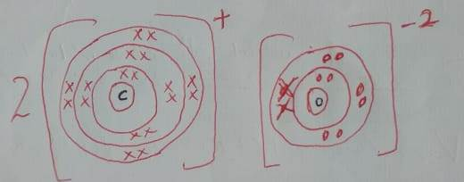

(b)Yshown in the table,period4 group vi
(c)(i)C is more reactive than A{1mks}
C has a larger atomic radius/lower ionization energy and therefore easily loose the outer most electron{1mks}
(ii)
A has a larger atomic radius than B /B has a shorter atomic radius than A[{1mks}B has more protons than A and therefore energy level attracted strongly towards the nucleus.{!mks}
(iii)Oxide of G has the higher melting point than the oxide of D.{1mks} Because oxide of G has a giant ionic structure with strong ionic bond while oxide of D has simple molecular structure with weak van der waals forces.{1mks}
(c) 2Na +2HCl $→$ 2NaCl +H₂ 1mk
Moles of A ₌
0.92/23 ( ½ )
=0.04moles
Mole ratio
2 : 1
Moles of hydrogen
0.04/2
= 0.02 ( ½ )
Volume of hydrogen
0.02 X24 = 0.48dm³ or 480cm³
4.(a) The reaction would start and then stop immediately {1mks}
Because calcium sulphate formed is insoluble and therefore forms a coating on calcium preventing further reaction ( 1mk)
(b)(i)Add a sample to;
White anhydrous copper (ii) sulphate, it would turn to blue.
OR
Blue anhydrous cobalt (ii) chloride, it would to pink.
NB/ REAGENT 1MK, CORRECT COLOUR CHANGES 1MK

(ii) Boil ½ , If it boils at a constant/fixed temperature. ½ REJ 100⁰ C
(c) (i) Mg_{(s)} + H₂O_{(g)} $→$ MgO_{(s)} + H_{2(g)}
(ii)It is less dense than air.
5.(a) MnO_{2(s)} +4HCl_{(aq)} $→$ MnCl_{2(aq)} + Cl_{(g)} +2H₂O_{(l)}
(b)
- It turns red then white{1mks}
- Red because the solution is acidic{1mks}
- White because the HOCl bleaches the dye in the litmus{1mks}

(c) sodium chlorate
(d) I) (i) To expel the air that was inside so that its oxygen doesn’t react with chlorine.
(ii) It would absorb both water moisture and un-reacted chlorine.
II) moles of chlorine gas=4000$/$24000
= 0.16677moles
2Fe + 3Cl₂$→$ 2FeCl₃ {1mks}
Mole ratio
Cl₂ : FeCl₃
3 : 2
Moles of product
If 3$→$0.1667
2$→?$
2$×$0.1667/3
=0.11111moles
Mass of product=moles $×$ RMM
0.11111$×$162.5
=18.0538g
6. (a) It is the spontaneous disentigration of an unstable nuclide to form a stable nuclide.
(b) (i) Step (I) Alpha $α$
Step (ix) Beta$β$
(ii) ₉₀²³⁰Th $→$₈₈²²⁶Ra + ₂⁴He

(iii) 30/6 = 5
48$→$24$→$12 ----- 6$→$3$→$1.5g
=1.5g
(c).

7. (a) 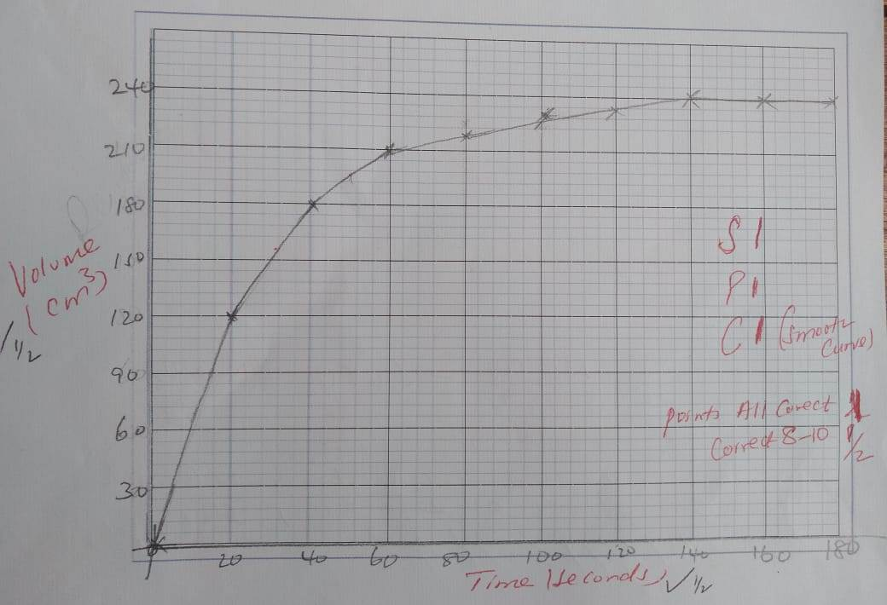
(b)(i) 240 - value at 50 {1mks} Answer {1mks}
(ii) value to be read from the gragh.
(c) Because 1g of calcium carbonate can only produce 240cm³(1mk)
That is 1/100 = 0.01 (½ )
Moles of CO2
CaCO₃ ;CO₂
1 : 1
0.01$×2400$0
=240cm³
(d) Tangent at 55th minute (1MK)
Dy/dx {1mks}
- Answer with units {1mks}
- Answer with no units{1/2mks}
- Use powdered calcium carbonate.
Warm the acid.

8. (i) Cu(NO₃)_{2(aq)} + Na₂CO_{3(aq)} $→$CuCO_{3(S)} +2NaNO_{3(aq).}{1mks}
(ii) A blue precipitate, ½ Insoluble in excess.{ ½ mks}

(iii) Brown copper solid dissolves forming a blue solution.
Brown fumes are seen escaping.
(iv) Cu_{(aq)}⁺² +2OH_{(aq)} ⁻$→$Cu(OH)₂
Cu(OH)_{2(S)} + 4NH_{3(aq)}$→$[Cu(NH₃)₄]_{(aq)}⁺² +2OH⁻_{(aq)}
V) To clean metals.
Manufacture of nitrogeneous fertilizers
Any other relevant

