Name ………………………………… ADM Number……………………

Signature ……………………………….. Date …………………/…….………/…………

**FORM 4**

**PAPER 1**

**END OF TERM 2**

**INSTRUCTIONS TO CANDIDATES**

1. *Write your name and index no in the spaces provided above.*
2. *Sign and write the date of exam in the spaces provided above.*
3. *Answer all the questions in the spaces provided after each.*
4. *All working must be clearly shown where necessary.*
5. *Candidates should check to ensure that all pages are printed as indicated and that no questions are missing.*
6. *All answers should be written in English.*

1.Describe how a sample of pure sodium chloride can be obtained from a mixture of

iodine,sodium chloride and sand. (3mks)

2.Study the flowchart below and answer the questions that follow.

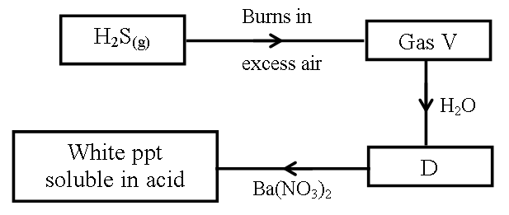

I.Name (2mks)

Gas V…………………………………………………………………………………………..

D…………………………………………………………………………………………..

II.Write an ionic equation for the formation of white precipitation. (1mk)

3.The set up below was used to prepare dry hydrogen gas. Study it and answer the questions that follow.

Cardboard

Hydrochloric

acid

Zinc granules

Liquid Y

(i) Identify a mistake in the set up (1mk)

…………………………………………………………………………………………………

(ii) Write an equation for the reaction for the reaction that produces hydrogen gas (1mk)

…………………………………………………………………………………………………

(iii) State one use of liquid Y (1mk)

4.The grid below is part of the periodic table. Use it to answer the questions that follow. ( The letters do not represent the actual symbols of elements.)

|  |  |  |  |  |  |  |  |  |  |
| --- | --- | --- | --- | --- | --- | --- | --- | --- | --- |
|  |  |  |  | | | | | |  |
|  |  |  |  |  |  | **R** | **S** |  |
| **N** | **Q** |  |  |  |  | **T** | **U** |
| **P** |  |  | |  |  |  |  |  |  |
|  |  |  | |  |  |  |  |  |  |

(a) Indicate in the grid the position of an element represented by letter V, whose atomic number

is 14. (1mk)

………………………………………………………………………………………………….

.

(b) Select a letter which represents a monoatomic gas. (1mk)

………………………………………………………………………………………………….

………………………………………………………………………………………………….

(c) write an equation for the reaction between Q and T (1mk)

………………………………………………………………………………………………………

………………………………………………………………………………………………………

5.Describe how a solid sample of Lead(II) Chloride can be prepared using the following reagents:Dilute Nitric Acid, Dilute Hydrochloric Acid and Lead Carbonate. (3mks)

………………………………………………………………………………………………………………………………………………………………………………………………………………

6.(a) State Graham’s law of diffusion. (1mk)

………………………………………………………………………………………………………………………………………………………………………………………………………………(b) 50cm3 ammonia gas diffuses through a small orifice in 20 seconds.How long will it take a similar volume of propane (C3H8) to diffuse through the same orifice under the same conditions of temperature and pressure? (C=12.0, H =1.0, N=14.0) (3mks)

………………………………………………………………………………………………………

………………………………………………………………………………………………………

……..………...…………………………………………………………………………………

7.A student reacted 0.2g of zinc granules with 2M hydrochloric acid and volume of hydrogen

Gasproduced was measured at various time intervals. A sketch graph of volume against time is

as shown below.

**Volume of**

**H2 (cm3)**

**Time (sec)**

(i).Explain why the graph is steepest at the beginning. (1mk)

……………………………………………………………………………………………………..

………………………………………………………………………………………………………

……………………………………………………………………………………………………..

(ii).On the same axis given above, draw a sketch graph of the reaction when 0.2g of zinc powder was used instead of zinc granules. Label it I (1mk)

(iii)Give a reason for the choice of your graph in (ii) above (1mk)

8.Dry carbon (II) oxide gas reacts with heated lead(ii)oxide as shown in the equation below.

PbO(s) + CO(g) Pb(s) + CO2(g)

(a) Name the process undergone by the lead(ii)oxide. (1mk)

(b) Give a reason for your answer in (a) above. (1mk)

…………………………………………………………………………………………………

…………………………………………………………………………………………………

(c) Name another gas that can be used to perform the same function as carbon(II)oxide gas in the above reaction. (1mk)

…………………………………………………………………………………………………

………………………………………………………………………………………………

9. Ammonia gas is manufactured by reacting nitrogen and hydrogen under the following

conditions; a temperature of 4500C, a pressure of 200 atmospheres and finely divided iron

catalyst. The reaction that takes place is:

N2(g) + 3H2(g)  2NH3(g): ΔH = -92KJ.

(a).How would the yield be affected by increasing the temperature to 6500C? give a reason (2mks)

(b).Give two uses of ammonia (1mks)

……………………………………………………………………………………………………………………………………………………………………………………………………………..

10.The table below shows ammeter readings recorded when two equimolar solutions were tested separately.

|  |  |
| --- | --- |
| Electrolyte | Current (A) |
| Dilute Sulphuric (VI) Acid  Ethanoic Acid | 7.2  4.0 |

Explain the difference in the ammeter readings. (1mk)

………………………………………………………………………………………………………

………………………………………………………………………………………………………

11.The table below gives atomic numbers of elements represented by the letters A, B, C and D.

|  |  |  |  |  |
| --- | --- | --- | --- | --- |
|  |  |  |  |  |
|  |  |  |  |  |



Use the information to answer the questions that follow.

(a) Name the type of bonding that exists in the compound formed when A and D react. (1mk)

……………………………………………………………………………………………….

(b) Select the letter which represents the best oxidizing agent.

Give a reason for your answer. (1mk)

………………………………………………………………………………………………

(c) Give a reason why phosphorous is stored under water. (1mk

…………………………………………………………………………………………………

12. 12.0cm3 of 0.05m hydrochloric acid reacted with calcium hydrogen carbonate to form calcium chloride, water and carbon IV oxide.

(a)Write the chemical equation for the reaction. (1mk)

………………………………………………………………………………………………

(b)Calculate the number of moles of hydrochloric acid used. (2mks)

………………………………………………………………………………………………

………………………………………………………………………………………………

(c)Determine the number of moles of calcium hydrogencarbonate used. (1mk)

…………………………………………………………………………………………………………………………………………………………………………………………………………….

13. Study the information in the table below and answer the question the table below the table.

|  |  |
| --- | --- |
| Bond | Bond energy (kJmol- |
| C-H | 414 |
| Cl-Cl | 244 |
| C-Cl | 326 |
| H-Cl | 431 |

Calculate the enthalpy change for the reaction (3mks)



………………………………………………………………………………………………………

………………………………………………………………………………………………………

……………………………………………………………………………………………………

14.Polyvinylchloride (PVC) is an example of an addition polymer whose monomer is Chloroethene.

(a).What is a polymer? (1mk)

………………………………………………………………………………………………

………………………………………………………………………………………………

(b).What is meant by addition polymerisation? (1mk)

………………………………………………………………………………………………

………………………………………………………………………………………………

(c).Using 2 molecules, draw the structure of PVC. (1mk)

………………………………………………………………………………………………

………………………………………………………………………………………………

15.The diagram below represents a paper chromatograph of pure A, B, C and D. A mixture of K

contains A and D only

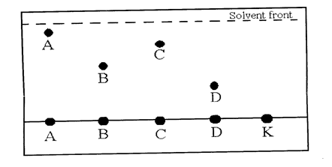

Indicate on the diagram the chromatograph of K (1mk)

16.The diagram below shows a set up of apparatus used to prepare oxygen gas and pass it over

burning candle. The experiment was allowed to run for several minutes.

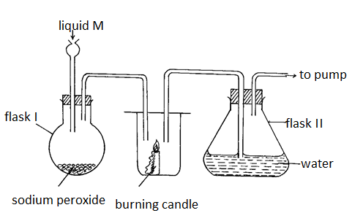

(i) Identify liquid M. (1mk)

*………………………………………………………………………………………………………*

(ii) Write an equation for the reaction that forms oxygen gas in the set up. (1mk)

*………………………………………………………………………………………………………………*

(ii) The pH of the solution in flask II was found to be less than 7. Explain. (2mks)

…………………………………………………………………………………………………..

………………………………………………………………………………………………….

…………………………………………………………………………………………………...

17.Give two reasons why a luminous flame is not used for heating purposes (2mks)

………………………………………………………………………………………………………

………………………………………………………………………………………………………

18.The diagram below shows copper (II) chloride crystals being heated until all has melted.

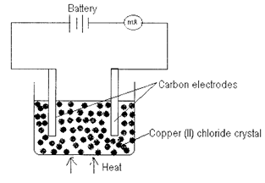

(a) State what was observed in the millimeter

(i) At the beginning. (1mk)

……………………………………………………………………………………………………………………………………………………………………………………………..

(ii) As copper (II) chloride was melted

………………………………………………………………………………………………………………………………………………………………………………………………………………

(b) Explain your answer in (a) above. (2 marks)

………………………………………………………………………………………………………

………………………………………………………………………………………………………

………………………………………………………………………………………………………

19.The figure below shows the behaviour of emissions by a radioactive isotope X

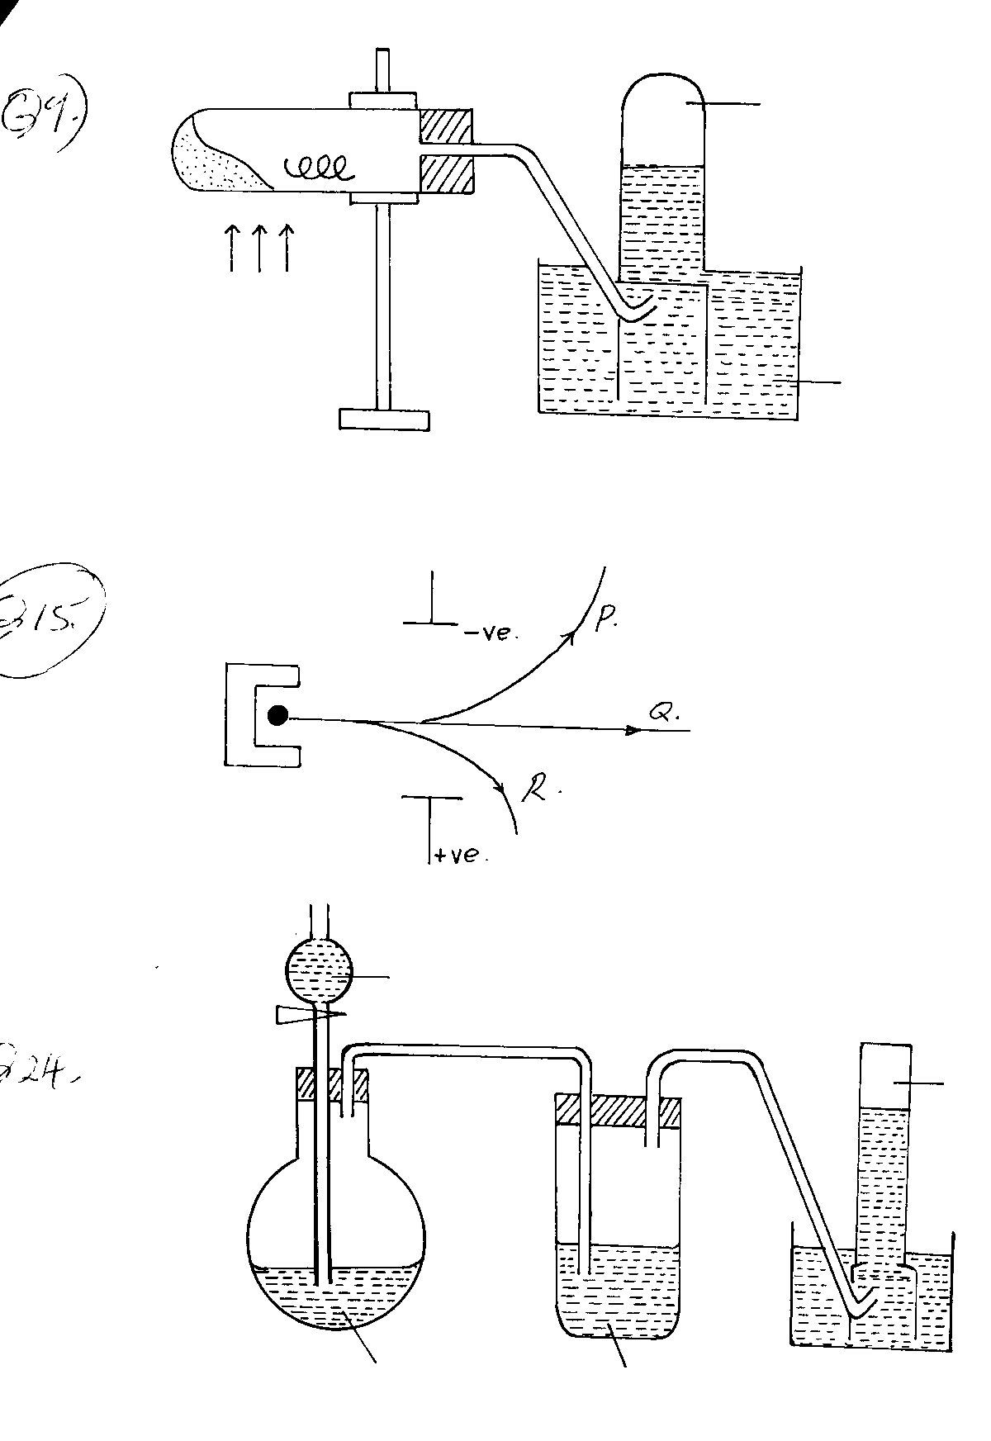

Electric field

(a) Identify the radiations (1½mks)

P ………………………………………………………………………………………

Q……………………………………………………………………………………..

R……………………………………………………………………………………..

1. Which of the radiations (P, Q, R) produces the strongest damage to human tissues. Explain

(1mk)

………………………………………………………………………………………………………

………………………………………………………………………………………………………

20.The standard electrode potentials for the elements chlorine and magnesium

Cl2(aq) + 2ē 2Cl-(aq), Eo = + 1.36V

Mg  + 2ē Mg(s),Eo = - 2.36V

i) Which one of the two elements will act as an oxidizing agent?Explain your choice

(2mks)

………………………………………………………………………………………………………………………………………………………………………………………………………………

(ii).Calculate the electromotive force of a cell where the overall reaction is

Cl2(aq) + Mg(g)  Mg Cl2(aq) (1mk)

21.Briefly describe how the Ph of soil sample can be tested to ascertain whether it is suitable for growing sugarcane. (3mks)

22. A form four student wanted to determine the solubility of PotassiumNitrate. He obtained the following results as shown below.

Mass of evaporating dish 15.13g

Mass of evaporating dish and solution 36.51g

Mass of evaporating dish and salt 19.41g

Use the information above to calculate the solubility of Potassium Nitrate. (3mks)

………………………………………………………………………………………………………………………………………………………………………………………………………………………………………………………………………………………………………………………………………………………………………………………………………………………………

23.. An equilibrium exists between the reaction of bromine and bromide ions as represented by the equation.

Br2(aq) + H2O(l)OBr-(aq) + Br-(aq) + 2H+(aq)

What effect would addition of sodium hydroxide solution have on the above equilibrium? Explain your answer (2mks)

………………………………………………………………………………………………………

………………………………………………………………………………………………………

24.Use the information below to answer the questions that follow:

**Equation:** **enthalpy of formation.**

(i) H2(g) + ½ O2(g) H2O(l) ΔH1 = -286kJmol-1

(ii)C(s)  + O2(g) CO2(g) ΔH2 = -394kJmol-1

(iii) 2C(s) + 3H2(g) + ½ O2(g) C2H5OH(l) ΔH3 = -277kJmol-1

Calculate the molar enthalpy of combustion of ethanol. Given that:

C2H5OH(l) + 3O2(g) 2CO2(g) + 3H2O(l) (3mks)

………………………………………………………………………………………………………………………………………………………………………………………………………………………………………………………………………………………………………………………………………………………………………………………………………………………………

25.(a) Define the term isomerism. (1mk)

(b) Draw and name two isomers of pentene. (2mks)

26.The table below shows the observations made when various salts are heated. Study it and answer the questions that follow.

|  |  |  |  |
| --- | --- | --- | --- |
| Salt | Mass before heating  (Grams) | Mass after heating  (Grams) | Other obserations |
| P | 2.34 | 2.34 | No change is observed |
| Q | 7.9 | 5.14 | Colourless gas, turns lime water to a white ppt |
| R | 1.83 | 0.962 | White fumes |
| S | 1.09 | 0.579 | Brown gas |

(i) Which salt is likely to be anhydrous sodium carbonate? Explain (1mk)

(ii) Identify lead(ii)nitate. (1mk)

(iii) Which salt reacts with an acid to form carbon (iv)oxide (1mk)

27. .The diagram below represents a set up used for the large scale manufacture of hydrochloric acid.

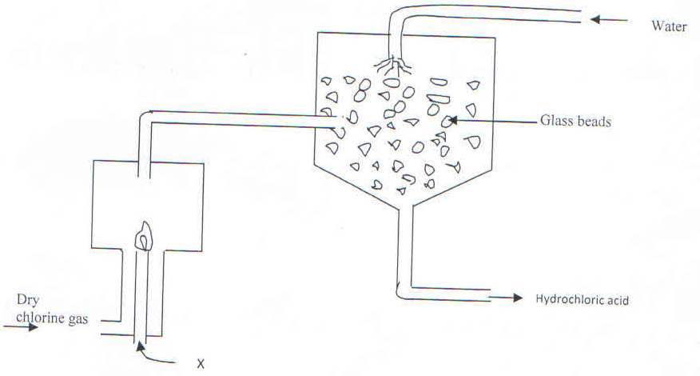

1. Name substance X (1Mark)
2. What is the purpose of the glass beads? (1Mark)
3. Give one use of hydrochloric acid (1 Mark)

28.The stages shown in the following diagram can be used to extract zinc from its oxide:-

Name the stage and the process taking place in it:-

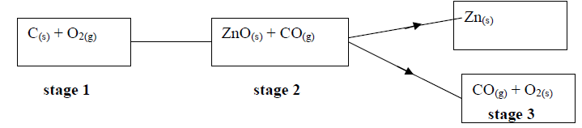

Stage 1……………………………………………………………………… (1mk)

Stage 2..................................................................................................................... (1mk)

Stage 3.................................................................................................................... (1mk)

29. Study the information in the table below and answer the questions that follow.

(The letters do not represent the actual symbols of the elements)

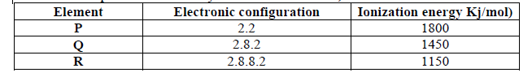

(a) What is the general name given to the group in which elements **P, Q** and **R** belong? (1mk)

(b) Explain why **P** has the highest ionization energy (1mk)

(c) Write a balanced chemical equation for the reaction between element**Q** and water (1mk)