**FORM 4 END TERM TWO PAPER 1 MARKING SCHEME**

1.Describe how a sample of pure sodium chloride can be obtained from a mixture of

iodine,sodium chloride and sand. (3mks)

**-heat the mixture to sublime iodine and collect it on cooler parts of the apparatus. Add water to the mixture to dissolve sodium chloride and filter to separate sand residue. Evaporate the filtrate to obtain sodium chloride.**

2.Study the flowchart below and answer the questions that follow.

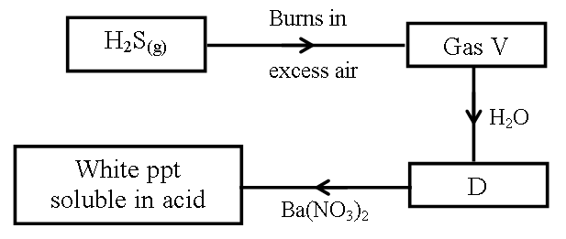

I.Name (2mks)

Gas V**- sulphur (iv) oxide**

D **–sulpuric (iv) acid**

II.Write an ionic equation for the formation of white precipitation. (1mk)

**Ba2+(aq) + SO32-(aq) 🡪 BaSO3(s)**

3.The set up below was used to prepare dry hydrogen gas. Study it and answer the questions that follow.

Cardboard

Hydrochloric

acid

Zinc granules

Liquid Y

(i) Identify a mistake in the set up (1mk)

**-hydrogen gas is collected by downward delivery and its less dense than air**

(ii) Write an equation for the reaction for the reaction that produces hydrogen gas (1mk)

**Zn(s) + 2HCl(aq) 🡪 ZnCl2(aq) + H2(g)**

(iii) State one use of liquid Y (1mk)

**-drying agent**

4.The grid below is part of the periodic table. Use it to answer the questions that follow. ( The letters do not represent the actual symbols of elements.)

|  |  |  |  |  |  |  |  |  |  |
| --- | --- | --- | --- | --- | --- | --- | --- | --- | --- |
|  |  |  |  | | | | | |  |
|  |  |  |  |  |  | **R** | **S** |  |
| **N** | **Q** |  | **✓** |  |  | **T** | **U** |
| **P** |  |  | |  |  |  |  |  |  |
|  |  |  | |  |  |  |  |  |  |

(a) Indicate in the grid the position of an element represented by letter V, whose atomic number

is 14. (1mk)

.

(b) Select a letter which represents a monoatomic gas. (1mk)

**U** ………………………………………………………………………………………………….

………………………………………………………………………………………………….

(c) write an equation for the reaction between Q and T (1mk)

………………………………………………………………………………………………………

**Q(s) + T2(g) 🡪 QT2(s)**

………………………………………………………………………………………………………

5.Describe how a solid sample of Lead(II) Chloride can be prepared using the following reagents:Dilute Nitric Acid, Dilute Hydrochloric Acid and Lead Carbonate. (3mks)

**-add lead carbonate to dil. Nitric acid, a little at a time until effervescence stops and filter excess carbonate. Add dil. Hydrochloric acid to the filtrate to precipitate lead (ii) chloride. Filter, wash and dry the residue.**

6.(a) State Graham’s law of diffusion. (1mk)

**-Under the same conditions of temperature and pressure , the rate of diffusion of a gas is inversely proportional to the square root of its density.**

(b) 50cm3 ammonia gas diffuses through a small orifice in 20 seconds.How long will it take a similar volume of propane (C3H8) to diffuse through the same orifice under the same conditions of temperature and pressure? (C=12.0, H =1.0, N=14.0) (3mks)

………………………………………………………………………………………………………

………………………………………………………………………………………………………

……..………...…………………………………………………………………………………

7.A student reacted 0.2g of zinc granules with 2M hydrochloric acid and volume of hydrogen

Gasproduced was measured at various time intervals. A sketch graph of volume against time is

as shown below.

**Volume of**

**H2 (cm3)**

**Time (sec)**

(i).Explain why the graph is steepest at the beginning. (1mk)

**-the concentration of reactants is higher at the beginning leading to more collisions**.

(ii).On the same axis given above, draw a sketch graph of the reaction when 0.2g of zinc powder was used instead of zinc granules. Label it I (1mk)

**-graph to start at the origin,curve above the line shown and level at the same point as the first one**

(iii)Give a reason for the choice of your graph in (ii) above (1mk)

-**reacts faster as there is greater surface area for contact with the acid**

8.Dry carbon (II) oxide gas reacts with heated lead(ii)oxide as shown in the equation below.

PbO(s) + CO(g) Pb(s) + CO2(g)

(a) Name the process undergone by the lead(ii)oxide. (1mk)

**-reduction**

(b) Give a reason for your answer in (a) above. (1mk)

**-lead(ii)oxide is reduced to lead metal, i.e loses oxygen to CO .**

(c) Name another gas that can be used to perform the same function as carbon(II)oxide gas in the above reaction. (1mk)

**Hydrogen gas**

9. Ammonia gas is manufactured by reacting nitrogen and hydrogen under the following

conditions; a temperature of 4500C, a pressure of 200 atmospheres and finely divided iron

catalyst. The reaction that takes place is:

N2(g) + 3H2(g)  2NH3(g): ΔH = -92KJ.

(a).How would the yield be affected by increasing the temperature to 6500C? give a reason.

**- the yield is reduced. High temperatures decompose ammonia gas to nitrogen and hydrogen**

(2mks)

(b).Give two uses of ammonia (1mks)

**-Manufacture of fertilizers**

**-removal of stains in laundry work**

**(any other relevant use)**

10.The table below shows ammeter readings recorded when two equimolar solutions were tested separately.

|  |  |
| --- | --- |
| Electrolyte | Current (A) |
| Dilute Sulphuric (VI) Acid  Ethanoic Acid | 7.2  4.0 |

Explain the difference in the ammeter readings. (1mk)

**-dil.sulphuric acid is a strong acid fullyionized hence more ions to conduct an electric current unlike ethanoic acid which is partially ionized with few hydrogen ions.**

11.The table below gives atomic numbers of elements represented by the letters A, B, C and D.

|  |  |  |  |  |
| --- | --- | --- | --- | --- |
|  |  |  |  |  |
|  |  |  |  |  |



Use the information to answer the questions that follow.

(a) Name the type of bonding that exists in the compound formed when A and D react. (1mk)

**Ionic**

……………………………………………………………………………………………….

(b) Select the letter which represents the best oxidizing agent.

Give a reason for your answer. (1mk)

**C. Reacts by gaining one electron**

(c) Give a reason why phosphorous is stored under water. (1mk

-**smoulders/reacts with atmospheric oxygen to form an oxide.**

12. 12.0cm3 of 0.05m hydrochloric acid reacted with calcium hydrogen carbonate.

(a)Write the chemical equation for the reaction. (1mk)

**Ca(HCO3)2(aq) + 2HCl(aq) 🡪 CaCl2(aq) + CO2(g) + 2H2O(l)**

(b)Calculate the number of moles of hydrochloric acid used. (2mks)

**(12 x 0.05)/1000 = 0.0006 mole.**

(c)Determine the number of moles of calcium hydrogencarbonate used. (1mk)

**0.5 x 0.0006 = 0.0003 mole**

13. Study the information in the table below and answer the question the table below the table.

|  |  |
| --- | --- |
| Bond | Bond energy (kJmol-) |
| C-H | 414 |
| Cl-Cl | 244 |
| C-Cl | 326 |
| H-Cl | 431 |

Calculate the enthalpy change for the reaction (3mks)



**Bonds broken bonds formed Enthalpy change**

**4 x 414 = 1656 3 x 414 =1242 1900-1999 = 999kJ**

**1 x 244 = 244 1 x 326 =326**

**Total=1900kJ 1 x 431 = 431**

**Total=1999kJ**

14.Polyvinylchloride (PVC) is an example of an addition polymer whose monomer is Chloroethene.

(a).What is a polymer?

**- a long chain molecule made of short unsaturated molecules called monomers**  (1mk)

(b).What are the conditions ofpolymerisation? (1mk)

**-high temperature, high pressure and special catalyst.**

(c).Using 2 molecules, draw the structure of PVC. (1mk)

**H HHH**

**│ │││**

**- C -C - C- C-**

**│ ││ │**

**H Cl H Cl**

15.The diagram below represents a paper chromatograph of pure A, B, C and D. A mixture of K

contains A and D only

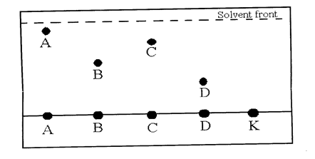

Indicate on the diagram the chromatograph of K (1mk)

16.The diagram below shows a set up of apparatus used to prepare oxygen gas and pass it over

burning candle. The experiment was allowed to run for several minutes.

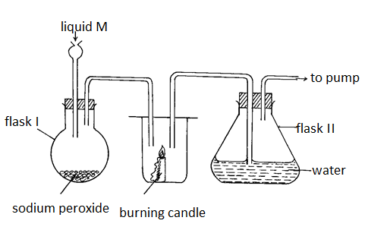

(i) Identify liquid M. (1mk)

**water**

(ii) Write an equation for the reaction that forms oxygen gas in the set up. (1mk)

**Na2O2 (s) + H2O (l) 🡪2NaOH (aq) + O2(g)**

(ii) The pH of the solution in flask II was found to be less than 7. Explain. (2mks)

**- sodium hydroxide is formed and is basic due to hydroxide ions formed.**

17.Give two reasons why a luminous flame is not used for heating purposes (2mks)

**-produces more heat tha luminous flame**

**-does not produce soot that make the apparatus dirty**

18.The diagram below shows copper (II) chloride crystals being heated until all has melted.

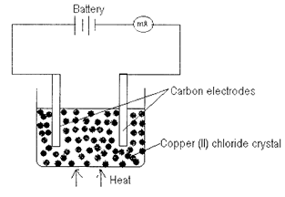

(a) State what was observed in the millimeter

(i) At the beginning. (1mk)

**-the milliametre did not show any reading**

(ii) As copper (II) chloride was melted

**- milliameter started showing some reading as copper(ii)chloride melted.**

(b) Explain your answer in (a) above. (2 marks)

**-When copper (ii)chloride melts, its ions become mobile thus conducts electric current**

19.The figure below shows the behaviour of emissions by a radioactive isotope X

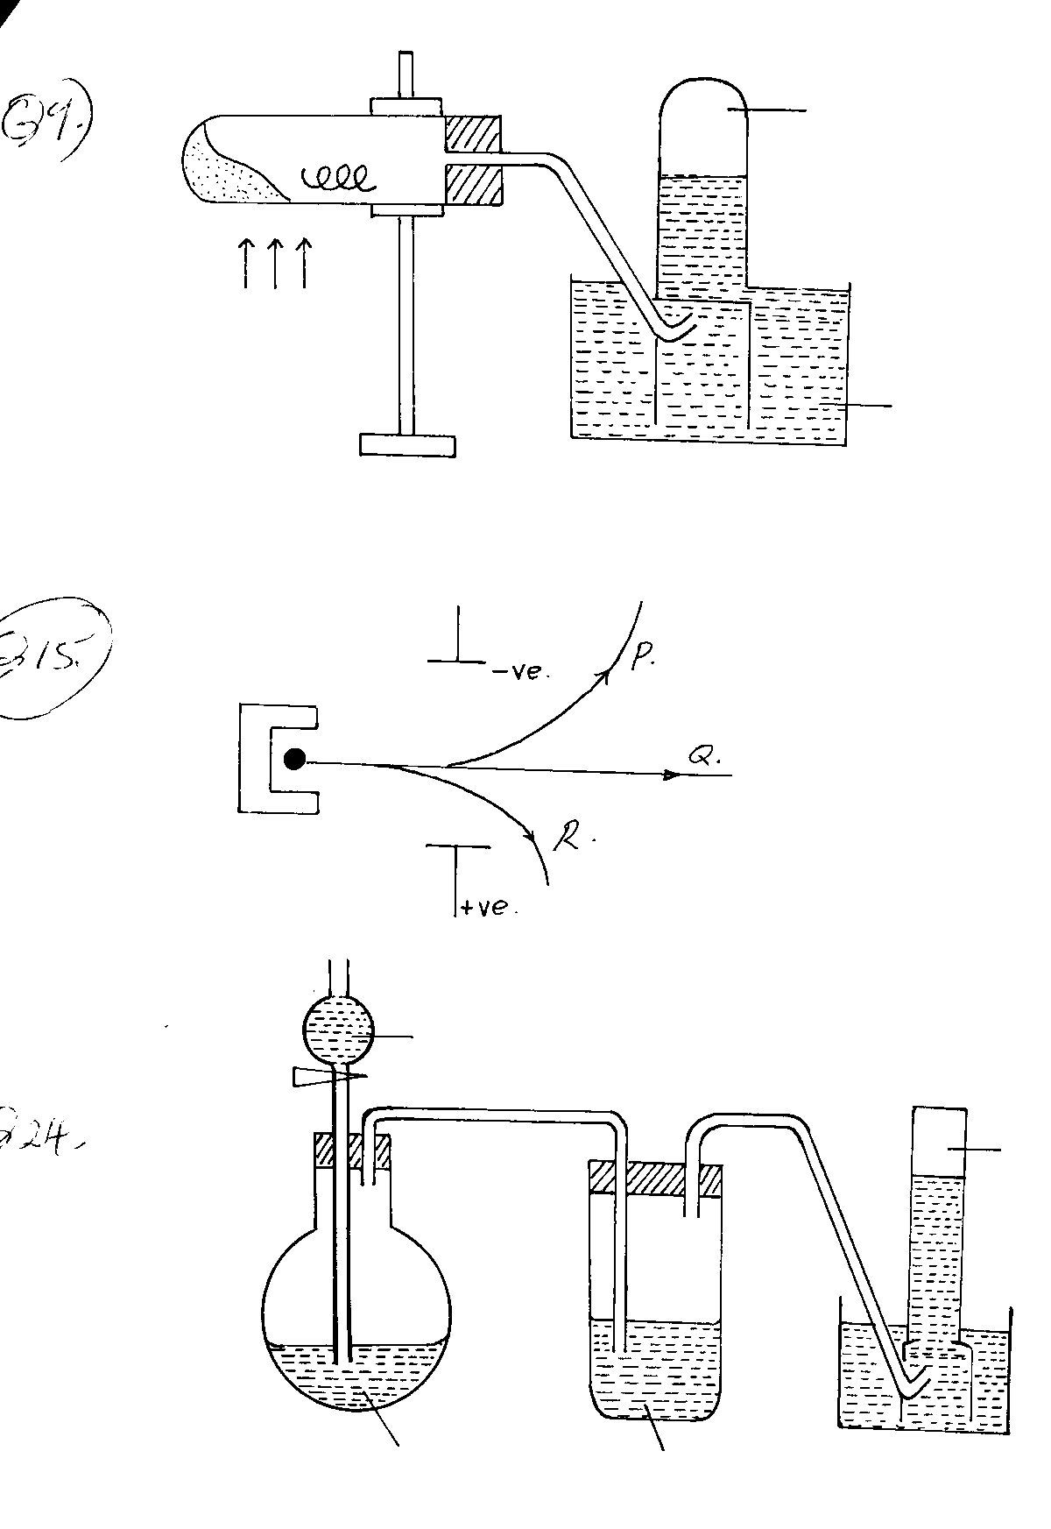

Electric field

(a) Identify the radiations (1½mks)

P **Alpha**

Q**Gamma**

R **Beta**

Which of the radiations (P, Q, R) produces the strongest damage to human tissues. Explain

(1mk)

**Gamma radiations. They have high penetrative power**

20.The standard electrode potentials for the elements chlorine and magnesium

Cl2(aq) + 2ē 2Cl-(aq), Eo = + 1.36V

Mg  + 2ē Mg(s),Eo = - 2.36V

i) Which one of the two elements will act as an oxidizing agent?Explain your choice

**Cl2(aq) has a positive reduction potential**(2mks)

(ii).Calculate the electromotive force of a cell where the overall reaction is

Cl2(aq) + Mg(g)  Mg Cl2(aq) (1mk)

**+1.36- -2.36 =3.72V**

21.Briefly describe ho,w the Ph of soil sample can be tested to ascertain whether it is suitable for growing sugarcane. (3mks)

**-grind a soil sample and add water. Filter .to a sample of the filtrate, add 2-3 the drops of universal indicator and compare the colour on a pH chart. Note and record the soil pH.**

22. A form four student wanted to determine the solubility of PotassiumNitrate. He obtained the following results as shown below.

Mass of evaporating dish 15.13g

Mass of evaporating dish and solution 36.51g

Mass of evaporating dish and salt 19.41g

Use the information above to calculate the solubility of Potassium Nitrate. (3mks)

**Mass of salt: 19.41-15.13 =4.28g**

**Mass of water: 36.51-19.41 =17.1g**

**Solubility: (4.28 x100)/17.1 = 25.0292g/100g of water.**

23. An equilibrium exists between the reaction of bromine and bromide ions as represented by the equation.

Br2(aq) + H2O(l)OBr-(aq) + Br-(aq) + 2H+(aq)

What effect would addition of sodium hydroxide solution have on the above equilibrium? Explain your answer (2mks)

**. Equilibrium will shift forward// to the right**

**- The concentration of H+(aq) will decrease hence the equilibrium shift to**

**the right to replace the H+ ions that will have reacted with hydroxides ions.**

24.Use the information below to answer the questions that follow:

**Equation:** **enthalpy of formation.**

(i) H2(g) + ½ O2(g) H2O(l) ΔH1 = -286kJmol-1

(ii)C(s)  + O2(g) CO2(g) ΔH2 = -394kJmol-1

(iii) 2C(s) + 3H2(g) + ½ O2(g) C2H5OH(l) ΔH3 = -277kJmol-1

Calculate the molar enthalpy of combustion of ethanol. Given that:

C2H5OH(l) + 3O2(g) 2CO2(g) + 3H2O(l) (3mks)

………………………………………………………………………………………………………………………………………………………………………………………………………………………………………………………………………………………………………………………………………………………………………………………………………………………………

From the energy cycle diagram:-

ΔH3

2O2(g)

3O2(g)

ΔH4 =

ΔH2

ΔH1 O2(g)

2CO2(g) + 3H2Oy

**2C(s) + 3H2(g) + ½ O2(g) C2H5OH**

**ΔH1 + ΔH2 = ΔH3 + ΔH4 ✓1**

**Then**

**ΔH3 = ΔH1 + ΔH2 – ΔH4**

**ΔH3 = (2 x -394) + (3 x -286) – (-277) ✓ 1**

**= -788 + 853 - -277**

**= -788 – 853 + 277**

**ΔH3 = -1646 + 277 = -1369**

**ΔH3 = -1369 KJMOI-1✓ 1**

25.(a) Define the term isomerism. (1mk)

**Existence of a compound in more than one form but in the same physical state.**

(b) Draw and name two isomers of pentene. (2mks)

26.The table below shows the observations made when various salts are heated. Study it and answer the questions that follow.

|  |  |  |  |
| --- | --- | --- | --- |
| Salt | Mass before heating  (Grams) | Mass after heating  (Grams) | Other obserations |
| P | 2.34 | 2.34 | No change is observed |
| Q | 7.9 | 5.14 | Colourless gas, turns lime water to a white ppt |
| R | 1.83 | 0.962 | White fumes |
| S | 1.09 | 0.579 | Brown gas |

(i) Which salt is likely to be anhydrous sodium carbonate? Explain (1mk)

**P. does not decompose on heating**

(ii) Identify lead(ii)nitate. (1mk)

**S**

(iii) Which salt reacts with an acid to form carbon (iv)oxide (1mk)

**P or Q**

27. .The diagram below represents a set up used for the large scale manufacture of hydrochloric acid.

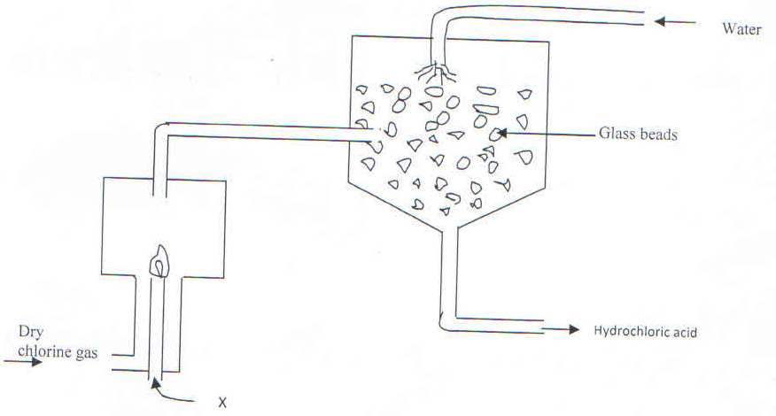

1. Name substance X (1Mark)

**Hydrogen gas**

1. What is the purpose of the glass beads? (1Mark)

**Increases the surface area for dissolution of hydrogen chloride gas**

1. Give one use of hydrochloric acid (1 Mark)

**-pickling of metals**

**-making dyes, photographic materials,drugsetc**

28.The stages shown in the following diagram can be used to extract zinc from its oxide:-

Name the stage and the process taking place in it:-



Stage 1 **oxidation; Coke is oxidized to CO (1mk)**

Stage 2 **Reduction: zinc is reduced to Zinc metal**

**(1mk)**

Stage 3. **Recycling stage; CO2 is reduced to regenerate CO**(1mk)

29. Study the information in the table below and answer the questions that follow.

(The letters do not represent the actual symbols of the elements)

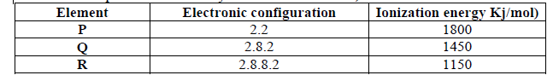

(a) What is the general name given to the group in which elements **P, Q** and **R** belong? (1mk)

**-alkaline earth metals(reject alkali earth metals)**

(b) Explain why **P** has the highest ionization energy (1mk)

-**has few energy levels hence valency electrons are strongly attracted by the positive nucleus therefore difficult to remove hence more ionization energy.**

(c) Write a balanced chemical equation for the reaction between element**Q** and water (1mk)

**Q (s) + 2 H2O(l) 🡪Q(OH)2(aq) + H2(g)**