**NAME ……………………………………..…… DATE ………………ADM NO. ……..**

**INDEX NO. …………….…………… SIGNATURE ….………..…..………..**

**233/2**

**CHEMISTRY**

**PAPER TWO**

**FORM FOUR**

**TIME: 2 HRS**

**OPENER EXAMINATION TERM 3, 2022**

***Kenya Certificate of Secondary Education***

**INSTRUCTIONS TO CANDIDATES: -**

* + *Write your name, Admission number and class in the spaces provided above.*
  + *Answer all the questions in the spaces provided*
  + *Candidates should answer the questions in English.*

1. The table below represents some elements. Use it to answer the questions that follow. The letters do not represent the actual symbols of the element.

|  |  |  |
| --- | --- | --- |
| **Element** | **Atomic Number** | **Melting Point OC** |
| Q  R  S  T  U | 11  13  14  17  19 | 97.8  660  1410  -101  63.7 |

1. Write the electron arrangement for the ions formed by elements.
2. R ( 1 mk)
3. T ( 1 mk)
4. Select an element which is ; i)The most reactive metal ( ½ mk)
5. A semi-conductor of electricity. ( ½ mk)

c) Compare the atomic radius of Q and R. Explain ( 2mk)

d) Use dots (.) and crosses (x) to represent electrons, show the bonding formed between S and T. (1mk)

e) Explain why the melting point of S is higher than that of Q (2mks)

f) i) Write an equation for the reaction between Q and water. (1mk)

ii) Calculate the mass of the solid formed when excess R reacts with 960cm3 of oxygen gas. (MGV= 24dm3, O=16, Al=23) (2mk)

1. (a) Use the information below to answer questions that follows

Ca(s) + ½O2(g) CaO(s) H=-635kJ/mole

C(s) + O2(g) CO2(g) H=-394kJ/mole

Ca(s) + C(s) + O2(g) CaCO3(s) H =-720kJ/mole

1. Calculate the enthalpy change for the reaction

CaO(s) + CO2(g) CaCO3(s) (3mks)

(b) Study the energy cycle below and use it to answer the questions that follow.

H1 Ca2+(g) + 2Cl-(g)

CaCl2(s) H2

H3 Ca2+(aq) + 2Cl-(aq)

(i) What name is given to the enthalpy change DH2 (1mk)

1. Given that DH1 = +2237kJ/mole and DH2 =-2378kJ/mole. Calculate the value of DH3 (2mks)

(c) (i) When 1.2g of element W was completely burnt in oxygen and all the heat evolved used to heat 250cm3 of water. The temperature of the water rose from 22oC to 29oC. Calculate the RAM of element W. (Specific heat capacity 4.2j/g-1k-1 , density of water 1.0g/cm3 and molar heat of combustion is -560kJ/mole) (2mks)

1. STATE two reasons why the molar heat of combustion of the above compound is different from the theoretical value. (1mk)

iii) Define the term, enthalpy of solution. (1mk)

(d) (i) Use the bond energies given below to calculate the heat of reaction for.

H2(g) + Cl2(g)  2HCl(g) (2mks)

|  |  |  |  |
| --- | --- | --- | --- |
| Bond | H - H | Cl - Cl | H - Cl |
| Bond energy kJ/mole | 435 | 243 | 431 |

(ii) Sketch the energy level diagram for the above reaction. (1mk)

1. (a) Starting with Zinc metal, describe how zinc carbonate can be prepared in the lab. (3mks)

(b) Three immiscible liquids Y, X and Z are such that X is less dense than Z and Y is denser than Z. Draw a well labeled diagram that can be used to separate the three liquids effectively. (3mks)

(c) When carbonate of metal T was heated, solid P which turned yellow on cooling was formed.

(i) State the identity of solid P (1mk)

(ii) Write a balanced chemical equation to show the effect of heat on the nitrate of silver. (1mk)

(d)  **Few drops** of ammonium hydroxide were added to copper II sulphate solution in a test tube.

(i) State the observation made (1mk)

1. **If excess** ammonium hydroxide is added to the resultant product above, state the observation made and write the equation for reaction that took place (2mk)
2. **I.** The table below shows volume of hydrogen gas produced when 0.00167g of zinc granules reacted with excess of dilute HCl

|  |  |  |  |  |  |  |  |  |  |  |  |  |  |
| --- | --- | --- | --- | --- | --- | --- | --- | --- | --- | --- | --- | --- | --- |
| Time (mins) | 0 | 0.5 | 1 | 1.5 | 2 | 2.5 | 3 | 3.5 | 4 | 4.5 | 5 | 5.5 | 6 |
| Volume (cm3) | 0 | 10 | 18 | 24 | 28 | 31 | 34 | 37 | 38 | 39 | 40 | 40 | 40 |

1. Plot a graph of volume of hydrogen gas produced against time. (3mks)



1. From the graph find the rate of reaction at minute 3.5 (2mks)
2. Explain why the rate of reaction
3. Is faster at the beginning of the experiment (1mk)
4. Remains constant from the 5th minute (1mk)
5. On the same axes sketch a graph for the reaction between the 2g zinc **powder** and 100cm3 of 2MHCl. (1mk)
6. In the production of hydrogen for use in Haber process, carbon (II) oxide is reacted with steam according to the following equations

CO(g) + H2O(g) CO(2)(g) + H2(g) H=+ve

1. What name is given to the above type of reaction (1mk)
2. State and explain the effect of
3. Removing carbon (IV) oxide from the mixture on the yield of hydrogen. (1 ½ mks)
4. Increasing the temperature of the system on the equilibrium mixture. (1 ½ mks)
5. a) Define the following term Binary electrolyte (1mk)
6. A form four student from MSHINDI secondary school was given the following list of elements with their reduction potentials.

|  |  |
| --- | --- |
| element | Electrode potential |
| G | 0.0 |
| Z | -0.6 |
| M | +1.82 |
| V | -1.9 |
| Y | +0.9 |
| J | -2.4 |

1. State the possible identity of element G and give a reason for your answer. (1mk)
2. Draw a well labelled diagram of the electrochemical cell by combining the half-cells of element Y and J (3mk)

Iii) Calculate the emf of the cell above. (1mk)

iv)Write the cell representation of a cell made by combining the half-cell of element M and Y.( Take their charges to be +2 respectively.) (1mk)

1. In the electrolysis of dilute sulphuric (VI) acid using platinum electrode, the volume of hydrogen collected is twice the volume of oxygen collected. Explain this observation. (2mk)

1. i) A current of 1.3 Amperes was passed through an electrolytic cell containing Copper ii sulphate solution for 2½ hours using graphite electrodes. Calculate the mass of copper deposited at cathode. (Faraday= 96500C, Cu= 63.5) (2mk)

ii) Apart from the deposition of brown copper metal, state another observation seen during the electrolysis.(1mk)

1. Study the flow chart below and answer the questions that follows

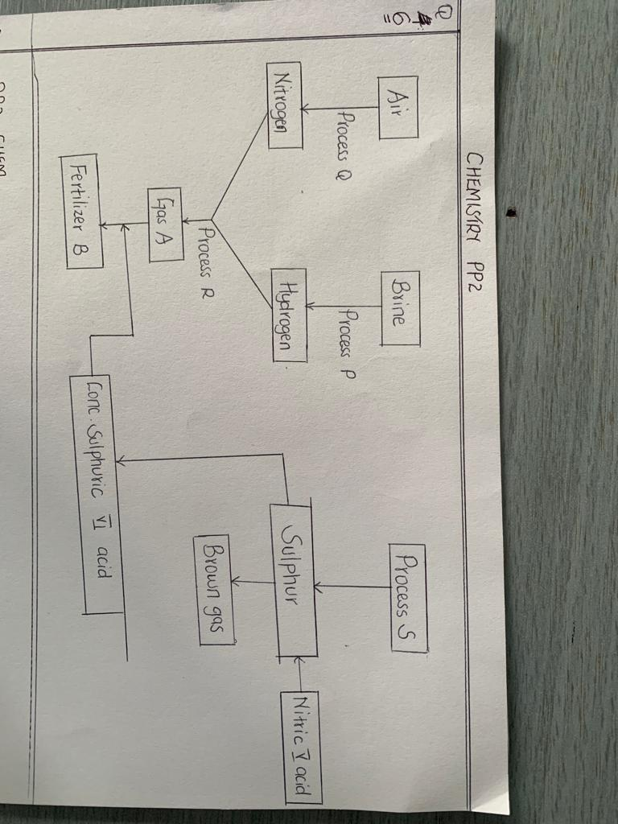

1. Name the following ( 1½ mk)
2. Process Q
3. Process R
4. Process S
5. Write equations for the formation Of Fertilizer B (1mk)
6. Name the catalyst and give conditions for process R.
7. Catalyst ( ½ mk)
8. Conditions (1mk)

-

-

1. Study the set up below and answer the questions that follow

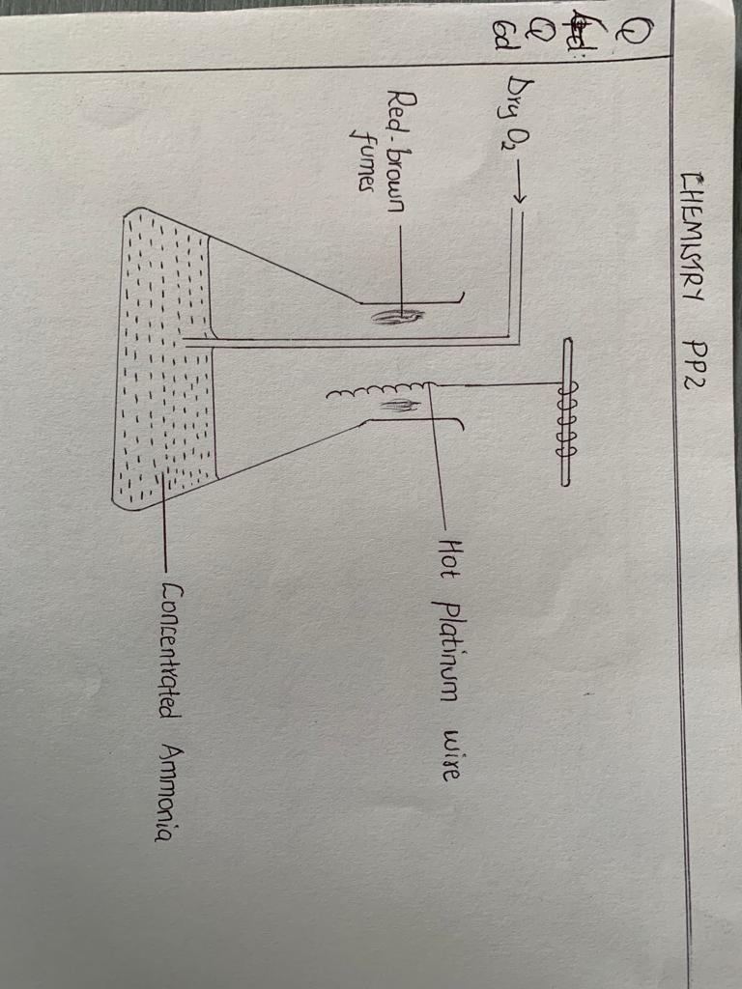

1. Write an equation for the reaction that takes place. (1mk)
2. Explain the source of red brown fumes. (1mk)
3. Describe a chemical test that can be used to distinguish between sulphur IV oxide gas and hydrogen sulphide gas. (2mk)
4. (a) Name the following compounds. (2mks)

i)CH3CH2COOH ----

ii) CH3CHClCHBrCH2CH3

1. Use the flow chart to answer the questions that follow

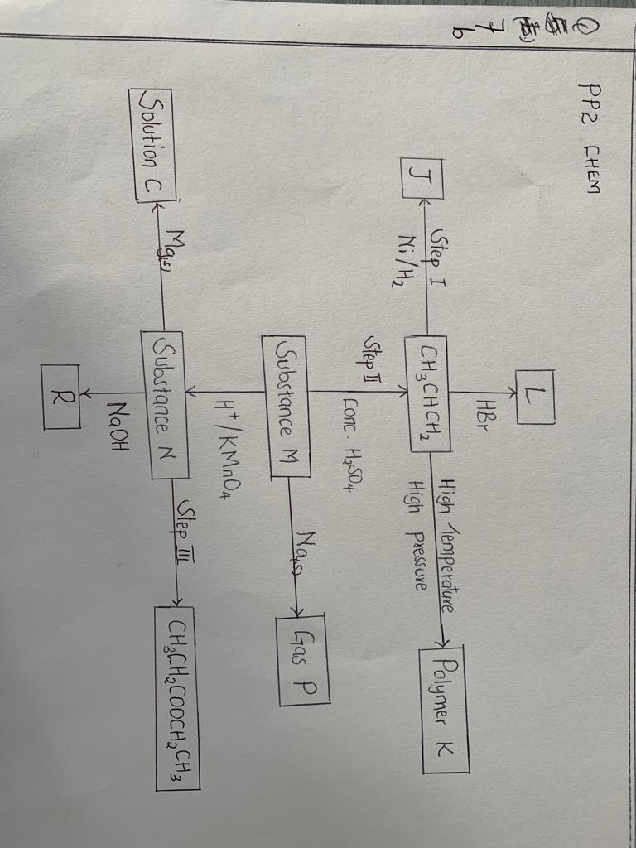

1. Name the following (1½ mks)
2. Gas P
3. Solution C
4. Substance J
5. Name the type of reaction involved in the following steps.

(1½ mks)

1. Step I
2. Step II
3. Step III

III. Draw and name the structure of Polymer K (2mk)

IV.Write a chemical equation for the reaction taking place during the formation of substance L. (1MK)

C iStudy the structure below

H H O O

$$\left[ N -{\left({CH}_{2}\right)}_{6}-N - C - {\left({CH}_{2}\right)}_{4 }- C \right]$$

1. Name the structure above. (1mk)
2. Draw the structures of the two monomers that make up the above structure. (2mks)

HN-(CH2)6-N-C-(CH2)4-C­

1. I. Below are two cleansing agents. Study them and answer the questions that follow.

B- R – COONa

C - R O O - SO3Na

I)Name the class to which cleansing agent B belongs? (1mks)

II. Which cleaning agent above is not environmentally friendly? Explain (2mks)