CHEMISTRY
OPENER EXAMINATION TERM 3, 2022
FORM FOUR PAPER 2
MARKING SCHEME
1 a) i)2,8 ii) 2,8,8
b) i) U ii) S
C) Q has a larger atomic radius than R/ R has a shorter atomic radius Q 1mk
R has a greater nucleic charge /protonic charge which attracts the energy levels reducing its size
d)

e) S has a giant atomic structure with strong covalent bonds while T HAS SIMPLE MOLECULAR STRUCTURE WITH WEAK VAN DER WAAL FORCES.
F i) 2Na + 2H₂0 -------------- 2 NaOH + H₂
2Q + 2H2O ---------------2 QOH + H2
ii) 4Al + 3 O₂ --------------- 2 Al₂O₃ 1mk
_{MOLES OF OXYGEN GAS} 960/24000= 0.04 ½mk
MOLES OF AL2O3 O2;AL2O3
3 ; 2
0.04; ?
0.04 X2 /3 = 0. 0267 ½ mk
Mass of AL2O3 = 0.0267 X 102= ½mk
2.7234g ½ mk

2.a)i) CaO………………..Ca+ ½ O₂ +635
CO₂………………….C + O₂ +394
Ca + 1 ½ O_{2 …………}CaCO₃ -720
=+309

b) i)DH Hydration
ii) DH3=DH1 +DH2
+2237-2378=-141

c) i) MCDT M= 250, C= 4.2 ,DT= 29-22= 7
250 X 4.2 X 7/1000=7.35kJ
If 1.2g= 7.35
?= 560
1.2 x 560 /7.35=
91
ii) Incomplete combustion of the compound.
Heat loss to the surrounding
iii) The enthalpy change when one mole of a substance is dissolved in water to form the most dilution solution possible/an infinitely dilute solution.

d) i) H-H + Cl –Cl ---------2H-Cl
+435 + 243 --------------2( -431) 1MK
678 – 862= -184 Kj 1mk

ii) exothermic , reactants above, products below, arrow facing down.
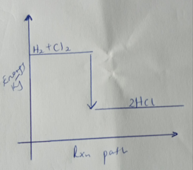
3 a) React zinc metal with dilute nitric v acid, stir until effervescence stops.
Filter. React the zinc nitrate solution formed with sodium carbonate to form insoluble zinc carbonate. Filter, rinse the residue with distilled water and dry between filter papers.
b)Nb/ separating funnel - 1MK
correct order of liquids- X
Z
Y
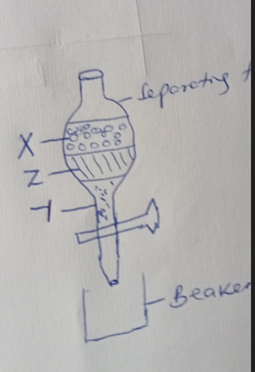
Beaker---------------- ½
Stand ---------------- ½
c) I) Lead oxide
Ii) 2AgNO_{3(aq)}………………2Ag(aq)+2NO_{2(g)} +O₂ (g )
d I) A blue precipitate is formed. 1mk
ii)Blue ppt dissolves forming a deep blue solution. 1mk
Cu (OH)_{2(s)} +4NH_{3(aq)} …………..[Cu(NH₃)₄]⁺² _{(aq)} +2OH⁻ _{(aq)}

4.I a) x-axis with correct units½
Y-axis with correct units ½
Plotting- 13 points- 1mk
12 points – ½ mk
11points and below- 0mk
b) tangent- 1mk dy/dx= ½ correct answer with units ½
c) i) the reactants are at a higher concentration in the beginning thus more particles hence higher chances of collision 1mk
ii) all the zinc has been used up and therefore reaction has come to an end.1mk
d) curve should start and level off at the same time with the other one but is ABOVE IT.
II a) Reversible reaction
b)i)The yield would increase.1MK Removing co₂ would favor the forward reaction forming more hydrogen.
ii) Equilibrium shifts to the right. 1mk The forward reaction is endothermic and therefore would be favored by an increase in temperature.

5.a) an electrolyte that contains only one cation and one anion.
b)i) Hydrogen. ½ It has an electrode potential of 0.0v ½ mk
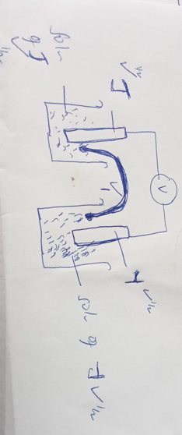
ii) E_{REDUCED} - E_{OXIDIZED}
+ .9- -2.4 = ½
0.9 +2.4= 3.3V
IV) Y/Y⁺² (aq) // M⁺² _{(aq)}/M_{(S)}
c) The electrons lost at anode must be the ones gained at cathode 1 mk , 4 electrons are lost at anode to form 1 mole of oxygen, when the four electrons are gained at cathode, 2 moles of hydrogen are formed1mk
also accept correct equations;
4OH⁻ _{(aq)} ------------ 2H₂0 + O₂ + 4e⁻
4H⁺ _{(aq)} + 4e⁻ ---------------- 2H₂ _{(g)}
Both equations must be correct to score two mks
d) i) Q=IT 1.3X 2.5 X60 X 60= 11,700C 1mk
63.5g of Cu= 2Faradays
If 63.5g ---------- 2 x96500
? ------------ 11700
63.5 x 11700/ 2x 96500 ½ mk= 3.8494g ½ mk
ii) - blue color of solution fades.
-bubbles of a colorless gas
6. a i) Electrolysis
ii) Haber
iii) Frasch
b) 2NH_{3 aq} + H2SO_{4 aq} ----------- ( NH₄)₂SO_{4 aq}
c i) finely divided iron ½ mk
Temp --450⁰c ½ mk
Pressure 200- 250 atm ½ mk
d )i) 4NH₃ + 5O₂----------- 4NO + 6H₂0
ii) The NO produced is readily oxidized to NO₂
e) Bubble a sample of each gas into acidified potassium manganite (vii), 1mk
- In both purple acidified KMnO₄ will turn colorless but with H₂S there will be a yellow deposit. 1mk
7. a ) i) Propanoic acid
ii) 3-Bromo-2-Chloro-pentane
b)i I Hydrogen
II Magnesium propanoate
III Propane
ii) I -hydrogenation
II- dehydration
III – esterification
IV. polypropene.
V . CH₃CHCH₂ + HBr--------- CH₃CH₂CHBr
C.i) nylon 6,6
ii) NH₂ (CH₂)₆NH₂ 1MK and HOOC (CH₂)₄COOH 1MK
iii) I- Soap detergents
II- C 1mk, it is non-biodegradable 1mk

