**NAME ……………………………………..…… DATE ………………ADM NO. ……..**

**INDEX NO. …………….…………… SIGNATURE ….………..…..………..**

**233/1**

**CHEMISTRY**

**PAPER ONE**

**FORM FOUR**

**TIME: 2 HRS**

**OPENER EXAMINATION TERM 3, 2022**

***Kenya Certificate of Secondary Education***

**INSTRUCTIONS TO CANDIDATES: -**

* + *Write your name, Admission number and class in the spaces provided above.*
  + *Answer all the questions in the spaces provided*
  + *Candidates should answer the questions in English.*

1. Name the process which takes place when: (3mks)

(a) Solid Carbon (Iv) Oxide (dry ice) changes directly into gas

(b) A red litmus paper turns white when dropped into chlorine water

(c) Propene gas molecules are converted into a giant molecule

2. Substance Qhas a melting point of 15oC and boiling point of 70oC.

(a) On the same axes, draw the melting point and boiling point graph for Q. (2mks)

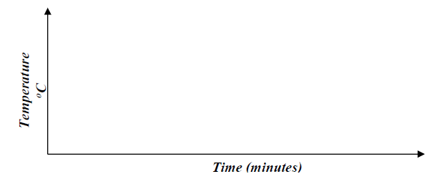

(b) State the physical state of substance **Q** at room temperature (room temperature =25oC) (1mk)

3. The table below shows solutions **A, B** and **C** are tested and observations records as shown:

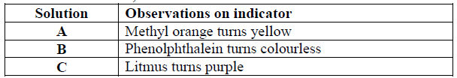

(a) Using the table above, name an acid (1mk)

(b) How does the pH value of 1M potassium hydroxide solution compare with that of

1M aqueous ammonia? Explain (2mks)

4(a) The set-up below is used to investigate the properties of hydrogen.



i) On the diagram, indicate what should be done for the reaction to occur. (1mk)

ii) Name another gas that can be used instead of hydrogen gas. (1mk)

iii) Write an equation for the reaction that occurs in the combustion tube. (1mk)

iv) Explain the observation made in the combustion tube (2mk)

5.Sulphur is extracted from underground deposits by a process in which three concentric pipes are sunk down to the deposits as shown below

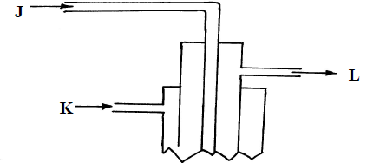

(a) Name the process represented above (1mk)

(b) What is passed down through pipe **J**? (1mk)

(c) Name the **two** allotropes of Sulphur (1mk)

6.The set-up below was used to investigate electrolysis of a certain molten compound;-

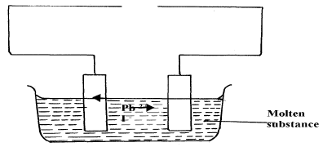

(a) Complete the circuit by drawing the cell in the gap left in the diagram. (1mk)

(b) Write half-cell equation to show what happens at the cathode (1mk)

(c) Using an arrow show the direction of electron flow in the diagram above (1mk)

7.Ammonium nitrate was gently heated and the products collected as shown in the diagram.

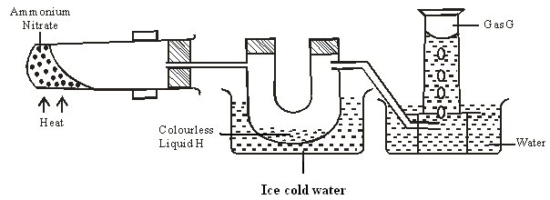

1. Identify:
   1. Colourless liquid H (1mk**)**
   2. Gas G (1mk)
2. Describe one physical and one chemical test that can be used to identify gas G. (2mk)

8.Name the following substances.

1. CH2 CH CH2 CH3 (1mk)
2. CH3 CH CH CH2 CH3 (1mk)

9.The diagram below shows the acidic and basic oxides fit into the general family of oxides.

Acidic Basic

Oxide Oxide

1. State the name given to the type of oxide that would be placed in the shaded area. (1mk)
2. Give the name of any oxide that would be placed in the shaded area. (1mk)

10.Laboratory results showed the composition of a compound to be 58.81% barium, 13.72%, sulphur and 27.47% Oxygen. Calculate the empirical formula of the compound. (Ba=137, S = 32, O = 16). (3mks)

11.(a)What is meant by the term allotrophy? (1mark)

(b)Graphite is one of the allotropes of carbon. Explain in terms of structure and bonding why graphite is soft with greasy feeling. (2marks)

12.A hydrocarbon Q was found to decolourise acidified potassium manganate (vii) solution. When two moles of Q were burnt completely six moles of carbon (iv) oxide and six moles of water were formed.

1. Write the molecular and structural formula of Q. (2mark)

(b)Name the homologous series to which Q belongs (1mark)

C) State Charles’ law. (1mk)

13.A gas occupies 4dm3 at -230C and 152 mmHg. At what pressure will its volume be halved, if the temperature then is 2270C.? (2marks)

14.Study the information in the table below and answer the questions that follow. The letters do not represent the actual symbols of the elements.

|  |  |  |  |
| --- | --- | --- | --- |
| **Substance** | **Solubility in water** | **Electrical conductivity** | |
| **Solid** | **Molten** |
| X | Insoluble | Good | Good |
| Y | Soluble | Poor | Good |
| Z | Insoluble | Poor | Poor |

1. Which of the substances is highly likely to be potassium chloride? Explain (2marks)
2. What type of bond exists in substance X? (1mark)
3. State a possible structure in substance Z? (1mark)

15. 200cm3 of oxygen gas took 60 seconds to diffuse through a porous plug. Determine the time taken by 300cm3 of sulphur (IV) oxide to diffuse through the same plug under the same conditions.

(O=16, S = 32) (3mks)

16.Dilute sulphuric acid was added to a compound X, of magnesium. The solid reacted with the acid to form a colourless solution Y and a colourless gas Z which formed a white precipitate when bubbled through lime water.

Name:-

1. Compound X (1mark)
2. Solution Y (1mark)
3. Colourless gas Z (1mark)

17.The set up below represents the apparatus that may be used to separate a mixture of two miscible liquids C and D whose boiling points are 800C and 1100C.

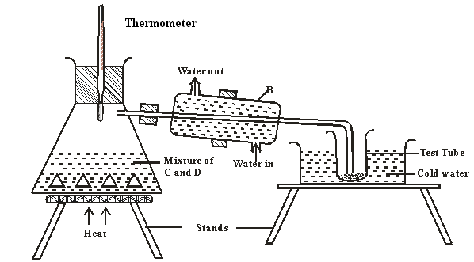

1. Name B (1mark)
2. What is the purpose of the thermometer (1mark)
3. Which liquid was collected in the test tube? (1mark)

18.In an experiment, dry chlorine gas was reacted with aluminium as shown in the diagram below

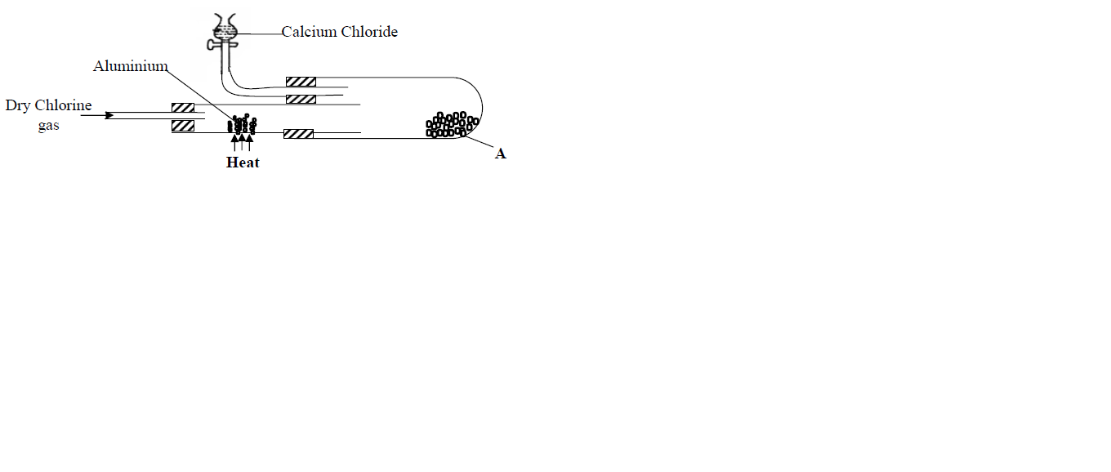 (i) Name substance A (1mk)

(ii) Write an equation for the reaction that took place in the combustion tube (1mk)

(iii) State the function of the calcium chlorine in the set-up above (1mk)

19.Differentiate between the bleaching action of chlorine and sulphur (IV) oxide gas. (1mk)

20.The grid given below represents part of the periodic table. Study it and answer the questions that follow. (The letters do not represent the actual symbols of the elements)



(i) What name is given to the group of elements to which C and F belong? (1 marks)

(ii) Which letter represents the element that is the least reactive? (1 marks)

(iii) What type of bond is formed when B and react? (1 marks)

(iv) Write the formula of the compound formed when element D and oxygen gas react (1 marks)

(vi) On the grid indicate with a tick the position of element G which is in the third

period of the periodic table and forms G3- ions. (1 marks)

21. In the manufacture of Sulphuric (VI) acid by contact process sulphur (IV) oxide is made to

react with air to form sulphur (VI) oxide as shown:-

2SO2(g) + O2(g)  2SO3(g) H = -196KJ

(i) Name the catalyst in this reaction (1mk)

(ii) State and explain the effect of the following changes on the yield of sulphur (VI) oxide

I. Increasing the pressure (1mk)

II. Using a catalyst (1mk)

(iii) Explain why sulphur (VI) oxide gas is absorbed in concentrated sulphur (VI) acid before

dilution (1mk)

22.(a) Give the name of each of the processes described below which takes place

when the salt are exposed to air for some time.

i) Anhydrous Copper (II) Sulphate becomes blue. (1mk)

ii) Calcium chloride forms an aqueous solution. (1mk)

iii) Fresh crystals of sodium carbonate (Na2CO3: 10H2O become covered with a white powder of formula Na2CO3: H2O. (1mk)

23.The table below gives the solubilities of potassium bromide and potassium sulphate at 00C and 400C.

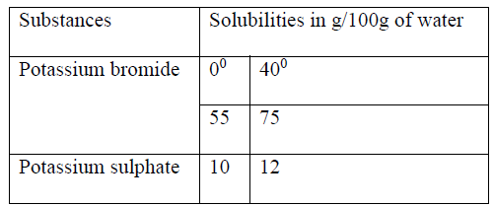

When aqueous mixture containing 60g of potassium bromide and 27g of potassium sulphate in 100g of water at 800C was cooled to 400C, some crystals were formed.

i) Identity the crystals. (1mk)

ii) Determine the mass of crystals formed. (1mk)

iii) Name the method used to obtain the crystals. (1mk)

iv) Suggest one industrial application of the method named in (c) (iii) above (1mk)

24.In an experiment a certain volume of air was passed repeatedly from one syringe to the other over heated excess zinc powder as shown in the diagram below 

The experiment was repeated using excess magnesium powder. In which of the experiments was the change in volume of air greatest? Give reasons. (3mks)

25. The graph below shows the changes that occur when a pure and an impure substance are heated.



a) Which curve represents pure substance? Explain. (2mks)

b) Name one factor which affects the melting point of a solid and state

effects. (2mks)

**THIS IS THE LAST PRINTED PAGE**