FORM 3 CHEMISTRY END TERM 2 MARKING SCHEME
1a) R/S
b) Effervesence /bubbles. Magnesium reacts with the acid to evolve bubbles of hydrogen gas
c)i) B ii) T
2. a)The rate of diffusion of a gas in inversely proportional to the square root of its density provided temperature and pressure is kept constant.
b)Time HCl/Time SO2= $√$ $(RMM$ HCl/ RMM SO2)
20/T =$√$ (36.5/64)
T = $√($20 X 2OX64/36.5)
= 26.48 Sec
c) 3x250/300= 6x v2/400
v2= 3x250x400/6x300=
166.67 seconds
3.a) Fe₂O₃. XH₂O
b) high temperature
acidic medium
salty medium
4. moles of calcium 1000x1000/1000= 1000moles ½mk
Moles of CO₂ = CO2; CaCO3= 1;1 ½mk
Volume of CO2= 24 X 1000 ( ½ mk) = 24000dm³ ( ½ mk)
5.a) Iron ii sulphide
b) because hydrogen sulphide is fairly soluble in water.
c) leaving the thistle funnel hanging above the reaction mixture /Not immersing the thistle funnel in the reaction mixture
d) purple H⁺ / KMnO₄ turns colourless ( 1/2 mk)
a yellow solid deposit ( ½ mk)
6. a)15.0 , 30.6 , 21.5
b) 15.0 + 15.2 + 15.1 /3 = 45.3/3 = 15.1 cm3
c) moles of sodium hydroxide in 250cm3
8/40= 0.2 moles
moles in a litre 0,2x1000/250= 0.8M
d)0.8 x 25/1000= 0.02moles
e) NaOH + HCl ……………… NaCl + H₂O
f) 1;1 0.02moles
g) i) 0.02 x 1000/15.1= 1.324M
ii) 1.324 x 36.5= 48.326 g/litre
h) methyl orange changes from yellow to orange
7. a) Reduction
b) carbon ii oxide , ammonia
c) orange/ red /yellow lead oxide turns grey
8.a) W- is in group iv and period 5
b) I- U II-D III-V
c) Mg + Cl₂ ---------- MgCl₂
d)i) P has a larger atomic radius than N, (1mk) it has more occupied energy levels. (1mk)
ii) D has a higher mp than R (1MK) because D has a giant atomic structure with strong covalent bonds while R has a simple molecular structure with weak van der waal forces (1mk)
iii) S is more reactive than T, (1mk) it has a shorter atomic radius therefore gains /attracts the incoming electron faster than T. OR S is more electronegative than T. (1mk)
e) 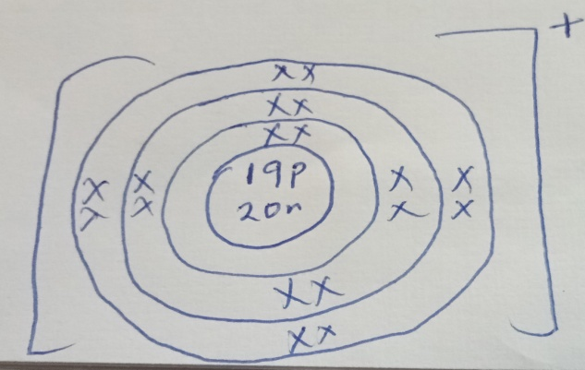
9.a) 2H₂ + O₂ ……………. 2H₂O
b) its mixture with oxygen is explosive
c) use white ANHYDROUS COPPER II SULPHATE turns blue
OR
Use blue anhydrous cobalt ii chloride turns pink
10.a) Heat ½ the mixture having placed a lid with ice cold water on top, iodine sublimes. Add water ½ to the mixture, sodium chloride dissolves, . filter 1mk, rinse ½ the residue of sand with distilled. Heat ½ the filtrate to get solid NaCl.
bi) simple distillation ( rej evaporation)
ii)solvent extraction.
Iii) fractional distillation
Iv) sublimation
1Q1. A) React dil nitric v acid with excess lead carbonate . stir until effervescence stops.Filter to obtain the filtrate. Dissolve potassium sulphate in distilled water. React its solution with the lead nitrate filtrate. Filter to obtain lead sulphate as the residue, rinse it with distilled water and dry between filter papers.
b)i-- a compound formed when some or all of the replaceable hydrogen ions of an acid are replaced by a metal cation or an ammonium radical.
ii…. It is the process of absorbing water from the atmosphere and dissolving in it to form a solution.
C) i) CUCO₃……………. CUO + CO₂
ii) 2Zn(NO₃)₂ ……………. 2ZnO + 4NO₂ +O₂
12. a)i.. reaction is highly exothermic and therefore requires water for cooling.
ii)to reduce the speed of the reaction mixture to allow time for more reaction
iii) CaO + H2O………Ca(OH)2
iv) –manufacture of glass, paper, softening of hard water
b i) graphite uses 3 of its 4 valence electrons leaving one delocalized but diamond uses all its valence electrons for bonding
ii) – glass cutting
-making of drilling bits
-as a jewellery
13. a I ) M
ii) O. melts before the room temperature but boils aboveroom temperature
b i) P. it has low MP and BP
ii) Q. high MP nad BP but poor conductor in all states
14. a)i) hexane ii) but-2-ene
b) bubble a sample of each into acidified KMnO4, IT TURNS from purple to colourless with C2H4 but not with C2H6 where it remains purple.
OR bromine water its turns from yellow to colourless with C2H4 but remains yellow with C2H6.
OR
burn a sample of each,

