NAME……………………….............................................ADM NO…………… CLASS…..……..
CHEMISTRY PAPER ONE
FORM THREE
Answer ALL questions in the spaces provided
1. The diagram shows an incomplete set-up for the laboratory preparation and collection of chlorine gas. Study it and answer the questions that follow.
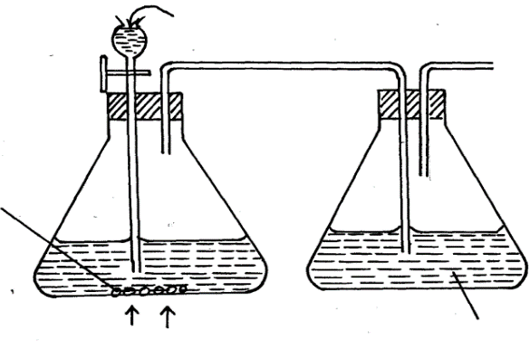
Conc. HCl

Black solid
Q

Heat
Water

(a) Complete the set-up to show how dry chlorine gas is collected. (2mks)

(b) Name substance Q.(1mk )

2) Give a reason why it is possible to separate nitric (V) acid from sulphuric (VI) acid which is used one of the reagents in the preparation of nitric (V) acid. (1mks)

3). Study the scheme below and answer the questions that follow
Carbon (IV) oxide
Solid K
Ca (OH) ₂
Solid W
Water
Heat

- Identify solids W and K (2mks)

- Write an equation for the formation of Ca(OH)₂ from solid K (1mk)

- Write an equation for the decomposition of solidW (1mk)

4) The ions M³⁺ and N²⁻ have identical electronic arrangement. M is in period three.
i) Write the electronic arrangement of
M (1mk)
N(1mk)
ii) Write the formula of the compound formed when M and N combine. (1mk)

5) Explain why there is a general increase in first ionization energy of elements in period three of the periodic table from left to right.

(1mk)
6When excess magnesium ribbon is burned in air, two products are formed.
i)identify the two products
(2mk)
ii) Write the two equations of the reactions that form the products in (i) above (2mks)

7. a) State the Boyle’s law. (1mk)

b) Calculate the pressure required to compress 12 liters of nitrogen gas at 1 atmosphere to give a volume of 4 liters. (2mks)

8. An element W of atomic number 11 and an atom of element Y of atomic number 9 combine to form a compound.
a) Write the formula of the compound. (1mk)

b) State the type of bond present in the compound formed. (1mk)

c) Identify the type of structure formed. (1mk)
9). A compound has the following composition by mass:
Carbon =40%, hydrogen=6.7%, oxygen=53.3%
Given that the relative molecular mass of the compound is 180, determine its molecular formula
(C=12, H=1, O=16.0) (3mks)

10). The melting point of phosphorous trichloride is -91⁰C while that of sodium chloride is 801⁰ C. In terms of structure and bonding, explain the difference in their melting points. (3mks)

11) Explain why the following substances conduct an electronic current.
a)magnesium metal
(1mk)
b) Molten magnesium chloride. (1mk)

12). The apparatus below was a set-up to show the catalytic oxidation of ammonia. Study the diagram and answer the questions that follow.
i)write an equation for the reaction that takes place in the in the gas jar. (1mk)
………………………………………………………………………………………………………………………………………………………………….
ii) Why is it necessary to have a hot nichrome wire in the gas jar? (1mk)

13). When 3.125g of a carbonate, MCO₃ was heated completely, the volume of carbon (IV) oxide evolved during the heating is 600cm³ at room temperature and pressure. Calculate the relative atomic mass of M. (Molar gas volume at r.t.p=24dm³) (3mks)

14). A sample of river water was suspected to contain zinc and sulphate ions. Describe how the presence of zinc and sulphate ions can be established. (3mks)

15). Using dots (.) and crosses(x) to represent electrons, show bonding in carbon (II) oxide(2mks)

16). When a burning candle is put into a gas jar of sulphur (IV) oxide gas, it goes off but a burning magnesium ribbon continues to burn. Explain these observations. (2mks)

17). Starting with copper metal, describe how pure copper (ii) carbonate can be prepared in the laboratory (3mks)

18). State the observations that would be made when chlorine gas is bubbled through potassium bromide solution. (1mk)

b) Write the ionic equation for the reaction in (a) above (1mk)

19. An element M has two isotopes.${}_{29}^{63}M$ And${}_{29}^{65}M$. The relative atomic mass of the naturally occurring M is 63.55. Calculate the percentage abundance of each isotope. (3mks)

20. Distinguish between the terms deliquescent and efflorescent as used in chemistry. (2mks)

21 10 cm³ of concentrated sulphuric(vi) acid was diluted to 100cm³. 10 cm³ of the resulting solution was neutralized by 36cm³ of 0.1M sodium hydroxide solution. Determine the mass of the sulphuric (vi) acid that was in the concentrated acid.
(S=32, H=1, O= 16) (3mks)

22. a) Explain why potassium carbonate cannot be manufactured by the Solvay process. (1mk)

b) Write the equation for the reaction that takes place in the Solvay tower (Carbonator) (1mk)

c) State one commercial use of soda-ash (1mk)

23. What name is given to each of the following?

a) Ability of an element to attract electrons (1mk)

b) Types of forces that holds the atoms of Neon together (1mk)

24. Zinc sulphate was prepared by adding excess Zinc oxide to dilute sulphuric (vi) acid in a beaker. The mixture was wormed until no more effervescence occurred. Excess Zinc oxide was filtered and the filtrate evapourated and then cooled. Fine crystals were obtained.
a) Write an equation for the above reaction (1mk)

b) Why was excess zinc oxide used (1mk)

c) How would you know that the reaction is over (1mk)

25. Hydrogen sulphide was passed through a solution of Iron (III) chloride
i) State the observation made (1mk)

ii) Write an ionic equation for the reaction that took place (1mk)

26. Study the flow chart below and answer the questions that follow
H₂O
O₂
Platinum
Ammonia
Gas X
Nitrogen (II) oxide
Nitrogen (IV) oxide
G & J
(aq)

- Identify gas X (1mk)

- Write an equation for the reaction between ammonia and gas X (1mk)

- Write an equation to show the formation of G and J (1mk)

27 All apparatus used during preparation nitric (V) acid are made of glass. Give a reason. (1mks)

28. Sulphur (IV) oxide gas was bubbled through acidified potassium chromate (VI) solution and Iron (III) Sulphate solution chromate. Explain the observations made in each case.
(i) With Potassium Chromate (VI) solution. (1 ½ mk2)

(ii) Iron (III) Sulphate solution (1 ½ mks)

29.3.22g of hydrated Sodium Sulphate, Na₂SO₄ºX H₂O were heated to a constant mass of 1.42g, determine the value of X in the formula. (Na = 23, S = 32, O = 16, H=1). (2 mks)

30. 20 cm³ of 2 M Sulphuric (IV) acid reacted completely with 3.2 g of WOH (O=16, H=1) Calculate the R.A.M of W in the formula WOH. (3 mks)

31) The figure below shows part of non-luminous flame.
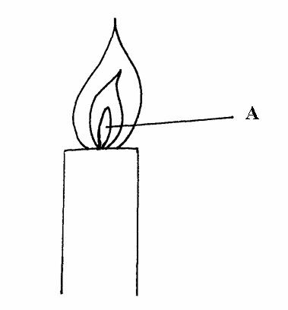
(a) (i) Describe an experiment that would confirm that region labeled A is not suitable
for heating. (1 ½ mks)

(ii) Explain why luminous flame produce light and soot. (1 ½ mks)

