NAME ……………………………………..…………………………DATE …………

ADM NO. …….. SIGNATURE …………

233
CHEMISTRY
FORM THREE
TIME: 2 HOURS

OPENER EXAMINATION TERM 3, 2022
Kenya Certificate of Secondary Education

INSTRUCTIONS TO CANDIDATES: -
  - Write your name, Admission number and class in the spaces provided above.
  - Answer all the questions in the spaces provided
  - Candidates should answer the questions in English.

1.The diagram below shows a set-up of apparatus used to separate miscible liquids.

a) Name the parts labelled A and B. (2marks)
A
B
b) State the function of the part labeled A . (1mark)

c) State the property of the mixture that makes it suitable to be separated by the method above.
(1 mark)

2. Study the table below which shows the pH values of solutions A, B, C, D and E.
Use it to answer the questions that follow.

Solution | A | B | C | D | E
pH | 13.0 | 7.0 | 9.0 | 6.5 | 2.0

i) Which solution is the most acidic? (1 mark)

(ii) Which solution is a neutral? (1 mark)

(iii) Identify the solution that is most likely to be: (3 marks)

  - Rain water

  - Antacids tablet

  - Sodium hydroxide

3. A student accidentally mixed potassium chloride with white sand in the laboratory. Briefly describe how the mixture can be separated. (3mks)

4.The diagram below shows laboratory preparation of hydrogen gas. Use it to answer the questions that follow.
- Identify solution W (1mk)

- State the observation made in flask K when liquid W is allowed to react with Zinc (1mk)

- What is the role/use of copper (ii) sulphate in the reaction (1mk)

- Write a word equation for the reaction producing hydrogen gas (1mk)

- State any two drying agents for hydrogen gas (2mks)

- State any two properties of hydrogen gas (2mks)

- State any two uses of hydrogen gas (2mks)

5. Use the grid below to answer the questions that follow. The letters do not represent the actual symbols of elements.
H H
 |  |  |  |  | M |  | O
F | J |  | K |  |  | N | P | Q
G
H

a) Give the family name of the group in which elements G and H are members? (1mk)

b)State and explain the difference in reactivity between ;
I. F and J (1mk)

II.O and P (1mk)

c).How does the atomic radius of N compare to that of Q? Explain . (1mk)

(d).Element R forms an oxide of the formula RO₂ and belongs to period two. Indicate in the grid the position of R. ( 1 mk)

e).Explain the trend in the melting points in the group of elements to which F and J belong?
(2mks)

(f).Give the formula of the compound formed between K and P. (1mk)

(g).Name the type of bond formed when F reacts with O. Explain. (2mks)

(h).Give one use of element Q ? (1mk)

(i).Give the electron arrangement of an ion of ;

G ( ½ mk)

M (½ mk)

6.Describe how a solid sample of Lead(II) Chloride can be prepared using the following reagents:Dilute Nitric Acid, Dilute Hydrochloric Acid and Lead Carbonate. (3mks)
7.(a)State Charles’s law (1mk)

(b).The volume of a sample of nitrogen gas at a temperature of 298k and 600minHg
pressure was 4.8 x 10⁻² m³. Calculate the temperature at which the volume of the gas
would be 3.2 x 10⁻² m³ if pressure is constant. (2 mks)

8.A compound X is made of carbon, hydrogen and oxygen whose percentage composition by mass are 62.1%, 10.3% and the rest oxygen respectively. The relative molecular mass of X is 58 (H = 1, O = 16, C = 12) Determine the molecular formula of the compound. (3 marks)

9. An element A has two isotopes ⁵⁰D and ⁵²D. The relative atomic mass of A is 51.5
Define the term isotopy (1mk)

- Determine the percentage abundance of each isotope. (2mks)

10. Using dots (∙) and crosses (×) to represent the outermost electrons, draw the structure to
show the bonding in CO₂. (C=6, O = 8). (2mk)

11. (a)State Graham’s law of diffusion. (1mk)

(b) 50cm³ of Carbon (IV) Oxide diffuses through a porous plate in 15 seconds. Calculate the time taken by 75cm³ of Nitrogen (IV) Oxide to diffuse through the same plate under similar conditions. (C = 12, 0 = 16, N = 14) (2mks)

12. 12.0cm³ of 0.05m hydrochloric acid reacted with calcium hydrogen carbonate to form calcium chloride, water and carbon IV oxide.
(a)Write the chemical equation for the reaction. (1mk)

(b)Calculate the number of moles of hydrochloric acid used. (2mks)

(c)Determine the number of moles of calcium hydrogencarbonate used. (1mk)

13.The diagram below shows students set-up for the preparation and collection of oxygen gas
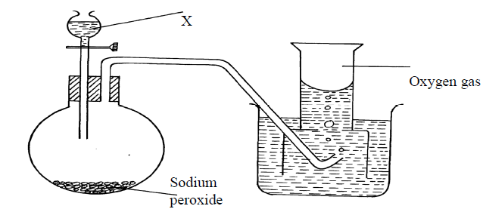
(a) Name substance X used (1mk)

(b) Write an equation to show the reaction of sodium peroxide with the substance named in 1(a)
(1mk)
(c) State ONE industrial uses of oxygen. (1mk)

14a)What is meant by Isomerism? (1mk)

b) Draw and name two Isomers of butane. (2mks)

c)Give the name of the substance CH ≡ CH (1mk)

15. Give two reasons why a luminous flame is not used for heating purposes (2mks)

16. Complete the table below to show the colour of the given indicator in acidic and basic solutions: 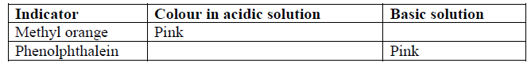
(2mks)
17.The set-up below was used to electrolyse a bromide of lead , PbBr₂.
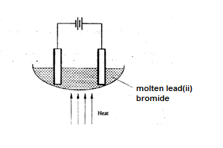
(i) Write equation for the reactions at the
I cathode (1 mark)

II anode (1 mark)

(ii) The electrodes used in the experiment were made of carbon and lead. Which of the two electrodes was used as the anode? Give a reason. (2 marks)

(iii) Give a reason why this experiment is carried out in a fume cupboard. (1 mark)

18. Excess Carbon (II) Oxide was passed over a heated sample of an oxide of iron as shown in the diagram below. Study the diagram and the data and use it to answer the questions that follow.
Dry Carbon (II)
Oxide
Oxide of iron
Heat
To fume chamber

Mass of empty dish =6.72g
Mass of empty dish + oxide of iron =9.04g
Mass of empty dish + residue=8.40g
(a)Determine the formula of the oxide of iron given that the relative formula mass of oxide of Iron is 232. (Fe = 56.0, O=16.0) (2marks)

(b) Write an equation for the reaction which took place in the dish (1mark)

19.Study the flow chart below and answer the questions that follow.

Ethanol
Ethene
U
A
B

Step 1

Step 2
Polymerization
Step 3. Temp. of 150⁰
Nickel catalyst, H₂

- Identify substances: A,B and C (1½ marks)

(b) State the conditions for the reaction in step 1 to occur. (2mks)

- Give one disadvantage of continued use of substances such as C. (½mk)

20. (a) When magnesium was burnt in air, a solid mixture was formed. On addition of water to the mixture a gas which turned moist red litmus paper blue was evolved. Explain these observations. (2 marks)

(b)Describe the process by which Nitrogen is obtained from air on a large scale. (4 marks)

21. The diagram below represents an allotrope of carbon.
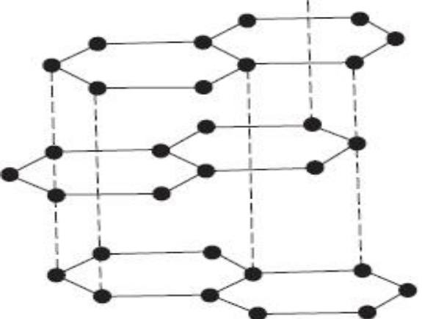
a) Name the allotrope. (1mk)

b)Explain why:- (2mks)
(i) it is slipperly
(ii) Conducts an electric current
22.Use the information in the table to answer questions that follow. (The letters are not the actual chemical symbols of the element)
Element | Atomic radius (nm) | Ionic radius (nm)
M | 0.158 | 0.097
N | 0.202 | 0.132
L | 0.133 | 0.061

Do these elements belong to a metallic or a non – metallic group? Give a reason. (2mks)

Which element is the most reactive? Explain. (1mk)

23.In an experiment a gas jar containing some damp iron fillings was inverted in a water trough
containing some water as shown in the diagram below. The set-up was left un-disturbed for three days. Study it and answer the questions that follow:

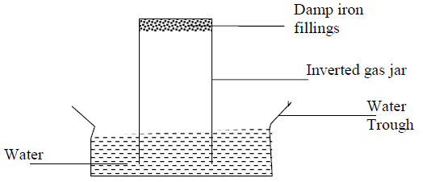
(a) Why were the iron filings moistened? (1mk)

(b) State and explain the observation made after three days. (2mks)

(c) State two conclusions made from the experiment. (1mk)

24.The set-up below was used to prepare dry carbon (II) Oxide gas. Use it to answer the questions below it:
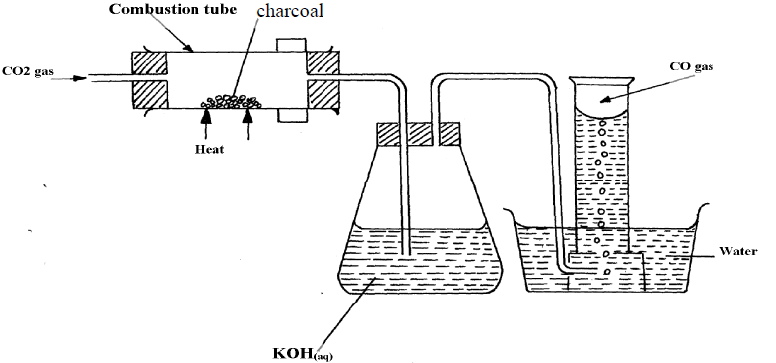
(a) (i) State two mistakes committed in the set-up arrangement above (2mks)

(iii) Write the equation for the reactions taking place in the combustion tube and the conical. (1mk)
flask:

(b) PbO(s) + CO(g) Pb(s) + CO2(g)
(i) Which property of carbon (II) Oxide is demonstrated by the above equation? (1mk)

(ii) State one use of carbon (IV) Oxide gas apart from fire extinguisher (1mk)

25. State the difference simple distillation and fractional distillation. (2mks)

