OPENER EXAMINATION TERM 3, 2022
CHEMISTRY EXAM - FORM 3
MARKING SCHEME
1.The diagram below shows a set-up of apparatus used to separate miscible liquids.

a)Name the parts labelled A and B. (2marks)
A Fractionating column
B Liebig’s condenser
b) State the function of the part labeled A . (1mark)
Condenses vapours whose boiling point have not been reached
c) State the property of the mixture that makes it suitable to be separated by the method above.
(1 mark)
Liquids in the mixture have close but different boiling points
2.Study the table below which shows the pH values of solutions A, B, C, D and E.
Use it to answer the questions that follow.

Solution | A | B | C | D | E
pH | 13.0 | 7.0 | 9.0 | 6.5 | 2.0

i) Which solution is the most acidic? (1 mark)
E
(ii) Which solution is a neutral? (1 mark)
B
(iii)Identify the solution that is most likely to be: (3 marks)

  - Rain water - D

  - Antacids tablet - C

  - Sodium hydroxide -A

3. A student accidentally mixed potassium chloride with white sand in the laboratory. Briefly describe how the mixture can be separated. (3mks)
-add water to the mixture to dissolve sodium chloride. Filter to obtain sand as residue and potassium chloride as filtrate. Evaporate the filtrate to obtain crystals of potassium chloride.
4.The diagram below shows laboratory preparation of hydrogen gas. Use it to answer the questions that follow.
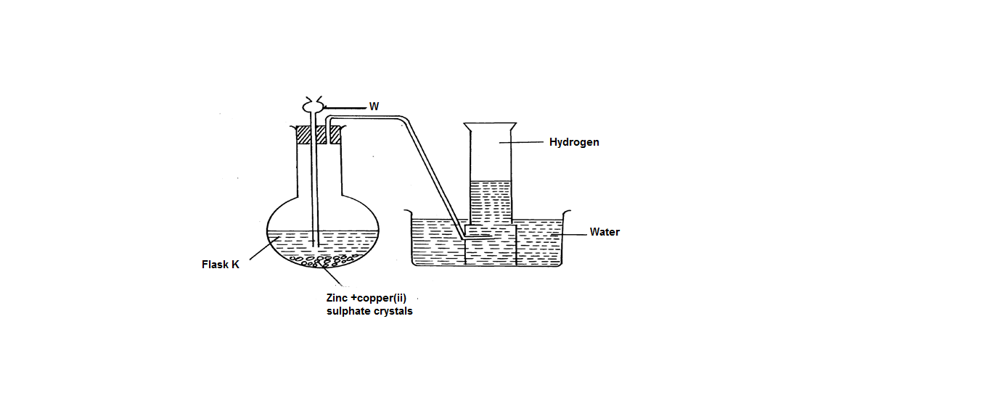
- Identify solution W (1mk)
Dilute hydrochloric acid or sulphuric acid
- State the observation made in flask K when liquid W is allowed to react with Zinc (1mk)
Effervescence/ bubbles of a colourless gas produced
- What is the role/use of copper (ii) sulphate in the reaction (1mk)
Speed up the reaction
- Write a word equation for the reaction producing hydrogen gas (1mk)
Relevant acid + Zinc Salt of zinc + Hydrogen gas
- State any two drying agents for hydrogen gas (2mks)
Concentrated sulphuric acid
Anhydrous calcium chloride
Calcium oxide
(Any 2 correct answers)
- State any two properties of hydrogen gas (2mks)
Less dense than air
Colorless and odorless gas
Insoluble in water
Burns in air to form water
- State any two uses of hydrogen gas (2mks)
Large scale manufacture of ammonia gas
Hydrogenation
Weather balloons
In oxy-hydrogen flame for welding and cutting of metals
Manufacture of hydrochloric acid
A rocket fuel
5. Use the grid below to answer the questions that follow. The letters do not represent the actual symbols of elements.
H H
 |  |  |  |  | M |  | O
F | J |  | K |  |  | N | P | Q
G
H

a) Give the family name of the group in which elements G and H are members ? (1mk)
Alkali metals
b)State and explain the difference in reactivity between ;
I. F and J (1mk)
F is more reactive than J. Valency electrons in F are loosely held than in J hence easily lost.
II.O and P (1mk)
O is more reactive than P. O gains electrons more readily than P .

c).How does the atomic radius of N compare to that of Q? Explain . (1mk)
N has a bigger atomic radius than Q. stronger nuclear charge in Q shrinks the atom.

(d).Element R forms an oxide of the formula RO₂ and belongs to period two. Indicate in the grid the position of R. ( 1 mk)

On the left of M in the same row.

e).Explain the trend in the melting points in the group of elements to which F and J belong?
(2mks)

(f).Give the formula of the compound formed between K and P. (1mk)

(g).Name the type of bond formed when F reacts with O. Explain. (2mks)
Ionic/ electrovalent bond. Formed by total transfer of electrons from F to O.

(h).Give one use of element Q ? (1mk)
-making light bulbs to prevent oxidation of filament

(i).Give the electron arrangement of an ion of ;

G 2:8:8 ( ½ mk)

M 2:8 (½ mk)

6.Describe how a solid sample of Lead(II) Chloride can be prepared using the following reagents:Dilute Nitric Acid, Dilute Hydrochloric Acid and Lead Carbonate. (3mks)
Dissolve (✓ ½) Lead carbonate in dilute Nitric acid (✓ ½ ) React the mixture with dilute Hydrochloric acid (1) Filter (✓ ½ ); to get Lead (II) Chloride (✓ ½ )
7.(a)State Charles’s law (1mk)
The volume of a fixed mass of gas is inversely proportional to it pressure at a constant temperature.
(b).The volume of a sample of nitrogen gas at a temperature of 298k and 600minHg
pressure was 4.8 x 10⁻² m³. Calculate the temperature at which the volume of the gas
would be 3.2 x 10⁻² m³ if pressure is constant. (2 mks)

= 198.671C✔1

8.A compound X is made of carbon, hydrogen and oxygen whose percentage composition by mass are 62.1%, 10.3% and the rest oxygen respectively. The relative molecular mass of X is 58 (H = 1, O = 16, C = 12) Determine the molecular formula of the compound. (3 marks)

C H O
62.1 10.3 27.6√ 1
12 1 16
Moles = 5.175 10.3 1.725
1.725 1.725 1.725√ 1
3 6 1
C₃H₆O √ 1
9.An element A has two isotopes ⁵⁰D and ⁵²D. The relative atomic mass of A is 51.5
Define the term isotopy (1mk)
Existence of atoms with the same atomic number but with different mass numbers
- Determine the percentage abundance of each isotope. (2mks)

-2x = -50
x = 25
⁵⁰D – 25%
⁵²D – 75⁰C

10. Using dots (∙) and crosses (×) to represent the outermost electrons, draw the structure to
show the bonding in CO₂. (C=6, O = 8). (2mk)

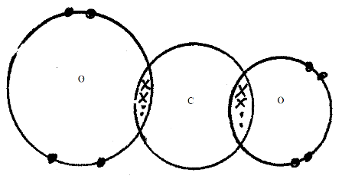

11.State Graham’s law of diffusion. (1mk)
Under the same conditions of temperature and pressure the rate of diffusion of a gas is inversely proportional to the square root of its density.
50cm³ of Carbon (IV) Oxide diffuses through a porous plate in 15 seconds. Calculate the time taken by 75cm³ of Nitrogen (IV) Oxide to diffuse through the same plate under similar conditions. (C = 12, 0 = 16, N = 14) (2mks)
73cm³ of CO₂ takes = $\frac{75 x 15}{50}$ second ✔ ½ = 22.5 seconds✔½
Rmm of CO₂ = 12 + 2 x 16 = 44 ✔ ½
Rmm of NO₂ = 14 + 2 x 16 = 46 ✔ ½
$\frac{{TNO}_{2}}{{TCO}_{2}}$= $\sqrt{\frac{{MNO}_{2}}{{MCO}_{2}}}$

TNO₂ = 22.5$\sqrt{\frac{46}{44}}$ seconds ✔ ½
= 23.006s ✔ ½
12. 12.0cm³ of 0.05m hydrochloric acid reacted with calcium hydrogen carbonate to form calcium chloride, water and carbon IV oxide.
(a)Write the chemical equation for the reaction. (1mk)
Ca(HCO₃)_{2(aq)} + 2HCl_{(aq)} CaCl_{2(aq)} + 2H₂O_{(l)} + 2CO_{2(g)} ✔1
- unbalanced eqn. – zero mk
- Penalise ½ mk for wrong or missing s.s

(b)Calculate the number of moles of hydrochloric acid used. (2mks)
Moles of HCl = 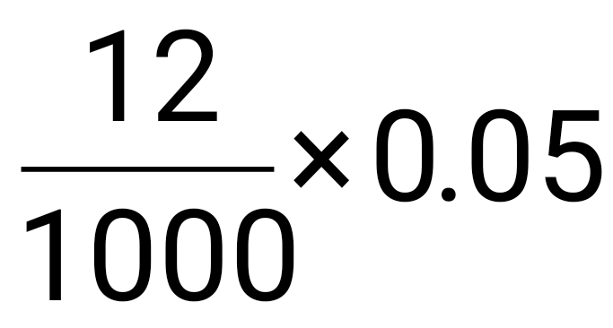✔ ½ = 0.0006mol ✔ ½

(c)Determine the number of moles of calcium hydrogencarbonate used. (1mk)
Moles of Ca(HCO₃)₂ = ½ x 0.0006 ✔ ½
= 0.0003mol ✔ ½
13.The diagram below shows students set-up for the preparation and collection of oxygen gas
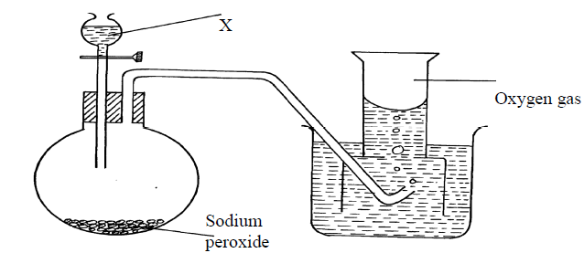
(a) Name substance X used (1mk)

Water
(b) Write an equation to show the reaction of sodium peroxide with the substance named in 1(a)
2 Na₂O_{2(s)} + 2 H₂O (l) 4 NaOH(aq) + O₂ (g) (1mk)
(c) State ONE industrial uses of oxygen. (1mk)
( any one relevant use of oxygen)

14a)What is meant by Isomerism? (1mk)
Existence of compounds with same molecular formula but different structural formulae.
b) Draw and name two Isomers of butane. (2mks)

c)Give the name of the substance CH ≡ CH (1mk)
Ethyne
15. Give two reasons why a luminous flame is not used for heating purposes (2mks)
-produces soot
-does not produce much heat compared to non- luminous flame.
16. Complete the table below to show the colour of the given indicator in acidic and basic
solutions:
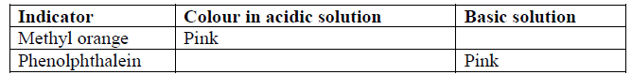
(2mks)
17.The set-up below was used to electrolyse a bromide of lead , PbBr₂.

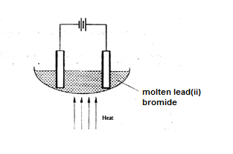

(i) Write equation for the reactions at the
I cathode (1 mark)
II anode (1 mark)
(ii) The electrodes used in the experiment were made of carbon and lead. Which of the two electrodes was used as the anode? Give a reason. (2 marks)

(iii) Give a reason why this experiment is carried out in a fume cupboard. (1 mark)

18. Excess Carbon (II) Oxide was passed over a heated sample of an oxide of iron as shown in the diagram below. Study the diagram and the data and use it to answer the questions that follow.
Dry Carbon (II)
Oxide
Oxide of iron
Heat
To fume chamber

Mass of empty dish =6.72g
Mass of empty dish + oxide of iron =9.04g
Mass of empty dish + residue=8.40g
(a)Determine the formula of the oxide of iron given that the relative formula mass of oxide of Iron is 232. (Fe = 56.0, O=16.0) (2marks)

$$mass of oxygen =9.04-8.40$$
$=0.64g$
$$mass of iron=8.40-6.72=1.68g$$
$Fe\frac{1.68}{56}=0.03$

$O \frac{0.64}{16}=0.04$

Mole ratio 3:4
Hence molecular formula F₃O₄✓1
(b) Write an equation for the reaction which took place in the dish (1mark)

Fe₃O_{4(s)} +4CO_{(g)} 3Fe_{(s)} +4 CO_{2(g)}

19.Study the flow chart below and answer the questions that follow.

Ethanol
Ethene
U
A
B

Step 1

Step 2
Polymerization
Step 3. Temp. of 150⁰
Nickel catalyst, H₂

Identify substances: A,B and C (1½ marks)
A– Water
B – Ethane
C – Polyethene

(c) State the conditions for the reaction in step 1 to occur. (2mks)
- Heat
- Conc. H₂SO₄

- Give one disadvantage of continued use of substances such as C. (½mk)

- Non biodegradable
- Blockage of water sources.

20. (a) When magnesium was burnt in air, a solid mixture was formed. On addition of water to the mixture a gas which turned moist red litmus paper blue was evolved. Explain these observations. (2 marks)

(b)Describe the process by which Nitrogen is obtained from air on a large scale. (4 marks)

21. The diagram below represents an allotrope of carbon.
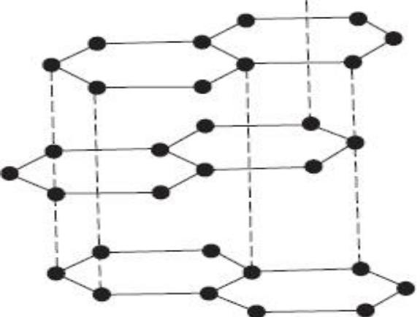
a) Name the allotrope. (1mk)

b)Explain why:- (2mks)
(i) it is slipperly
(ii) Conducts an electric current
22.Use the information in the table to answer questions that follow. (The letters are not the actual chemical symbols of the element)
Element | Atomic radius (nm) | Ionic radius (nm)
M | 0.158 | 0.097
N | 0.202 | 0.132
L | 0.133 | 0.061

Do these elements belong to a metallic or a non – metallic group? Give a reason. (2mks)

Metals ionic radius is shorter than the atomic radius
Which element is the most reactive? Explain. (1mk)
N. it has the longest atomic radius and therefore has lest ionization energy

23.In an experiment a gas jar containing some damp iron fillings was inverted in a water trough
containing some water as shown in the diagram below. The set-up was left un-disturbed for three days. Study it and answer the questions that follow:

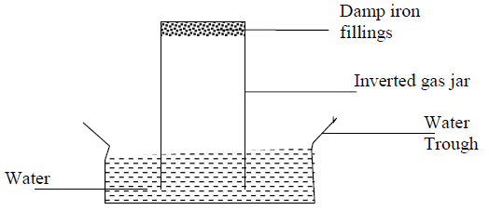
(a) Why were the iron filings moistened? (1mk)
So that they may stick to the gas Jar to prevent them from falling into water when the
gas jar is inverted
(b) State and explain the observation made after three days. (2mks)
Iron filings turned to reddish brown because they reacted with oxygen in presence
of moisture to form rust.
- The level of water inside the gas jar rise so as to occupy the volume initially occupied
by part of air used up for rusting
(c) State two conclusions made from the experiment. (1mk)
- Air is made up of two parts; - the active part that is necessary for rusting and the inactive
part that is not used for rusting

24.The set-up below was used to prepare dry carbon (II) Oxide gas. Use it to answer the questions
below it:
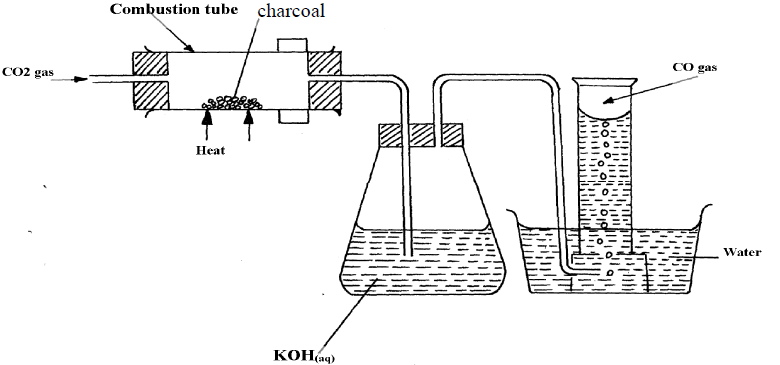
(a) (i) State two mistakes committed in the set-up arrangement above (2mks)
– The gas is collected over water
- The gas is not passed through a drying agent
(iii) Write the equation for the reactions taking place in the combustion tube and the conical. (1mk)
flask:
CO2(g) + C(s) 2CO(g)
(b) PbO(s) + CO(g) Pb(s) + CO2(g)
(i) Which property of carbon (II) Oxide is demonstrated by the above equation? (1mk)
Reducing Property
(ii) State one use of carbon (IV) Oxide gas apart from fire extinguisher (1mk)
– Solid CO2 used as a refrigerant
Used in making aerated drinks
Solid CO2 is used in cloud-seeding
CO2 used as an ingredient/air material in solvary process
25. State the difference simple distillation and fractional distillation. (2mks)

