Name ………………………………… ADM Number……………………

Signature ……………………………….. Date …………………/…….………/…………

**FORM 2**

**END OF TERM 2**

**INSTRUCTIONS TO CANDIDATES**

1. *Write your name and index no in the spaces provided above.*
2. *Sign and write the date of exam in the spaces provided above.*
3. *Answer all the questions in the spaces provided after each.*
4. *All working must be clearly shown where necessary.*
5. *Candidates should check to ensure that all pages are printed as indicated and that no questions are missing.*
6. *All answers should be written in English.*

1.The diagram below shows a set up of apparatus used to prepare oxygen gas and pass it over

burning candle. The experiment was allowed to run for several minutes.

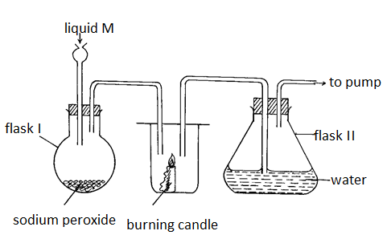

(i) Identify liquid M. (1mk)

*………………………………………………………………………………………………………*

(ii) Write an equation for the reaction that forms oxygen gas in the set up. (1mk)

*………………………………………………………………………………………………………………*

(ii) Drops of methyl orange indicator was added to solution formed in flask II . State and explain the observations made. (2mks)

…………………………………………………………………………………………………..

………………………………………………………………………………………………….

…………………………………………………………………………………………………...

1. The apparatus below was used to separate a mixture of liquid A and B.

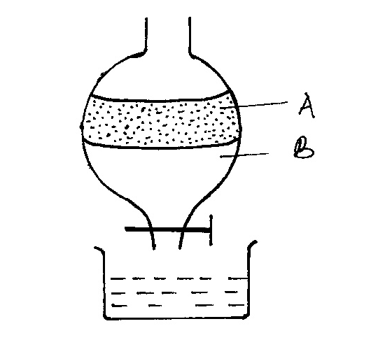

1. State two properties of the liquids that make it possible to separate them are using such apparatus. (2 marks)

3*.* solid sodium carbonate was added to a solution of Aluminium chloride in a test tube.State and explain the observations made. (2mk)

…………………………………………………………………………………………………

………………………………………………………………………………………………….

4. The table below shows some elements in the periodic table. Use it to answer the questions that follow. The letters are not the actual symbols of the elements.

|  |  |  |  |  |  |  |  |  |
| --- | --- | --- | --- | --- | --- | --- | --- | --- |
|  |  |  |  | | | | |  |
|  |  |  |  |  |  |  | **F** |
| **A** | **G** | **E** |  | **B** |  | **D** |  |
| **C** |  |  |  |  |  |  |  |  |

1. (i) Show the electron arrangement of :

**G**………………………………………… (1mk)

**Ion of D**………………………………………. (1mk)

(ii) Write the formula of the compound formed between the elements C and G. (1mk)

…………………………………………………………………………………………………..

1. Show on the grid above an element **Y** which forms an oxide with the formular Y2O3belonging to Period 2 . (1mk)

(c). Compare the following with explanations:

(i) The reactivity of **A** and **C** (2mks)

………………………………………………………………………………………………………

………………………………………………………………………………………………….

(ii) Atomic radii of elements **A** and **E** (2mks)

(iii) Ionization energies of elements **A** and **C**. (2mks)

………………………………………………………………………………………………………

…………………………………………………………………………………………………..

iv) write an equation to show the effect of heat on

1. nitrate of C(1mk)
2. hydrogen carbonate of G (1mk)

v) what name is given to the group of elements to which element G belong (1mk)

5 .Name the process which takes place when

(i)Iodine changes directly from solid to gas (1mark)

……………………………………………………………………………………………………

(ii)Water changes to water vapour (steam) (1mark)

………………………………………………………………………………………………………

(iii)Ability of a metal to be drawn into thin wires (1mk)

6.The table below gives atomic numbers of elements represented by the letters A, B, C and D.

|  |  |  |  |  |
| --- | --- | --- | --- | --- |
|  |  |  |  |  |
|  |  |  |  |  |



Use the information to answer the questions that follow.

(a) Name the type of bonding that exists in the compound formed when A and D react. (1mk)

……………………………………………………………………………………………….

(b) Select the letter which represents the best oxidizing agent.

Give a reason for your answer. (1mk)

………………………………………………………………………………………………

(c) Give a reason why phosphorous is stored under water. (1mk

…………………………………………………………………………………………………

7 .Study the set up below and answer the questions that follow.

(a).Identify gas M. (1mark)

……………………………………………………………………………………………

(b).Write an equation of the reaction that takes place in the combustion tube. (1marks)

…………………………………………………………………………………………………….

8. In the industrial preparation of oxygen, state:

(a).How dust particles are removed from air. (1mk)

…………………………………………………………………………………………………….

(b).Why carbon (IV) oxide is removed before the mixture is cooled to – 250C (1mk)

…………………………………………………………………………………………………

…………………………………………………………………………………………………

9.Describe how a sample of pure sodium chloride can be obtained from a mixture of

iodine,sodium chloride and sand. (3mks)

………………………………………………………………………………………………………………………………………………………………………………………………………………………………………………………………………………………………………………………

10. The set up below was used to prepare dry hydrogen gas. Study it and answer the questions that follow.

Cardboard

Hydrochloric acid

acid

Zinc granules

Liquid Y

(i) Identify a mistake in the set up (1mk)

…………………………………………………………………………………………………

(ii) Write an equation for the reaction for the reaction that produces hydrogen gas (1mk)

…………………………………………………………………………………………………

(iii) State one use of liquid Y (1mk)

…………………………………………………………………………………………………

11. An element E has relative atomic mass of 69.39. Given that the element has two isotopes of atomic masses 60.15 and 70.15, calculate the relative abundance of each of the isotopes. (3mks)

………………………………………………………………………………………………………………………………………………………………………………………………………………………………………………………………………………………………………………………

12.Describe how a solid sample of Lead(II) Chloride can be prepared using the following reagents:Dilute Nitric Acid, Dilute Hydrochloric Acid and Lead Carbonate. (3mks)

………………………………………………………………………………………………………………………………………………………………………………………………………………

………………………………………………………………………………………………………

13. Amino acids K and L were found to be pure compounds. A chromatogram of these amino acids of K and L and also of three sugars, glucose, fructose and galactose was made with the results shown below.

**Key**

K Amino acid K

L Amino acid L

III Glucose

IV Fructose

V galactose

V Galactose

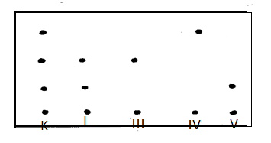

a) What two simple sugars must be present in powders K and L? (1 mk)

…………………………………………………………………………………………………….

b) Indicate the solvent font on the diagram above. (1 mk)

c) State two properties on which the separation above depends on (1mk)

d)state one application of the process above (1mk)

14. Using dots (•) and crosses (×) to represent the outermost electrons, draw the structure to

show the bonding in (C=6, O = 8 , N=7, H=1)

1. CO. (2mk)
2. NH4+ (2mk)

15. The electron arrangement of ions Q2- and R3+ are as 2, 8, 8, and 2,8 respectively.

(a) Write the electron arrangement of the elements Q and R (2marks)

(b) Write the formula of the compound that would be formed between Q and R (1mark)

16.Study the diagram below then use it to answer the questions that follow.



1. Draw the wooden splint at the end of the experiment. If it was slipped then removed. (1 mark)

b) Explain the appearance of the wooden splint in (a) above. (2 marks)

**17.** Study the diagram below and answer the questions that follow. The diagram shows the method used to separate component of mixture P.

**a)** Name X ................................................................................................................... (½ mark)

**b)** What is the name given to the method used in separation of mixture P ? (½ mark)

**c)** What would happen if the inlet and outlet of water were interchanged ? (1 mark)

**d)** Which physical property is used to separate mixture P ? ( 1 mark)

**18.** Below are PH values of some solutions.

|  |  |  |  |  |
| --- | --- | --- | --- | --- |
| Solution | Z | Y | X | W |
| PH | 6.5 | 13.5 | 2.2 | 8.0 |

**i)** Which solution is likely to be

I. acidic rain ................................................................................................ (½ mark)

II. Potassium hydroxide ................................................................................. (½ mark)

**ii)** A solution which could be used as anti acid (1mk)

19. The diagram below is used in preparation of liquid L

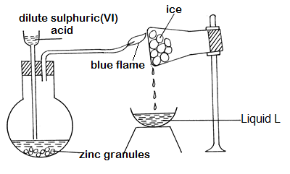

a) Explain the observations that would be made if calcium turnings were used instead of zinc granules in the above experiment. (2mk

*……………………………………………………………………………………………………………….*

b) (i) Explain how liquid L can be identified by chemical means. (2mks

………………………………………………………………………………………………………

……………………………………………………………………………………………………..

(ii) How could the purity of liquid L be confirmed? (1mk

*…………………………………………………………………………………………………………………*

*………………………………………………………………………………………………………………....*

(c)Name asuitable catalyst for the reaction above (1mk)

…………………………………………………………………………………………………

(d) When magnesium is heated in steam it reacts rapidly forming a white solid and gas X.

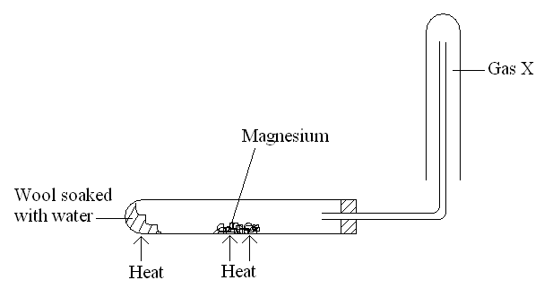

(i)Write an equation that took place in the heated test tube. (1mk)

………………………………………………………………………………………………….

**(ii).**Why is the gas X collected as shown in the diagram above? (1mk)

…………………………………………………………………………………………………..

**(iii).**How would you confirm the gas collected? (1mk)

……………………………………………………………………………………………..

20.An iron sculpture was produced to commemorate the anniversary of founder of a certain village. To prevent it from rusting, the village elder attached it by a wire to a block of zinc which was stored underground out of sight.

(i).Explain how the village elder’s action would prevent the rusting of the sculpture. (1mk)

………………………………………………………………………………………………………………

……………………………………………………………………………………………………………..

(ii).What name is given to this method of preventing rusting? (1mk)

……………………………………………………………………………………………………

(iii).List down **two** other ways in which rusting of the statue could be prevented. (1mk)

………………………………………………………………………………………………………………

……………………………………………………………………………………………………….………

………………………………………………………………………………………………………………

21. Study the table below and answer the questions that follows

|  |  |  |  |  |  |  |
| --- | --- | --- | --- | --- | --- | --- |
| Substance | A | B | C | D | E | F |
| Melting point (oC) | 801 | 113  119 | 139 | 5 | -101 | 3700 |
| Boiling point (oC) | 1410 | 445 | 457 | 54 | -36 | 4027 |
| Electrical conductivity | Solid | Poor | Good | Poor | Poor | Poor |
| liquid | poor | Good | Poor | Poor | Poor |

a)Identify with a reason the type of structure in

1. Substance A (1mk)

Structure………………………………….

Reason…………………………….

1. Substance C (1mk)

Structure………………………

Reason……………………..

1. Which compound have a simple molecular structure and exist as a liquid at room temperature (1mk)
2. Suggest a reason why substance B has two melting points (1mk)
3. Which substance could have giant atomic substance. (1mk)

22. when solid H was left exposed, it became dump. What property of solid H is demonstrated

(1mk)