NAME ……………………………………..…………………………DATE …………

ADM NO. …….. SIGNATURE …………

233
CHEMISTRY
FORM TWO
TIME: 2 HOURS

OPENER EXAMINATION TERM 3, 2022
Kenya Certificate of Secondary Education

INSTRUCTIONS TO CANDIDATES: -
  - Write your name, Admission number and class in the spaces provided above.
  - Answer all the questions in the spaces provided
  - Candidates should answer the questions in English.

- a) Draw a dot (•) and a cross (x) diagram to show bonding in Cl2O. (2mks)
(Cl=17, O=8)

b) Explain why the compound Cl2O has a very low melting and boiling point. (1mk)

- Below is a set up used to collect hydrogen gas.

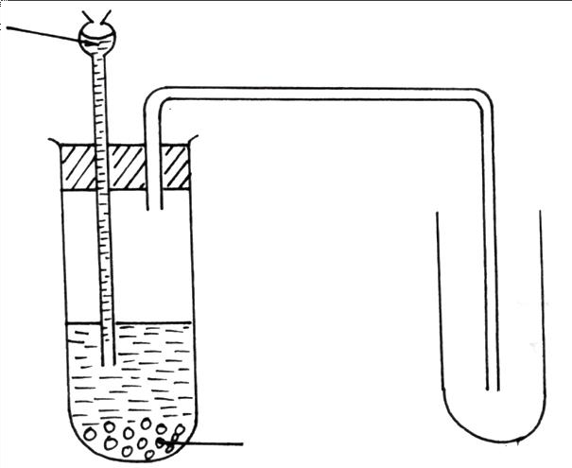
Dilute nitric acid

Zinc granules

  - Identify with reasons, two mistakes in the set up. (2mks)

  - state the role of hydrogen in the manufacture of margarine. (1mk)

c) Explain why it’s not advisable to prepare hydrogen gas by reacting dilute hydrochloric acid with potassium metal. (2mks)

- Explain the following:-
  - Helium is used instead of Hydrogen in balloons for metrological research. (1mk)

  - The boiling and melting points of alkali metals decreases down the group while the melting and boiling points of halogens increase down the group (2mks)

4.The grid below represents part of the periodic table. Study it and answer the questions that follow. The letters are not actual symbols of the elements.

B | A |  |  | G |  | E | H
 | C |  | D | L |  |  |  | I
F |  |  |  |  | T

- What name is given to the family of elements to which H belong? (1mk)

- Write the formula of the sulphate of element D. (1mk)

- Which letter represents the most reactive; (2mks)
- Metal

- Non-metal

- Name the bond formed when B and H react. Explain your answer. (2mks)

- Select one element that belongs to period 4. (1mk)

- Explain why the ionic radius of element E is bigger than the atomic radius. (2mks)

- The electron configuration of a divalent anion of element N is 2.8.8. Indicate the position of element N on the periodic table above. (1mk)

- The oxide of G has a lower melting point than the oxide of L. Explain. (2mks)

- How do the atomic radii of I and C compare. Explain. (2mks)

- Explain the trend in the 1st ionization energies of the elements B and F. (1mk)

5.a) Describe how to light and obtain a non- luminous flame from a Bunsen burner.(3 mks)

b) State one disadvantage of the flame obtained above.(1 mk)

6. State the type of changes undergone by the following substance,
a) Obtaining kerosene from crude oil. (1 mk)

b) Souring of milk. (1 mk)

7. A beekeeper found that when stung by a bee application of a little solution of ammonium hydroxide helped to relieve irritation from the affected area. Explain. (2 mks)

8. The set up below was used to collect gas F produced by the reaction between water and calcium metal
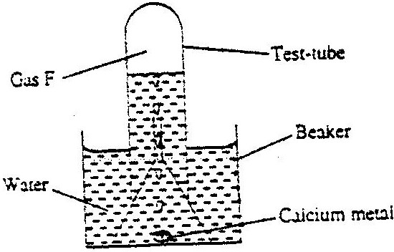

i) Name gas F.(1 mk)
i) At the end of the experiment the solution in the beaker was found to be a weak base. Explain why the solution is a weak base.(2 mks)

ii) write a chemical equation for the reaction that took place in the beaker. (1 mk)

9. a) What is a radical as used in chemistry. (1 mk)

b) State the formula of the compound formed when the following radicals combine
i) Ammonium and sulphate. ⁽1 mk)

10. Four metals F, G, H and J were each separately added to cold water and steam. Metal F melted into a silvery ball in cold water and reacted violently with steam. Metal J showed no reaction with water and steam. Metal G reacted with steam but not with cold water. Metal H reacts explosively with water.
A) Suggest the identify of metal J. (1 mk)

b) Arrange the metals in order of reactivity starting with the most reactive. (1 mk)

c) Apart from melting into a silver ball. State any other observation made when F is added to water (1mk)

d) Write a chemical equation for the reaction between H and steam. (1 mk)

11. Name the method of separation that can most suitably be used to separate the following mixtures
a) Component of crude oil. (1mk)

b) Benzoic acid and potassium carbonate. (1mk)

c) Oil from cashew nuts. (1mk)

12. The table below shows information about three solid substances A,B and C.Study it and answer the question that follow.
SOLID A | COLD WATER | HOT WATER
A | Soluble | Soluble
B | Insoluble | Insoluble
C | Insoluble | Soluble

Describe how you will separate the three solids from a mixture of these three. (3mks)

13. The table below gives information on four elements by letters K,L,M and N.Study it and
answer the questions that follow. The letters do not represent the actual symbol of the
elements
Element | Electron arrangement | Atomic radius (nm) | Ionic radius(nm)
K | 2.8.2 | 0.136 | 0.065
L | 2.8.7 | 0.099 | 0.181
M | 2.8.8.1 | 0.203 | 0.133
N | 2.8.8.2 | 0.174 | 0.099

a) Which two elements have similar properties?
Explain (2mks)

b) Which element is a non – metal. Explain. (1mk)

14. State and explain what would be observed when hydrogen gas is passed over heated copper (II) oxide in a combustion tube. (2 mks)

15. Solution R, S and T have PH values shown in the table below:

Solution | pH value
R | 1.0
S | 6.5
T | 8.0

a) What do you deduce about the nature of solution S? (1mk)

b) Which solution would react most vigorously with sodium hydrogen carbonate? (1mk)

c) Which solution is likely to be ammonia solution? (1mk)

16. The electron arrangement of ions X⁺² and Y⁻³ are 2.8.8 and 2.8 respectively.
Write the electron arrangement of the atoms of
a) X (1mk)

b) Y (1mk)

  - Write the formula of the compound formed when X and Y react (1mk)

17.The diagram below shows two nails A and B wrapped with two different metal strip and are exposed to moist air
zinc
iron
copper
iron
X Y
- State what would happen in set up X and Y after one week (2mk)

- Explain your observation in diagram Y (1mk)

18. The table below gives some properties of three substances A, B and C.
SUBSTANCE | A | B | C
Appearance | Brown solid | Yellow solid | Yellow solid
Melting point (ºC) | 1017 | 115⁰C | 402⁰C
Solubility in water | Insoluble | Insoluble | Sparingly
Electrical conductivity (solid) | Conducts | Does not conduct | Does not conduct
Electrical conductivity (liquid) | Conducts | Does not conduct | Conduct but decomposed
- Giving reasons for your answers, which of the substances A, B and C has
- Giant ionic lattice 2mks
- Simple molecular lattice 2mks
- Giant metallic lattice 2mks
- Why does C conduct electricity only in molten state but not in solid state 1mk

- Why is A not decomposed when it conducts electricity 1mk

19. Salt is sprinkled on roads in Europe during winter to prevent formation of ice on roads. Explain how the salt works. (2mks)

20. The figure below shows the heating curve of solid M. Use it to answer the questions that follow.
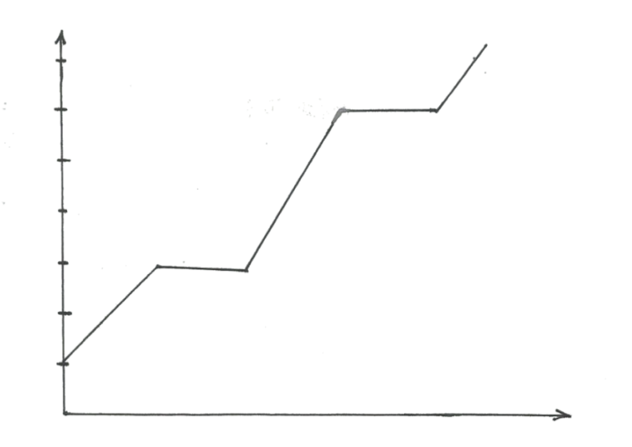
F
E
D
C
B
A
Temperature (⁰C)
Time (sec)

- In which state was substance M between C and D. 1mark)

b) State whether M was an impure or a pure substance. (1mk)

  - Explain why part BC is horizontal. (1mk)

21. (a) The relative atomic masses of some elements are not whole numbers. Explain. (1mk)

- An elements Gallium has relative atomic mass 69.8. In 100 atoms of Gallium 60atoms are Gallium 69 and 40 atoms are Gallium X. Determine the value of X. (2mks)

22. Given iron fillings, a crucible, a plain piece of paper, sulphur powder, magnet , a source of heat and any other laboratory apparatus, explain how you can distinguish between a mixture and a compound (2mk)

