OPENER EXAMINATION TERM 3, 2022
CHEMISTRY EXAM - FORM 2
MARKING SCHEME

- a) Draw a dot (•) and a cross (x) diagram to show bonding in Cl2O. (2mks)
(Cl=17, O=8)

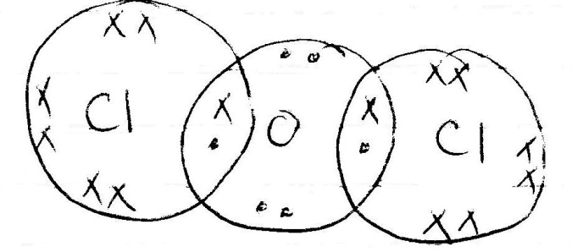

b) Explain why the compound Cl2O has a very low melting and boiling point. (1mk)
-it has simple molecular structure1/2 mk with weak van der waals forces ½ mk which require low temperature to break

- Below is a set up used to collect hydrogen gas.

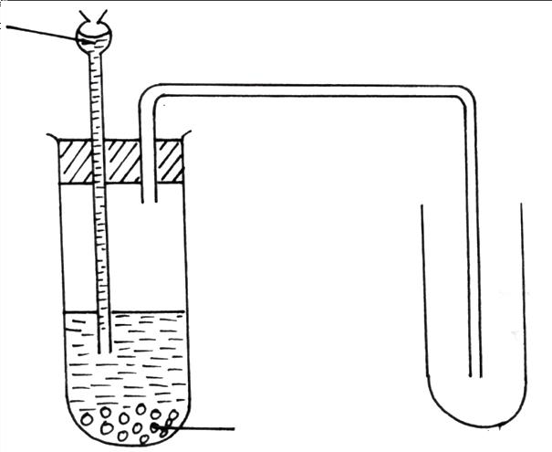
Dilute nitric acid

Zinc grnaules

  - Identify with reasons, two mistakes in the set up. (2mks)
-using nitric v acid. Nitric v acid is a strong oxidizing agent hence oxidizes hydrogen formed to water
-collected by downward delivery. hydrogen is lighter than air
  - state the role of hydrogen in the manufacture of margarine. (1mk)

-hardening of oil to fat(margarine)
c) Explain why it’s not advisable to prepare hydrogen gas by reacting dilute hydrochloric acid with potassium metal. (2mks)
-potassium is a very reactive metal hence explode when reacted with dilute acid

- Explain the following:-
  - Helium is used instead of Hydrogen in balloons for metrological research. (1mk)
-helium is inert hence reduce chances of explosion
  - The boiling and melting points of alkali metals decreases down the group while the melting and boiling points of halogens increase down the group (2mks)
-the atomic radius of alkali metals increases down the group. This decreases the strength of metallic bond down the group thus increases heat energy needed to break them while as the atomic radius increases in halogens, the number and strength of the van der waals forces increases.
4.The grid below represents part of the periodic table. Study it and answer the questions that follow. The letters are not actual symbols of the elements.

B | A |  |  | G |  | E | H
 | C |  | D | L |  | N |  | I
F |  |  |  |  |  |  | T

- What name is given to the family of elements to which H belong? (1mk)
-Halogens
- Write the formula of the sulphate of element D. (1mk)
- D₂ (SO₄)₃

- Which letter represents the most reactive; (2mks)
- Metal
-F
- Non-metal
-H
- Name the bond formed when B and H react. Explain your answer. (2mks)
-IONIC / ELECTROVALENT BOND.
-COMPLETE TRANSFER OF ELECTRONS FROM B TO H

- Select one element that belongs to period 4. (1mk)
-F , T

- Explain why the ionic radius of element E is bigger than the atomic radius. (2mks)
-E . forms ion by gaining electrons. The incoming elections are repelled by existing electrons thus ion bulge outward.

- The electron configuration of a divalent anion of element N is 2.8.8. Indicate the position of element N on the periodic table above. (1mk)

- The oxide of G has a lower melting point than the oxide of L. Explain. (2mks)
-OXIDE OF G HAS SIMPLE MOLECULAR STRUCTURE WITH WEAK VAN DER WAALS THAT REQUIRE LITTLE ENERGY TO BREAK.
-OXIDE OF L HAS GIANT ATOMIC STRUCTURE WITH STRONG COVALENT BONDS THAT REQUIRE HIGH TEMPERATURE TO BREAK
- How do the atomic radii of I and C compare. Explain. (2mks)
-I HAS SMALLER ATOMIC RADIUS THAN C.
-I HAS HIGHER NUCLEAR CHARGE THAN C HENCE STRONGER NUCLEAR PULL OF THE OUTERMOST ENERGY LEVEL THAN C

- Explain the difference in the 1st ionization energies of the elements B and F. (1mk)
-B has a larger ionization energy than F. B has smaller atomic radius than F hence its outermost electrons are more attracted hence requiring more energy to remove than F

5.a)( Describe how to light and obtain a non- luminous flame from a Bunsen burner.(3 mks)

-connect the burner with external source of gas using a rubber tubing.
- close the air hole
-light the burner
- open the air hole

b) State one disadvantage of the flame obtained above.(1 mk)
- uses a lot of laboratory gas in burning
- cannot be used in lighting as it is less bright

6. State the type of changes undergone by the following substance,
a) Obtaining kerosene from crude oil.(1 mk)
-physical/ temporary

b) Souring of milk.(1 mk)
-chemical/ permanent

7. A beekeeper found that when stung by a bee application of a little solution of ammonium hydroxide helped to relieve irritation from the affected area. Explain.(2 mks)
-bee sting produce an acid. ammonium hydroxide is a weak base which neutralizes the acid reducing pain

8. The set up below was used to collect gas F produced by the reaction between water and calcium metal
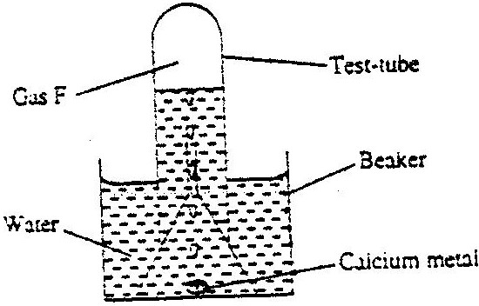

i) Name gas F.(1 mk)
-hydrogen

i) At the end of the experiment the solution in the beaker was found to have a pH of 9.0. Explain.(2 mks)

-calcium reacts with water to produce calcium hydroxide which is a weak base

ii) write a chemical equation for the reaction that took place in the beaker.(1 mk)

Ca_{(s)} + 2 H₂O_{(l)} Ca(OH)₂ _{(aq)} + H₂ _{(g)}
9. a) What is a radical as used in chemistry.(1 mk)
-a group of atoms behaving and reacting as a unit
b) State the formula of the compound formed when the following radicals combine
i) Ammonium and sulphate ^{.(}1 mk)

(NH₄)₂SO₄
10. Four metals F,G,H and J were each separately added to cold water and steam. Metal F melted into silvery ball in cold water and violently with steam. Metal J showed no reaction with cold water and steam. Metal H reacted explosively with water. Metal G reacted with steam but not with cold water.
A) Suggest the identify of metal J.(1 mk)
- copper or silver or mercury or gold
b) H˃F˃G˃J
c) floats on water, colourless gas formed, darts on water surface
d) Write an equation for the reaction between metal H and steam.(1 mk)
- 2H (s) + 2H₂O (l) 2 HOH (aq) + H₂ _{(g)}
NB. you can use Na for H
11. Name the method of separation that can most suitably be used to separate the following mixtures
a) Component of crude oil. (1mk)
fractional distillation
b) Benzoic acid and potassium carbonate. (1mk)
-sublimation
c) Oil from cashew nuts. (1mk)
-solvent extraction
12. The table below shows information about three solid substances A,B and C.Study it and answer the question that follow.
SOLID A | COLD WATER | HOT WATER
A | Soluble | Soluble
B | Insoluble | Insoluble
C | Insoluble | Soluble

Describe how you will separate the three solids from a mixture of these three. (3mks)
Add hot water to the mixture and stir. Filter to obtain B as residue. Allow the filtrate to cool and filter when cold to obtain C as residue and A as filtrate.

13. The table below gives information on four elements by letters K,L,M and N.Study it and answer the questions that follow. The letters do not represent the actual symbol of the elements
Element | Electron arrangement | Atomic radius (nm) | Ionic radius(nm)
K | 2.8.2 | 0.136 | 0.065
L | 2.8.7 | 0.099 | 0.181
M | 2.8.8.1 | 0.203 | 0.133
N | 2.8.8.2 | 0.174 | 0.099

a) Which two elements have similar properties?
Explain (2mks)
-K and N . Have two electrons in the outermost energy level
c) Which element is a non – metal. Explain. (1mk)
- L. Ionic radius larger than atomic radius or form ion by gaining electrons or have more than for electrons in the outermost energy level
14. State and explain what would be observed when hydrogen gas is passed over heated copper (II) oxide in a combustion tube. (2 mks)
- Black solid turns brown. CuO reduced to Cu
OR colourless liquid forms on the cooler parts of the combustion tube.H₂ oxidized to water)
15. Solutio n R, S and T have PH values shown in the table below:

Solution | pH value
R | 1.0
S | 6.5
T | 8.0

a) What do you deduce about the nature of solution S? (1mk)
-acidic
b)Which solution would react most vigorously with sodium hydrogen carbonate? (1mk)
-R
c) Which solution is likely to be ammonia solution? (1mk)
-T
16.a) The electron arrangement of ions X⁺² and Y⁻³ are 2.8.8 and 2.8 respectively. Write the
electron arrangement of the atoms of
X (1mk)
-2.8.8.2
Y (1mk)
2.5

17.write the formula of the compound formed when X and Y react (1mk) The diagram below shows two nails A and B wrapped with two different metal strip and are exposed to moist air
zinc
iron
copper
iron

X Y
- state what would happen in set up X and Y after one week (2mk)
X-Rust or brown coating on iron
Y- no rust or brown coating on iron
- Explain your observation in diagram Y (1mk)
-zinc is more reactive than iron hence acts as a sacrificial protector for iron
18. The table below gives some properties of three substances A, B and C.
SUBSTANCE | A | B | C
Appearance | Brown solid | Yellow solid | Yellow solid
Melting point (ºC) | 1017 | 115⁰C | 402⁰C
Solubility in water | Insoluble | Insoluble | Sparingly
Electrical conductivity (solid) | Conducts | Does not conduct | Does not conduct
Electrical conductivity (liquid) | Conducts | Does not conduct | Conduct but decomposed
- Giving reasons for your answers, which of the substances A, B and C has
- Giant ionic lattice 2mks
-C. poor conductor in solid state but good conductor in molten state
-is decomposed hence electrolyte
- Simple molecular lattice 2mks
-B. poor conductor and low melting point
- Giant metallic lattice 2mks
-A. good conductor in all states and high MP
Why does C conduct electricity only in molten state but not in solid state 1mk
- in solid state, ions are not mobile hence do not conduct
- in liquid state, the ions are mobile hence conduct
- Why is A not decomposed when it conducts electricity 1mk
-conduct by use of delocalized electrons not mobile ions
19. Salt is sprinkled on roads in Europe during winter to prevent formation of ice on roads. Explain how the salt works. (2mks)
The salt lowers the freezing point of water. This maintains water in liquid form
20. The figure below shows the heating curve of solid M. Use it to answer the questions that follow.
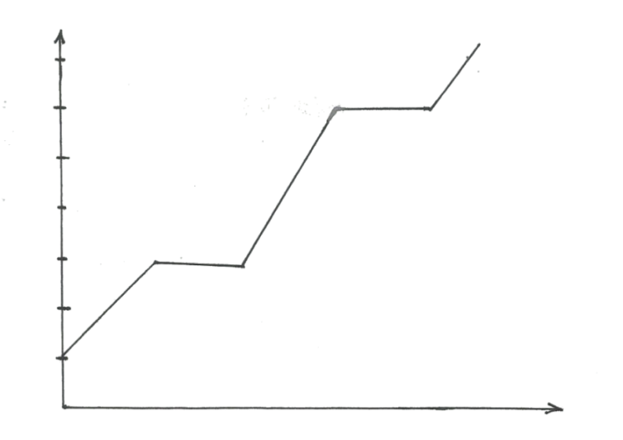
F
E
D
C
B
A
Temperature (⁰C)
Time (sec)
a)In which state was substance M between C and D. (1mark)
-liquid
b) State whether M was an impure or a pure substance. Give a reason (1mk)
-pure.
- sharp MP or BP

  - Explain why part BC is horizontal. (1mk)
-heat absorbed at AB is used to overcome the forces of attractions holding solid particles together rather than raising the temperature.
21. (a) The relative atomic masses of some elements are not whole numbers. Explain. (1mk)
-RAM is the average of the masses of rhe isotopes.
- An elements Gallium has relative atomic mass 69.8. In 100 atoms of Gallium 60atoms are Gallium 69 and 40 atoms are Gallium X. Determine the value of X. (2mks)
69.8= $\frac{\left(60X 69\right)+( 40 x)}{100}$
x = 71
22. Given iron fillings, a crucible, a plain piece of paper, sulphur powder, magnet , a source of heat and any other laboratory apparatus, explain how you can distinguish between a mixture and a compound (2mk)
- spread the mixture of iron and sulphur on a plain paper
- pass a magnet over the mixture. iron is attracted leaving sulphur
-put the mixture in a beaker. heat them and pass the magnet over the mixture. Iron will not be attracted thus a compound

