Name ………………………………… ADM Number……………………

Signature ……………………………….. Date …………………/…….………/…………

**FORM 1**

**END OF TERM 2 EXAM**

**INSTRUCTIONS TO CANDIDATES**

1. *Write your name and index no in the spaces provided above.*
2. *Sign and write the date of exam in the spaces provided above.*
3. *Answer all the questions in the spaces provided after each.*
4. *All working must be clearly shown where necessary.*
5. *Candidates should check to ensure that all pages are printed as indicated and that no questions are missing.*
6. *All answers should be written in English.*

1.The diagram below shows the physical state of matter

S

R V

SOLID

GAS

LIQUID

U W

T

1. Name the processes represented by letters
2. (4mks)
3. Name two substances which undergo process T.
4. (2mk)

2. Complete the following table to show the colour of the following indicators in acidic and basic solution (6mks)

|  |  |  |
| --- | --- | --- |
| indicator | Colour in |  |
|  | Acidic solution | Basic solution |
| Phenolphthalein |  |  |
| Methyl orange |  |  |
| Litmus solution |  |  |

3. The diagram below shows the heating curve of a pure substance. Study it and answer the

questions that follow:

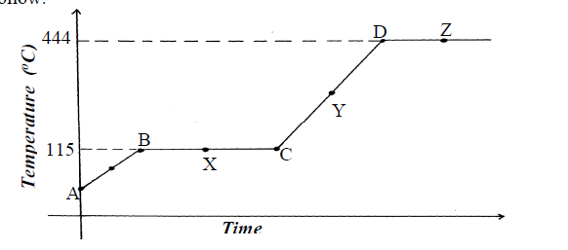

(a) What physical changes are taking place at points X and Z? (2mks)

**X-**

**Z-**

(b)what happens to the melting point when sodium chloride added to this substance. (1mks)

(c) In terms of kinetic theory, briefly explain why there is no rise in temperature in region BC despite continued heating of the substance. (2mks)

4. The diagram below shows a set – up used by a student to find out what happens

when Copper (II) sulphate crystals are heated

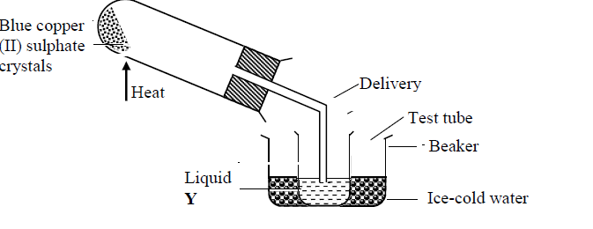

(i) State the observations made when the blue copper (II) sulphate crystals are heated. (2mks)

(ii) What is the purpose of ice-cold water in the above set up? (1mk

(iii) Identify liquid Y and write an equation for its formation. (2mks)

(iv) How can purity of liquid Y be confirmed? (1mk)

5. The setup below was used to separate two miscible liquids Q and T

(Boling points; Q =98°C, T=78°C)

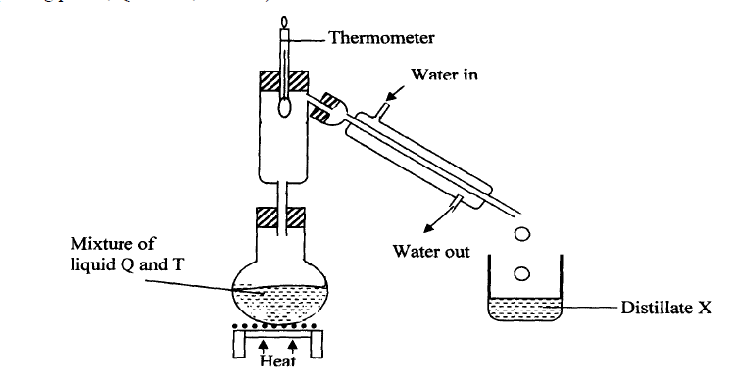

(a) Identify the mistakes in the setup above (2mks)

(b)Name the method of separating mixtures shown. (1mk)

(c)Identify Distillate X (1mk)

(d) What is the role of the thermometer in the above set up? (1mk)

6. The information below gives PH values of solutions V, W, X, Y Z

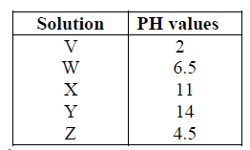

(a)Which solution is likely to be:

(i) Calcium hydroxide? (1mk)

(ii) Rain water? (1mk)

(iii) Lemon juice (1mk)

(b) Which solution would react most vigorously with Zinc carbonate ? (1mk)

(c) Identify a substance that can:-

(i) be used to raise the soil pH (1mk)

(ii) react with sodium hydroxide to form salt and water. (1mk)

(d) Select a pair that would react to form a solution with a pH of 7. (1mk)

7. The diagram below shows spots of pure substances A, B, and C on a chromatography

paper. Spot Dis that of a mixture

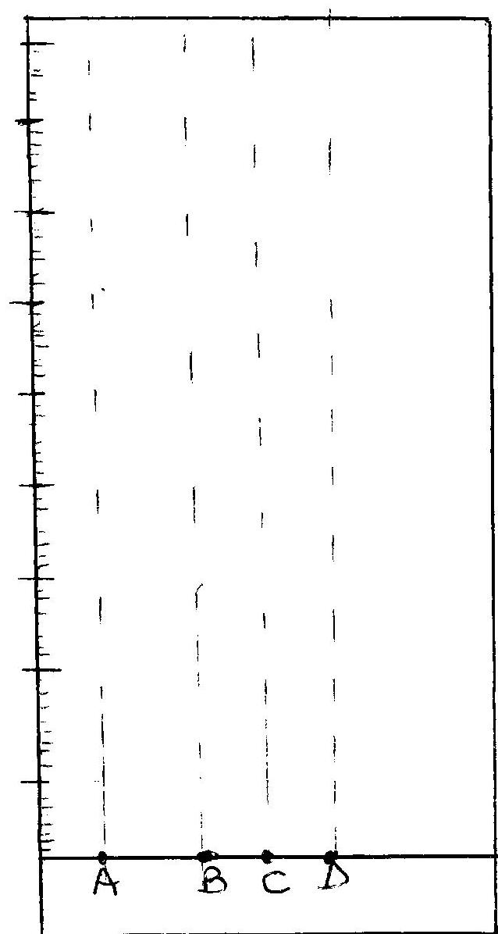

(a) After development A, B and C were found to have moved 8cm, 4cm and 6cm respectively.

D has separated into two spots which have moved 6cm and 8cm:-

On the diagram:-

I. Label the baseline and show the solvent front (1mk)

II. Show the position of all the spots after development (1mk)

III. Identify the substances present in mixture D (1mk)

IV. State one application of chromatography. (1 mark)

8.State the method used to separate the following mixtures (3mks)

(i) Sodium chloride and iodine

(ii) oil from groundnuts

(iii) components of crude oil

9. (i) Define Chemistry. (1mark)

(ii) Give three importance of studying Chemistry. (3marks)

10. The diagram below shows the apparatus commonly used in a laboratory.

(i) Name the apparatus. (1mark)



(ii) State the function of the parts labeled in the above apparatus.

a) Chimney. (1 mark)

b) Collar (1mark)

c) Air hole. (1 mark)

**-**

(iii)What is a flame? (lmark)

iv) The following diagrams represent the two types of flames.

 Identify the flames (a) and (b) (2marks)

a)

b**)**

b) Which type of the flames identified above is preferred for heating?

Give a reason for your answer. (2marks)

c) Give two differences between the flames (a) and (b) above. (2marks)

11. Consider the following general reaction.

Acid + Base Salt + Water

(i) Name the type of reactions shown above. (1 mark)

(ii)Name one example of each of the following. (2 marks)

Acid :

Base:

12.The follow set-up was used by some students to study some properties of air.



(a) State ONE observations made after a few minutes. (1 mark)

(b) Name the gas that occupies the largest volume after the experiment (1 mark)

(c) The percentage of air used was calculated to be 19.375% while the approximate percentage of oxygen is 21%. State ONE source of error. (1 mark)

(d) Why is sodium hydroxide solution preferred to water in this experiment? (1 mark)

(e) Why is it advisable to allow the apparatus to cool before the final volume is taken? (1 mark)

13. Complete the table below (8mks)

|  |  |  |  |
| --- | --- | --- | --- |
| element | symbol | element | Symbol |
|  | Na | Mercury |  |
| Patassium |  |  | Cu |
|  | S |  | Co |
| iron |  | hydrogen |  |

14. Matyang a form one student was stung by a bee in the school apiary. The lab technician applied wood ash solution on her she was relieved off the pain. Explain why this was done. (2mks)

15. Complete the word equations for the following reactions; (3mks)

(a) sodium carbonate + sulphuric acid =

(b) Zinc + hydrochloric acid =

(c) Calcium hydroxide + nitric acid =

16.State ONE laboratory rule to observe when preparation of gases. (1mk)

17.Define the following terms and give an example of each (3mks)

(a) An atom

(b) -Molecule

(c) Compound